# Citi-Bike-Analytics

Click [here](https://public.tableau.com/profile/tasneem.bhaijee#!/vizhome/NYBikeReportFinal/NewYorkBikeStationsReport?publish=yes) to open the workbook.

The objective of this exercise is to create a dashboard for the [New York Citi Bike](https://en.wikipedia.org/wiki/Citi_Bike) Program.

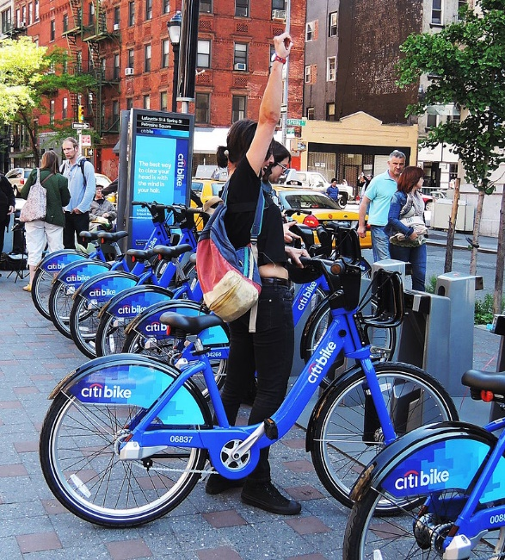

The data is collected, organized, and made public on the [Citi Bike Data](https://www.citibikenyc.com/system-data) webpage.

# Here are Some of the findings:

1: The peak hours during a day is usually 7-8 AM and 5-6 PM throughout the year.

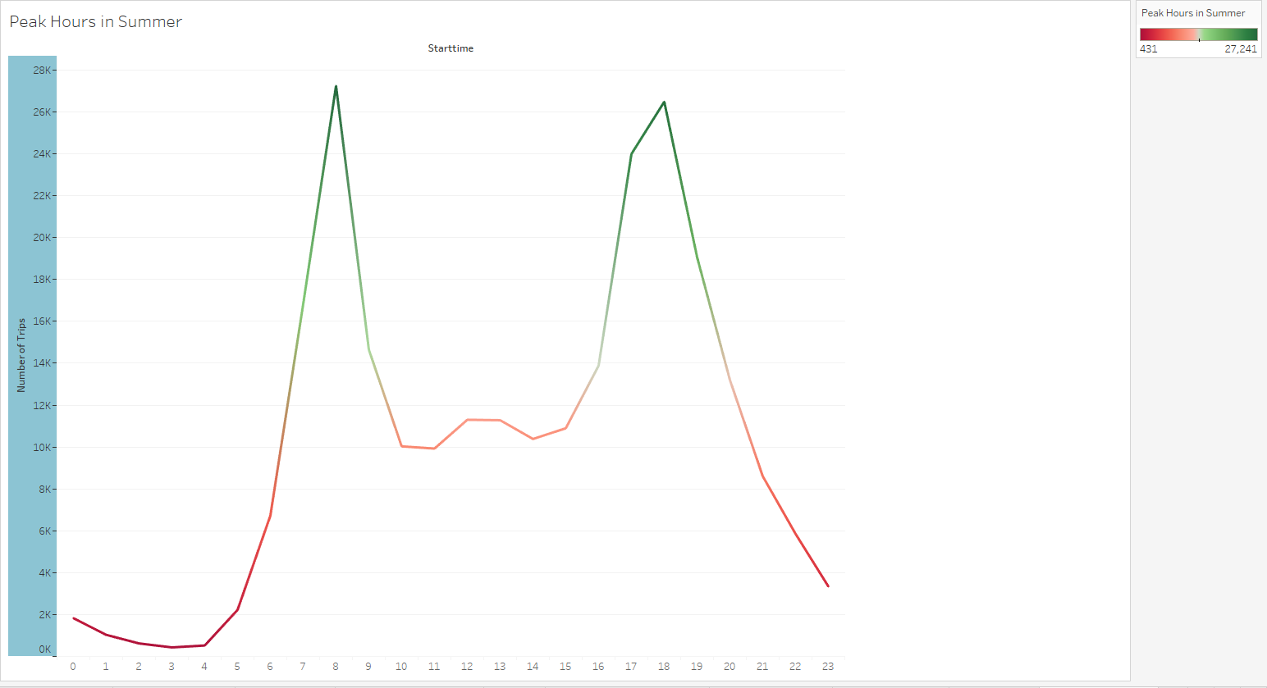

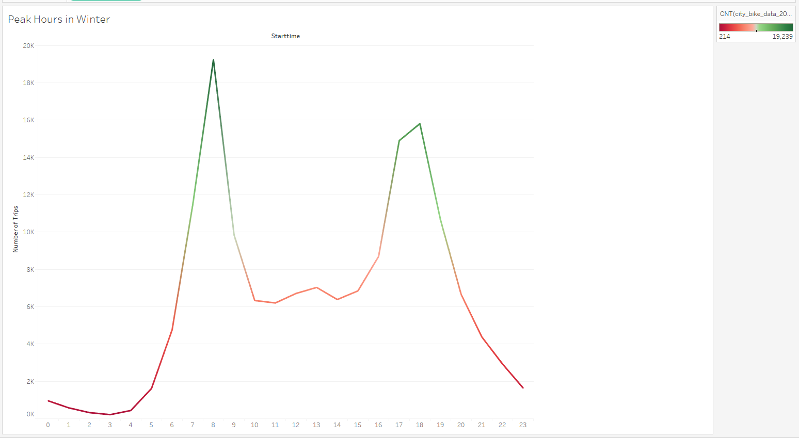

2: As compared to the summer months the total ridership value goes down by a significant amount during the winter months.

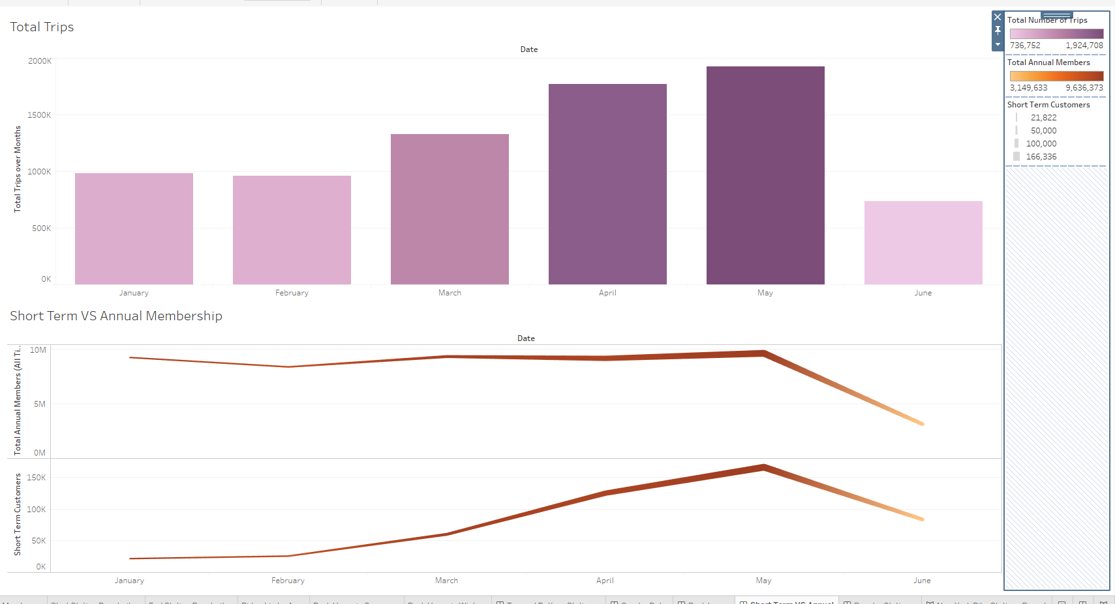

3: The major bike riders fall into the age group of 25-30 and 45-50 years of males. However the ridership among female users also seems to be increasing over time.

The peak at the age group of 45-50 years and the ridership data at the older age groups (above 80-90 years) may also indicate the input error of birth year at the user end.

