MEDICINE STOCK MANAGEMENT SYSYTEM

DBMS PROJECT

TUSHAR SINGH BHAL
05410102716
IVTH CSE

SUBMITTED TO:

Dr. Shailender Kumar

INTRODUCTION

For my DBMS project I have made a Medicine Stock Management. This program uses python programming language and python’s SQLITE3 library. The program consists of two python files. One of the files consists of all operations and button and the other generates the database if not exists.

The program uses python’s Tkinter library to generate GUI to display results. Tkinter generates a very minimalistic GUI’s for python programs.
Our GUI consists of Six Buttons and 5 Windows. Four of them for entering or updating various attributes and one for displaying the output obtained.

Various functions from the library Tkinter are used.
SQLite3 is used for managing database.
In medicine.py we have all our function which appear on the GUI as output and backend.py connects those functions with the database.

When for the first time we run the program the SQLite3 connects it to the database by creating one and showing tables with the given attributes.
That database can be seen by using any DB Browser for SQLite.

DEMONSTRATION

First we will go to our directory where we have our program:
cd Desktop/DBMS_Project and then press enter
Now we are in our working directory now we will open terminal or shell.
After opening terminal type
python medicine.py

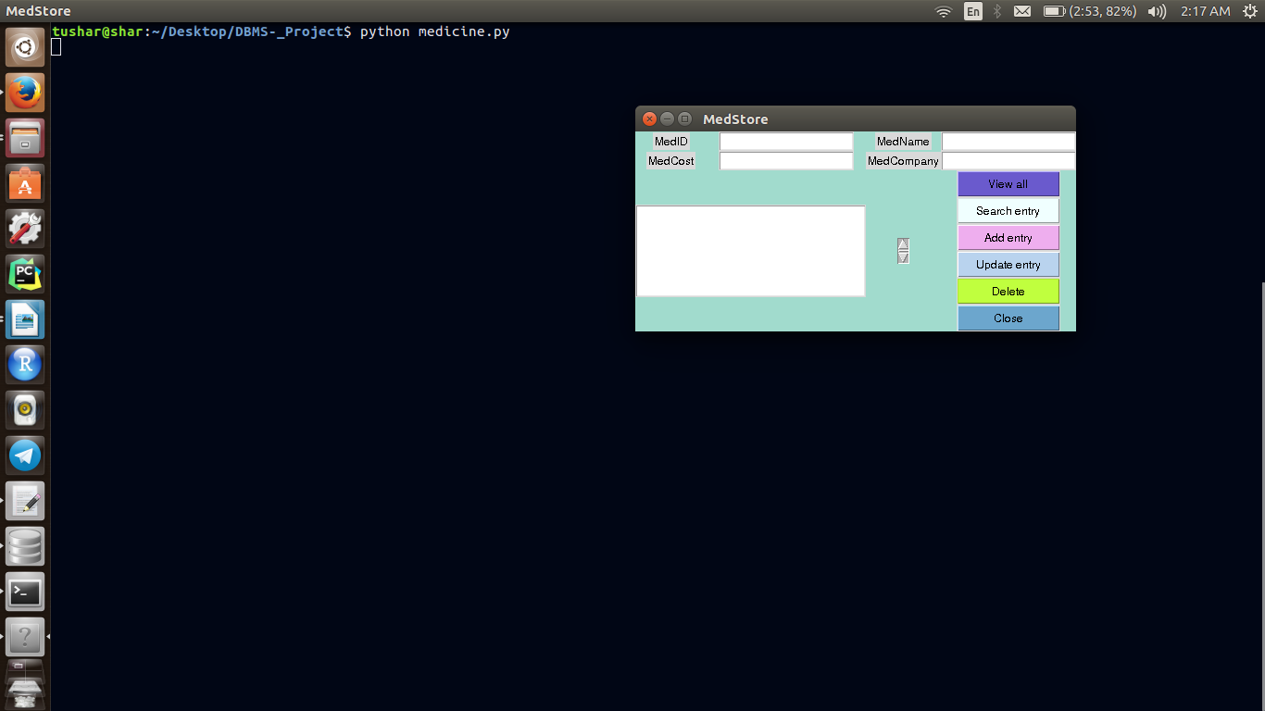

One screen appears which is our GUI from where we have to do our operations.
Showing all the attributes entered in database using the button View all.

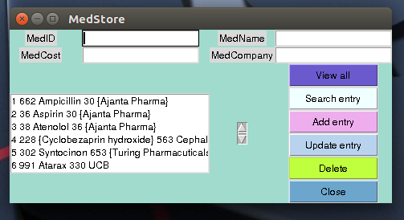

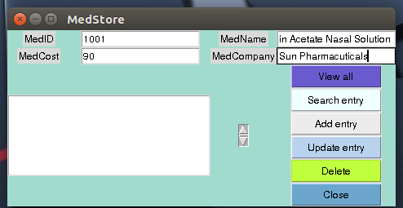
Adding an entry in database using Add entry

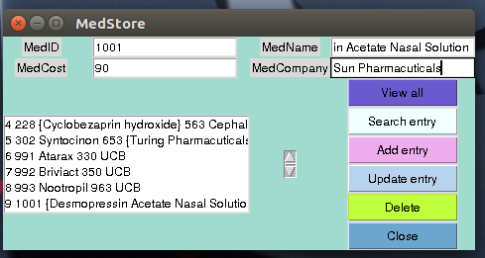

Searching an entry by using Search entry
showing the results when searched using company name.
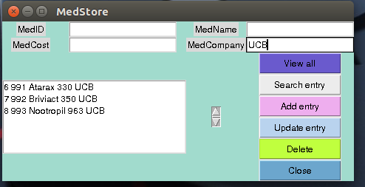

Showing the results when searched using Medicine name
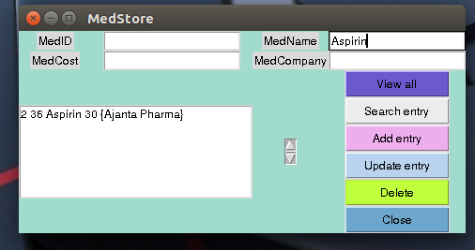

Deleting an Entry using Delete entry

