
26CA1103E - LINUX SYSTEMS PROGRAMMING
MINI PROJECT REPORT
ON
STUDENT ATTENDANCE MANAGEMENT

Team Name: Open Source Crew
Submitted by
S.No | Student Name | Roll No.
1 | Venkatesh Sharma | 2610520025
2 | T. Bharata | 2610520018
3 | Manchala Keerthy | 2610520035
4 | Mohammad Idris Ahmed | 2610520008

Department | CSA – BCA
Year / Semester | I Year – I Semester
Course | LINUX SYSTEMS PROGRAMMING
Course Code | 26CA1103E
Environment | Ubuntu Linux / WSL
Technology | Bash Shell Scripting
Course Coordinator | Dr. Alampally Sreedevi
Academic Year | 2026–2027
CERTIFICATE

This is to certify that the mini project titled “Student Attendance Management” has been successfully completed by Venkatesh Sharma (R.No: 2610520025), T. Bharata (R.No: 2610520018), Manchala Keerthy (R.No: 2610520035) and Mohammad Idris Ahmed (R.No: 2610520008) of Team Open Source Crew, I Year – I Semester, Department of CSA – BCA, KL University, as part of the 26CA1103E - LINUX SYSTEMS PROGRAMMING course during the academic year 2026–2027.
The project demonstrates the use of Linux command-line tools, file handling and Bash shell scripting to solve a simple academic record-keeping problem.

Dr. Alampally Sreedevi  Course Coordinator |  | Dr. D. S. Rao  HOD- CSA-BCA

DECLARATION
We hereby declare that the project report titled “Student Attendance Management” is our own work, carried out as part of the 26CA1103E - LINUX SYSTEMS PROGRAMMING course in the Department of CSA – BCA, KL University. We have used Bash shell scripting and standard Linux commands to design and implement the project. The project has been prepared for academic learning and demonstration purposes.

Venkatesh Sharma  R.No: 2610520025 |  | T. Bharata  R.No: 2610520018
Manchala Keerthy  R.No: 2610520035 |  | Mohammad Idris Ahmed  R.No: 2610520008

Date: 13/10/2026
Place: Hyderabad

ACKNOWLEDGEMENT
We express our sincere gratitude to our Course Coordinator Dr. Alampally Sreedevi, Department of CSA – BCA, KL University, for the guidance and encouragement given throughout this mini project.
We also thank the Head of the Department Dr. D.S.Rao, and our institution for providing the Linux / WSL environment required for implementation.
This project helped us understand basic Linux commands, Bash scripting, variables, conditions, functions, loops, menu-driven programs, input validation, and file handling using text files. Finally, we thank our friends and family for their support.

Venkatesh Sharma – 2610520025
T. Bharata – 2610520018
Manchala Keerthy – 2610520035
Mohammad Idris Ahmed – 2610520008

ABSTRACT
The Student Attendance Management system is a beginner-friendly Linux Bash project designed to automate the recording and analysis of student attendance. The application provides a menu-driven interface through which the user can add students, mark daily attendance as Present or Absent, view the attendance of any date, and generate a student-wise attendance report showing the attendance percentage and whether the student meets the minimum 75% requirement.
Student and attendance records are stored permanently in plain text files, so the data remains available every time the program is run. The project runs entirely from the Linux terminal and does not require a graphical interface or database. It introduces students to practical shell scripting concepts such as variables, read commands, loops, case statements, functions, text-file handling, grep, cut, printf and arithmetic expressions.
Keywords: Linux, Bash, Shell Scripting, Attendance Management, File Handling, Terminal

TABLE OF CONTENTS
1. Introduction 1
2. Problem Statement 1
3. Objectives 1
4. Scope of the Project 2
5. Existing System 2
6. Proposed System 2
7. Requirements 3
8. System Design 4
9. Algorithm 5
10. Implementation 5
11. Source Code 5
12. Sample Execution 8
13. Testing 10
14. Team Member Responsibilities 11
15. Advantages and Limitations 11
16. Future Enhancements 12
17. Learning Outcomes 12
18. Conclusion 12
19. References 13
Appendix A – Basic Commands Used 13
Appendix B – Viva Questions 13

1. INTRODUCTION
Linux provides a powerful command-line environment in which users can automate repetitive tasks using shell scripts. Bash is one of the most widely used shells in Linux. For beginners, a small academic application is a useful way to understand how commands and programming logic work together.
This project uses Bash to create a simple Student Attendance Management system. The user can add students, mark attendance for each day as Present (P) or Absent (A), view the attendance of a particular date, and generate a report that shows each student’s attendance percentage and eligibility. The records are stored in text files so that the data is not lost when the program ends.

2. PROBLEM STATEMENT
Maintaining attendance in paper registers is time-consuming. Counting the number of days present, calculating the attendance percentage and identifying students with attendance shortage must be done manually, which can lead to counting errors and delays. A simple command-line application is required to record attendance and automatically produce the attendance summary.
The system should:
- Store the roll number and name of each student.
- Record daily attendance (Present / Absent) for every student.
- Prevent duplicate roll numbers and duplicate attendance entries for the same date.
- Display the attendance of all students for a selected date.
- Calculate the attendance percentage of each student.
- Identify students whose attendance is below the required 75%.
- Keep the records permanently in files.

3. OBJECTIVES
- Understand the Linux terminal and basic Bash scripting.
- Use variables and user input in a shell script.
- Create a menu-driven program using while loop and case statement.
- Create and use Bash functions.
- Store and retrieve data using text files (file handling).
- Use commands such as grep, cut, printf, date and touch inside a script.
- Perform arithmetic calculations (percentage) in Bash.
- Validate user input and handle invalid entries.
- Develop a small working project that can be demonstrated from the terminal.

4. SCOPE OF THE PROJECT
The project is intended for academic demonstration and beginner-level Linux learning. It manages the attendance of one class at a time using plain text files. The current version does not use a database or graphical user interface.
- Platform: Ubuntu Linux / WSL.
- Interface: Command-line terminal with a numbered menu.
- Input: Roll number, student name, date and attendance status (P/A).
- Output: Student list, date-wise attendance and attendance percentage report.
- Storage: students.txt and attendance.txt (comma-separated text files).
- Users: Students or faculty demonstrating basic shell scripting.

5. EXISTING SYSTEM
In a basic manual system, attendance is written in a paper register or entered in a spreadsheet. At the end of the month or semester, the number of present days is counted and the percentage is calculated separately for every student.
Limitations:
- Manual counting takes additional time.
- Arithmetic mistakes are possible.
- Students with attendance shortage are identified late.
- Paper registers can be lost or damaged and are difficult to search.
- The process does not demonstrate Linux automation.

6. PROPOSED SYSTEM
The proposed system automates attendance recording and reporting using a Bash shell script. The user selects an option from a menu, enters the required details through the terminal, and the program stores the data in files and displays the results.
Basic workflow:
- Start the Bash script.
- Create the data files if they do not exist.
- Display the main menu and read the user’s choice.
- Add students (roll number and name) to students.txt.
- Mark attendance for a date as P or A for every student.
- Save each attendance entry in attendance.txt.
- View attendance of any selected date.
- Generate the attendance report with percentage and status.
- Repeat until the user selects Exit.
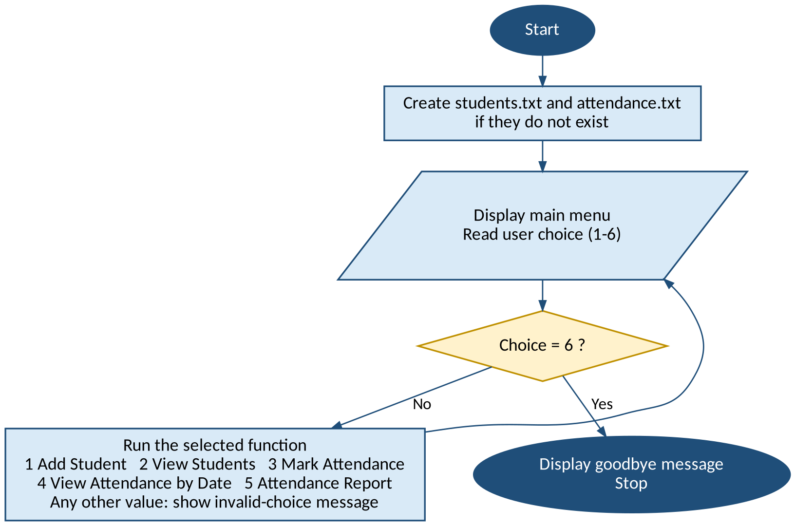
Figure 1: Process flow of the Student Attendance Management system

7. REQUIREMENTS

7.1 Hardware Requirements
- Computer or laptop.
- Minimum 4 GB RAM recommended.
- Keyboard and display.

7.2 Software Requirements
- Ubuntu Linux or Ubuntu through Windows Subsystem for Linux (WSL).
- Bash shell.
- Terminal application.
- Any text editor such as nano or vim.
- Standard Linux utilities: grep, cut, printf, date, touch.

8. SYSTEM DESIGN

8.1 Input
- Menu choice (1 to 6).
- Roll number of the student.
- Student name.
- Date of attendance (YYYY-MM-DD).
- Attendance status for each student (P for Present, A for Absent).

8.2 Processing
- Validate roll number, date and status values.
- Check for duplicate roll numbers and duplicate date entries.
- Append student and attendance records to the data files.
- Count total classes and present days of each student using grep.
- Calculate Percentage = (Present × 100) / Total.
- Compare the percentage with the minimum requirement of 75%.

8.3 Output
- List of registered students.
- Date-wise attendance (Present / Absent).
- Attendance report with total classes, present days and percentage.
- Eligibility status (ELIGIBLE / SHORTAGE).

8.4 Attendance Criteria
Attendance % | Status | Condition
>= 75 | ELIGIBLE | Meets the minimum attendance requirement
< 75 | SHORTAGE | Attendance shortage
No records | NO DATA | Student has no attendance entries yet

8.5 Data Files
File | Format | Example
students.txt | roll,name | 101,Rahul
attendance.txt | date,roll,status | 2026-10-05,101,P

9. ALGORITHM
- Start.
- Create students.txt and attendance.txt if they do not exist.
- Display the menu and read the choice.
- If choice = 1, read roll number and name, validate, check duplicates and save the student.
- If choice = 2, display all students from students.txt.
- If choice = 3, read the date; for every student read P or A (repeat until valid) and save date, roll and status in attendance.txt.
- If choice = 4, read a date and display the attendance records of that date.
- If choice = 5, for every student calculate Total, Present and Percentage = Present × 100 / Total; if Percentage >= 75 then ELIGIBLE, otherwise SHORTAGE.
- If choice = 6, display a goodbye message and go to step 10.
- For any other choice display an error message and go back to step 3.
- Stop.

10. IMPLEMENTATION

10.1 Create the Project Directory
mkdir attendance_project
cd attendance_project

10.2 Create the Bash File
nano attendance.sh

10.3 Give Execute Permission
chmod +x attendance.sh

10.4 Run the Project
./attendance.sh

11. SOURCE CODE
#!/bin/bash

# Student Attendance Management System
# Beginner Linux / Bash Mini Project

STUDENTS="students.txt"
ATTENDANCE="attendance.txt"
MIN_PERCENT=75
REPORT_FORMAT="%-8s %-15s %-8s %-8s %-8s %s\n"

# Create the data files if they do not exist
touch "$STUDENTS" "$ATTENDANCE"

add_student() {
read -p "Enter roll number: " roll

if [[ ! "$roll" =~ ^[A-Za-z0-9]+$ ]]; then
echo "Invalid roll number. Use letters and digits only."
return
fi

if grep -q "^$roll," "$STUDENTS"; then
echo "Roll number $roll already exists."
return
fi

read -p "Enter student name: " name
name=${name//,/ }

if [ -z "$name" ]; then
echo "Name cannot be empty."
return
fi

echo "$roll,$name" >> "$STUDENTS"
echo "Student added successfully."
}

view_students() {
if [ ! -s "$STUDENTS" ]; then
echo "No students found."
return
fi

printf "%-10s %s\n" "Roll No" "Name"
echo "------------------------------"
while IFS=, read -r roll name
do
printf "%-10s %s\n" "$roll" "$name"
done < "$STUDENTS"
}

mark_attendance() {
if [ ! -s "$STUDENTS" ]; then
echo "No students found. Add students first."
return
fi

read -p "Enter date (YYYY-MM-DD) or press Enter for today: " date
if [ -z "$date" ]; then
date=$(date +%F)
fi

if [[ ! "$date" =~ ^[0-9]{4}-[0-9]{2}-[0-9]{2}$ ]]; then
echo "Invalid date format."
return
fi

if grep -q "^$date," "$ATTENDANCE"; then
echo "Attendance for $date is already marked."
return
fi

echo "Enter P for Present and A for Absent."
while IFS=, read -r roll name <&3
do
while true
do
read -p "$roll - $name (P/A): " status
status=${status^^}
if [ "$status" = "P" ] || [ "$status" = "A" ]; then
echo "$date,$roll,$status" >> "$ATTENDANCE"
break
else
echo "Invalid input. Enter P or A."
fi
done
done 3< "$STUDENTS"

echo "Attendance saved for $date."
}

view_by_date() {
read -p "Enter date (YYYY-MM-DD): " date

if ! grep -q "^$date," "$ATTENDANCE"; then
echo "No attendance record found for $date."
return
fi

echo "Attendance on $date"
printf "%-10s %-20s %s\n" "Roll No" "Name" "Status"
echo "----------------------------------------"
grep "^$date," "$ATTENDANCE" | while IFS=, read -r d roll status
do
name=$(grep "^$roll," "$STUDENTS" | cut -d, -f2)
if [ "$status" = "P" ]; then
label="Present"
else
label="Absent"
fi
printf "%-10s %-20s %s\n" "$roll" "$name" "$label"
done
}

attendance_report() {
if [ ! -s "$ATTENDANCE" ]; then
echo "No attendance records available."
return
fi

echo "ATTENDANCE REPORT (Minimum required: $MIN_PERCENT%)"
printf "$REPORT_FORMAT" "Roll" "Name" "Total" "Present" "Percent" "Status"
echo "----------------------------------------------------------------"

while IFS=, read -r roll name
do
total=$(grep -c ",$roll,[PA]$" "$ATTENDANCE")
present=$(grep -c ",$roll,P$" "$ATTENDANCE")

if [ "$total" -eq 0 ]; then
printf "$REPORT_FORMAT" "$roll" "$name" "0" "0" "-" "NO DATA"
continue
fi

percent=$((present * 100 / total))

if [ "$percent" -ge "$MIN_PERCENT" ]; then
status="ELIGIBLE"
else
status="SHORTAGE"
fi

printf "$REPORT_FORMAT" "$roll" "$name" "$total" "$present" "$percent%" "$status"
done < "$STUDENTS"
}

while true
do
echo
echo "=========================================="
echo " STUDENT ATTENDANCE MANAGEMENT SYSTEM"
echo "=========================================="
echo "1. Add Student"
echo "2. View Students"
echo "3. Mark Attendance"
echo "4. View Attendance by Date"
echo "5. Attendance Report"
echo "6. Exit"
echo "------------------------------------------"
read -p "Enter your choice (1-6): " choice
echo

case $choice in
1) add_student ;;
2) view_students ;;
3) mark_attendance ;;
4) view_by_date ;;
5) attendance_report ;;
6) echo "Thank you. Goodbye!"; exit 0 ;;
*) echo "Invalid choice. Please enter a number from 1 to 6." ;;
esac
done

12. SAMPLE EXECUTION

12.1 Running the Program and Adding a Student
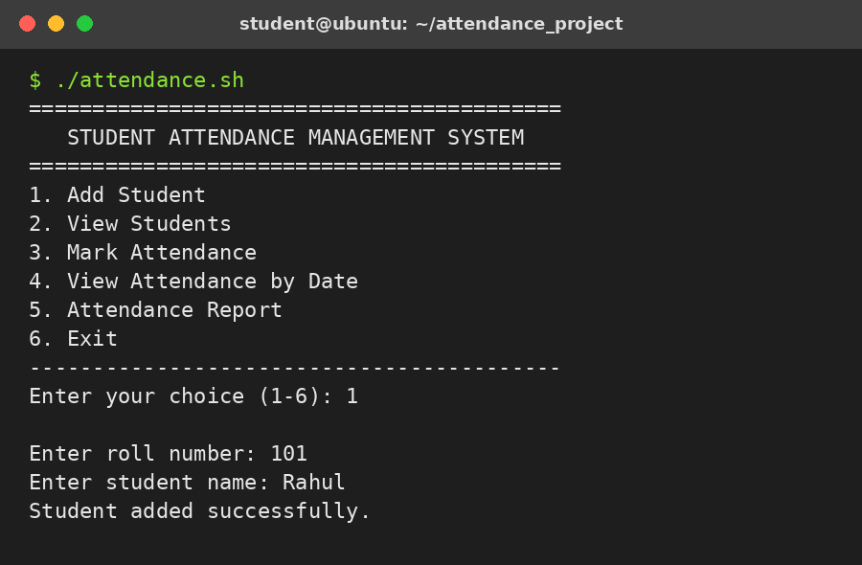
Figure 2: Main menu and Add Student option

12.2 Marking Attendance
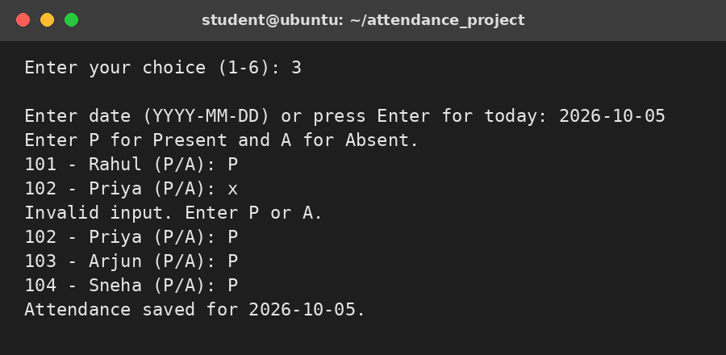
Figure 3: Marking attendance (with an invalid entry "x" rejected)

12.3 Viewing Attendance by Date
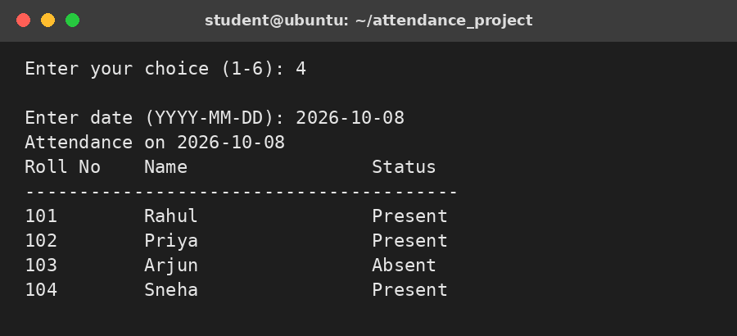
Figure 4: Attendance of 2026-10-08

12.4 Attendance Report
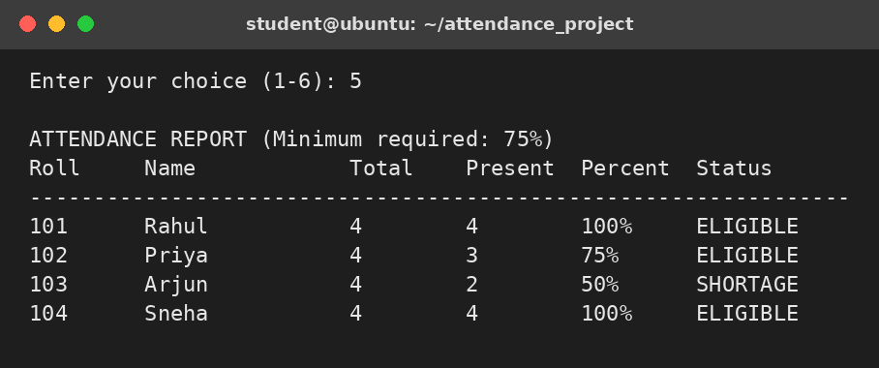
Figure 5: Student-wise attendance report

12.5 Invalid Input Examples
Enter roll number: 101
Roll number 101 already exists.

Enter roll number: 10 1
Invalid roll number. Use letters and digits only.

Enter your choice (1-6): 9
Invalid choice. Please enter a number from 1 to 6.

Enter date (YYYY-MM-DD) or press Enter for today: 2026-10-05
Attendance for 2026-10-05 is already marked.

12.6 Data Files Created
$ cat students.txt
101,Rahul
102,Priya
103,Arjun
104,Sneha

$ cat attendance.txt
2026-10-05,101,P
2026-10-05,102,P
2026-10-05,103,P
2026-10-05,104,P
2026-10-06,101,P
2026-10-06,102,A
2026-10-06,103,P
2026-10-06,104,P
2026-10-07,101,P
2026-10-07,102,P
2026-10-07,103,A
2026-10-07,104,P
2026-10-08,101,P
2026-10-08,102,P
2026-10-08,103,A
2026-10-08,104,P

13. TESTING
Testing was performed using different input values to verify student registration, attendance marking, input validation, percentage calculation and eligibility status.
Test | Input / Action | Expected Result | Actual Result
1 | Add student 101, Rahul | Student added and saved | Student added successfully
2 | Add roll number 101 again | Duplicate rejected | Roll number 101 already exists
3 | Roll number "10 1" (contains space) | Invalid roll rejected | Invalid roll number message
4 | Attendance status entered as "x" | Rejected, prompt repeated | Invalid input. Enter P or A.
5 | Mark attendance for 2026-10-05 twice | Duplicate date rejected | Attendance already marked
6 | View attendance of 2026-10-08 | Shows Present/Absent of all students | Table displayed correctly
7 | Report: Rahul present 4 of 4 days | 100%, ELIGIBLE | 100% ELIGIBLE
8 | Report: Priya present 3 of 4 days | 75%, ELIGIBLE | 75% ELIGIBLE
9 | Report: Arjun present 2 of 4 days | 50%, SHORTAGE | 50% SHORTAGE
10 | Menu choice 9 | Invalid choice message | Error message displayed

14. TEAM MEMBER RESPONSIBILITIES
Team Member | Responsibilities | Deliverables
Venkatesh Sharma (2610520025) | Problem analysis, Bash logic, menu design, file handling | Source code and algorithm
T. Bharata (2610520018) | Add student and mark attendance functions | Add student and mark attendance modules
Manchala Keerthy (2610520035) | View attendance and report functions | View attendance and report modules
Mohammad Idris Ahmed (2610520008) | Testing, sample outputs, documentation, presentation | Test cases and project report

15. ADVANTAGES AND LIMITATIONS

15.1 Advantages
- Simple and easy for beginners.
- Runs directly in the Linux terminal.
- Reduces manual counting and calculation.
- Stores data permanently in text files.
- Automatically identifies students with attendance shortage.
- Requires no database or external software.
- Demonstrates practical Bash programming and file handling.

15.2 Limitations
- Only one class is managed at a time.
- There is no option to edit or delete a student or an attendance entry.
- The attendance percentage is an integer value.
- Data is stored in plain text files without a password or encryption.
- Only the format of the date is checked, not whether it is a real calendar date.
- There is no graphical user interface.

16. FUTURE ENHANCEMENTS
- Add Update and Delete options for students and attendance.
- Support multiple classes, sections and subjects.
- Add a login system for faculty.
- Export the attendance report to a CSV or text report file.
- Send automatic reports of students with shortage using cron.
- Store data in a database such as SQLite or MySQL.
- Add a graphical or web-based interface.

17. LEARNING OUTCOMES
After completing this project, students should be able to:
- Navigate directories using Linux commands.
- Create and edit files from the terminal.
- Change file permissions using chmod.
- Write and execute a Bash script.
- Use variables and read for input.
- Use while loops and case statements to build a menu.
- Create and call functions.
- Read from and write to files using redirection (>>), grep and cut.
- Apply arithmetic expressions and if-else decision making.
- Validate user input using regular expressions.
- Test and debug a basic Linux shell program.

18. CONCLUSION
The Student Attendance Management system successfully demonstrates how Linux and Bash shell scripting can be used to solve a simple real-world academic problem. The project combines basic Linux commands with programming concepts such as variables, functions, loops, case statements, input validation and file handling.
As a beginner-level project, it provides a strong foundation for students to move toward larger Linux projects involving process management, automation, cron jobs, log analysis, and other command-line utilities. The project also gives students practical experience in creating, executing, testing, and documenting a Bash application.

19. REFERENCES
- The Linux man-pages: bash, grep, cut, printf, date, chmod, mkdir, cd, nano and related commands.
- GNU Bash Reference Manual.
- Ubuntu Linux documentation.
- Course notes and laboratory material provided by the faculty.

APPENDIX A – BASIC COMMANDS USED
Command | Purpose
pwd | Display current directory
ls | List files and directories
cd | Change directory
mkdir | Create a directory
nano | Edit a text file
chmod +x | Give execute permission
./attendance.sh | Run the Bash script
touch | Create an empty file if it does not exist
grep | Search for a pattern in a file
cut | Extract a field from a line
printf | Print formatted output
date +%F | Get today’s date as YYYY-MM-DD
cat | Display file contents

APPENDIX B – VIVA QUESTIONS
No. | Question
1 | What is Linux?
2 | What is Bash?
3 | What is a shell script?
4 | Why is chmod +x used?
5 | What is the purpose of the read command?
6 | How are the student and attendance records stored in this project?
7 | What is the use of the grep command in this project?
8 | Why did you use functions and a case statement?
9 | How is the attendance percentage calculated in Bash?
10 | How can this project be extended to multiple classes?

