­­­­­

|  |  |
| --- | --- |
|  |  |



Development

Specification

Document

Table of Contents

I. Purpose 3

II. Automated process details 4

4 Runtime guide 5

4.1 Architectural structure of the Master Project 5

4.2 Master Project Runtime Details 5

4.3 Project details 6

4.4 Project(s) workflows 7

5 Other Details 8

6 Glossary 9

# Purpose



The purpose of the document is to record the outcome specific to the automated master project and its sub components: projects, workflows, sequences etc.

Some of the content will be taken from the Solution Design Document, whereas the content specific to this will be more detailed and is designed to enable troubleshooting of the automated solution in UAT as well as post release into production.Objectives

# Automated process details

Details filled in need to reflect the actual information for the Master Project released for production. The following table will be populated:.



|  |  |
| --- | --- |
| Item | Description |
| Master Project Name | Take from Solution Design Document |
| Robot Type | Take from Solution Design Document |
| Orchestrator used? | Take from Solution Design Document |
| Scalable | Take from Solution Design Document |
| UiPath version used | Take from Solution Design Document |

# Runtime guide

## Architectural structure of the Master Project

Display the interaction between components (package / robots, Orchestrator queues, and running order) in a diagram

## Master Project Runtime Details

Outlines the details of the automated process by filling in the table below.

|  |  |
| --- | --- |
| ITEM NAME | DESCRIPTION  Fill in each bolded section - empty fields are not allowed. If the section does not apply to your automation then mark as n/a. |
| Production environment details | Take from Solution Design Document |
| Prerequisites to run | Take from Solution Design Document |
| Input Data | Take from Solution Design Document |
| Expected output | Take from Solution Design Document |
| How to start the automated process | Take from Solution Design Document |
| How to restart the process from a certain step? | ***Example:*** *Not possible. The process can only be restarted.* |
| Reporting  (queues reporting, Kibana or another platform) | *Take from Solution Design Document* |
| Manual error handling?  (roll back or manually complete failed transactions). Procedures to reset the item. E.g. “set status as investigating” | ***Example:*** *In case of error, the process can be restarted after the two steps are completed. No need for manual fix.* |
| How to resume the process in case of error? | ***Example:*** *Check that the last email in Zendesk_Reporting@uipath.com is unread*  *Delete the folder C:\ZendeskReporting\#currentdate#* |
| How to manually fix transactions with error? | ***Example:*** *n/a.* |
| How is Orchestrator used? | Take from Solution Design Document |
| Password policies  (mention any specific compliance requests) | Take from Solution Design Document |
| Stored credentials  (Never use hardcore credentials in the workflow!) | Take from Solution Design Document1 |
| List of Asset Names  (Naming convention: ProcessName_AssetName) | ***Example:*** *n/a.* |
| List of queues names  (Naming convention: ProcessName_QueueName) | Take from Solution Design Document1 |
| Schedule Details | Take from Solution Design Document1 |
| Multiple Resolutions Supported?  (in case of image automation / Citrix and VDI) | Take from Solution Design Document1 |
| Recommended Resolution | Take from Solution Design Document |

## Project details

In this section describe all the projects that compose the automated process. For each project the following table should be filled in.

**Project Name: Taken from Solution Architecture Document**

|  |  |
| --- | --- |
| ITEM NAME | DESCRIPTION  Fill in each section - empty fields are not allowed. If the section does not apply to your automation then mark as n/a. |
| Environment used for development  (name, location, configuration details etc) | Take from Solution Design Document |
| Environment prerequisites  (OS details, libraries, required apps) | Take from Solution Design Document |
| Repository for project  (where is the developed project stored) | Take from Solution Design Document |
| Configuration method  (assets, excel file, Json file) | Take from Solution Design Document |
| Configuration details  (path for input files, configuration Orchestrator assets used) |  |
| List of reused components | ***Component name:*** *Take from Solution Design Document* |
| ***Description / comments:*** *Take from Solution Design Document* |
| Login Level | ***Example:*** *Info.* |
| Details about automation (if the apps were automated using UI Automation, Image & Text) | ***Example:*** *UI automation kept to a minimum. Using keystrokes for navigation. Using Excel application scope because formulas needed to be applied at runtime.* |
| In case of FOR, can the user operate the computer while the robot is running? |  |
| Custom error logs defined in the workflows  (where Throw Activity was used or custom log message was defined) | ***Example:***   1. *EmailNotAvailable – No email is present in the mailbox at the processing time* 2. *FileMissing – One attachment is missing from the attachment list* 3. *CorruptedData – the .xlsx files are corrupted* 4. *SourceMissing – the source files are not present* 5. *FileAccessError – the drive can’t be accessed for creating the necessary folders* |
| Frequent errors found in the development phase | ***Example:***  *1. Errors with selectors in Excel.*  *2. Expiring license for Excel account (can also happen in prod)* |
| Workarounds used in the automation phase | ***Example:***  *1. Key combinations instead of selectors for Excel UI*  *2. Hard processing using data tables (can be optimized)* |

Add tables for as many projects as you need and fill them in.

## Project(s) workflows

Workflows specific to: Specify Project Name from section above

For the workflow files defined below please specify the input and output parameters.

|  |  |  |  |
| --- | --- | --- | --- |
| Workflow Name | Description | Input Argument | Output Argument |
| Take from Solution Design Document | Take from Solution Design Document and edit if need be |  |  |

# Other Details

Please mention here any other points that you consider relevant for the automation process.

### Debugging Tips

Help out your fellow developers with some tips :)

### Post UAT Specifications

Please fill in the following table.

|  |  |
| --- | --- |
| ITEM NAME | DESCRIPTION  Fill in each bolded section - empty fields are not allowed. If the section does not apply to your automation then mark as n/a. |
| Average Handling Time per Transaction |  |
| Recommended Number of Robots for the specified volumes - insert volume per frequency from PDD, Process Overview, Values for Number of times the process is ran per selected frequency and Process Frequency and |  |
| Specified Schedule | Take from Solution Design Document Master project Runtime Details, Schedule Details |

# Glossary

The main terms used in the Solution Architecture Document are defined below:

**Master project** - the overall output of the development, containing one or multiple projects that together cover the scope of the robotic process automation. There is a 1 to 1 connection between the Master Project and the Process to be automated (As presented in the PDD).

**Project** - an UiPath Studio project containing one or multiple workflow files. A project can be converted to a package and run independently, covering a particular scope within the master project. Or multiple projects can be converted into one package depending on the aims and restrictions of the automation. The project is used when defining the development and support phase of the automation.

**Package** - the output of compiling one or multiple projects. A package can be deployed on the robot machine and be executed by the robot service. Only one package can be executed at a given time by a robot. The package is used when defining the running phase of the automation.

Workflow - a component of the package, the workflow encapsulates a part of the project logic. The workflow can be of type: sequence, flowchart or state machine. A workflow is saved as an .xaml file inside the project folder. A workflow file can be invoked from another workflow and by default there is an initial workflow file that will run when executing the package.

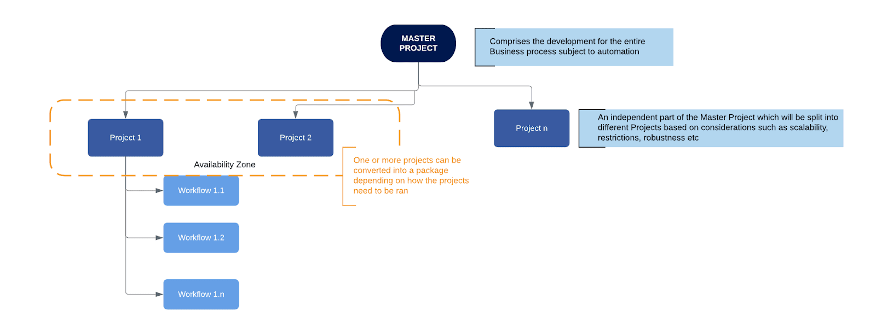

**Activity** - an action that the robot executes.

**Sequence** - a workflow where activities are executed one after another, in a sequential order

**Flowchart** - a workflow where activities are connected by arrows and the logic of the workflow can be easily followed in a visual manner. The flowchart can also be exported as an image from UiPath studio.

**State machine** - a more advanced way of organizing a workflow, similar to a flowchart.

**BOR** - Back office robot

**FOR** – Front office robot

**Orchestrator** – Enterprise architecture server platform supporting: release management, centralized logging, reporting, auditing and monitoring tools, remote control, centralized scheduling, queue/robot workload management, assets management.

