­­­­­

|  |  |
| --- | --- |
|  |  |



Solution Design

Document

Table of Contents

I. Purpose 3

II. Automated process details 4

3 Runtime guide 5

3.1 Architectural structure of the Master Project 5

3.2 Master Project Runtime Details 5

3.3 Project name 1 6

3.4 Project(s) workflows 6

3.5 Packages 7

3.6 Architectural structure of the Master Project 7

4 Other Details 8

Future Improvements 8

Other Remarks 8

5 Glossary 9

# Purpose



Outlines the major components of the Master Project (the overall output of the development, containing one or multiple projects that together cover the scope of the robotic process automation) taking into account all the business restrictions (scheduling, peaks, future increases in volume etc.). The focus of the Solution Architect will be on:

* Robustness;
* Scalability;
* Efficiency;
* Replicability;
* Reusability of component

The information herein is targeted primarily at the developers that will initially implement the solution and subsequently at the support developers in case of change requests.

# Automated process details

Details filled in need to reflect the actual information for the Master Project released for production. The following table will be populated:

|  |  |
| --- | --- |
| Item | Description |
| Master Project Name | = process name |
| Robot Type | e.g. BOR, FOR or Mix |
| Orchestrator used? | e.g. Yes |
| Scalable | e.g. No |
| UiPath version used | e.g. 2019.4 |

# Runtime guide

## Architectural structure of the Master Project

Display the interaction between components (package / robots, Orchestrator queues, and running order) in a diagram

## Master Project Runtime Details

Outlines the details of the automated process by filling in the table below.

|  |  |
| --- | --- |
| ITEM NAME | DESCRIPTION  *Fill in each bolded section - empty fields are not allowed. If the section does not apply to your automation then mark as n/a.* |
| Production environment details | ***Example:*** *Running on Sparky , the virtual backoffice machine. Scheduled every night after the report is generated from Zendesk.* |
| Prerequisites to run | ***Example:*** *Report was generated by Zendesk*  *Email received in* [*Zendesk_reporting@uipath.com*](mailto:Zendesk_reporting@uipath.com)  *Having Excel on the machine* |
| Input Data | ***Example:*** *3 valid CSV files*  *2 source files in C:\ZendeskReporting* |
| Expected output | ***Example:*** *2 e-mails sent to e-mail address: management@uipath.com* |
| How to start the automated process | ***Example:*** *3 valid CSV files* |
| Reporting | *2 source files in C:\ZendeskReporting* |
| (queues reporting, Kibana or another platform) | ***Example:*** *2 e-mails sent to e-mail address: management@uipath.com* |
| How is Orchestrator used? | ***Example:*** *The process will be started from orchestrator server (demo.uipath.com)* |
| Password policies |  |
| (mention any specific compliance requests) | ***Example:*** *Orchestrator logs and jobs dashboards.* |
| Stored credentials | ***Example:*** *Orchestrator used for scheduling and asset passwords.* |
| (Never use hardcore credentials in the workflow!) | ***Example:*** *G-mail password only, not expiring.* |
| List of queues names | ***Example:*** *Stored in Orchestrator Assets* |
| (Naming convention: ProcessName_QueueName) | ***Example:*** *n/a* |
| Schedule Details | ***Example:*** *Daily, 6 A.M CET* |
| Multiple Resolutions Supported?  (in case of image automation / Citrix and VDI) | ***Example:*** *Yes, No or N/A* |
| Recommended Resolution | ***Example:*** *n/a* |

## Project name 1

|  |  |
| --- | --- |
| ITEM NAME | DESCRIPTION  *Fill in each section - empty fields are not allowed. If the section does not apply to your automation then mark as n/a.* |
| Environment used for development  (name, location, configuration details etc) | ***Example:*** *DEV_Env1_EMEA ( UiPath computer)* |
| Environment prerequisites  (OS details, libraries, required apps) | ***Example:*** *Windows 7, BackOffice&Studio license, Microsoft Excel* |
| Repository for project  (where is the developed project stored) | ***Example:*** *\\myshare.com\Zendesk* |
| Configuration method  (assets, excel file, Json file) | ***Example:*** *Assets* |
| List of reused components | ***Example:*** *found via MyGo!* |
|
| List of new reusable components | ***Example:*** *placeholders created in MyGo!* |

Add tables for as many projects as you need and fill them in.

## Project(s) workflows

Workflows specific to: Specify Project Name from section above

For the workflow files defined below please specify the input and output parameters.

|  |  |
| --- | --- |
| Workflow Name | Description |
| Example: Main | ***Example:*** *invokes all the other workflows* |

## Packages

Include the list of packages and high-level description for each of them, to explain their purpose

|  |  |
| --- | --- |
| Package Name | Description |
| *Example: ZendeskReports.1.0.6285.31077.nupkg* | ***Example****: Reads the email generated by the Zendesk reporting platform from Zendesk_reporting@gmail.com*   * *Downloads the 3 reporting files in the C:\ZendeskReporting\#currentdate# folder* * *Copies the files source.xlsx and source_fantastic.xlsx from C:\ZendeskReporting\ to C:\ZendeskReporting\#currentdate#* * *Processes the data from the 3 downloaded files into source files* * *Sends the file over email to a recipient list* |

## Architectural structure of the Master Project

Display the interaction between components (package / robots, Orchestrator queues, and running order) in a diagram.

# Other Details

### Future Improvements

Fill in any improvements that need to be considered for the future:

***Example:***

*• Optimize the processing algorithm*

*• Implement process error recovery (retry)*

*• Enable support for multiple template files*

### Other Remarks

Please mention here any other points that you consider relevant for the automation process.

***Example:*** *The workflow should run every night at 7AM. Be careful not to schedule it before the report is generated by Zendesk.*

The Zendesk generated data is always 1 day old.

# Glossary

The main terms used in the Solution Architecture Document are defined below:

**Master project** - the overall output of the development, containing one or multiple projects that together cover the scope of the robotic process automation. There is a 1 to 1 connection between the Master Project and the Process to be automated (As presented in the PDD).

**Project** - an UiPath Studio project containing one or multiple workflow files. A project can be converted to a package and run independently, covering a particular scope within the master project. Or multiple projects can be converted into one package depending on the aims and restrictions of the automation. The project is used when defining the development and support phase of the automation.

**Package** - the output of compiling one or multiple projects. A package can be deployed on the robot machine and be executed by the robot service. Only one package can be executed at a given time by a robot. The package is used when defining the running phase of the automation.

Workflow - a component of the package, the workflow encapsulates a part of the project logic. The workflow can be of type: sequence, flowchart or state machine. A workflow is saved as an .xaml file inside the project folder. A workflow file can be invoked from another workflow and by default there is an initial workflow file that will run when executing the package.

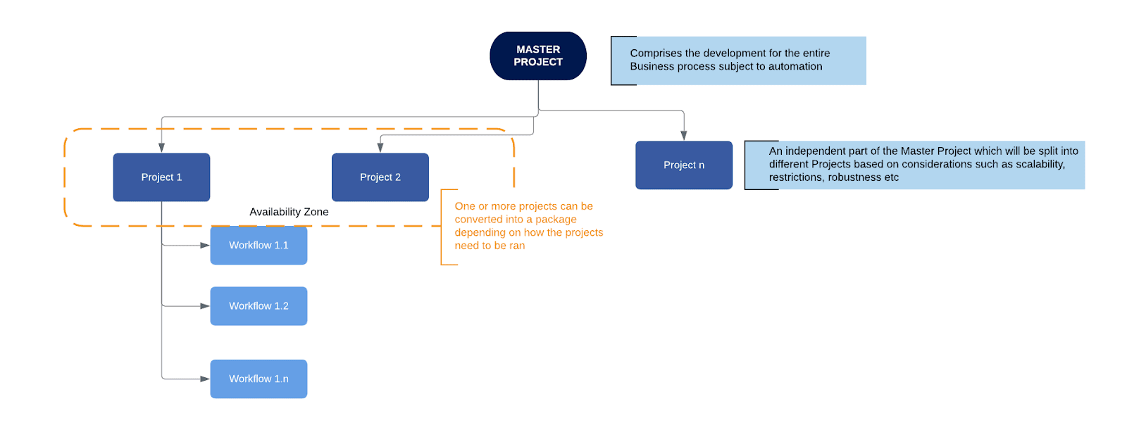

**Activity** - an action that the robot executes.

**Sequence** - a workflow where activities are executed one after another, in a sequential order

**Flowchart** - a workflow where activities are connected by arrows and the logic of the workflow can be easily followed in a visual manner. The flowchart can also be exported as an image from UiPath studio.

**State machine** - a more advanced way of organizing a workflow, similar to a flowchart.

**BOR** - Back office robot

**FOR** – Front office robot

**Orchestrator** – Enterprise architecture server platform supporting: release management, centralized logging, reporting, auditing and monitoring tools, remote control, centralized scheduling, queue/robot workload management, assets management.