Robust Low-Light Image Restoration and Enhancement (P1)
Team TXX: Name1 (USN1), Name2 (USN2), Name3 (USN3), Name4 (USN4)
Computer Vision Hackathon 2026

1. Problem
Photos taken at night or in dark rooms are dark, noisy and often have a colour cast. If we just increase brightness, the noise also gets bigger, bright lamps become pure white and colours look wrong. The task is to build a system that brightens the image “intelligently”: it should look at each image, decide how much to brighten, remove noise and fix colour, without halos or over-exposure.

2. Our idea in one line
Run a classical Retinex method and a small deep learning model (Zero-DCE) side by side, then mix their results pixel by pixel using the illumination map: the darkest areas take the Retinex result, the lit areas take Zero-DCE. All strengths come from measurements on the input image.
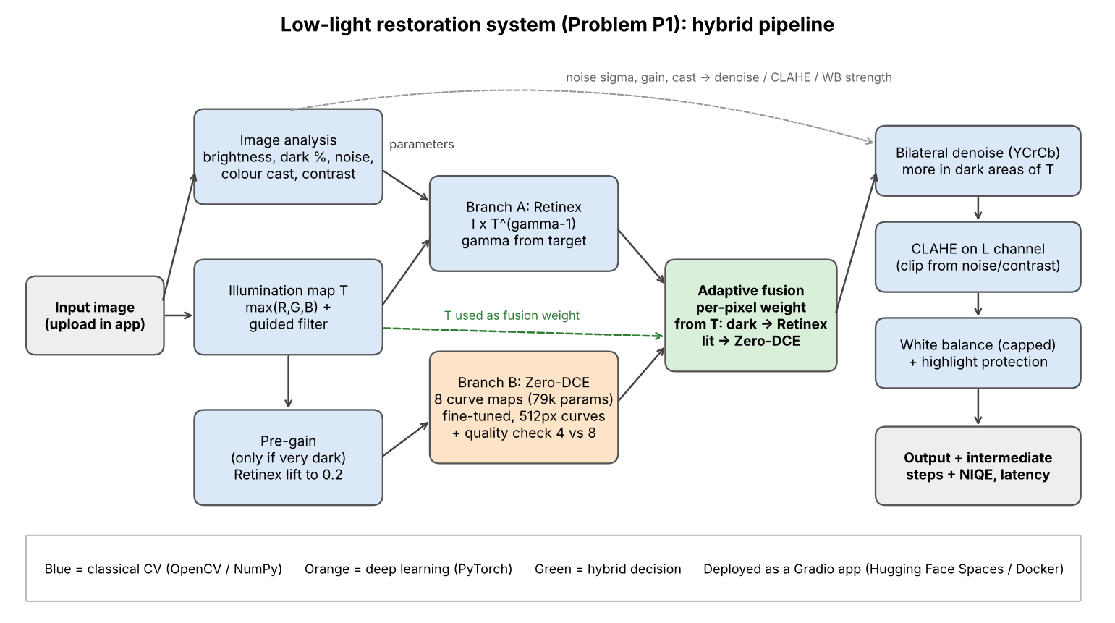
architecture

3. Pipeline

3.1 Image analysis (adaptive parameters)
We measure six numbers from the input:
Measure | How | Used for
mean brightness | mean of luminance | brightening target, pre-gain on/off
dark ratio | % of pixels below 0.1 | reported in app
noise sigma | wavelet estimate (skimage.estimate_sigma) | denoise strength, CLAHE clip
colour cast | how far R, G, B means are from grey | white balance strength
non-uniformity | std / mean of a very blurred luminance | reported in app
contrast | 95th minus 5th percentile | CLAHE clip
Noise gets amplified roughly by target / mean brightness, so the denoise strength is noise sigma x that gain x 6 (clipped to 0..1). This way a clean, bright image gets almost no smoothing and a dark, noisy one gets strong smoothing.

3.2 Illumination estimation (classical)
Retinex theory says an image = reflectance (the real colours) x illumination (the light). We estimate the illumination T like the LIME paper: take max(R, G, B) for every pixel, then smooth it with a guided filter that uses the image itself as the guide. The guided filter keeps edges between bright and dark objects, which is what stops halos. We wrote the guided filter ourselves with box filters (15 lines), so no extra library.

3.3 Retinex enhancement (classical branch)
We change the light, not the colours: output = I x T^(gamma - 1). gamma is chosen so the mean of the new light T^gamma hits a target (0.45, or 0.38 for extremely dark photos so we do not just show noise). A floor of 0.02 on T stops black pixels from blowing up.

3.4 Zero-DCE (deep learning branch)
Zero-DCE (CVPR 2020) predicts 8 per-pixel curves instead of an image. Each curve is x + r(x^2 - x), which is smooth and stays inside 0..1, so colours rarely go strange. The model has only 79,416 parameters. What we added:
- Fine-tuning on LOL-v2 Train (Section 6). Validation PSNR went from 13.23 dB (original weights) to 14.58 dB.
- Fast inference: curves are predicted on a copy resized to max 512 px, then upsampled and applied on the full image.
- Quality-aware output: the model gives a result after 4 curves and after 8 curves. We keep the one whose brightness is closest to 0.5 with the fewest clipped pixels.
- CPU fix: torch.set_flush_denormal(True) made one 512 px image go from 13.6 s to 0.37 s on our CPU. Without it the app would be too slow.

3.5 Pre-gain (hybrid)
Zero-DCE was trained on images that are dark but not black. When the mean brightness is below 0.10 we first lift the image a little with the Retinex map (target 0.20) and give that to Zero-DCE. This is where classical illumination estimation directly helps the deep model.

3.6 Adaptive fusion (hybrid)
Each pixel gets a Zero-DCE weight w = clip(T / t_high, 0, 1), smoothed with a Gaussian (sigma 5) so there are no seams. Output = w x ZeroDCE + (1 - w) x Retinex. So in the darkest parts of the photo (T near 0) we trust the Retinex branch, and in parts that already have some light we trust Zero-DCE. The app shows this weight map.
We did not guess this rule. We first tried four rules on the validation part of our own darkened photos (60 pairs):
Fusion rule (first validation set, 60 pairs) | PSNR (dB) | SSIM
exposure-fusion weights (Mertens), our first try | 16.72 | 0.579
fixed 50/50 average | 17.24 | 0.596
inverse-noise weighting | 17.26 | 0.598
weight from illumination T | 17.48 | 0.614
The first try (well-exposedness x contrast weights) did worst because Zero-DCE’s output is noisier, and noise looks like “contrast”, so the weights went to the noisy branch. Looking at the best mix per image showed that Zero-DCE is weak in the darkest regions, which gave us the idea to use T directly.
With the official data, scripts/tune_fusion.py --official re-picks t_high and the CLAHE strength on the 158 LOL-v2 validation pairs (score = PSNR + 10 x SSIM):
Setting (LOL-v2 validation, 158 pairs) | PSNR (dB) | SSIM
fixed 50/50 average | 14.60 | 0.502
T weight, t_high = 0.2 | 14.61 | 0.514
T weight, t_high = 0.3 | 14.45 | 0.512
T weight, t_high = 0.6 | 14.11 | 0.507
t_high = 0.2, CLAHE off | 14.44 | 0.530
t_high = 0.2, CLAHE scale 0.35 (chosen) | 14.72 | 0.529
t_high = 0.2, CLAHE scale 0.7 | 14.61 | 0.514
The chosen values are saved in weights/fusion_config.json and read by the app. Full log: results/tune_fusion_official.txt.

3.7 Post-processing
- Denoising: bilateral filter in YCrCb, stronger on colour channels (chroma noise looks worst). The result is mixed back using T: dark areas, which were amplified most, get full denoising; bright areas keep their original detail.
- CLAHE on the L channel of LAB only, so colours do not shift. Clip limit is lower for noisy images because CLAHE also boosts noise. In the hybrid the clip limit is scaled by 0.35 (chosen on validation), because both branches already add contrast.
- Colour: grey-world white balance, but only partially (capped at 0.3) and only when the cast is strong. Then a soft knee above 0.85 so lamps fade to white smoothly instead of clipping.

4. Why these choices
Choice | Reason | Alternative we did not pick
Zero-DCE | tiny (79k parameters), runs on CPU, does not need paired data, curves cannot create fake colours | EnlightenGAN / RetinexNet: much bigger, GAN can hallucinate textures
Guided filter for T | edge aware, fast, easy to explain | Gaussian blur (halos), optimisation like LIME (slow)
Bilateral denoise | asked in the problem, fast | Non-local means (better but slower), BM3D (too slow)
Fusion weight from T | simple, explainable, best on validation | Mertens exposure fusion (followed noise), a learned fusion network (needs more data and time)
Gradio app | quick to build, works on phone, free hosting on Hugging Face | Flask + custom front end

5. Data
Main data: the official LOL-v2 dataset (Kaggle, tanhyml/lol-v2-dataset), as given by our faculty. LOL v1 was also downloaded for an extra test. MIT-Adobe FiveK was not used: it has no paired dark images (only expert retouches of normal photos) and is about 50 GB.
Set | Images | Use
LOL-v2 Real_captured Train + Synthetic Train | 689 + 900 = 1,589 pairs | 90% fine-tune, 10% (158) validation
LOL-v2 Real_captured Test | 100 pairs | main test
LOL-v2 Synthetic Test | 100 pairs | test
LOL v1 eval15 | 15 pairs | extra test (some scenes may overlap LOL-v2 Real train)
DICM, LIME, RetinexNet samples | 26 real dark photos, no ground truth | NIQE
The validation split is random (seed 0) and saved in data/official_val.json. The test sets were never used to train or to pick any setting.
Before we had the official data, we built our own paired set by darkening clean photos in linear light with shot and read noise and a colour cast (scripts/make_dataset.py: CBSD68 for train/val, Kodak24 + McMaster for test). The first design decisions (the fusion rule, the white-balance cap) were made on that set; the official LOL-v2 results are the ones we report as final.

6. Training
scripts/finetune_zerodce.py --train_dir LOL-v2/Real_captured/Train --train_dir LOL-v2/Synthetic/Train: start from the original Zero-DCE weights, Adam, lr 2e-4, 15 epochs, 128 px random crops, batch 8, about 90–150 s per epoch on a MacBook CPU. Loss = Zero-DCE’s four zero-reference losses (spatial consistency, exposure at 0.5, colour constancy, curve smoothness) + 20 x L1 to the ground truth. The best validation epoch (6) is saved.

7. Evaluation
Main result on the official LOL-v2 Real test set (100 pairs): hybrid PSNR 19.63 dB / SSIM 0.761 / LPIPS 0.230, classical 18.02 / 0.673 / 0.286, Zero-DCE alone 18.12 / 0.580 / 0.313. On LOL v1 eval15 the hybrid scores 18.37 dB, on LOL-v2 Synthetic 16.95 dB (equal to fine-tuned Zero-DCE).
See eval_P1_TXX.md for all numbers, ABLATION_AND_FAILURES.md for ablation and failure cases. Metrics: PSNR, SSIM, LPIPS (AlexNet), CIEDE2000 colour error, edge correlation, remaining noise, over-exposed pixels, NIQE on real photos and latency.

8. Deployment
Gradio app (app.py) hosted on Hugging Face Spaces (CPU). Images larger than 1280 px are resized so the answer comes in a few seconds. Error messages for no image or a too small image. A Dockerfile is included for any other host.

9. Limitations
- Fine-tuning on mixed Real + Synthetic LOL-v2 made Zero-DCE alone worse on Real photos (18.12 → 15.58 dB). Inside the hybrid it makes no difference, but a Real-only validation set would be the right fix.
- On LOL-v2 Synthetic the hybrid adds nothing over Zero-DCE, and NIQE on real photos slightly prefers the classical output.
- Grey-world white balance can still change scenes that really are one colour (sunset, neon). We capped it, but it is not solved.
- Bilateral filtering smooths fine texture like grass when the noise is very high.
- Zero-DCE has a non-commercial licence, so this project is for research/education.

10. Ethics and responsible use
- Enhanced images should not be used as evidence (for example in court or by police) without saying they were processed: the denoising and fusion change pixel values and can remove or soften small details.
- We do not store uploaded images. The app processes them in memory only.
- Datasets used (LOL-v2, LOL, DICM, LIME, CBSD68, Kodak24, McMaster) are public research sets.

Evaluation Results – Problem P1 (Low-Light Image Restoration), Team TXX
All numbers come from scripts/evaluate.py and scripts/ablation.py, run on a MacBook Pro (CPU only). Raw files are in results/ (paired_lolv2_real_summary.csv and others).

Data and split
Set | Images | Used for
LOL-v2 Real_captured Train + Synthetic Train | 1,589 pairs | 90% (1,431) fine-tuning, 10% (158) validation
LOL-v2 Real_captured Test | 100 pairs | main test result
LOL-v2 Synthetic Test | 100 pairs | test
LOL v1 eval15 | 15 pairs | extra test (see note)
Real dark photos without ground truth (DICM, LIME, RetinexNet samples) | 26 | NIQE only
The test sets were never used for training or for choosing any setting. The fusion setting (t_high = 0.2) and CLAHE strength (0.35) were chosen on the 158 validation pairs (results/tune_fusion_official.txt).
Note on eval15: LOL-v2 Real_captured was built partly from LOL v1 photos, so some eval15 scenes may also appear in LOL-v2’s training set. We treat LOL-v2 Real Test as the main, clean result.
Methods: input (nothing done), classical only, deep learning only (Zero-DCE with original weights and with our LOL-v2 fine-tuned weights), hybrid (ours, uses the fine-tuned weights).

1. PSNR and SSIM
Method | LOL-v2 Real PSNR / SSIM | LOL-v2 Synthetic PSNR / SSIM | LOL v1 eval15 PSNR / SSIM
Input (no enhancement) | 9.72 / 0.196 | 10.90 / 0.407 | 7.77 / 0.191
Classical only | 18.02 / 0.673 | 15.51 / 0.671 | 16.37 / 0.656
DL only – Zero-DCE pretrained | 18.12 / 0.580 | 16.69 / 0.721 | 14.98 / 0.564
DL only – Zero-DCE fine-tuned | 15.58 / 0.485 | 16.98 / 0.724 | 16.79 / 0.520
Hybrid (ours) | 19.63 / 0.761 | 16.95 / 0.722 | 18.37 / 0.742
On LOL-v2 Real the hybrid is 1.61 dB above classical and 1.52 dB above the best Zero-DCE. On LOL-v2 Synthetic the hybrid and fine-tuned Zero-DCE are equal (0.03 dB apart).

2. LPIPS (perceptual distance, lower is better)
Method | LOL-v2 Real | LOL-v2 Synthetic | LOL v1 eval15
Input (no enhancement) | 0.520 | 0.440 | 0.560
Classical only | 0.286 | 0.321 | 0.291
DL only – Zero-DCE pretrained | 0.313 | 0.254 | 0.335
DL only – Zero-DCE fine-tuned | 0.460 | 0.267 | 0.419
Hybrid (ours) | 0.230 | 0.280 | 0.223
LPIPS uses AlexNet features (lpips package).

3. NIQE (no reference, 26 real dark photos, lower is better)
Method | NIQE
Input (no enhancement) | 5.11
Classical only | 4.55
Hybrid (ours) | 4.76
NIQE favours the classical output slightly. NIQE was designed for daylight photos and rewards strong local contrast, so it does not always agree with PSNR/SSIM. In the earlier run with our first weights, Zero-DCE alone scored 4.41 but clipped 1.6% of pixels to white.

4. Processing latency (MacBook CPU, LOL images 600x400)
Method | ms per image
Classical only | 69
DL only (Zero-DCE) | 366–380
Hybrid (ours) | 447
These are from our second run. In the first run on the same laptop, the times were about half (classical 34 ms, Zero-DCE 200 ms, hybrid 240 ms), so they depend on what else the laptop is doing. Zero-DCE takes most of the hybrid’s time.

5. Noise suppression, edges, colour, exposure (LOL-v2 Real)
Method | Remaining noise σ ↓ | Edge correlation ↑ | Colour error ΔE2000 ↓ | Over-exposed pixels % ↓
Input (no enhancement) | 0.0067 | 0.818 | 27.24 | 0.011
Classical only | 0.0194 | 0.852 | 13.45 | 0.000
DL only – pretrained | 0.0318 | 0.881 | 14.15 | 0.013
DL only – fine-tuned | 0.0557 | 0.785 | 18.78 | 0.014
Hybrid (ours) | 0.0146 | 0.865 | 12.99 | 0.000
Noise σ is the wavelet estimate on the output (the dark input has a low σ only because its pixel values are tiny). Edge correlation = correlation of Sobel gradients with the ground truth.

6. Ablation summary (LOL-v2 Real test, full table in ABLATION_AND_FAILURES.md)
Change | PSNR change | SSIM change
fusion removed (Zero-DCE branch only) | −5.73 | −0.144
fusion replaced by fixed 50/50 average | −1.62 | −0.046
denoising removed | −1.59 | −0.265
adaptive parameters replaced by fixed values | −0.30 | −0.020
pre-gain removed | −0.27 | −0.002
colour correction removed | −0.18 | −0.001
original Zero-DCE weights instead of fine-tuned | +0.03 | +0.001
CLAHE removed | +0.66 | +0.023

7. Fine-tuning
Zero-DCE was fine-tuned for 15 epochs on 1,431 LOL-v2 training pairs. Validation PSNR went from 13.23 to 14.58 dB (best epoch 6). On the test sets the effect was mixed: better on Synthetic (+0.29 dB) and eval15 (+1.82 dB), worse on Real (−2.54 dB). Inside the hybrid it makes no real difference (19.63 vs 19.67 dB). See ABLATION_AND_FAILURES.md for why.

8. Reproduce
sh scripts/run_official.sh LOL-v2 LOLdataset # fine-tune, tune, evaluate, ablation
or step by step:
python scripts/finetune_zerodce.py --train_dir LOL-v2/Real_captured/Train --train_dir LOL-v2/Synthetic/Train --epochs 15
python scripts/tune_fusion.py --official
python scripts/evaluate.py --test_dir LOL-v2/Real_captured/Test --name lolv2_real
python scripts/evaluate.py --test_dir LOL-v2/Synthetic/Test --name lolv2_synthetic
python scripts/evaluate.py --test_dir LOLdataset/eval15 --name lol_v1_eval15
python scripts/ablation.py --test_dir LOL-v2/Real_captured/Test --name lolv2_real

Ablation Study and Failure Analysis

1. Ablation study (official LOL-v2 Real test, 100 pairs)
We switch off one part at a time and run the same 100 unseen test pairs. NIQE is measured on 26 real dark photos without ground truth. Source: results/ablation_lolv2_real.csv, made by python scripts/ablation.py --test_dir LOL-v2/Real_captured/Test --name lolv2_real.

Hybrid pipeline
Variant | PSNR ↑ | SSIM ↑ | ΔE2000 ↓ | Edge corr ↑ | Over-exp % ↓ | NIQE real ↓
Hybrid full | 19.63 | 0.761 | 12.99 | 0.865 | 0.000 | 4.76
without adaptive parameters (fixed values) | 19.33 | 0.741 | 12.47 | 0.856 | 0.006 | 4.61
without pre-gain | 19.36 | 0.759 | 12.92 | 0.877 | 0.000 | 4.81
without fusion (Zero-DCE branch only) | 13.91 | 0.618 | 23.78 | 0.759 | 0.000 | 4.76
fusion replaced by fixed 50/50 average | 18.01 | 0.715 | 15.71 | 0.844 | 0.000 | 4.68
without denoising | 18.04 | 0.497 | 14.90 | 0.815 | 0.000 | 4.87
without CLAHE | 20.29 | 0.784 | 12.23 | 0.868 | 0.000 | 4.80
without colour correction | 19.45 | 0.760 | 13.36 | 0.866 | 0.024 | 4.74
original Zero-DCE weights (no fine-tuning) | 19.67 | 0.762 | 12.23 | 0.874 | 0.000 | 4.67

Classical pipeline
Variant | PSNR ↑ | SSIM ↑ | ΔE2000 ↓ | Edge corr ↑ | NIQE real ↓
Classical full | 18.02 | 0.673 | 13.45 | 0.852 | 4.55
Retinex replaced by global gamma | 18.86 | 0.755 | 12.79 | 0.827 | 4.46
without adaptive parameters | 17.25 | 0.623 | 13.40 | 0.833 | 4.41
without denoising | 16.34 | 0.407 | 15.99 | 0.777 | 4.82
without CLAHE | 19.39 | 0.766 | 12.60 | 0.873 | 4.73

What we learn
- Fusion is the most important part. Zero-DCE alone is 5.73 dB worse, and a plain 50/50 average is 1.62 dB worse. So the per-pixel weight from the illumination map does real work: dark regions take the Retinex result, lit regions take Zero-DCE.
- Denoising matters most for structure. Without it SSIM drops from 0.761 to 0.497. Brightening a dark photo makes its noise just as much bigger.
- Adaptive parameters and pre-gain help a little (−0.30 and −0.27 dB when removed). Fixed parameters also let some pixels clip to white.
- CLAHE: what validation chose vs what test shows. Removing CLAHE completely would give +0.66 dB on the test set. We did not remove it because of that. We put CLAHE strength into the validation tuning: on the 158 validation pairs, the light setting (0.35) scored best on PSNR (14.72 dB, against 14.44 with CLAHE off), so that is what we use. Choosing it from the test set would be overfitting to the test set. LOL’s reference photos are smooth and evenly lit, so extra local contrast counts as an error, which is why test prefers less.
- Global gamma beats Retinex on PSNR/SSIM in the classical pipeline (18.86 vs 18.02 dB) but keeps edges worse (0.827 vs 0.852). LOL’s reference photos look like a simple global brightening, and Retinex brightens shadows more than lit areas. Inside the hybrid the Retinex branch is still useful, because it is what fixes Zero-DCE’s darkest regions.
- Fine-tuning did not help the hybrid on LOL-v2 Real (19.63 vs 19.67 dB with the original weights). See failure 1 below.

Earlier study on our own darkened photos (Kodak24 + McMaster, 126 pairs)
This was run before we had the official data, with our first fine-tuned weights and the first fusion setting (t_high = 0.3, CLAHE 0.7). Source: results/ablation.csv.

Hybrid pipeline
Variant | PSNR ↑ | SSIM ↑ | ΔE2000 ↓ | Edge corr ↑ | Over-exp % ↓ | NIQE real ↓
Hybrid full | 17.66 | 0.569 | 12.68 | 0.763 | 0.0001 | 4.49
without adaptive parameters (fixed values) | 16.31 | 0.506 | 15.30 | 0.703 | 0.0093 | 4.53
without pre-gain | 17.63 | 0.582 | 12.73 | 0.776 | 0.0003 | 4.50
without fusion (Zero-DCE branch only) | 15.82 | 0.488 | 15.43 | 0.677 | 0.0000 | 4.70
fusion replaced by fixed 50/50 average | 17.33 | 0.543 | 13.13 | 0.732 | 0.0000 | 4.62
without denoising | 15.29 | 0.357 | 19.75 | 0.609 | 0.0000 | 4.53
without CLAHE | 17.54 | 0.590 | 13.25 | 0.780 | 0.0000 | 4.61
without colour correction | 17.78 | 0.571 | 12.43 | 0.763 | 0.0169 | 4.46
without fine-tuning (original Zero-DCE weights) | 17.44 | 0.576 | 12.92 | 0.760 | 0.0000 | 4.59

Classical pipeline
Variant | PSNR ↑ | SSIM ↑ | ΔE2000 ↓ | Edge corr ↑ | NIQE real ↓
Classical full | 17.09 | 0.562 | 13.14 | 0.759 | 4.55
Retinex replaced by global gamma | 16.09 | 0.508 | 15.02 | 0.566 | 4.46
without adaptive parameters | 15.59 | 0.486 | 15.90 | 0.689 | 4.41
without denoising | 14.81 | 0.341 | 20.22 | 0.592 | 4.82
without CLAHE | 15.93 | 0.578 | 15.02 | 0.787 | 4.73

What we learned there
- Denoising matters most. Without it SSIM falls from 0.569 to 0.357. Brightening a dark photo by 10x also makes the noise 10x larger.
- Fusion is the second biggest part. Zero-DCE alone is 1.84 dB worse. Using the illumination map to decide where to trust each branch is 0.33 dB better than a plain average, so the adaptive weighting is doing real work, not just averaging.
- Adaptive parameters add 1.34 dB over fixed values. Fixed values over-smooth clean images and under-smooth very noisy ones.
- Retinex vs global gamma: edge correlation drops from 0.759 to 0.566 with a global gamma, because a single curve cannot brighten shadows without washing out lit areas.
- Honest mixed results:
  - CLAHE raises PSNR and NIQE but lowers SSIM a little (it boosts contrast beyond the ground truth). We keep it because real photos look flat without it (NIQE 4.61 → 4.49).
  - Removing colour correction gives +0.13 dB here, because our synthetic colour cast is random and grey-world does not always undo it. But without the highlight protection inside that step, over-exposed pixels rise 170x, so we keep it.
  - Pre-gain gives almost no change on this test set (−0.03 dB). It was added for extremely dark real photos; we keep it but it is a candidate to remove.
  - Fine-tuning helps the DL-only model by 0.74 dB, but inside the hybrid the gain is only 0.22 dB, because the Retinex branch already covers Zero-DCE’s weak dark areas.

2. Failure analysis

Failure 1 – fine-tuning helped one kind of data and hurt the other
Zero-DCE fine-tuned on LOL-v2 got better on Synthetic (16.69 → 16.98 dB) and eval15 (14.98 → 16.79 dB) but clearly worse on Real (18.12 → 15.58 dB, with more noise: σ 0.032 → 0.056). Our training and validation mixed Real (689 pairs) and Synthetic (900 pairs), so validation was mostly synthetic images and the saved epoch was the one that suited them. Real photos have heavier sensor noise, and the network learned to push brightness harder, which also lifts the noise. Fix: validate on Real images only, or fine-tune one model per domain. The hybrid hides most of this damage because the Retinex branch handles the darkest, noisiest regions.

Failure 2 – LOL-v2 Synthetic: the hybrid adds nothing over Zero-DCE
On Synthetic the hybrid (16.95 dB) and fine-tuned Zero-DCE (16.98 dB) are equal, and Zero-DCE has better LPIPS (0.267 vs 0.280). These images are made from normal photos darkened by a formula, with little real noise, so the Retinex branch and denoising have less to fix. The hybrid still avoids clipping (0% over-exposed pixels vs 1.41% for Zero-DCE).

Failure 3 – NIQE prefers the classical result
On real dark photos without ground truth, classical gets NIQE 4.55 and the hybrid 4.76. NIQE rewards strong local contrast, which classical Retinex + CLAHE gives, while the hybrid is smoother. PSNR, SSIM and LPIPS on the paired sets all prefer the hybrid, so we report both and do not claim the hybrid wins everywhere.

Failure cases on our own darkened photos
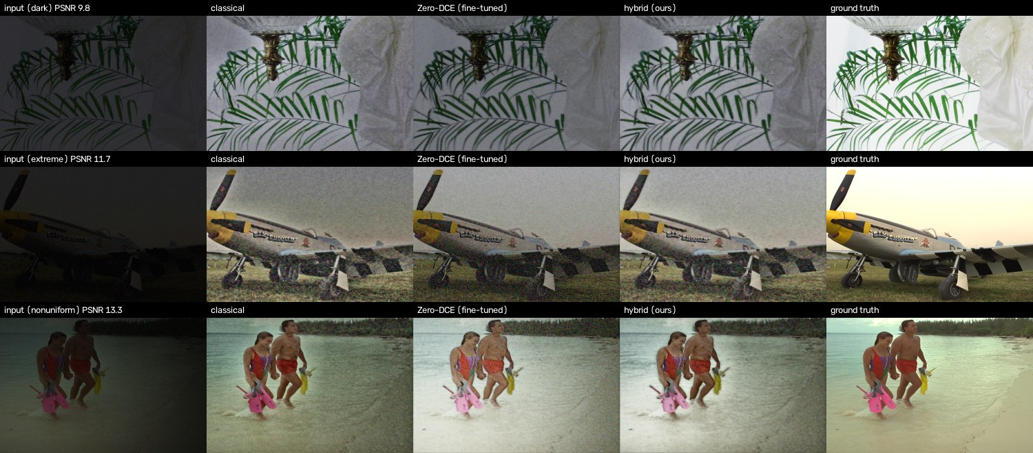
failures
Columns: input | classical | Zero-DCE | hybrid | ground truth. These are the worst hybrid result for each lighting condition (scripts/make_figures.py).
Failure 4 – bright white scene stays grey (McMaster_4, dark, PSNR 9.8). The ground truth is almost white (white background and curtain). Our brightness target is 0.45, so the output is a medium grey. The system has no way to know the true scene was that bright; it chooses “average” exposure. Possible fix: predict the target from the image content (a small regressor), or let the user move a brightness slider.
Failure 5 – extreme darkness: colour noise and lost texture (kodim20, extreme, PSNR 11.7). At 0.4–1.2% light, only a few photon levels are left. After brightening, the grass is mostly noise, the bilateral filter cannot separate grass texture from noise, and some coloured speckles remain on the plane. Classical and DL both fail here; the hybrid is cleaner than Zero-DCE but still noisy. Possible fix: a learned denoiser (e.g. a small DnCNN) or burst/multi-frame input.
Failure 6 – non-uniform light: dark corners and colour tint (kodim12, nonuniform, PSNR 13.3). The lamp position leaves one corner almost black. The illumination floor (0.02) limits how much that corner is lifted, so it stays darker than the rest, and the random colour cast is not fully removed because white balance is capped at 0.3. This is also the one condition where the classical pipeline beats the hybrid on PSNR (17.22 vs 16.81 dB on average). Possible fix: a lower floor plus stronger local denoising in very dark regions.
Failure 7 – real photo, coloured scenes (LIME/7, purple background, see docs/compare_real.jpg). Zero-DCE turns the purple wall bright magenta and grey-world white balance tries to “neutralise” it. We capped white balance at 0.3 after seeing a sunset turned blue in our first test (DICM/05). The hybrid looks acceptable, but any scene that really is one colour is at risk.

3. Limits of this evaluation
- LOL v1 eval15 has only 15 images, and some of its scenes may also be in LOL-v2’s training set, so we treat LOL-v2 Real Test as the main result.
- NIQE was designed for daylight images and can prefer sharper, more contrasty outputs even when they are less faithful.
- Latency was measured on one laptop CPU and varied by about 2x between our two runs.
- The failure images in docs/failures.jpg are from our own darkened photos, not LOL.

Appendix: example results
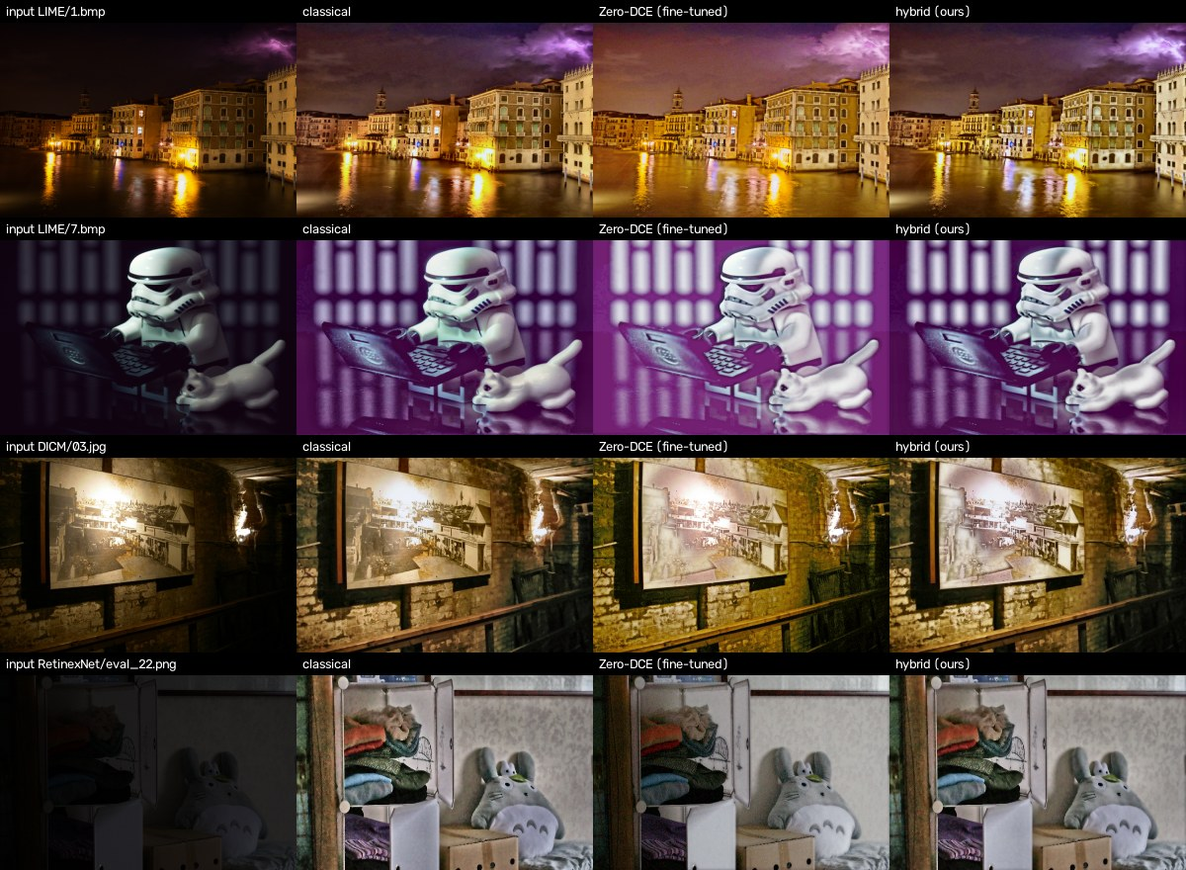
Real dark photos: input, classical, Zero-DCE, hybrid
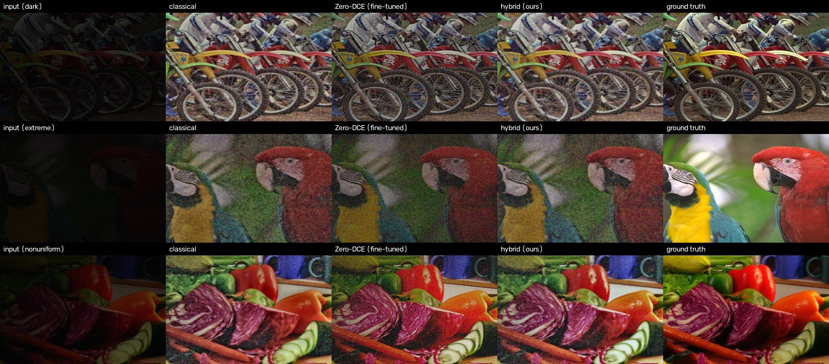
Synthetic test: input, classical, Zero-DCE, hybrid, ground truth
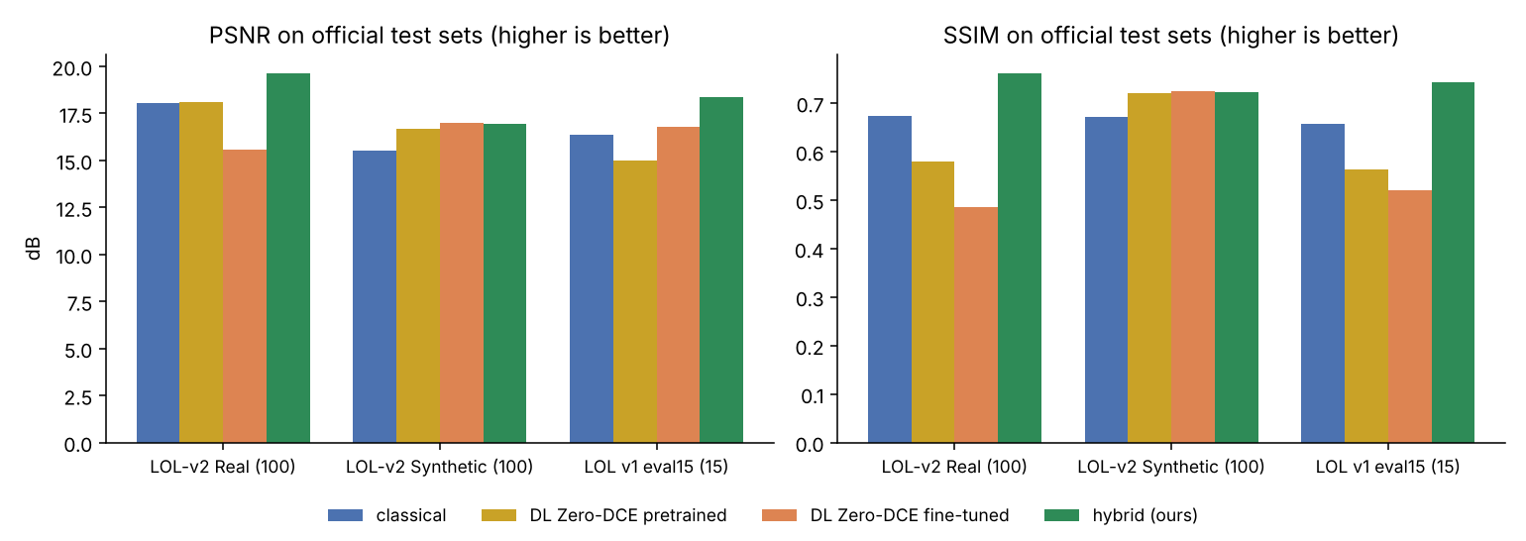
PSNR and SSIM on the official test sets
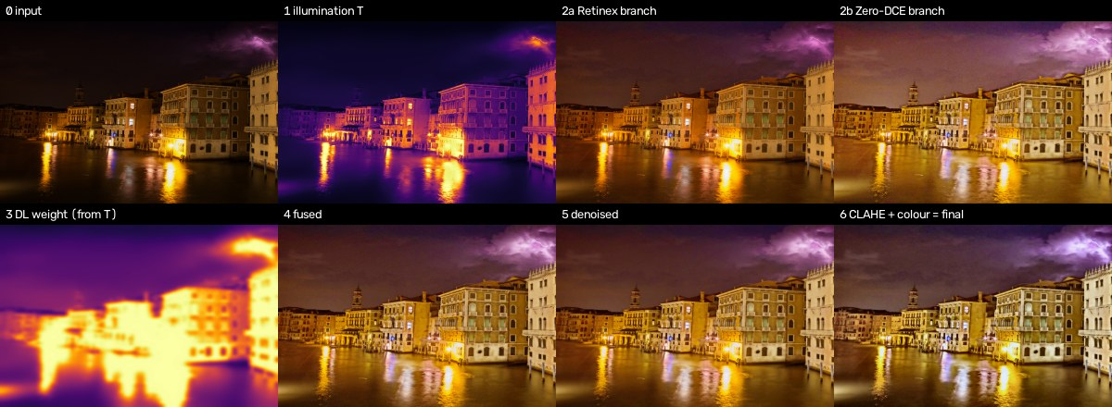
Intermediate steps of the hybrid pipeline

