Brook90_R_FNS_v4_5layer_ABRLBA

| Table xx.Summary of evapotranspiration, including monthly and annual means, and errors for daily values by month. Means and RMSE are in mm/day. | | | | | |
| --- | --- | --- | --- | --- | --- |
| **Month** | **Observed** | **Model** | **RMSE** | **nRMSE** | **pbias** |
| Jan | 2.9 | 3.1 | 0.4 | 14.5 | 8.5 |
| Feb | 2.7 | 2.8 | 0.4 | 15.6 | 6.2 |
| Mar | 2.7 | 3.1 | 0.5 | 17.0 | 12.2 |
| Apr | 3.1 | 3.0 | 0.4 | 14.5 | -3.8 |
| May | 2.8 | 2.7 | 0.5 | 16.8 | -4.0 |
| Jun | 2.5 | 2.2 | 0.6 | 25.2 | -12.6 |
| Jul | 2.5 | 2.0 | 0.8 | 32.0 | -17.4 |
| Aug | 2.0 | 1.8 | 0.4 | 21.0 | -10.0 |
| Sep | 2.6 | 2.7 | 0.6 | 22.7 | 0.9 |
| Oct | 3.2 | 3.0 | 0.5 | 16.9 | -6.7 |
| Nov | 3.1 | 3.1 | 0.3 | 11.0 | 0.9 |
| Dec | 2.9 | 3.0 | 0.4 | 12.4 | 2.7 |
| Ann | 2.8 | 2.7 | 0.5 | 18.9 | -3.0 |

Excluding 1993:

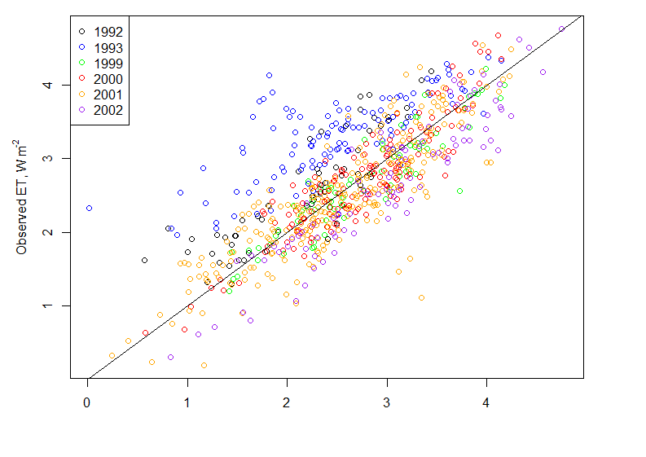

With LAIMAX = 3.9 for ABRACOS:

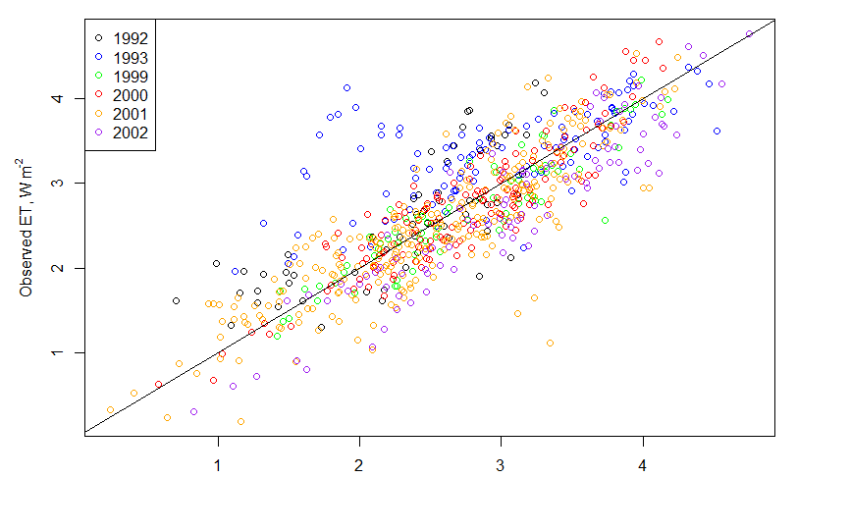

ET/PET:

