LOCKEDME.COM

OUTPUT SCREENSHOTS

|  |  |  |
| --- | --- | --- |
| **Author** | **Date** | **Version** |
| Tushar Binnar | 15-08-2021 | 1.0 |
|  |  |  |
|  |  |  |

Contents

Folder Structure 3

Welcome Screen 3

List of Files 3

File Operation Menu 4

File Added Successfully 4

Delete File 5

Search File 5

Return to Main Menu 6

Exit from Main Menu. 6

# Folder Structure

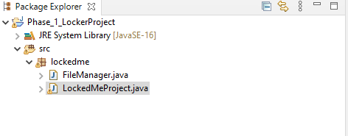

# Welcome Screen

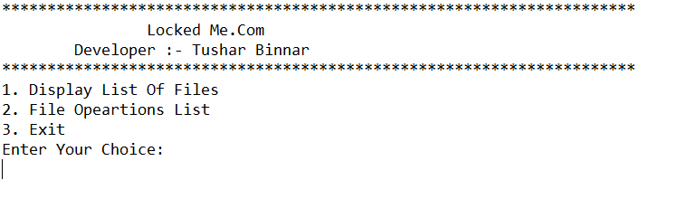

# List of Files

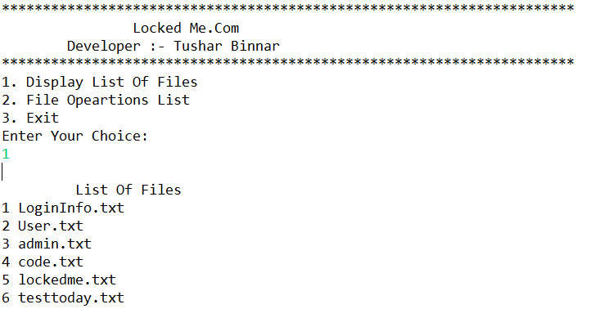

# File Operation Menu

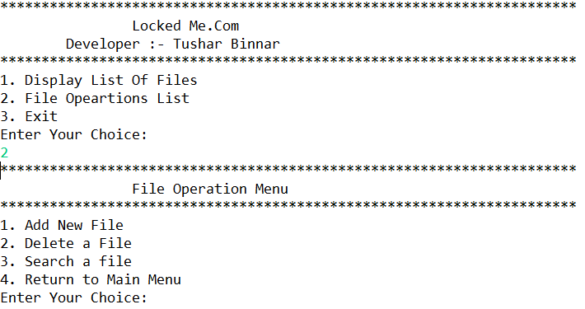

# File Added Successfully

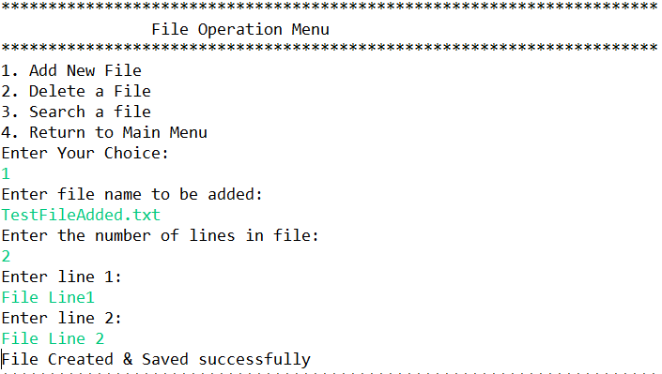

# Delete File

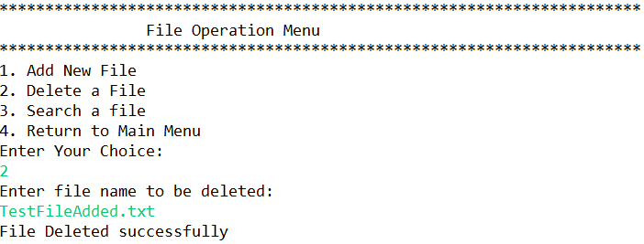

# Search File

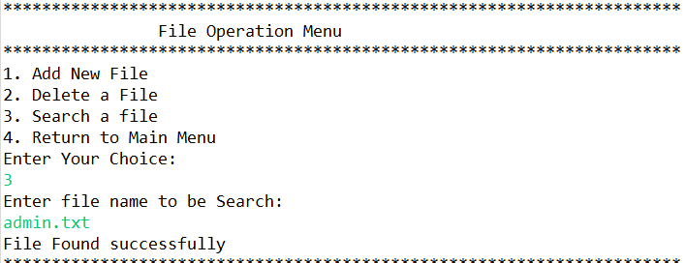

# Return to Main Menu

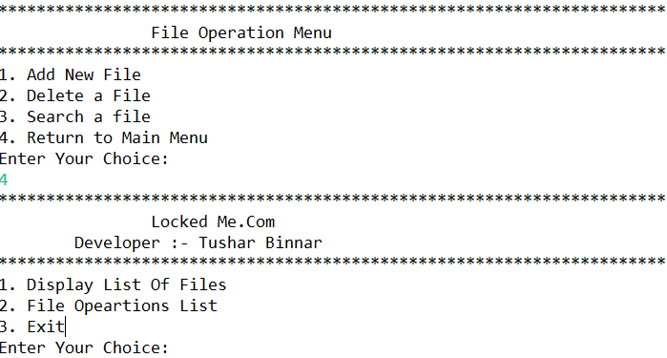

# Exit from Main Menu.

