I pledge my honor that I have abided by the Stevens Honor System

Original Site:

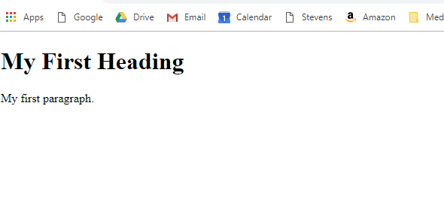

Site Variant:



Website name: teddysweb.com