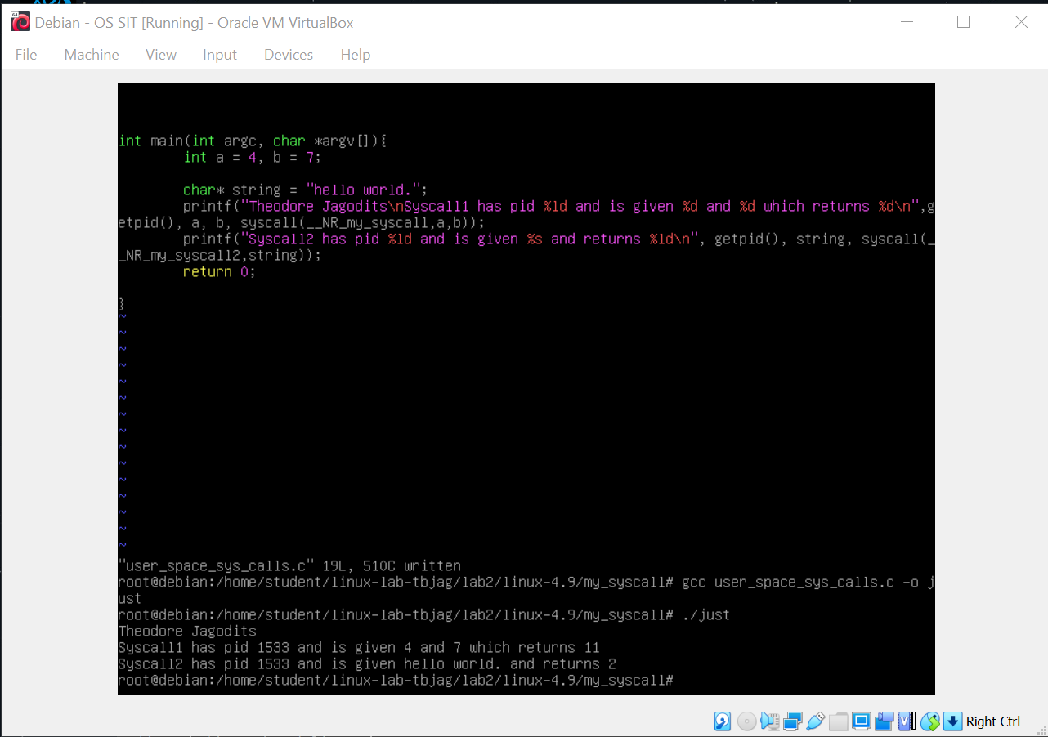 Less than 128 byte array

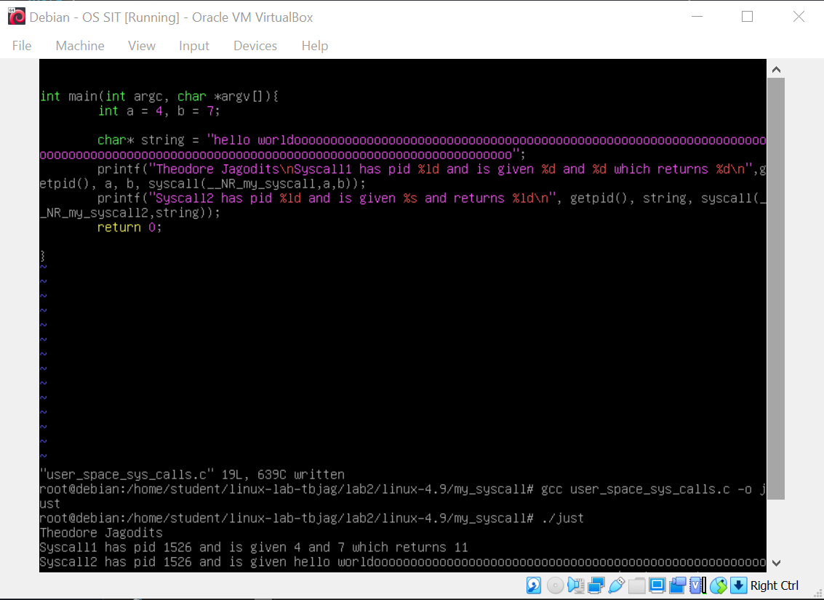greater than 128 byte array

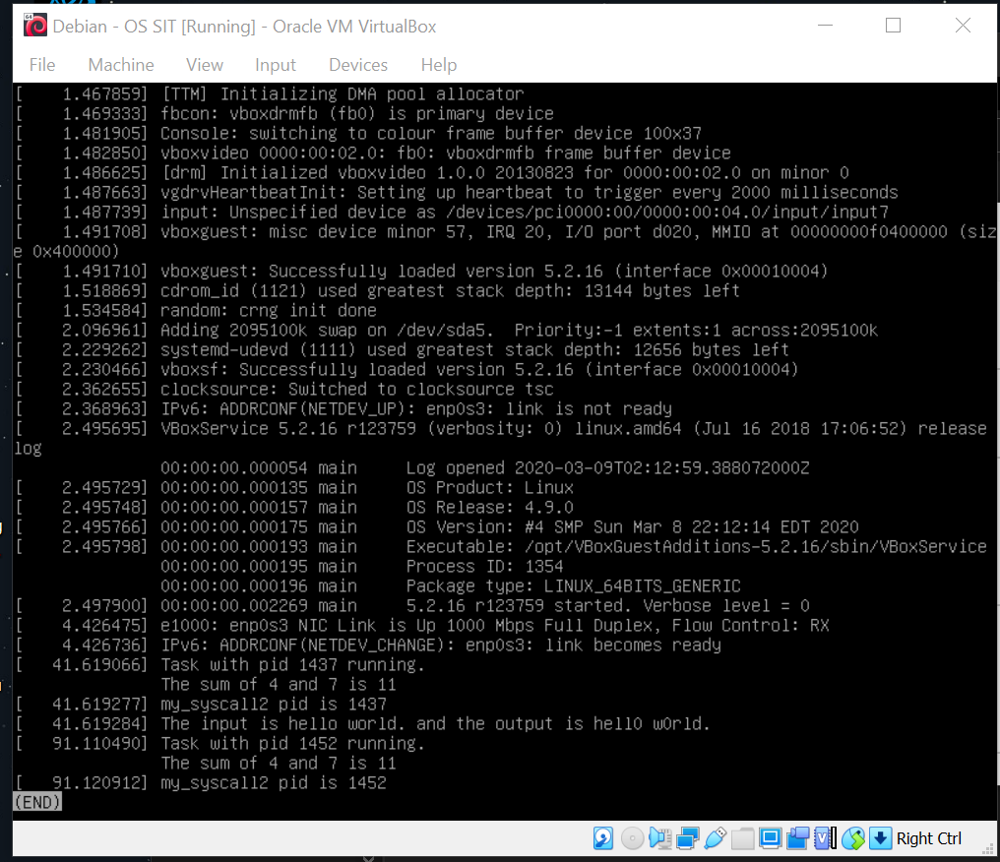

Output of both runs in order, in the log

Report:

There were a few steps involved making the syscalls. First was creating the appropriate c file for the syscall. Using built in SYSCALL_DEFINE1/2 I created the functions and put them in my own folder. Then I changed the tables for arch/x86/entry/syscalls/syscall_64.tbl and added 2 entries for my two syscalls. Then I changed the include/linux/syscalls.h file by adding two function declarations.

Then I had to edit the kernel makefile and build my own include path by changing the core-y in the makefile and obj-y += my_syscall.o to include it in the system.

After that compile with the new kernel and run it.

NOTE: could not retrieve the /include/linux/syscalls.h providing screenshot, and is in my git

