“I pledge my honor that I have abided by the Stevens Honor System.” –cli50

Homework 6

12.41

a. 1 = µ2 -

b.2 = - µ3

12.42

a.

First sample:

H0: 1 = 0

Ha:1 0

Second sample:

H0: 2 = 0

Ha:2 0

b.

1 = c1 = -

Blue:

Brown: $\overline{x_{2}}$ = 3.724

Gaze down: $\overline{x_{3}}$ = 3.107

Green: = 3.86

1 = c1 = - = 3.724 – = 0.197

2 = c2 = - = - 3.107 = 0.486

c.

sp = 1.68

SEc1 = sp  = 1.68 $\sqrt{\frac{{(1)}^{2}}{37}+\frac{{(-\frac{1}{2})}^{2}}{67}+\frac{{(-\frac{1}{2})}^{2}}{77}}$ = 0.3098

SEc2 = sp  = 1.68 $\sqrt{\frac{{(\frac{1}{3})}^{2}}{67}+\frac{{(\frac{1}{3})}^{2}}{37}+\frac{{(\frac{1}{3})}^{2}}{77}+\frac{{(-1)}^{2}}{41}}$ = 0.2933

d.

t = $\frac{c_{1}}{{SE}_{c1}}$ = $\frac{0.197}{0.3098}$ = 0.64

dfn = k – 1 = 4 – 1 = 3

dfd = N – k = 222 – 4 = 218

P-value = tdist(0.64, 218, 2) = 0.523

Because the P-value is greater than the level of the significance level, 0.05, we fail to reject the null hypothesis. Thus, there is not enough sufficient evidence to say that the average score of the brown eyes with the average of the other two eye colors.

t = $\frac{c_{2}}{{SE}_{c2}}$ = $\frac{0.486}{0.2933}$ = 1.66

dfn = k – 1 = 4 – 1 = 3

dfd = N – k = 222 – 4 = 218

P-value = tdist(1.66, 218, 2) = 0.0983

Because the P-value is greater than the level of the significance level, 0.05, we fail to reject the null hypothesis. Thus, there is not enough sufficient evidence to say that the average score when the model is looking at you versus the score when looking down are not the same.

e.

95% confidence interval for 1 is:

df = N – 1 = 222 – 1 = 221

c1 ± t * SEc1 = 0.197 ± (1.9707)(0.3098) = (-0.41, 0.81)

The 95% confidence interval for 1 lies between -0.41 and 0.81.

95% confidence interval for 2 is:

df = N – 1 = 222 – 1 = 221

c2 ± t * SEc2 = 0.486 ± (1.9707)(0.2933) = (-0.09, 1.06)

The 95% confidence interval for 2 lies between -0.09 and 1.06.

13.39

a.

|  |  |  |  |  |  |
| --- | --- | --- | --- | --- | --- |
|  | Tool 1 | Tool 2 | Tool 3 | Tool 4 | Tool 5 |
| Time 1 | 25.03, 0.012 | 25.017, 0.0012 | 25.006, 0.0015 | 25.012, 0 | 24.997, 0.0012 |
| Time 2 | 25.028, 0 | 25.013, 0.0012 | 25.013, 0.0012 | 25.019, 0.0012 | 25.006, 0 |
| Time 3 | 25.026, 0 | 25.009, 0 | 25.009, 0 | 25.014, 0.004 | 25, 0.0015 |

b.

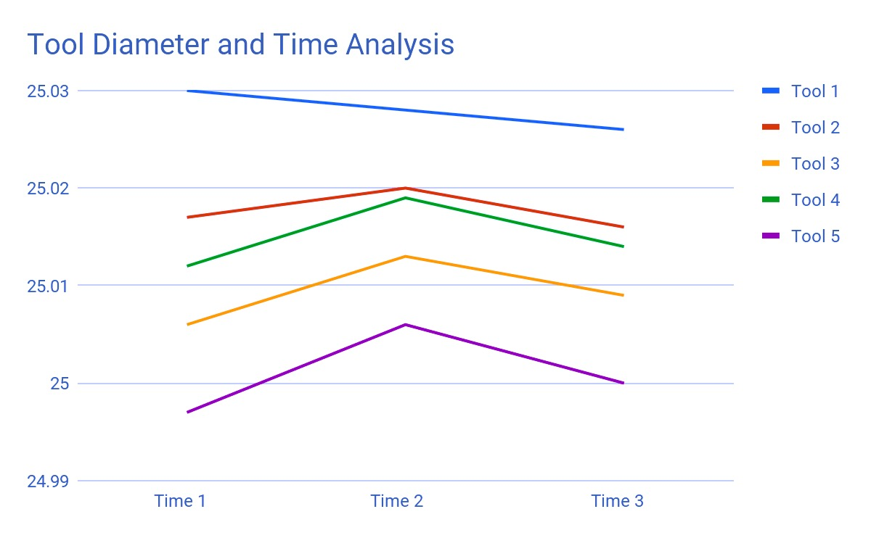

c.

|  |  |  |  |  |  |
| --- | --- | --- | --- | --- | --- |
| Source | DF | SJ | MS | F | P |
| Tools | 4 | 0.0036 | 0.001 | 412.9 | 9.27 * 10-26 |
| Time | 2 | 0.00019 | 9.5 * 10-5 | 43.6 | 1.33 * 10-9 |
| Tools Time | 8 | 0.00013 | 1.67 * 10-5 | 7.65 | 1.55 * 10-5 |
| Error | 30 | 6.53 * 10-5 | 2.18 * 10-6 |  |  |
| Total | 44 | 0.003985 |  |  |  |

d.

Tools, time and tools time are all statistically significant for this test, yet tools are by far the most significant followed by time and then tools times. Looking at the P-values and MS values, the order is flipped, meaning that tools time is by far the most significant followed by time and then tools.