I pledge my honor that I have abided by the Stevens Honor System. –cli50

HW #2

1i. pbinom(8.25,20,0.4) = 0.5955987

pbinom(8.25,30,0.4) = 0.09401122

pbinom(8.25, 50, 0.4) = 0.0002305229

pbinom(8.25, 100, 0.4) = 5.431127e-13

1ii. P(N=20) = 0.6339374

P(N=30) = 0.1129094

P(N=50) = 0.0005819138

P(N=100) = 8.918223e-11

1iii. n= 20 -> | 0.6339374 - 0.5955987 | = 0.0383387

n = 30 ->| 0.1129094 - 0.09401122 | = 0.01889818

n = 50 -> | 0.0005819138 - 0.0002305229 | = 0.00035139

n = 100 -> | 8.918223e-11 - 5.431127e-13 | = 8.8650117e-11

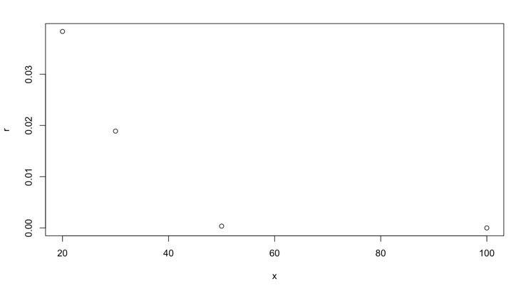

1iv. Based on the error plot in 1iii., as n increases, the errors get smaller and smaller to where it will always be as close to 0 as possible but the error points will never hit 0.

2i. y equation is (X-2)/ (√(3^2/n))

z equation is ((n-1) \* S^2)/ (3^2)

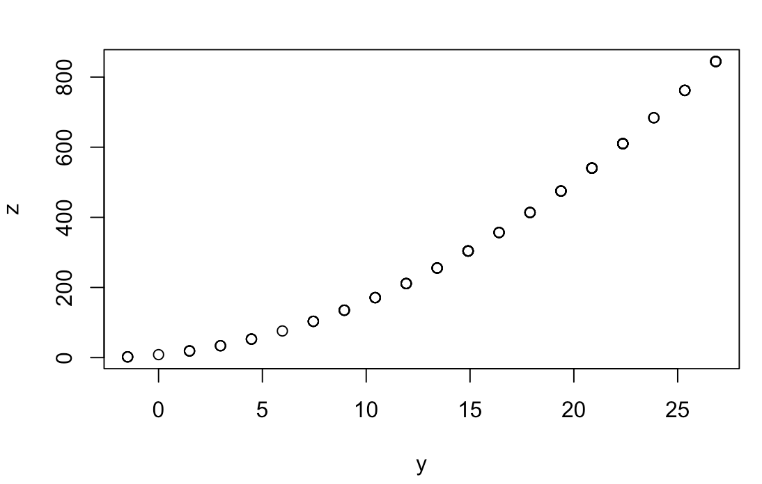

2ii. b equation is (X-2)/ (√(3^2/n))

c equation is ((n-1) \* S^2)/ (3^2)

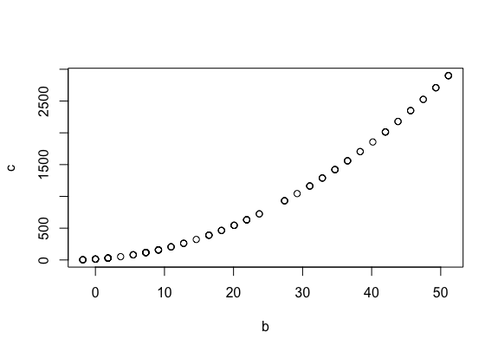

2iii. y equation is (X-2)/ (√(3^2/n))

z equation is ((n-1) \* S^2)/ (3^2)

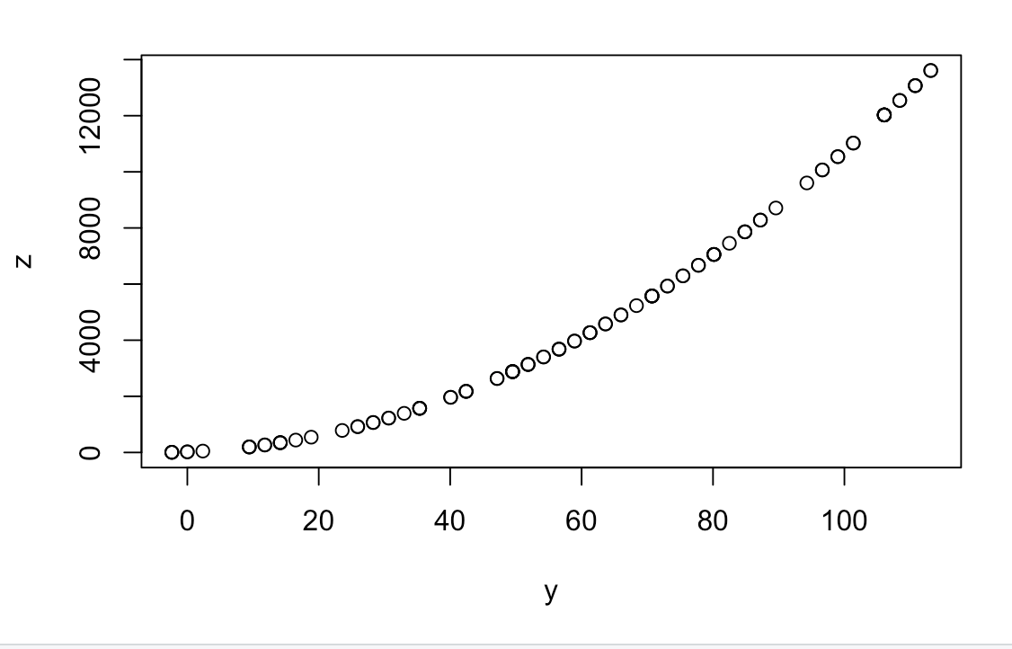

2iv. Based on the plots from 2i-2iii, the biggest difference is that the z values (also the same as c values) are increasing as n increases in size. The z values increase from 800 to 2,500 to over 12,000 from these three graphs. In addition, even though sample of size n is generated randomly for each of the three graphs, they all show very similar slopes no matter what the y (also b) and z (also c) values are.