MA 331 / Final Project Report / Theodore Jagodits / 5/7/20

I pledge my honor that I have abided by the Stevens Honor System.

**Introduction:**

This study looks at the effects of acetic acid content, hydrogen sulfide content and lactic acid content in cheddar cheese from LaTrobe Austria. Thirty samples were taken and sampled for the chemicals mentioned above. Then they were given a score on a taste test. The score is made from several different tasters. This study is used to determines which variables and combination of them to predict the score value as best as possible. The data is given in an .xls file and it was used in R.

**Tools:**

We use the .xls file given to us and use statistical analysis in R and some graphs in excel. The rest of the details are in the R code file.

**Summary:**

The variables are first given a statistical summary to learn a little bit more about them. I looked at mean, median, standard deviation and Interquartile Range. I also check for any outliers, which there are not, and the data seems to normally distributed. Then I performed a correlation test on the different variables on each other. H2S and Acetic are strongly correlated, since the zero-point correlation test gave me a very low p-value, so we reject the null hypothesis that the correlations are zero.

Using the equation y i = β0 +β1 i +εi for to model (x1 … xN) for taste (y1 … yN). I propose that the null hypothesis for each case is slope 0 and the alternative hypothesis is that the slope has some significant correlation model for taste. The first model is y = -61.5 + 15.55(acetic content) and the p-value is 0.0017, which is very low. Which means acetic content has a significant impact on the taste of the cheese. On the second model, y = -9.78 - +5.77(H2S content) for which the p-value was almost zero, so H2S also had a significant impact on taste. For Lactic, the equation y = -29.85 + 37.72(Lactic Content) and the p-value was negligible as well. All the cases had approximately normally distributed residuals.

Next, I tried a generic model that used a linear combination of the variables. The first model I tried was y = -26.94 + 3.5(Acetic content) + 5.15(H2S content). The p-value for the Acetic content was .4 and the H2S was 0.0002 so we could not reject the null hypothesis for this model because of the Acetic content. The second model was Lactic and H2S, y = -27.59 + 19.89(Lactic content) + 3.95(H2S content). The p-values where both very low (0.018 and 0.0017 respectively), so these two coefficients were the best in this study so we select them as our best model.

Finally I tried a model with all variables that ended up y = -28.877 + 0.32(Acetic Content) + 3.9(H2S) + 19.671(Lactic). The p-values respectively were .94, 0.0042 and 0.031. Acetic was deemed not significant so I removed it from the model and so the model was based on the previous exercise.

**11.53**

Descriptive Statistics

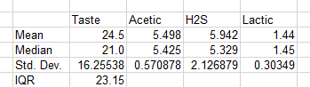

Stem plots of the Response and Explanatory Variables

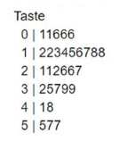

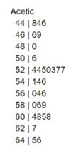

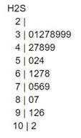

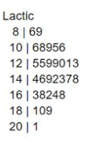

Normal Quantile Plots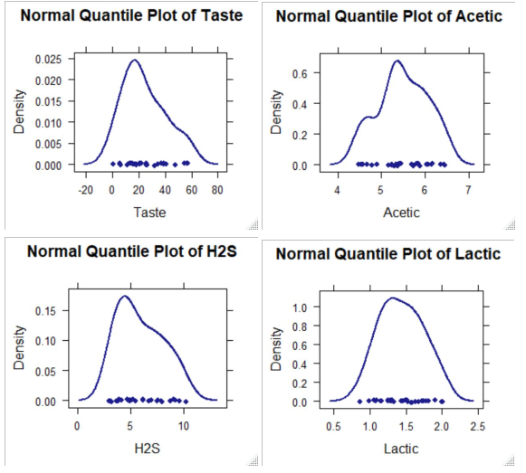

All the variables look approximately normal and have no obvious outliers. Lactic looks the most normal, then Taste with a slight skew. Acetic and H2S both have more of a skew but nothing out of the ordinary. We can do linear regression.

**11.54**

Scatterplot of Each Variable

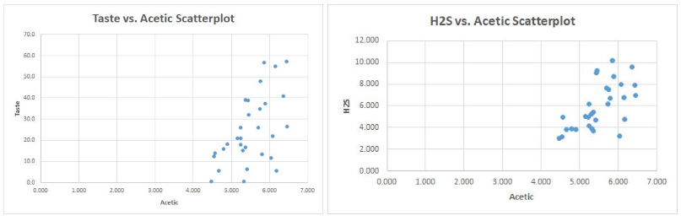

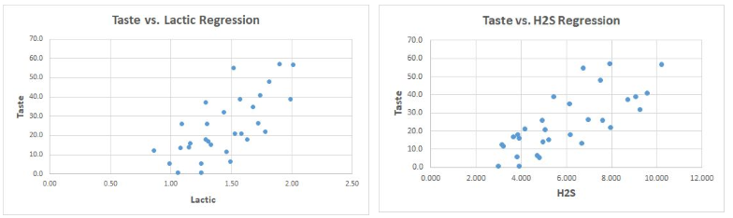

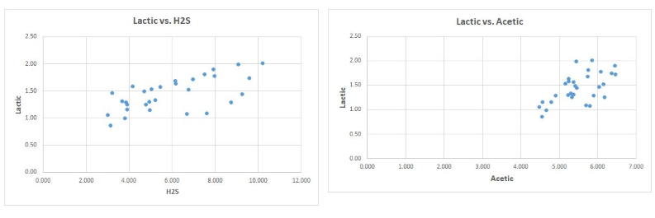

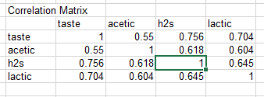

Pvalue Test of Zero Population Correlation Test

Taste vs Acetic = 0.002

Taste vs H2s = 1e-06

Taste vs Lactic = 1e-05

From the correlation matrix above we can see that Taste vs. Acetic is 0.55, Taste vs. H2S is 0.756 and Taste vs. Lactic is 0.704. The strongest relationship of them is Taste vs. H2S. The p-values above indicate that we can reject the null hypothesis for all the variables vs. Taste is 0.

**11.55**

Linear Regression on Taste vs. Acetic

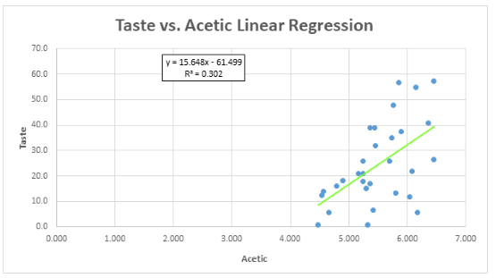

The model shows Taste = -61.5 + 15.55(Acetic Content)

T-Stat: 3.48

P-Value: 0.0017

Confidence Interval (2.5% - 97.5%): Intercept [-112.39, -10.6]; Acetic [6.44,24.9]

Residuals vs. Explanatory Variables

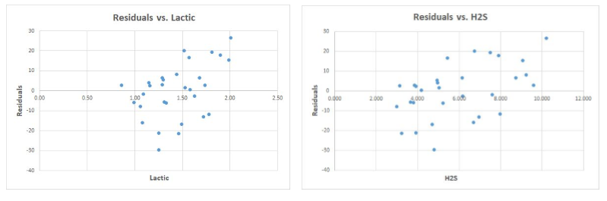

Analysis:

Both residuals appear to be normally distributed and look like they are positively associated with H2S and Lactic Content. The P-Value was very low so there is a relationship between Taste and Acetic Content.

**11.56**