Theodore Jagodits / MA 331 / HW#1

I pledge my honor that I have abided by the Stevens Honor System

(i)

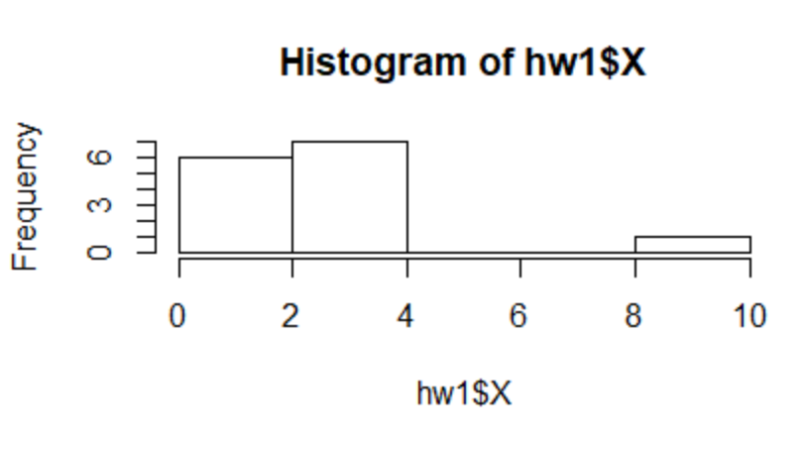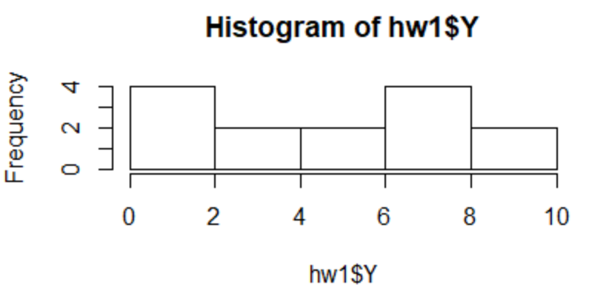

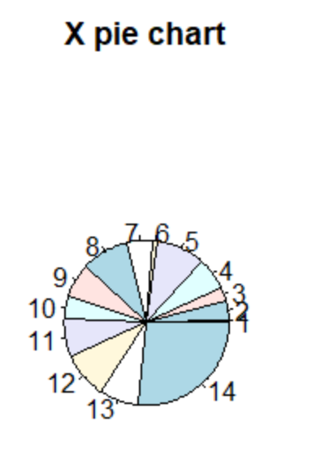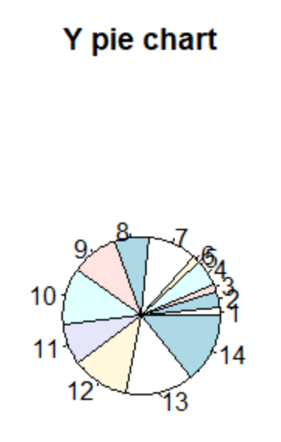

Description of X: the data seems to be skewed to the right, with an outlier on the left. The values are spread out between 0 and 10. Median: 2.25, Mean: 2.407

Description of Y: the data seems very uniform with no obvious skews to the left or eight. The values are also spread out between 0 and 10 with no obvious outliers. Median: 5.3, Mean: 4.87

(ii)

Boxplot of X: Boxplot of Y:

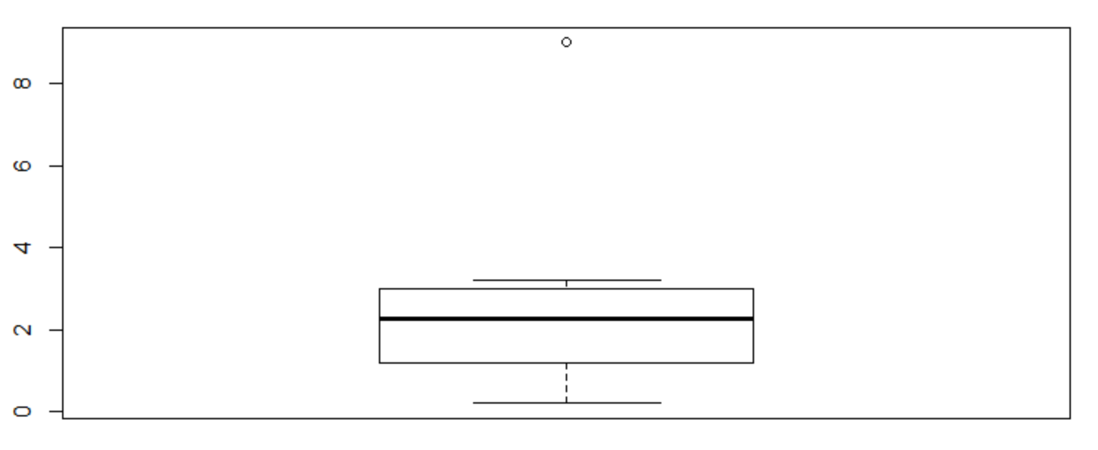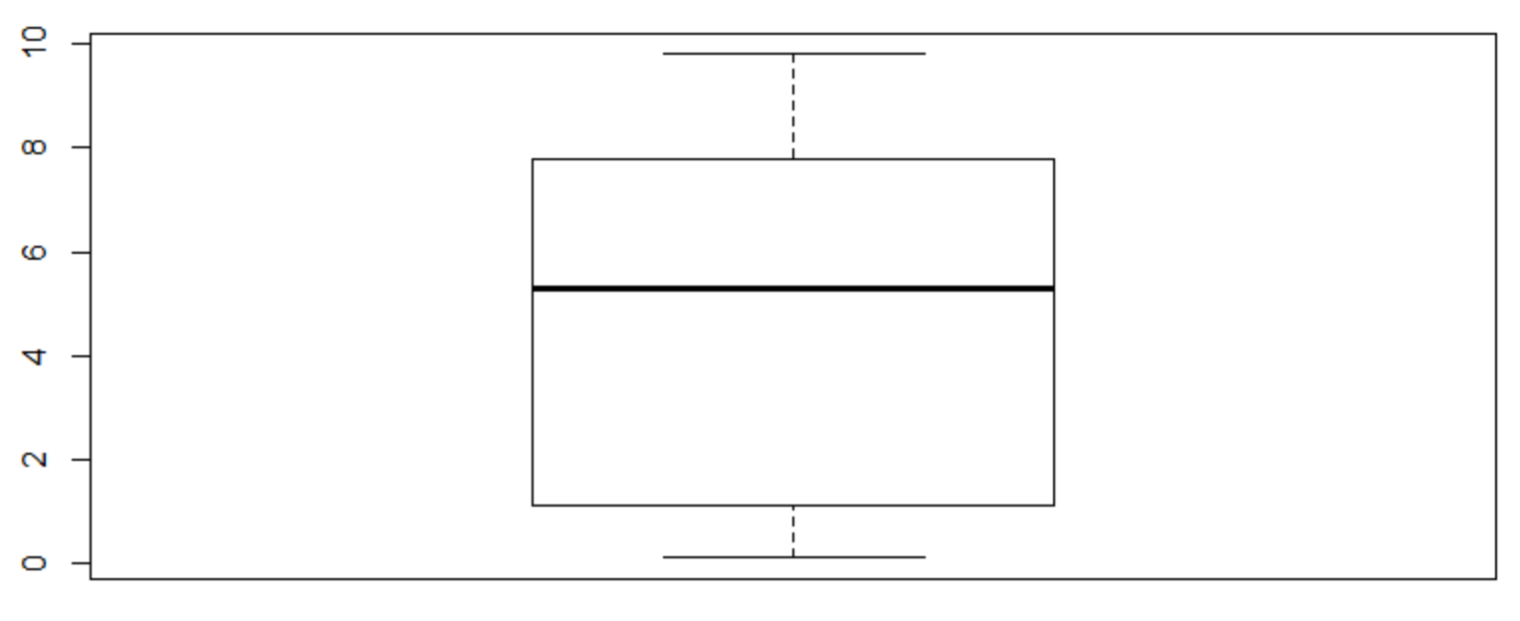

X has an outlier that is around 9. There are no obvious outliers in Y.

(iii)

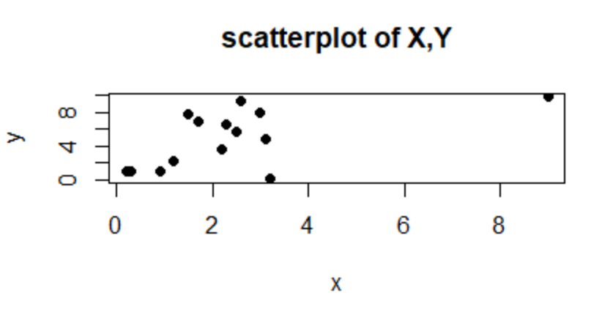

The correlation coefficient is 0.5679, which is positive which means they move in the same direction, .56 means there is a significant correlation.

(iv)

With the outliers removed, the correlation coefficient drops to 0.4586

(v)

The difference observed is that the correlation coefficient drops when the outlier is removed. It looks like that it was skewing the data to make it seem that there was a higher correlation than there was.

(vi)

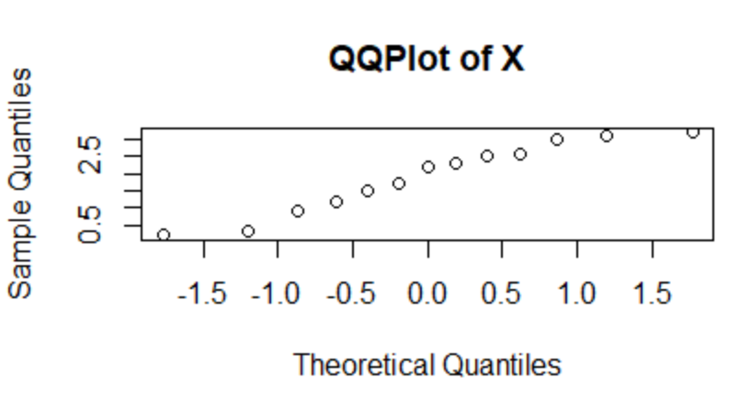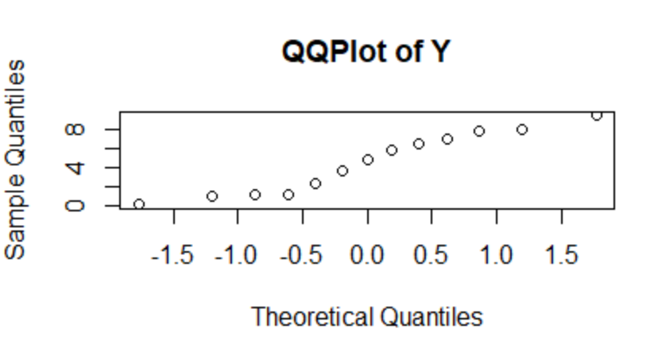

After looking at the QQ lines of both plots, X without the outlier seems to follow the normal distribution more than Y as more data points fit the line.

