Theodore Jagodits / MA 331 / HW#2

I pledge my honor that I have abided by the Stevens Honor System

**Problem 1.**

(i)

N = 20, P(N <= 8.25) = 0.5955987

N = 30, P(N <= 8.25) = 0.09401122

N = 50, P(N <= 8.25) = 0.0002305229

N = 75, P(N <= 8.25) = 1.826106e-08

N = 100, P(N <= 8.25) = 5.431127e-13

(ii)

n=20, P(N<=8.25)= 0.5207689

n=30, P(N<=8.25)= 0.3012414

n=50, P(N<=8.25)= 0.1637488

n=75, P(N<=8.25)= 0.1133488

n=100, P(N<=8.25)= 0.09293155

(iii)

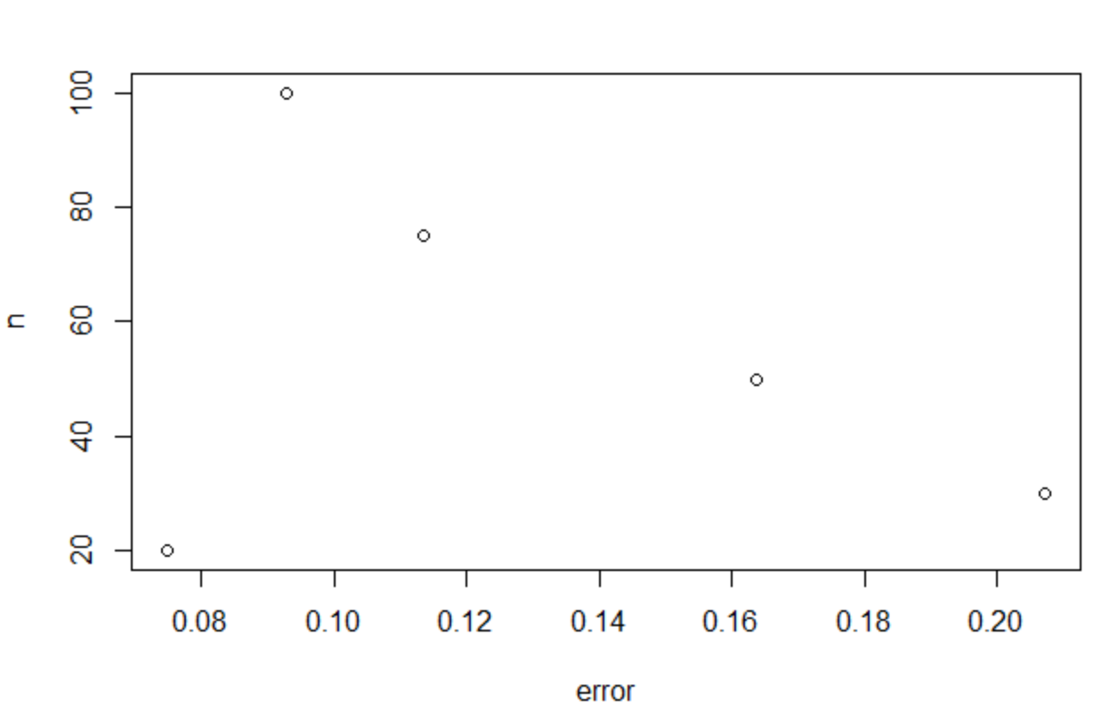

(iv)

The plot follows kind of linearly after the first point n=20. But it looks like it follows some kind of equation to and the error clearly decreases as N gets larger.

**Problem 2.**

(i)