Theodore Jagodits / MA 331 / HW#2

I pledge my honor that I have abided by the Stevens Honor System

Problem 1.

(i)

Pbinom(k,n,p) in R

(ii)

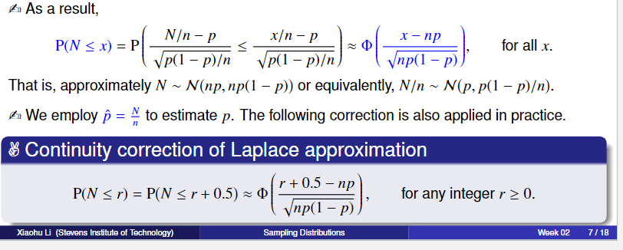

(iii)

Error approximate/scatter plot

(iv)

Thoughts on scatterplot