Theodore Jagodits / HW #6 / MA 331

I pledge my honor that I have abided by the Stevens Honor System

**12.31**

a)

|  |  |  |  |
| --- | --- | --- | --- |
| **Group** | **Sample Size** | **Mean** | **Standard Deviation** |
| *Control* | 35 | -1.01 | 11.50 |
| *Individual* | 35 | -3.71 | 9.08 |
| *Group* | 34 | -10.79 | 11.14 |

b) Yes, it is fine to pool variances 2 * 9.08 = 18.16 > 11.50

c)

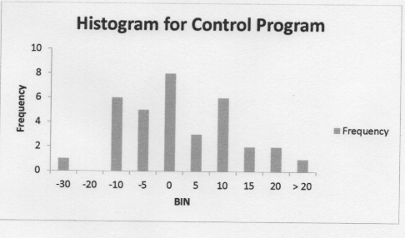

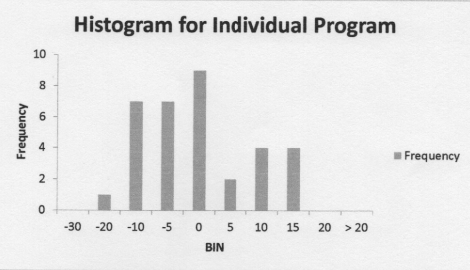

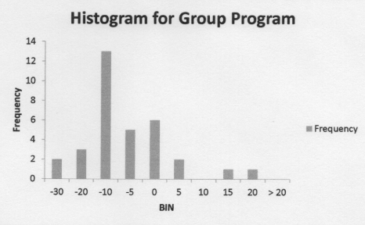

The control group is the only one with a symmetric distribution. The other two groups have a left skew in their distribution. Since the sample sizes are large enough that we can say that they are approximately normal distributed we can neglect any discrepancies in the normal model.

**12.32**

a) The test statistic, p value, and degrees of freedom are in the table. Since the P-value is than 0.05, we can reject the null hypothesis, that there is no difference between the means of the different groups. So we can conclude that there is at least one mean different than the others.

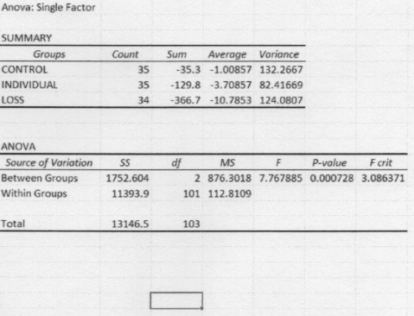

c)

Least-Significant Difference method is this equation:

LSD = t * sqrt(MSW * (1/N1 + 1/N2 + 1/N3))

I used excel to calculate the critical value (T.INV.2T(0.05,101) with an alpha of 0.01 and 101 degrees of freedom. T = 1.98

The MSW is 112.8109 and corresponds to the sample sizes of each group.

LSD = 6.187

And the difference between the means of the group and the individual groups is 7.-8.

*Since 6.1 < 7.08, we can conclude that there is statistical significance and that there is a difference between the mean values of each group.*

**12.33**

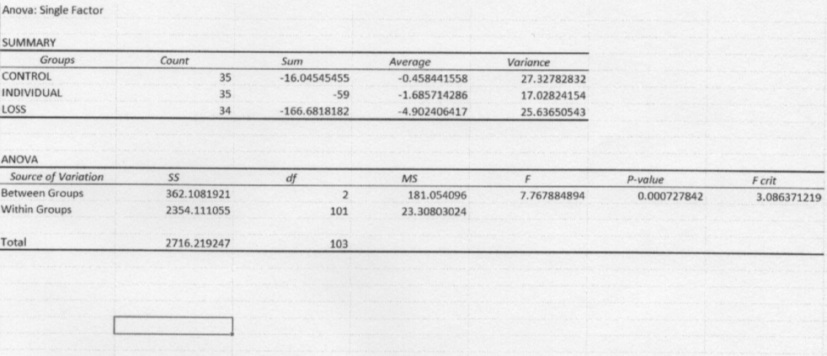

After doing the math in kilograms instead of pounds, nothing really changed. The test statistic, degrees of freedom and p-value stayed the same. The entire data set was changed by a constant so nothing changed the actual statistic, moreover it just changed the means to different values but did not change the statistics. We conclude again the alpha is 0.001 and that we reject the null hypothesis

**12.41**

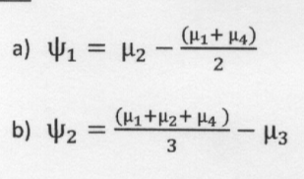

**12.42**

|  |  |  |  |
| --- | --- | --- | --- |
| **Group** | **Sample Size** | **Mean** | **Standard Deviation** |
| **Blue** | 67 | 3.194 | 1.755 |
| **Brown** | 37 | 3.724 | 1.715 |
| **Down** | 41 | 3.107 | 1.525 |
| **Green** | 77 | 3.860 | 1.666 |

