USER GUIDE

CONTENT

1 Setup And Start 1
1-1 Basic Accessories 1
1-2 Control Panel 2
1-3 Console Operation 3
1-4 Start 4
1-5 Main Menu Setting 5
1-5-1 Connecting the Internet（WI-FI or Ethernet） 5
1-5-2 Change Language 6
1-5-3 Screen Setting 6
1-5-3-1 Connecting screen synchronization 6
1-5-3-2 Vertically or horizontally screen flip 6
1-5-3-3 Horizontal screen flip 7
1-5-4 Online update 7
1-5-5 Technical support 8
1-5-6 Equipment information 9
1-5-7 Shutdown 9
1-6 Toolbox 10
1-6-1 Toolbox mode Control 10
1-6-2 Brush setting 11
1-6-2-1 Brush 11
1-6-2-2 Color Setting 11
1-6-2-3 Pause the Brush Function 12
1-6-2-4 Erase Brush 12
1-6-2-5 Clear All Handwriting 12
1-6-2-6 Brush Adjustment 12
1-6-3 Multimedia player 13
1-6-4 Screenshot 14
1-6-5 Screen Recording 15
1-7 CD Software Update 16
1-8 Moving And Positioning Setting 17
1-9 Lifting Control 17
1-10 Precautions 20
1-10-1 Precautions For Power Plug And Power Cord 21
1-10-2 Precautions For Transport And Installation 21
1-10-3 Precautions For Information Safety 21
1-10-4 Cleaning Consideration 22
2 Device Information 23
2-1 Specification 23
2-2 FCC Supplier’s Declaration of Conformity 24
2-3 Troubleshooting 25
2-3-1 Unable To Boot Normally 25
2-3-2 Unable To Operate Normally 25
2-4 Product Warranty Statement 25
2-4-1 Warranty Coverage 25
2-4-1-1 Warranty Period 25
2-4-1-2 Warranty Details 26
2-4-2 Exclusions from Warranty Coverage 26
2-4-2-1 Damage Due to Human Factors or Improper Operation 26
2-4-2-2 External Forces and Environmental Conditions 26
2-4-2-3 Issues Caused by Non-Genuine Parts or Accessories 26
2-4-2-4 Installation or Use of Unauthorized Software 27
2-4-2-5 Expired Warranty 27
2-4-3 Supplementary Warranty Terms 27
2-4-4 Additional Notes 27
2-5 Contact Information 27

- Setup And Start
Please carefully read all the installation instructions before use of the multi-touch digital image dissection table for the first time.
This product includes instructions for the hardware computer equipment and software program system. Please read this manual carefully before using this product and follow the system start-up mode to enable and operate the multi-touch digital image dissection table properly to avoid personnel injury and other damages caused by improper usage.
If you have any questions, please refer to the instruction documentation of the multi-touch digital image dissection table. If further instruction or clarification is needed, please contact us.
  - Basic Accessories
Product accessories include: one host computer, one 99 inches touch screen display, and one AC power cord.
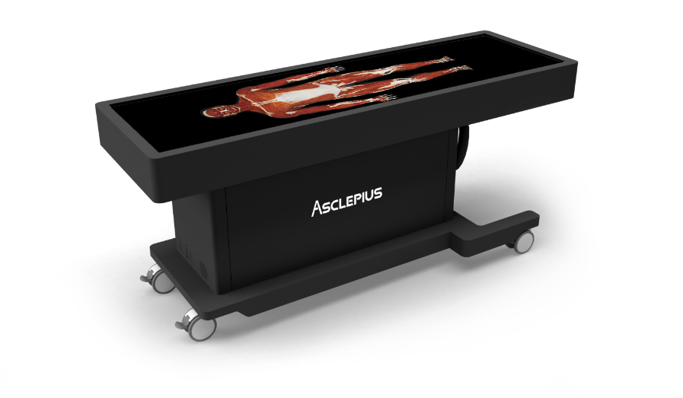 | 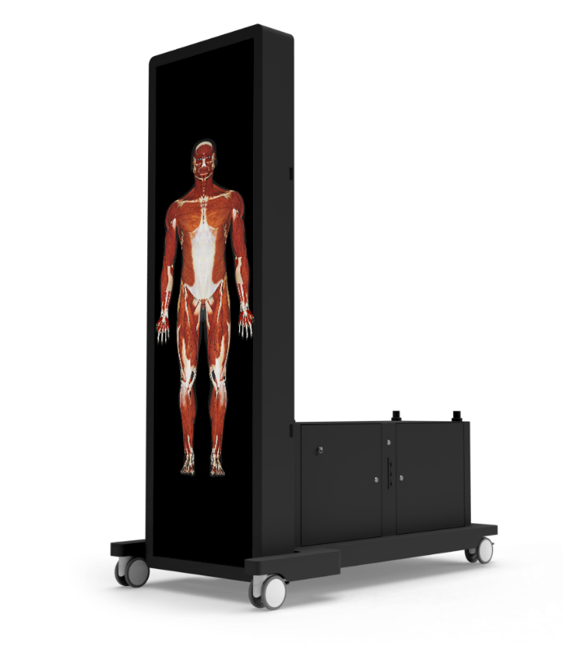
Figure 1.1 99 inches touch screen display (Horizontal) | Figure 1.2 99 inches touch screen display (Vertical)

  - Control Panel
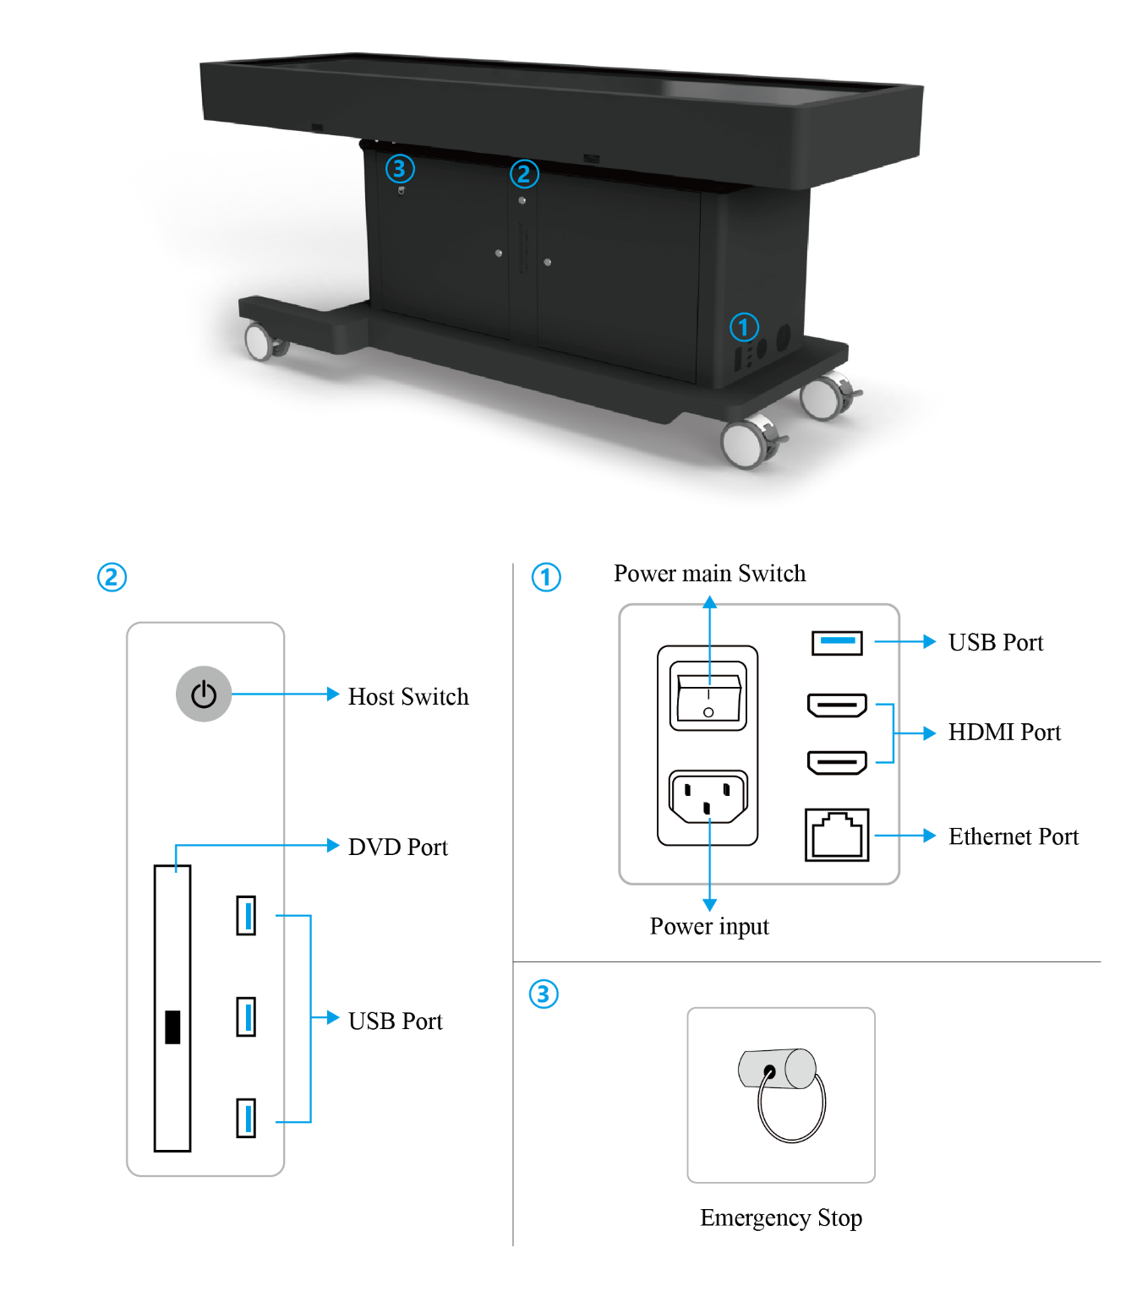
Figure 1.3 Control Panel

  - Console Operation
Button Operation   Power On/Off   Media controls   USB：Switch to USB file CMS：Switch Source to CMS HDMI：Switch Source to HDMI   Resolution Setting   Go to the Home Page   No function   No function  Enter the Source Selection Page  Setting   Information  Open the External Menu   Navigation button   Confirm/OK   +/-: Adjust the Sound Volume Splice: Full Screen display Divide: Single screen display   Return to Previous/Exit   Mute/Unmute  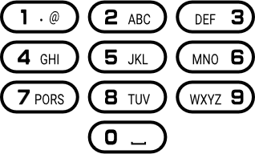 Enter Number   Return   Help | 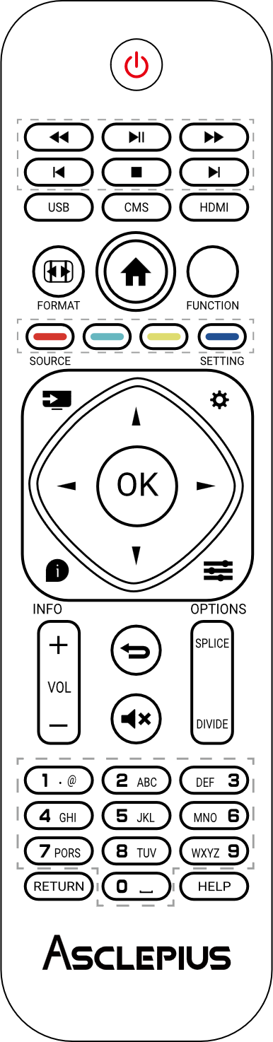
Figure 1.4 Console interface

Tilt Upward
Tilt Downward
Figure 1.5 Console interface (Horizontal/Vertical)
  - Start
Configure the hardware equipment and power cord to start operation of the multi-touch digital image dissection table. Now, we will guide you through the final procedures in setting up the multi-touch digital image dissection table.
To finish setting up the multi-touch digital image dissection table. Please follow the following procedures:
- Configuring the power supply of the host system
- Please connect the console of the Asclepius to the AC power cord. Plugs may vary based on your country.
- Please turn on the Asclepius, at this time you will hear the sound running the host.
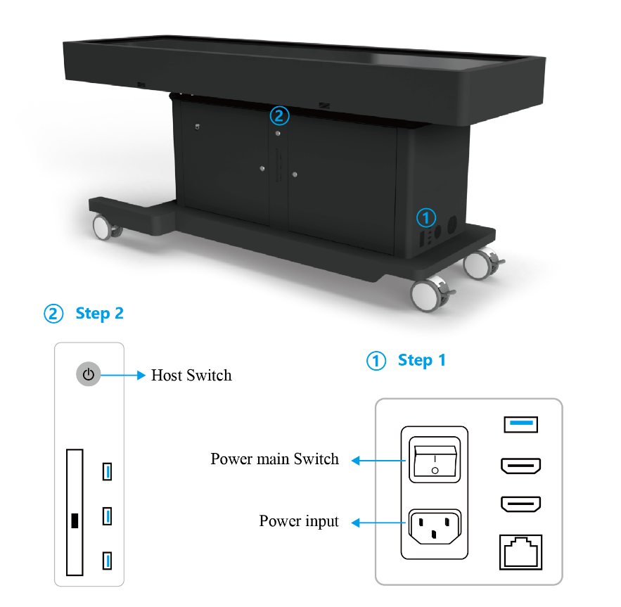
Figure 1.6 Power main switch and host switch
  - Main Menu Setting
    - Connecting the Internet（WI-FI or Ethernet）
- Connect the Asclepius to the Ethernet interface (10/100/1000 Base-T)
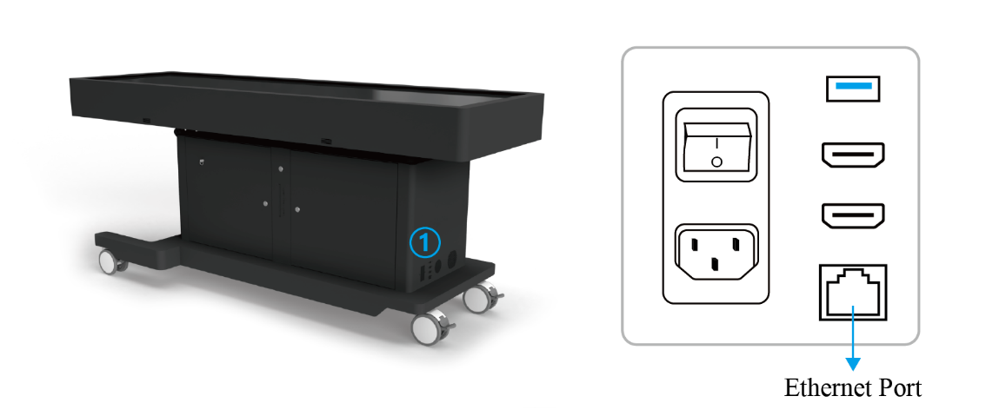
Figure 1.7 Connect the Ethernet
- Connecting the WI-FI
Step 1. Click the WI-FI icon on the main menu screen.
Step 2. Select a WI-FI name you want to connect. If the name of the
WI-FI you want to connect, does not appear automatically, click the refresh button until it appears. WI-FI name must be composed of English letters, Chinese name will not be displayed.
Step 3. After clicking the keyboard icon, touch the password input field
to enter the WI-FI password.
Step 4. After entering the password, click the Connect icon.
Step 5. After the connection is completed, click refresh again until the
WI-FI name selected by the user appears in the current network
field.
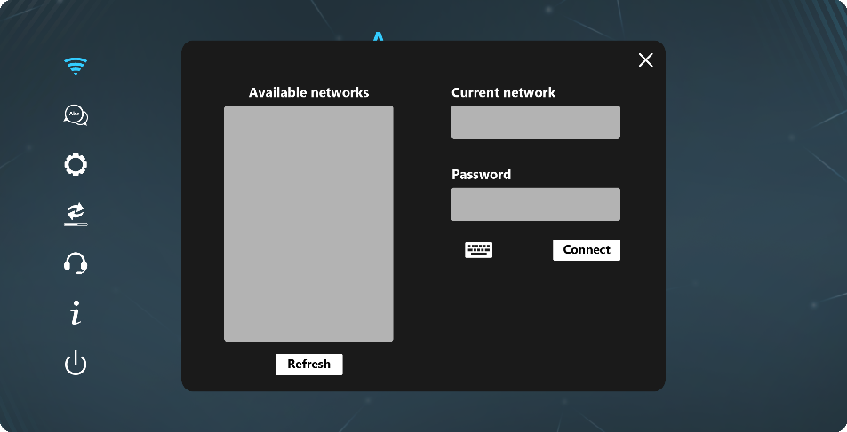
Figure 1.8 Connect the WI-FI

    - Change Language
Change the language of the software.
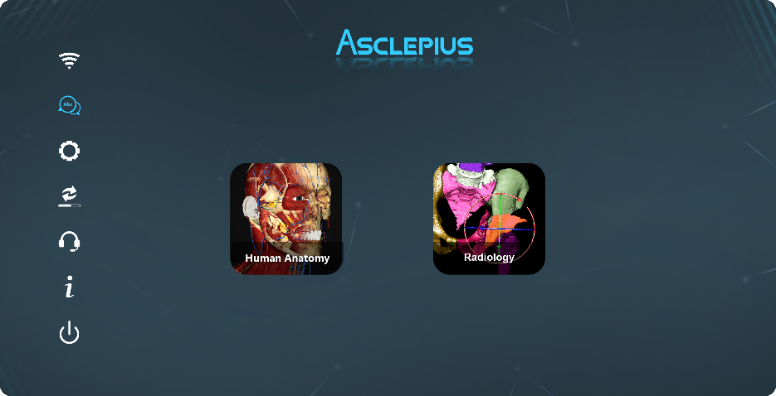
Figure 1.9 Change Language
    - Screen Setting
      - Connecting screen synchronization
- Connect the HDMI cable to the HDMI port of the multi-touch digital image dissection table and press the screen synchronization button on the main screen to synchronize the screen to the external monitor.
- If the sharing screen is a touch screen, first plug one end of the USB cable into the USB socket of the multi-touch digital image dissection table, and then plug the other end of the USB cable into the USB socket of the sharing screen.
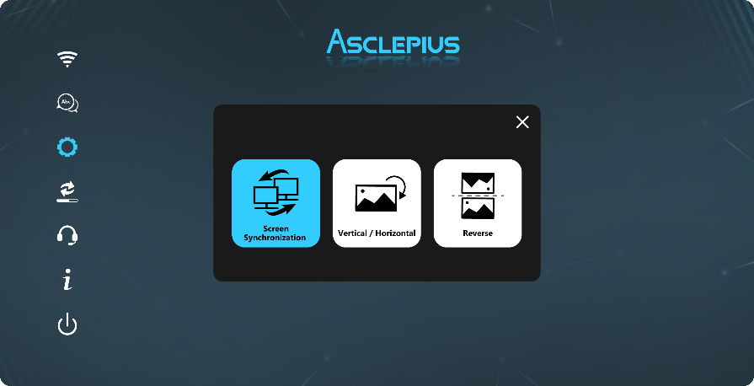
Figure 1.10 Connecting screen synchronization
      - Vertically or horizontally screen flip
Flipping the screen vertically or horizontally.
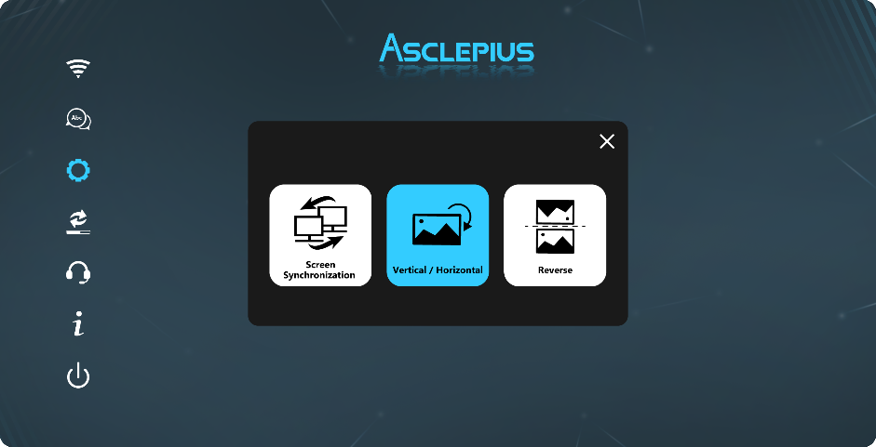
Figure 1.11 Screen rotation
      - Horizontal screen flip
Which is convenient for teachers to teach in various positions.
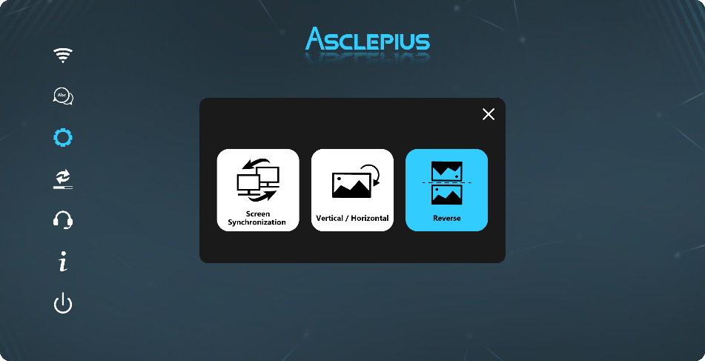
Figure 1.12 Horizontal screen flip
    - Online update
  - If the Asclepius table is connected to the internet, every time the dissection table is started, it will automatically detect whether it is the latest version, and if there is an updateable version, the system will automatically download it. After the download is completed, the user can choose whether to install. The installation process will take some time. During this process, please do not perform any operations on the dissection table, and do not turn off the power to avoid system damage.
  - If users need to delay the update, they can click the update button on the homepage at an appropriate time, select the software to be updated in the new version section, and click the download button to download and install it.
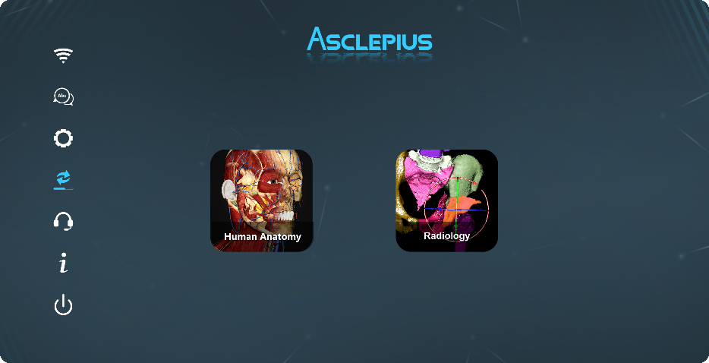
Figure 1.13 Online update
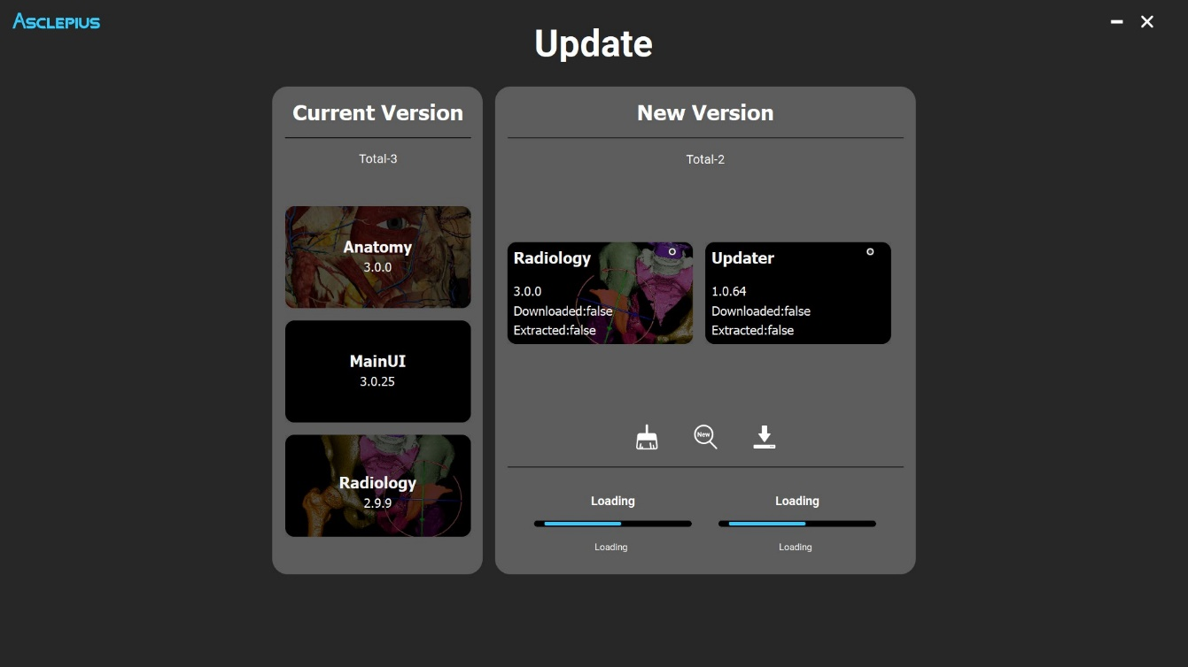
a
b
c
Figure 1.14 (a) Current version list, click to confirm the update content of the current version. (b) Latest version detection and download. (c) Download progress.
 | Clear Download File Temporary Storage
 | Check for new version update
 | Download and install

    - Technical support
If 2-3 Troubleshooting cannot work, please contact us. We will use this function to provide online support.
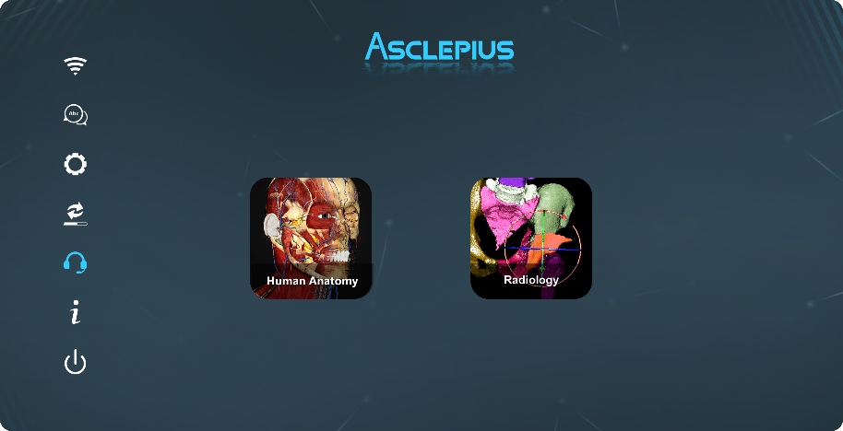
Figure 1.15 Technical support
    - Equipment information
Press this button to display detailed information about the device.
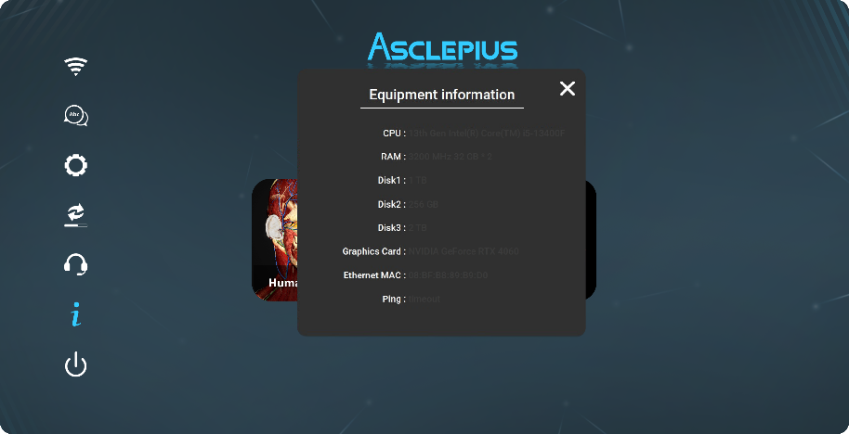
Figure 1.16 Equipment information
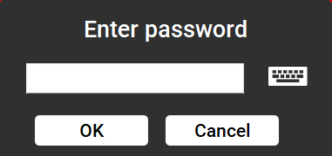 | 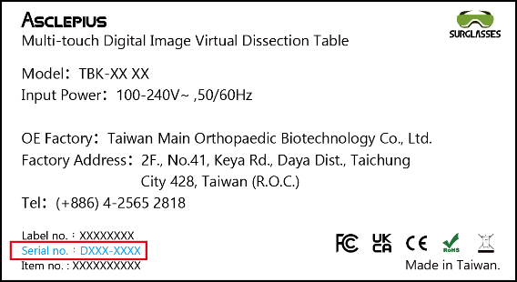
Figure 1.17 Enter password | Figure 1.18 Password location: product label on the device（DXXX-XXXX）

    - Shutdown
Press the shutdown button on the main interface of the software, and confirm to turn off. Wait for the screen of the multi-touch digital image dissection table to be completely dark, and the sound of the main unit is stopped. Switch the power switch to 0, and put the dust cover back on the screen to protect it from being dirty.
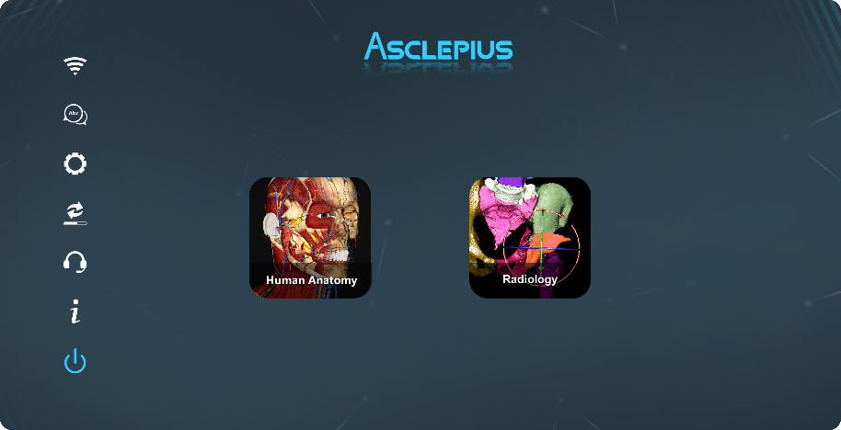
Figure 1.19 Shutdown the multi-touch digital image dissection table
  - Toolbox
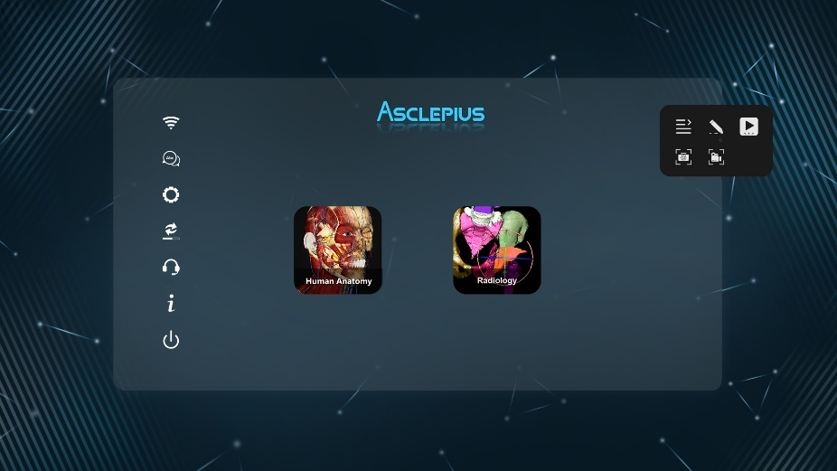

Figure 1.20 Toolbox
    - Toolbox mode Control

Switch the display mode of the toolbox.
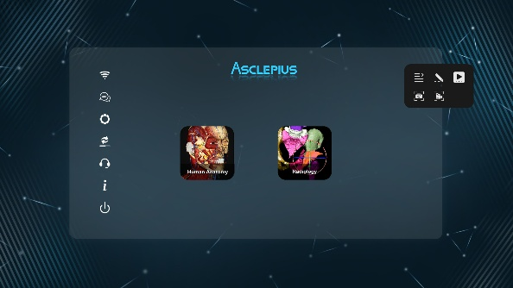 | 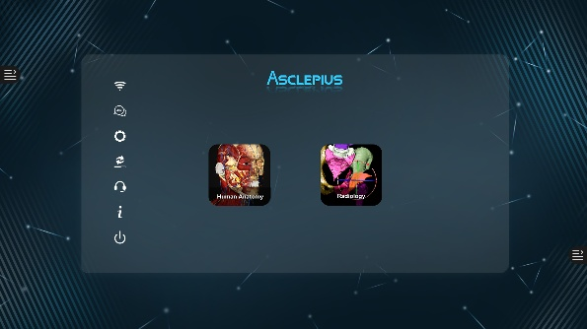
Figure 1.21 Toolbox | Figure 1.22 Toolbox narrowing

    - Brush setting

Open or close the brush functions.
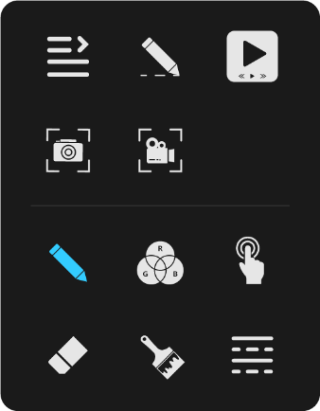

Figure 1.23 Brush setting
      - Brush

Brush functions to give users the ability to make notes or scribbles in real time. When the pen is operated, the software will be locked and the user will not be able to use other functions in the software.
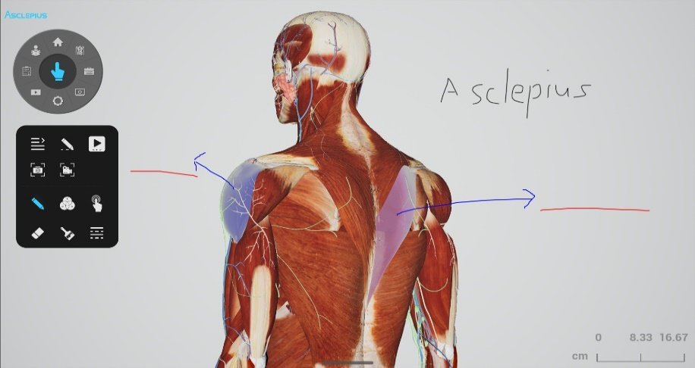

Figure 1.24 Brush
      - Color Setting

The brush color can be adjusted according to your needs.
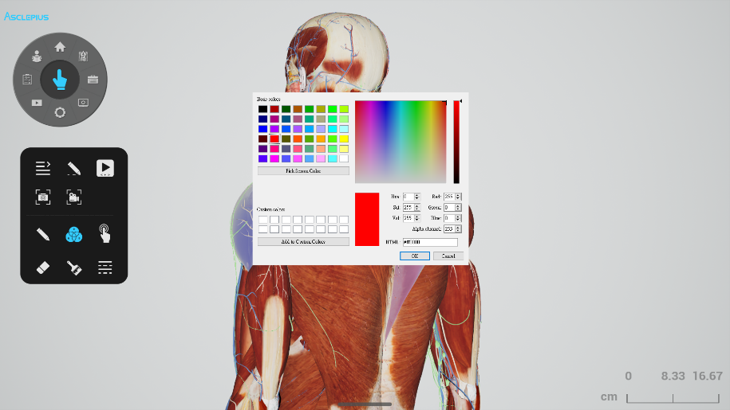

Figure 1.25 Brush color setting
      - Pause the Brush Function

When the icon is blue, the software lock will be unlocked, and the user can use all functions in the software.
      - Erase Brush

The eraser can be used to click on the position to clear the brush.
      - Clear All Handwriting

All brush will be clear at once.
      - Brush Adjustment

The user can adjustment the brush style, line type, alpha and width.
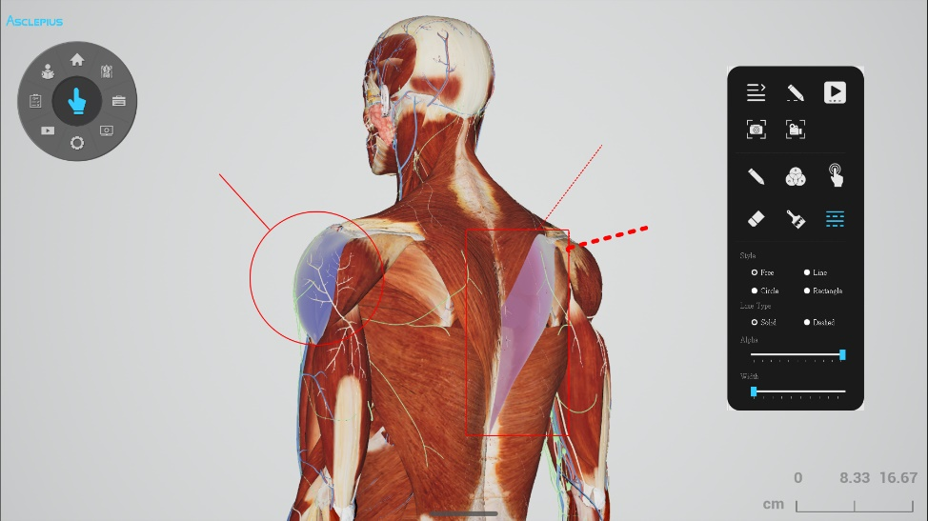

Figure 1.26 Brush adjustment
    - Multimedia player

It is used to view pictures and videos in the flash drive. The left window is a black frame where the video is played, and the right window is the playback history. Double-click the list to play the record. Image reading formats support *.jpg, *.png, *.tif, *.gif and *.bmp. Video reading formats support *.mkv, *.mp4, *.wav and *.mp3.
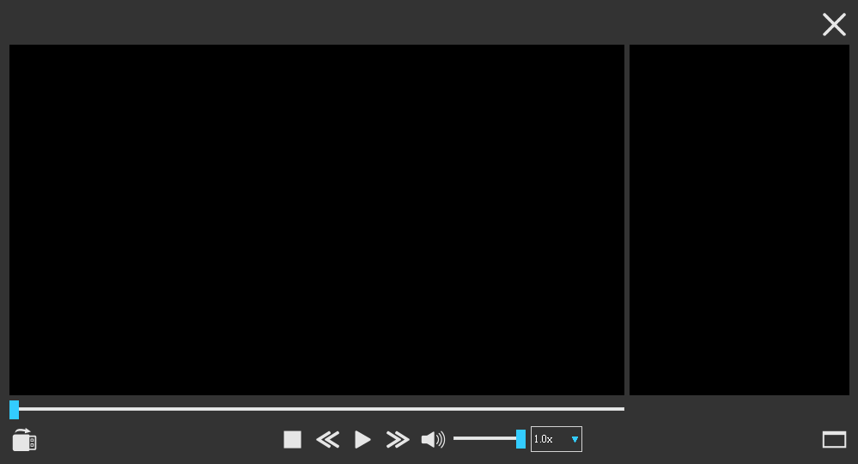
Figure 1.27 Multimedia player
Button | Operation
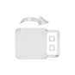 | Open File
 | Media Stop
 | Previous / Next
 | Media Play / Pause
 | Mute / Unmute
 | Full Screen Mode  Double click on the screen or press Esc to exit full screen
 | Speed Control
 | Exit the Multimedia player

    - Screenshot

It provides users with interactive operations such as screenshots to achieve the application of teaching and learning materials. The user can input operation steps or key points into a portable disc. When a screenshot is taken it will prompt the user to save the screenshot. Image files will be saved in .jpg format.
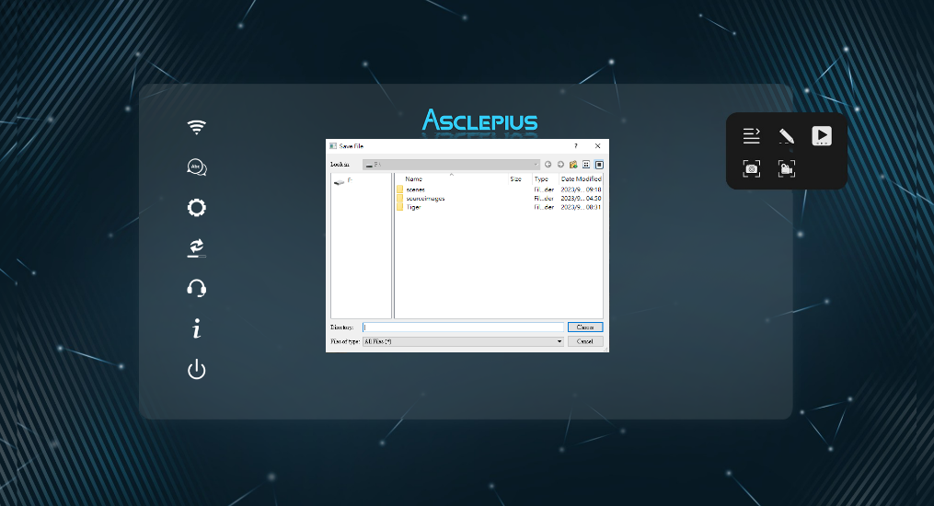
Figure 1.28 Screenshot save file as
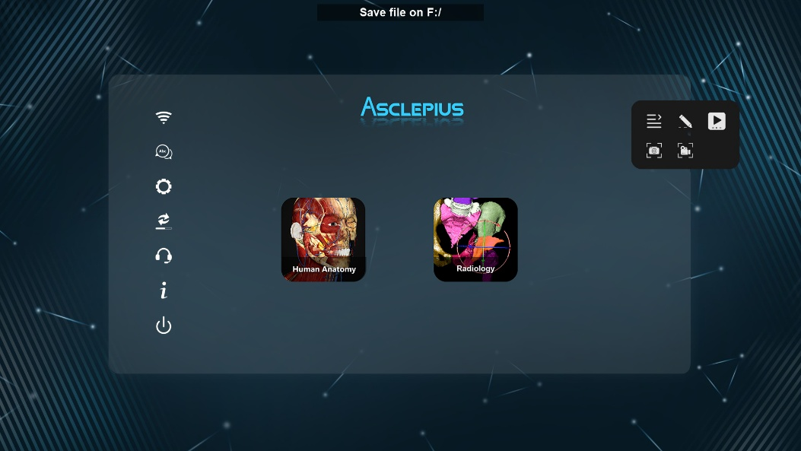
Figure 1.29 Screenshot successful
    - Screen Recording

It provides users with interactive operation of screen recording to achieve the application of teaching and learning materials. By means of the screen recording function, the user can record the operation while operating and export the video into a portable disc. After the recording is finished it will prompt the user to save the screen recording. Video files will be saved in *.mkv format.
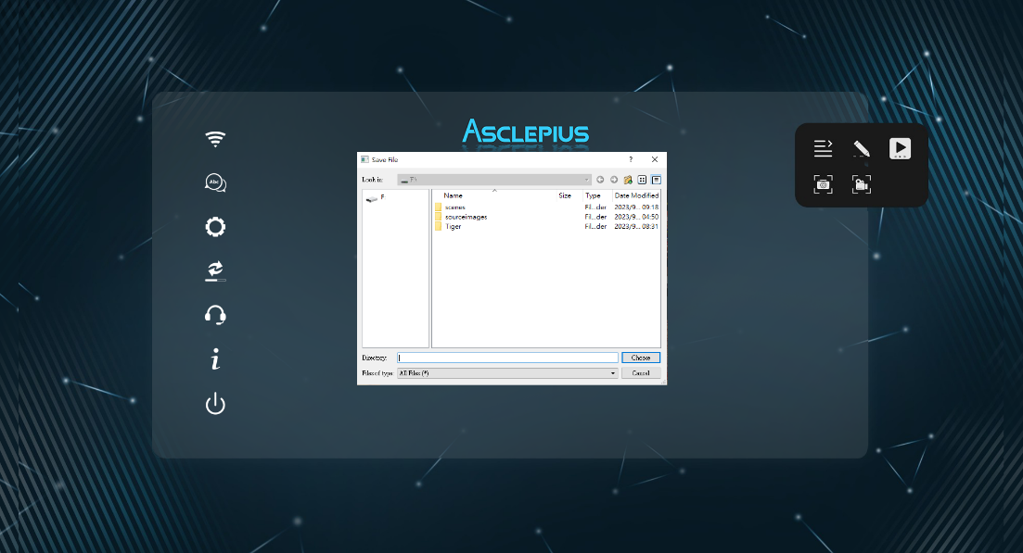
Figure 1.30 Video save file as
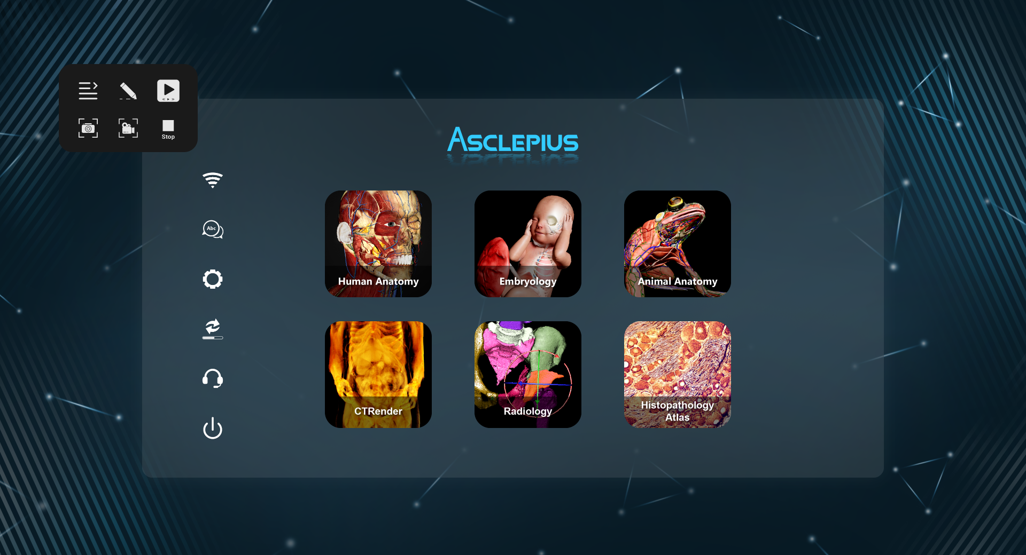

Figure 1.31 Stop recording

Figure 1.32 Recording successful
  - CD Software Update
The CD can be used to update software when the network is unavailable.
Step 1. Turn on the multi-touch digital image dissection table.
Step 2. Insert the update disc.
Step 3. Restart the virtual dissection table.
Step 4. The system will ask whether to update, press OK to start the update process.
Step 5. After the update is completed, it will ask whether to update again, press NO.
Step 6. After the system enters the main page, please remove the disc and the update
is completed.
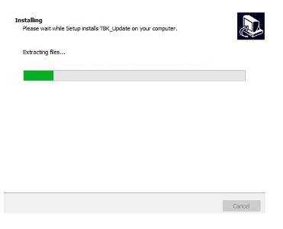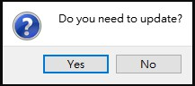
Figure 1.33 Whether to update the software window and update screen
  - Moving And Positioning Setting
The Asclepius with an 84-inch screen is equipped with an electronically controllable platform which enables converting the table position from Horizontal to Vertical using the remote. Taking into consideration the safety, the table also comes with surge protection. In case the power is cut off during the movement from horizontal to vertical, the table stays at its own place and neither goes up nor down.
- To move the multi-touch digital imaging anatomy table, please release the movable caster brake pedal on the base to ensure the smooth movement of the multi-touch digital imaging anatomical table.
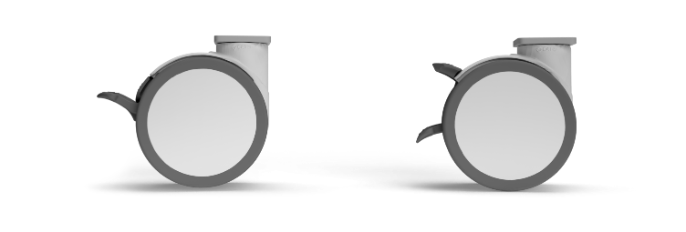
Lock
Open
Figure 1.34 The movable caster brake pedal
  - Lifting Control
Operating instructions: long press button / button , the machine will start to operate the upright/lying function, when the warning sound "beep" is heard, please stay away from the multi-touch digital image dissection table. Wait until the process is complete before approaching.

Tilt Upward
Tilt Downward
Figure 1.35 Console interface (Horizontal/Vertical)
- Do not continuously perform the hardware rotation of the multi-touch digital image dissection table to the upright or flat function, and each time the operation to switch the upright/flat function operation must wait for at least 5 minutes before you can perform the hardware rotation again to the upright or flat function.
Note:
Due to the safety mechanism, if the machine is operated continuously for more than 3 times in a short period of time (within 5 minutes), the dissection table rotates to an upright or flat function, which will cause the multi-touch digital image dissection table machine to enter the "safety protection mechanism" and would be locked for 18 minutes. During this period of "safety protection mechanism", the vertical or horizontal function cannot be executed. Please wait for 18 minutes patiently. After the "safety protection mechanism" is unlocked, the machine can resume rotating to the vertical or horizontal function.

- The lifting mechanism of the multi-touch digital image dissection table is a shared system. When there is more than one multi-touch digital image dissection table in the same space and if the lifting mechanism is operated, it may cause all the multi-touch digital image dissection table in the same space to perform the lifting mechanism simultaneously.
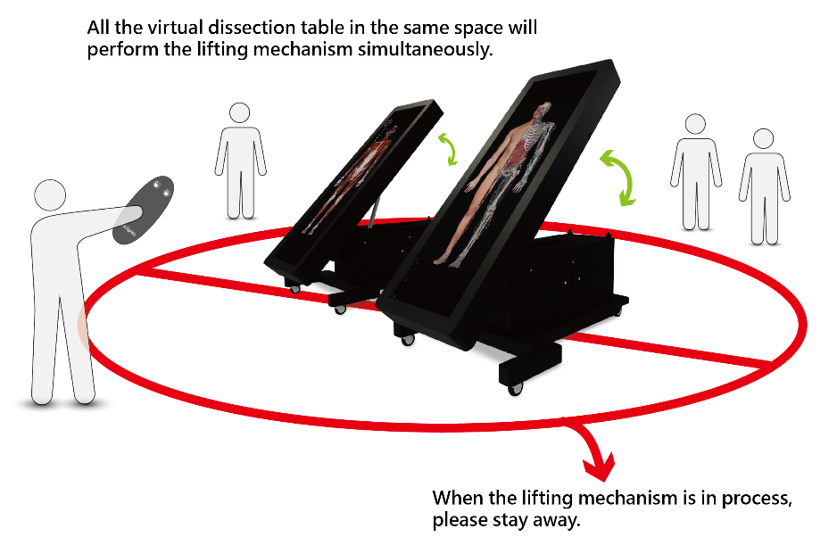
Figure 1.36 All the Virtual Anatomy Table in the same space will perform the lifting mechanism simultaneously.
- In order to prevent the user from affecting the synchronous action of the rest of the multi-touch digital image dissection table during the lifting mechanism, the user can remove the emergency stop latch of the lifting system of the other multi-touch digital image dissection table (or remove the other multi-touch digital image dissection table from power).
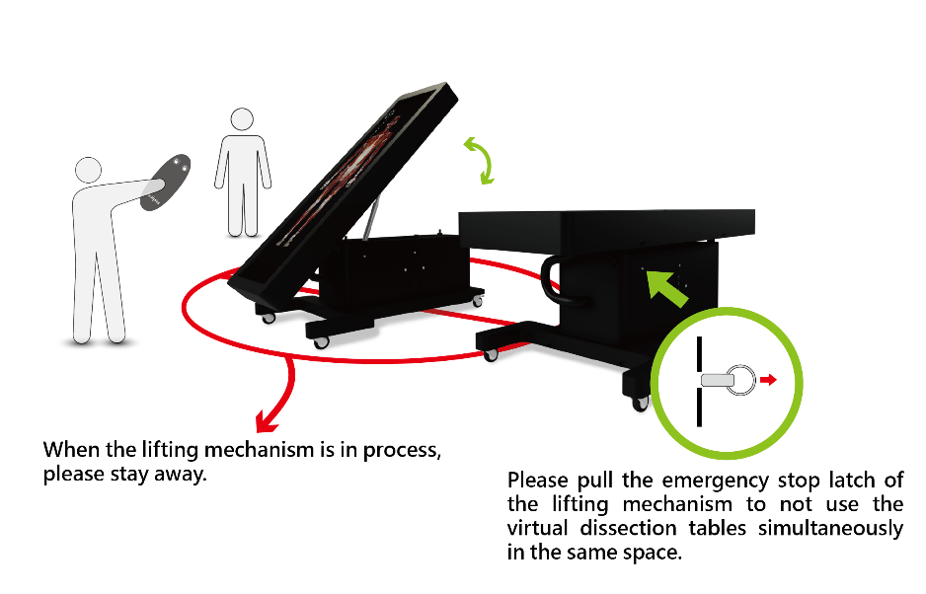
Figure 1.37 Please pull the emergency stop latch of the lifting mechanism to not use the multi-touch digital image dissection table simultaneously in the same space.
- If you need to stop the vertical/horizontal function in an emergency, please pull the emergency stop latch on the lower left door panel immediately.
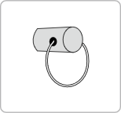
Figure 1.38 Emergency Stop latch
- If the emergency stop latch is pull out to stop standing upright/lying down, reinsert the emergency stop latch after the emergency is removed. After reinsert the emergency stop latch, the upright/lying down function operation will be resume.

- Do not carry the multi-touch digital imaging dissection table during the switch between upright and flat functions to avoid danger.

- For Safety Reason: Do not leave the table in inclined position.

After the vertical or horizontal switching of the multi-touch digital image dissection table is completed, it can be adjusted by flipping the screen vertically or horizontally on the main interface for subsequent software operations of the multi-touch digital image dissection table.
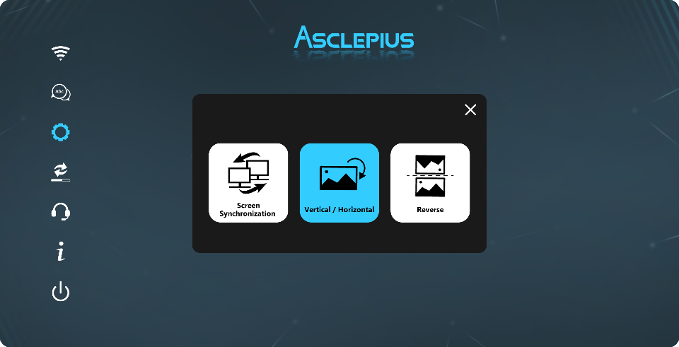
Figure 1.39 Screen rotation
  - Precautions
The system damage caused by not following the 1-10 precautions, abnormal or human behavior will not be covered under warranty.
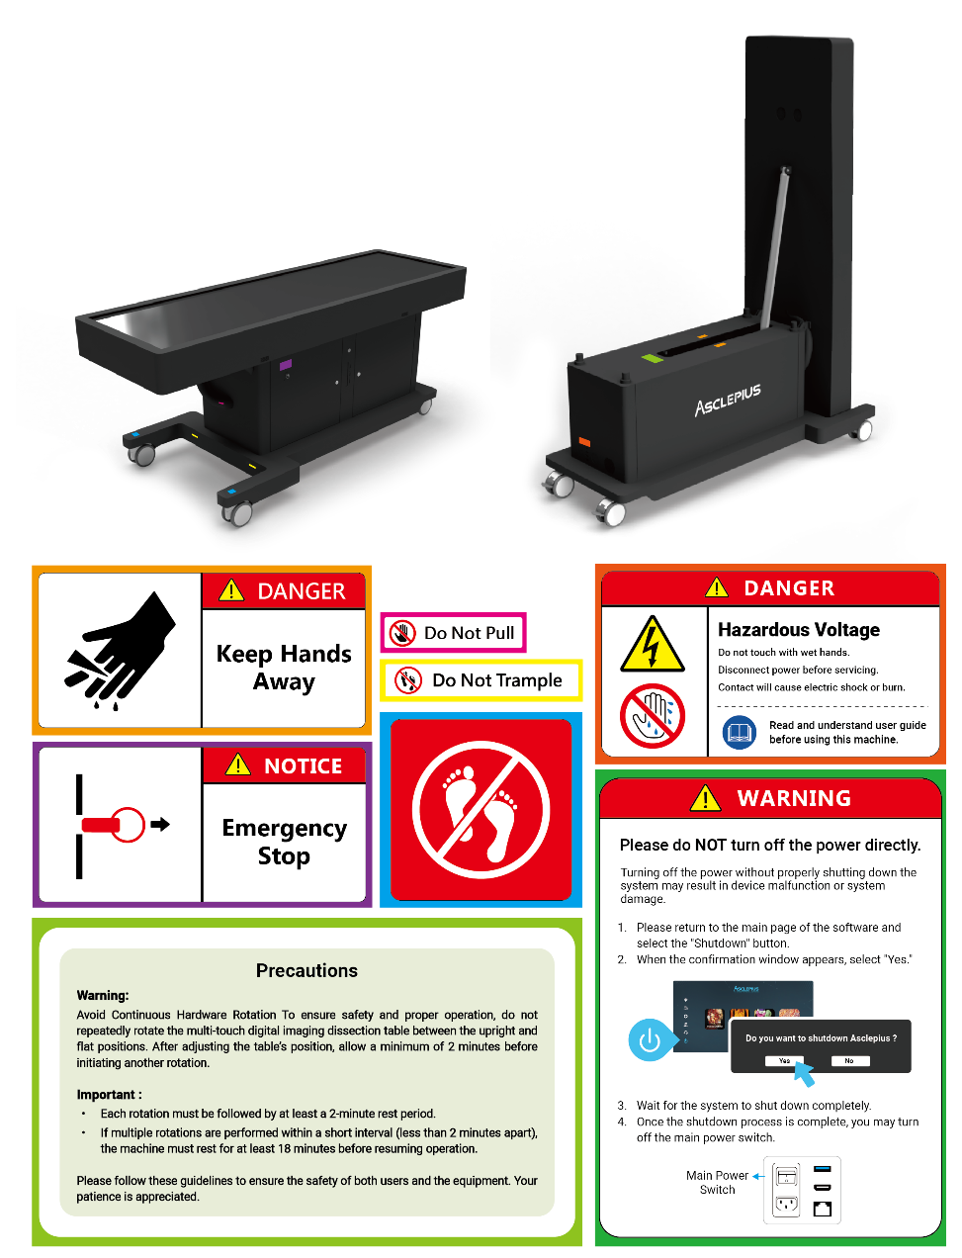
Figure 1.40 Safety labels
    - Precautions For Power Plug And Power Cord
- Please fully insert the power plug into the power socket (if the plug is loose, it may cause the multi-touch digital image dissection table to fail to operate).
- Do not damage the power cord (This may result in fire, electric shock, etc.).
- Do not touch the power plug and power cord when your hands are wet.
    - Precautions For Transport And Installation
- When transporting and installing, please ensure that the screen is completely flat. Please be careful with the screen.
- Do not move Cart with Display in highest position.
- Do not push Cart from front or back of lift.
- Please have the panel to the lowest position while moving the trolley.
- Do not squeeze the outer box and the product during transport. This may deform the device or cause damage to the screen.
- Please pay attention to the operating environment of the Asclepius. If the ground is uneven, it may easily fall and be damaged.
- Do not disassemble, modify, or change the multi-touch digital image dissection table. Doing so may cause damage to the product.
- Keep the installation site ventilated. Do not block the vents on the multi-touch digital image dissection table.
- Please maintain a safe distance before using the lift/tilt mechanism.
- Duty cycle: please take rest for 18 minutes for every 2 minutes continuous operation of lift /tilt mechanism.
- For Safety Reason: Do not leave the table in inclined position.
    - Precautions For Information Safety
- When operating the multi-touch digital image dissection table, please ensure that the power cord is connected. Improper power-off or removal of the power cord while the Asclepius is on may cause damage to the host computer and its software data.
- Use the lock all the time to avoid slipping/ sliding of the equipment or accidentally pushed by the user which may result in physical injury.
- If the multi-touch digital image dissection table is improperly stored or used, it will void the manufacture warranty.
- Please careful of the legs of the stands of the equipment and do not trample on the legs as it might result in physical injury.
- The platform on the equipment should not be used to store any kind of material, being it books, soft drinks, etc, as the surface is not water proof and might result in electric shock or physical injury.
- The multi-touch digital image dissection table is used in conjunction with the touch screen. Please use appropriate force when clicking, do not press or tap the screen, which will cause damage to the screen and cannot be used normally, or do not use pens or pencils, ruler or any sharp object to operate the screen so as not to cause damage and scratches to the screen glass panel or hardware system, resulting in errors or failures in the use of the touch screen.
- Age 10 or less are not advised to use the equipment without prior consent of their parents and should be allowed to use the equipment under the supervision of the authorized personnel only.
- Do not deliberately dismantle the touch screen, including the system body and workstation, do not forcibly pull out, dismantle, or perform any hardware dismantling and modification, or copy, write or modify any related configuration files of the internal software of the system. etc., resulting in the warranty status being void of the original product shipments. The warranty will be terminated, and legal liability will be pursued for any misappropriation.
    - Cleaning Consideration
Please do not use volatile materials, generally commercially available cleaners or water to rinse and clean, so as not to cause damage to the screen glass, panel or hardware circuit board, which may cause errors or failures in using the touch screen, please use the special wiping cloth for the screen to dry wipe. (Generally, if not in use, please cover the table with special dust jacket provided with the table).

- Device Information

  - Specification
Product name | Asclepius
Model | TBK-99 EA
Size | 99-inch
Touch module | Optical touch / Multi-touch
Overall dimension | Horizontal：L 253.3cm x W 98.4cm x H 90.9cm  Vertical：L 174.5cm x W 98.4cm x H 259.8cm  (±5% error allowed)
Net weight | 360 kg
Max Contrast Ratio | 3500: 1
Resolution | 3840 x 1080
Max Brightness | 500cd/㎡
Screen bezel | Bezel to bezel 3.5mm (±5% error allowed)
Tempered glass | 5mm
Touch method | Stylus or Finger
Signal Input | USB*4，CD Rom*1，RJ45*1
Signal Output | HDMI*2
Power supply | Input：100V~240V AC、50/60Hz、8A
Temperature/humidity | 0-40°C; 30%-80%(non-condensing)
Non-working Temperature/humidity | 0 - 60°C;20% - 90% (non-condensing)
Computer Specifications | CPU：Intel(R)Core i9  RAM：32 GB  HDD：8 TB  SSD：2 TB
System | WIN 11 system
Software | ANATOMY, RADIOLOGY, HISTOPATHOLOGY ATLAS, CTRENDER, EMBRYOLOGY and ANIMAL ANATOMY
Year of manufacture | 2025
*Taiwan Main Orthopaedic Biotechnology Co., Ltd. will upgrade the system for better performance at our own discretion.

  - FCC Supplier’s Declaration of Conformity
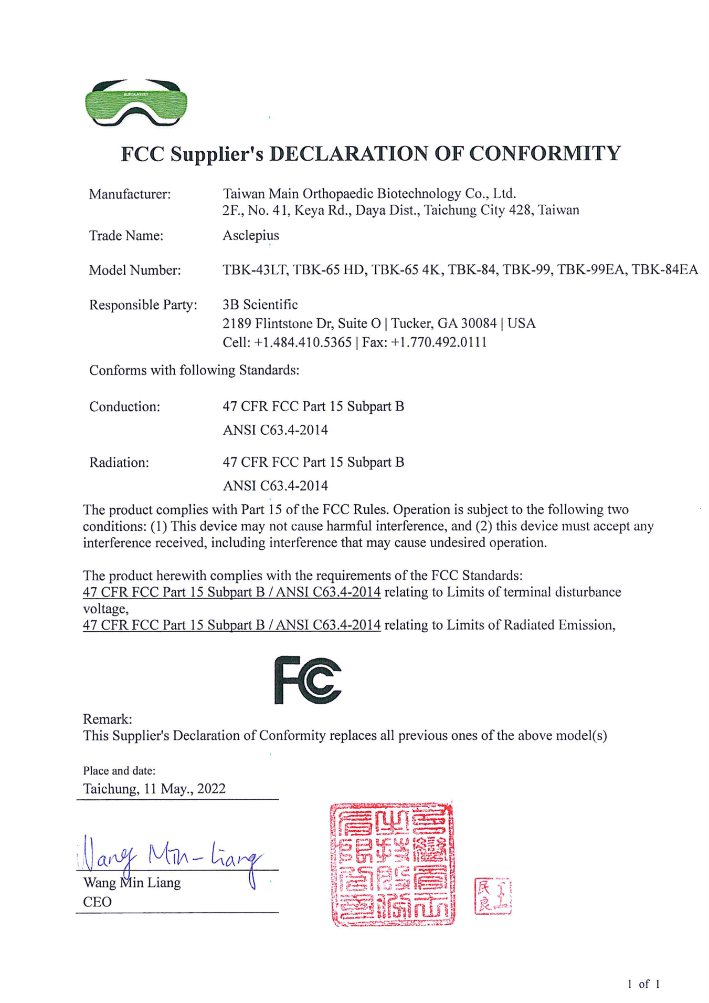
  - Troubleshooting
    - Unable To Boot Normally
- Please confirm whether the multi-touch digital image dissection table host computer and the touch screen power supply are normally connected and powered on.
- Please confirm whether the power transformer of the multi-touch digital image dissection table is normally turned on.
- If the multi-touch digital image dissection table host computer and the touch screen power supply are normally connected and remain powered on, please confirm whether the multi-touch digital image dissection table host computer is powered on, otherwise press the power on key to power on.
- If all connected normally and powered on. Please contact us if the power still cannot be turned on normally. Please refer to the instructions 2-5 to contact us.
    - Unable To Operate Normally
- If the software operation is completely inoperable and the software cannot be switched during use, and the system has been stopped, please press the hot key (Use keyboard)：
  - Shut down：Ctrl + Alt + F1
  - Restart：Ctrl + Alt + F2
  - Close and restart the software：Ctrl + Alt + F11
If the hot key cannot work, please press the multi-touch digital image dissection table host computer power switch for five seconds to shut down and restart.
- If the system fails to operate normally after restarting, please contact us, refer to the instructions 2-5 to contact us.
  - Product Warranty Statement
    - Warranty Coverage
Taiwan Main Orthopaedic Biotechnology Co., Ltd. (hereinafter referred to as “the Company”) provides the following warranty services to protect the rights and interests of our customers:
      - Warranty Period
Each product unit is labeled with its warranty period before shipment.

      - Warranty Details
- During the warranty period, the software will be automatically updated to the latest version free of charge, with at least 3 to 4 updates per year.
- If the product malfunctions due to defective materials or manufacturing defects, the Company will provide free repair or parts replacement.
- If the original parts are discontinued or unavailable, the Company reserves the right to replace them with functionally equivalent components.
- Replaced parts shall continue under the original warranty period and will not extend the warranty term.
    - Exclusions from Warranty Coverage
The following conditions are not covered by the free warranty, and repair or replacement will incur service charges:
      - Damage Due to Human Factors or Improper Operation
- Malfunctions caused by failure to follow the user manual, collision, drop, foreign object intrusion, liquid ingress, moisture, or excessive heat exposure.
- Disassembly resulting in broken warranty seals, modification, soldering, or repairs performed by unauthorized personnel.
      - External Forces and Environmental Conditions
- Damage caused by natural disasters or external factors such as fire, flood, earthquake, lightning, power surge, or pest infestation.
- Usage in an environment inconsistent with the Company’s recommendations (e.g., high temperature, high humidity, or dusty conditions).
Recommended operating environment:
Operating temperature | 0°C to 40°C
Operating humidity | 30% to 80% (non-condensing)
Storage temperature | 0°C to 60°C
Storage humidity | 20% to 90% (non-condensing)
Product damage resulting from use outside these conditions is not covered under warranty.
      - Issues Caused by Non-Genuine Parts or Accessories
Use of non-genuine or unauthorized accessories, components, software, or consumables.

      - Installation or Use of Unauthorized Software
The Company provides warranty and technical support only for officially licensed software and firmware versions.
      - Expired Warranty
After the warranty period expires, repair or replacement services will be subject to material and service fees.
    - Supplementary Warranty Terms
- The warranty applies solely to product defects and excludes damages caused by human error or natural disasters.
- Improper operation, such as unplugging the power without following the shutdown procedure, is not covered under warranty.
- In the event of power instability, outages, or surges, customers are advised to use a UPS (Uninterruptible Power Supply) to protect the equipment; damages caused by failure to do so are not covered.
- Screen defects with fewer than five bright pixels, observed at a distance of 35 cm under lighting above 200 Lux, comply with international standards and are not considered warranty defects.
- This product uses tempered glass, if the tempered glass produces a little white fog, it is considered normal and not a defect.(Since tempered glass is produced, it will be affected by the temperature during production, resulting in white fog phenomenon, which cannot be completely avoided, and has no effect on the quality and condition of tempered glass.)
    - Additional Notes
- This warranty statement applies only to products purchased through officially authorized sales channels of the Company.
- The Company reserves the right to make final amendments and interpretations of the warranty terms.
  - Contact Information
Company Name: Taiwan Main Orthopaedic Biotechnology Co., Ltd. (Surglasses)
Address: 2F, No. 41, Keya Rd., Daya Dist., Taichung City, Taiwan
Phone: (+886) 4-2565-2818
Email: support@surglasses.com
Service Hours: Monday to Friday, 09:00–18:00

