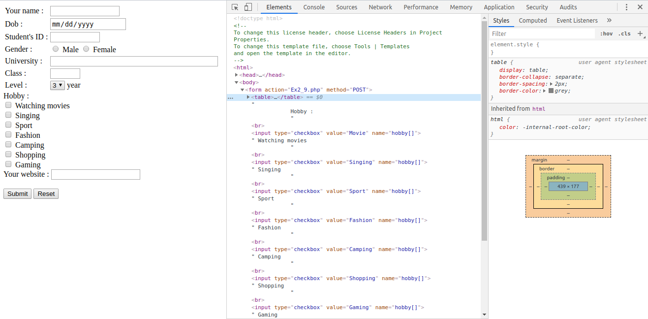Figure 1: DOM inspector (Exercise 2.9)

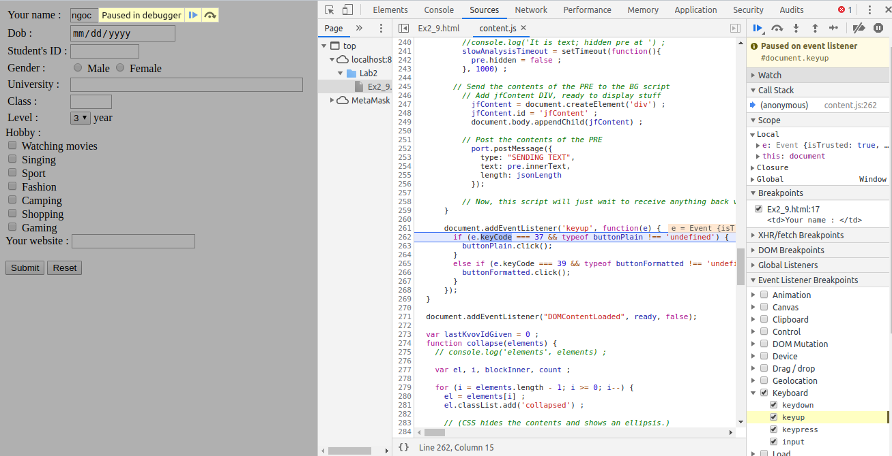Figure 2: Debugger (Exercise 2.9)

