CS3215 Software Engineering Project

 NETS

USER GUIDE



Version 2.0

Dang Thu Giang

Hoang Nguyen Nhat Tao

Nguyen Hoang Hai

Nguyen Thi Yen Duong

Tran Binh Nguyen

Vu An Hoa

Table of Content

Introduction 2

File Synchronization 2

What Is NETS? 2

What’s New in Version 2.0 3

Information 3

Getting Started 4

Create New Profile 5

View/Edit Profile’s Details 5

Run Profile 5

Delete Profile 6

Advance Options 6

Additional Settings 7

Profile Name Suggestion 8

Context Menu Entries 8

Smart Sync 8

Sync With… 8

Safe Delete 8

Disable Settings 8

Easy IVLE Workbins SynChronization 9

What Is IVLE? 9

Important Note 9

IVLE Workbins Synchronization 10

About Us 11

About Developers 11

Website 11

Introduction

Here, you will outline what your audience will learn in this chapter or section:

* What Is File-Synchronization Software?
* What Is NETS?
* What’s New In Version 2.0
* Technical Information

# FILE SYNCHRONIZATION

**File synchronization** (or 'syncing') in computing terms is the process of making sure that files in two or more locations are updated through certain rules.

* **One-way synchronization:** The destination folder will be synced with the source folder after synchronization.
* **Two-way sync:** Last versions of each folder will be reflected in both source and destination.

# WHAT IS NETS?

NETS is a File Synchronization software, which aims for speedy and accurate file synchronization. NETS features Synchronization Profile to support regular sync jobs to be easily and quickly done.

NETS also features an unique function for the students of National University of Singapore, from where this group of developers are from.

# WHAT’S NEW IN VERSION 2.0

* **Smart Sync:** can be done via folders drop-and-drag besides right-click
* **IVLE Sync:** able to select which modules to download
* **Faster** sync for big files
* **Polished** and **improved GUI**

# INFORMATION

* **Current Version**: 2.0
* **Operation System**: Windows XP, Windows Vista, Windows 7
* **System Requirement**: .NET framework 3.0+

Getting Started

What is in this section?

* Create New Profile
* Save A Profile
* Run Profile
* Delete Profile
* Sync Settings Explanation

View application settings

View developer team’s information

View profile page

View IVLE Sync Page

Get help

Exit application

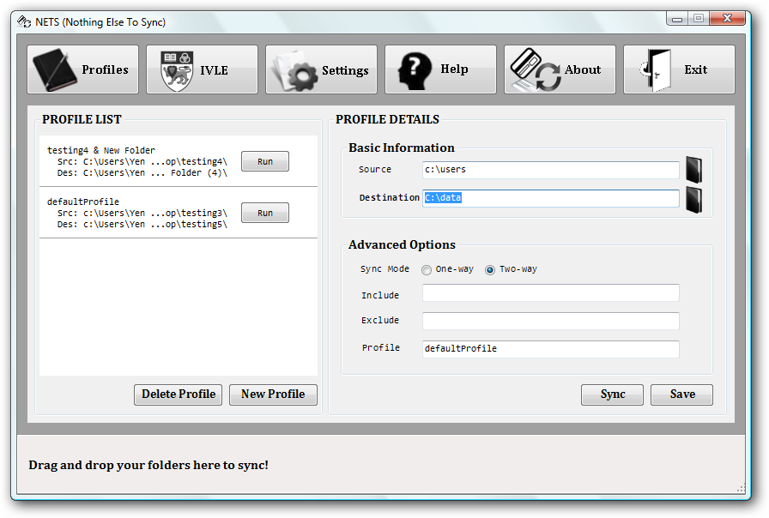

Figure 1. Starting Window/Profiles Tab

Run nets.exe to start the program

# CREATE NEW PROFILE

1. Select the **Profiles** tab.
2. Click on **New Profile** button.
3. Choose the two folders to synchronize. You can click *Open Folder* button to browse for your folders, or drag-and-drop the folders into the NETS window. Fill in other details.

**Your profile is ready to run.** See *Run Profile* for more information.

If you want to save the profile for later usage, continue to step 4 and 5.

1. Enter profile name in **Profile** textbox. The default name is **<folder 1>&<folder 2>**. The program will pop up error message if your profile name has existed
2. Click **Save Profile** to save the profile. The new profile will appear immediately in the *Profile List.*

# VIEW/EDIT PROFILE’S DETAILS

1. Double click on a profile in the *Profile List* to view details of the profile.
2. Click **Save Profile** to save the modified profile information.

# RUN PROFILE

1. Click on the **Run** button beside a profile in *Profile List* to run it.

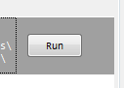

1. Alternatively, you can double-click on the profile to view its detail, and click on **Sync** button in *Profile Details* to run current profile.

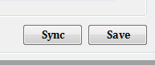

1. Upon completion of the synchronization process, a **View Log** option will enable you to view details of the sync job.

# DELETE PROFILE

1. Select a profile and click on **Delete Profile** to delete it.
2. A window will pop up to ask for your confirmation. Select *yes* to permanently delete the profile.

# ADVANCE OPTIONS

* **Sync Mode:** Choose either *One-way* or *Two-way* sync mode. Default: *Two-way.*
* **Include:** files to be involved in the sync process by filling in the Include textbox. By default, an empty Include textbox means that all files/folders in source and destination folders are included in the sync process.
* **Exclude:** The idea is the same as Include. **NETS** will not sync files in the excluded list. Note that exclude always has higher priority than include. If one file is both included and excluded, it will be excluded from the sync process.

We support the use of wildcard * to represent zero or more characters.

*Example:*  
- To exclude all files that have extension “exe”: enter ***\*.exe*** in *Exclude* box  
- To include all files whose names contain “cs3215”: enter ***\*cs3215\**** in *Include*- You can specify multiple patterns by separating them by comma “,”: ***\*exe, *cs3215*, *.pdf***  
- Please do not use “,” in your names of files/folders you want to include/exclude. Otherwise your patterns will be interpreted wrongly and you will not get what you want.

You should enter the correct format in the filter for it to work as expected.

Additional Settings

What is in this section?

* Profile Name Suggestion
* Context Menu Entries
* Safe Delete

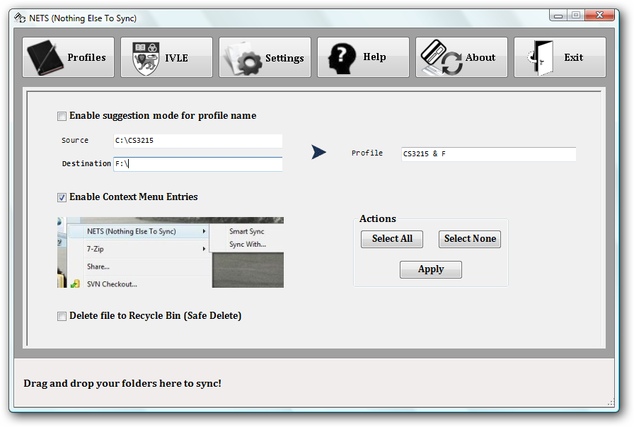

Figure 2. Settings Tab

Click Apply to save your setting options

# PROFILE NAME SUGGESTION

Enable/Disable default profile name suggestion.

Default: Enable.

Suggested profile name is **<folder 1> & <folder 2>**

# CONTEXT MENU ENTRIES

Enable this option to use **Smart Sync** and **Sync With…** outside the main program

Default: Enable.

Right-click on any folder in Windows Explorer or on your Desktop, there is an option to use the Smart Sync and Sync With features of NETS

**

Figure 3

## Smart Sync

**Smart Sync** is a shortcut function to enable you to run your profile from outside **NETS** main program, providing there is *at least one* existing profile containing the chosen folder.

If there are more than one existing profile containing the chosen folder, NETS will ask for which profile you want to run.

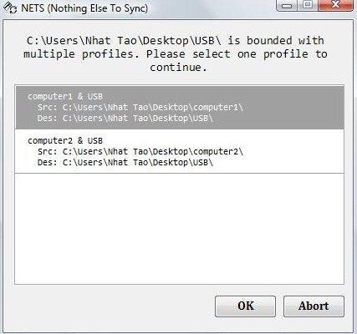

If there is no existing profile, a new window will pop up, asking you to fill in the details for a new profile.

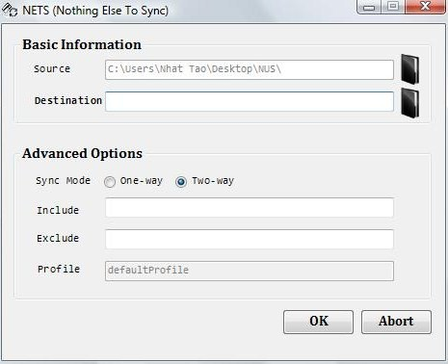

## Sync With…

**Sync With…** enables you to quickly synchronize the chosen folder with another one without opening NETS main program. When you use this function, a new window will pop up, asking you to fill in the details for a new profile and run it.



# SAFE DELETE

Enable/Disable moving deleted file(s) to Recycle Bin instead of directly deleting from the hard disk.

Default: Enable.

# DISABLE SETTINGS

To disable a setting, deselect it and click **Apply**.

Easy IVLE Workbins

Synchronization

What is in this section?

* What Is IVLE?
* Important Note
* How To Sync IVLE Workbins With Your Local Folders

# WHAT IS IVLE?

**IVLE** stands for *Integrated Virtual Learning Environment –* National University of Singapore online course management.

Website: <https://ivle.nus.edu.sg>

**To NUS students:**

Tired of checking and downloading new files uploaded in a trillion different workbins? This is just what you need. Simply login with your NUSNET account and click Sync, your folders on PC will be synchronized with the workbins. In other words, all the new files are downloaded to your PC.

This is a unique feature designed especially to benefit NUS students. We developer team hope you will enjoy this.

# IMPORTANT NOTE

If you use this function for the first time, be aware that every file in the selected workbin will be downloaded. This may cause long waiting time (for it to be downloaded) due to the large total file size (can be up to hundreds of MBs)

From the second run onwards, the download time would be much shorter, since only newly uploaded files are downloaded.

# IVLE WORKBINS SYNCHRONIZATION

1. Click on **IVLE** tab.
2. Enter your NUSNET ID and password and click **Start** to login. Remember to choose the folder you wish to save the files to.

Your modules will be display upon successful login.

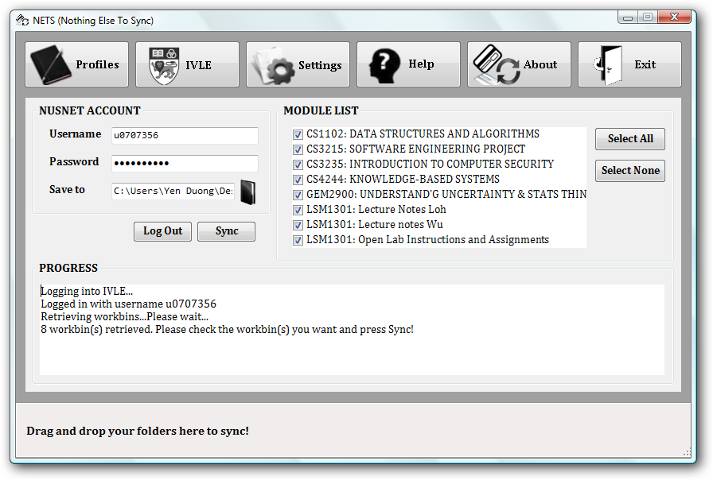

Figure 4. Sample IVLE login

1. Choosing the module(s) which you wish to download.
2. Click on **Sync** to start downloading.
3. A notice window will pop up to inform you upon when the synchronization is finished successfully.

# SPECIAL NOTES

Note that for a pair of files which have been synchronized at least once, if you delete the file in one folder and update it in another folder, the updated file will be copied to the folder where it was deleted. That is for the safety of the data if user accidentally deletes important files.

About Us

# About Developers

We are a group of students from School of Computing – National University of Singapore.

# Website

Find our latest update on NETS at:

[http://nothing-else-to-sync.info](http://nothing-else-to-sync.info/)