Batcha Gems — Colombo
Top Picks for the U.S. Market — Best-Sellers & Most Unique
Prepared 2026-09-07. 15 pieces selected from the atelier photos — each with what I believe the piece to be and an estimated comfortable U.S. retail.
How to read the prices. "Comfortable U.S. retail" is what a U.S. boutique or online seller could realistically ASK and achieve for a comparable finished piece — not what to pay for it, and not an appraisal. These are fine-jewelry pieces (genuine Ceylon sapphires set in gold with diamonds), so values run much higher than silver goods.
Estimates assume HEATED Ceylon sapphires of good commercial quality and the gold + diamond content visible in the photos, with carat weights estimated from images. Confirm on each piece: carat weight, heated vs unheated + lab report, metal purity/weight, and total diamond carat — an unheated stone with a GRS/GIA/SSEF report can multiply the value several times over.

1. Emerald-Cut Blue Sapphire Diamond-Halo Cocktail Ring [Both]
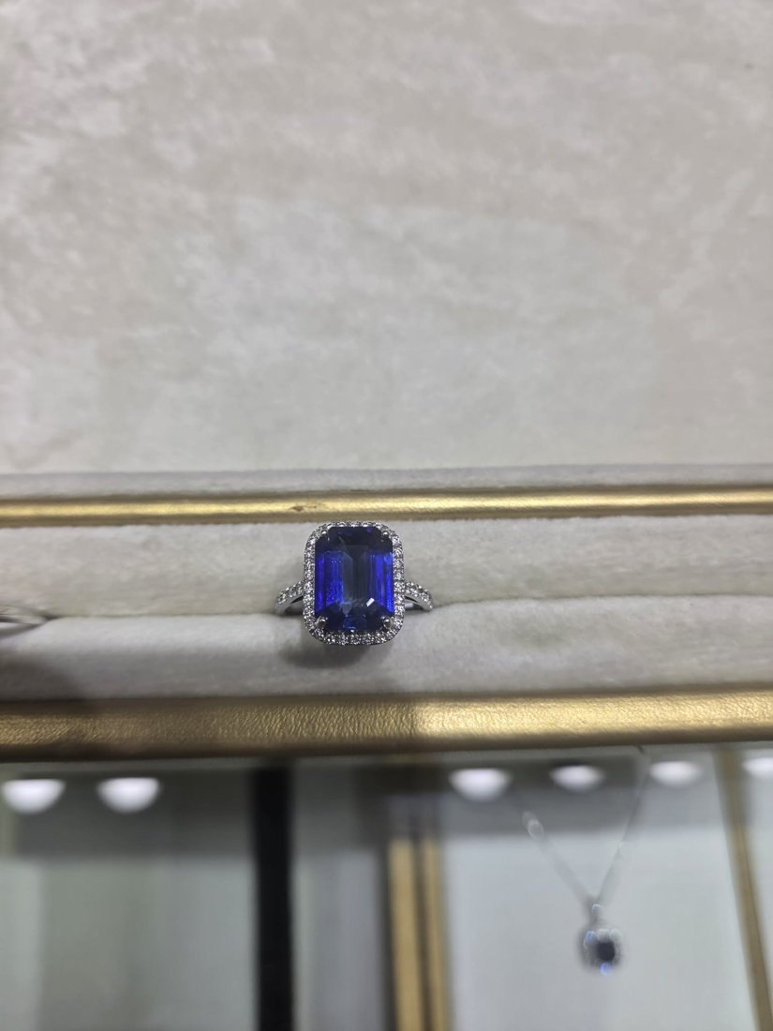
Type / Gem / Metal: Ring · Blue Ceylon sapphire · 18k white gold + diamonds
What it is: A vivid royal-blue emerald-cut sapphire (est. ~4–6 ct) in a full round-diamond halo on a diamond split-shank. The hero cocktail/right-hand ring — also works as a statement engagement ring.
Comfortable U.S. retail (est.): $3,500 – $6,500
Note: Carat + heat/cert drive this most. Estimate assumes a heated Ceylon stone; an UNHEATED stone with a GRS/GIA report can push comfortable retail to $10k+.

2. Pink & Blue Sapphire Diamond-Halo Studs + Pear Drop Earrings [Best-seller]
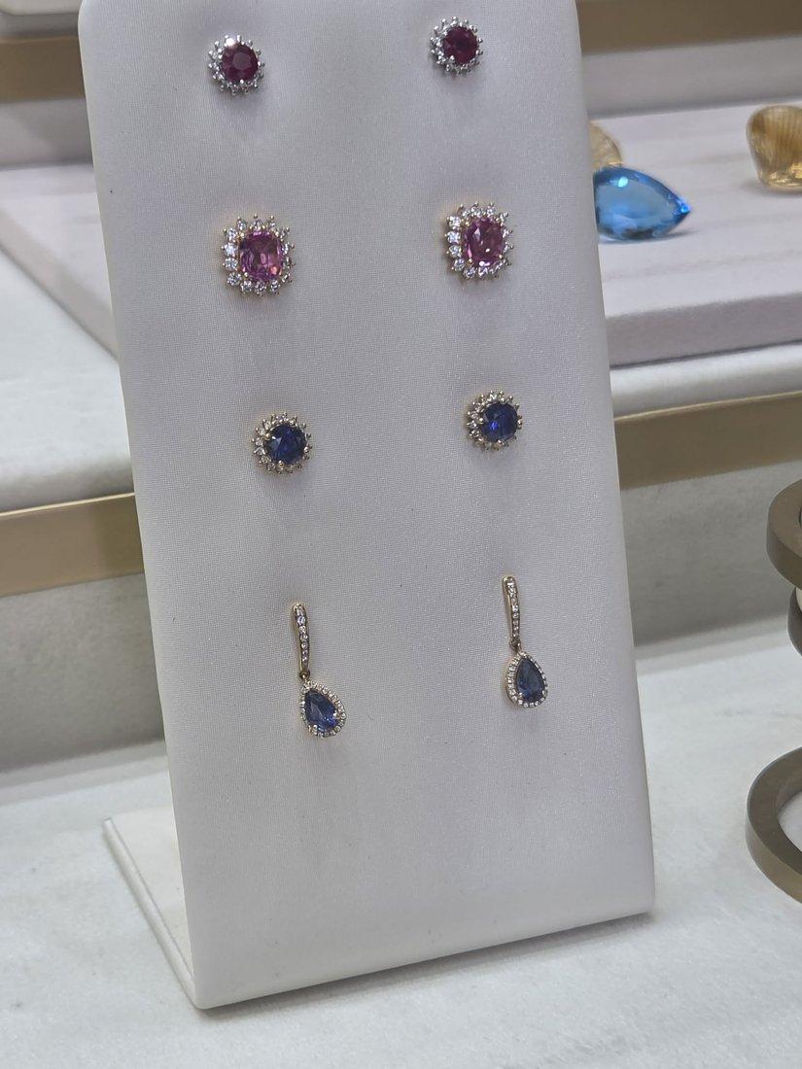
Type / Gem / Metal: Earrings · Pink & blue Ceylon sapphire · White/rose gold + diamonds
What it is: A board of everyday best-sellers: cushion pink-sapphire diamond-halo studs, round blue-sapphire halo studs, and dainty rose-gold pear blue-sapphire diamond drop earrings. Classic, giftable, fast-moving.
Comfortable U.S. retail (est.): $600 – $1,400
Note: Per pair. Halo studs ~$600–1,300; pear drop earrings ~$700–1,400, depending on carat and gold weight.

3. Blue Sapphire Chandelier Drop Earrings [Both]
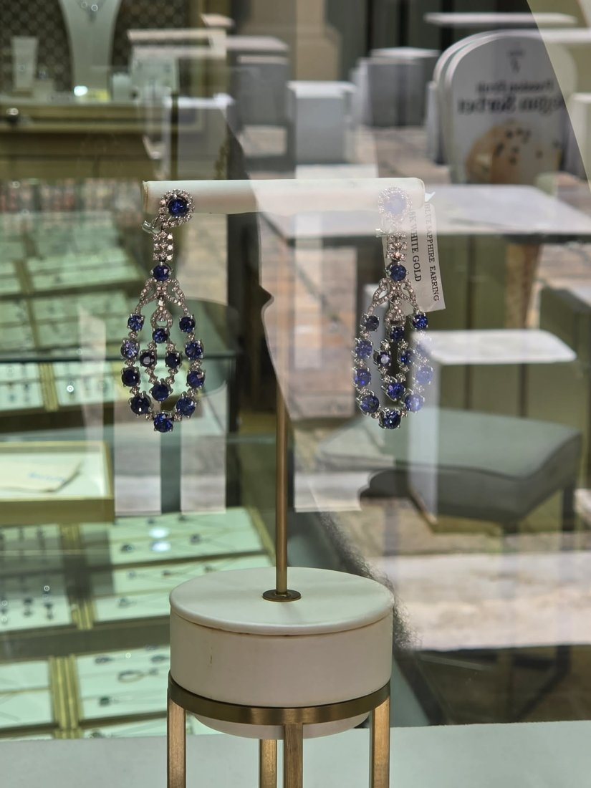
Type / Gem / Metal: Earrings · Blue Ceylon sapphire · 18k white gold + diamonds
What it is: Open-teardrop chandelier earrings set with graduated round blue sapphires and pavé diamonds (tagged 18k white gold). A bridal / event statement pair with real presence.
Comfortable U.S. retail (est.): $1,800 – $3,800
Note: Depends heavily on total sapphire + diamond carat weight; confirm both.

4. Rainbow Fancy-Sapphire Tennis Bracelet [Best-seller]
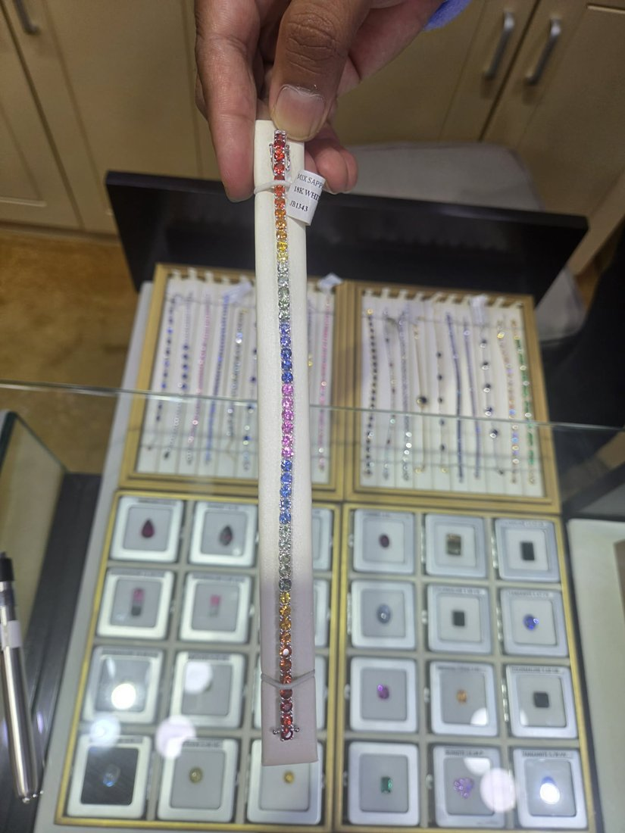
Type / Gem / Metal: Bracelet · Multi-color Ceylon fancy sapphire · 18k white gold
What it is: A full-spectrum line bracelet of round fancy sapphires (blue, teal, green, yellow, orange, pink, purple) — tagged 18k white gold. A social-media magnet and one of the most reliably sellable 'wow' pieces here.
Comfortable U.S. retail (est.): $2,500 – $5,500
Note: Value scales with total carat weight (often 8–12 ct+). Confirm cttw and gold weight.

5. Rainbow Invisible-Set Princess Sapphire Bracelet [Unique]
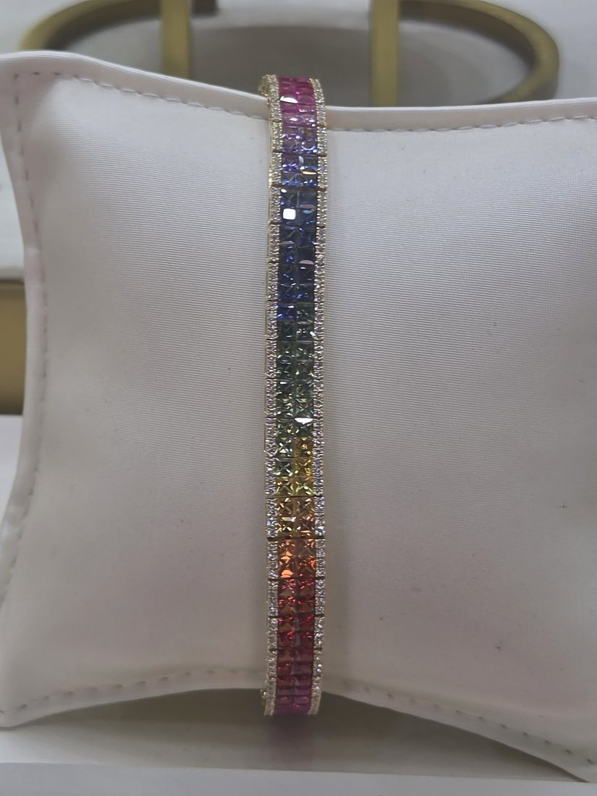
Type / Gem / Metal: Bracelet · Multi-color Ceylon fancy sapphire · Yellow gold + diamonds
What it is: A wide statement bracelet: channel/invisible-set princess-cut rainbow sapphires bordered by pavé diamonds. Denser and more couture than a standard tennis line — a true showpiece.
Comfortable U.S. retail (est.): $3,000 – $6,500
Note: Higher end due to princess-cut calibrated sapphires + diamond borders; confirm cttw.

6. Rainbow Sapphire Heart Station Necklace [Unique]
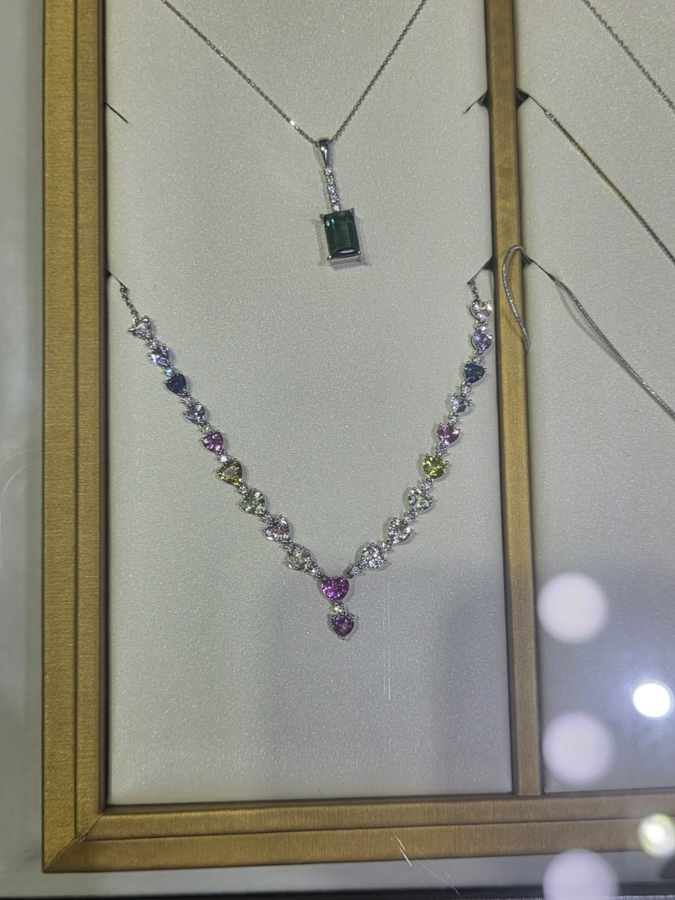
Type / Gem / Metal: Necklace · Multi-color Ceylon fancy sapphire · White gold + diamonds
What it is: A V-layout necklace of heart-shaped fancy sapphires graduating in color, finishing in a pink-sapphire heart drop. Romantic, distinctive, and photographs beautifully.
Comfortable U.S. retail (est.): $2,000 – $4,500
Note: Heart-cut fancy sapphires are labor-intensive; confirm total carat and drop count.

7. Sri Lanka Map Pendant [Unique]
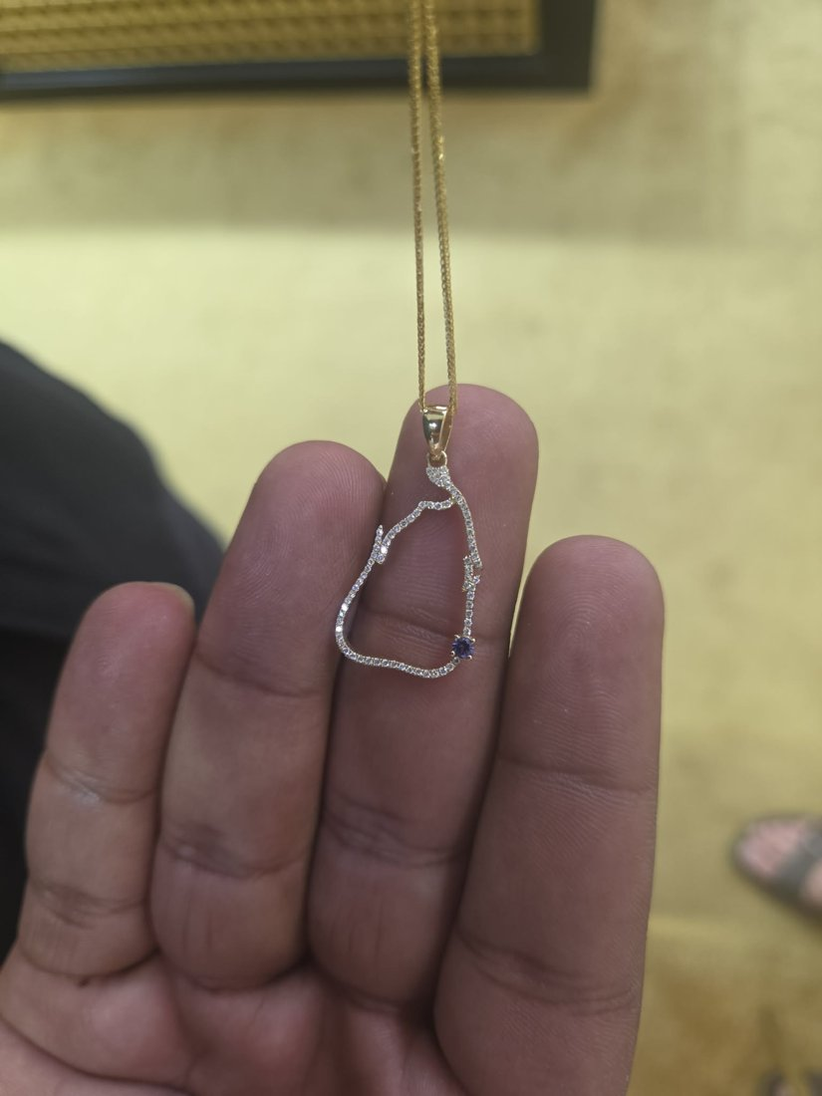
Type / Gem / Metal: Pendant · Blue Ceylon sapphire accent · Yellow gold + diamonds
What it is: The outline of Sri Lanka traced in pavé diamonds with a single blue sapphire set at the island's south. A one-of-a-kind souvenir/story piece — instant appeal for the 'sourced in Ceylon' narrative.
Comfortable U.S. retail (est.): $700 – $1,600
Note: Modest diamond/sapphire content; value is mostly design + gold weight. A signature branding piece.

8. Scatter 'Confetti' Multi-Sapphire Teardrop Pendant [Unique]
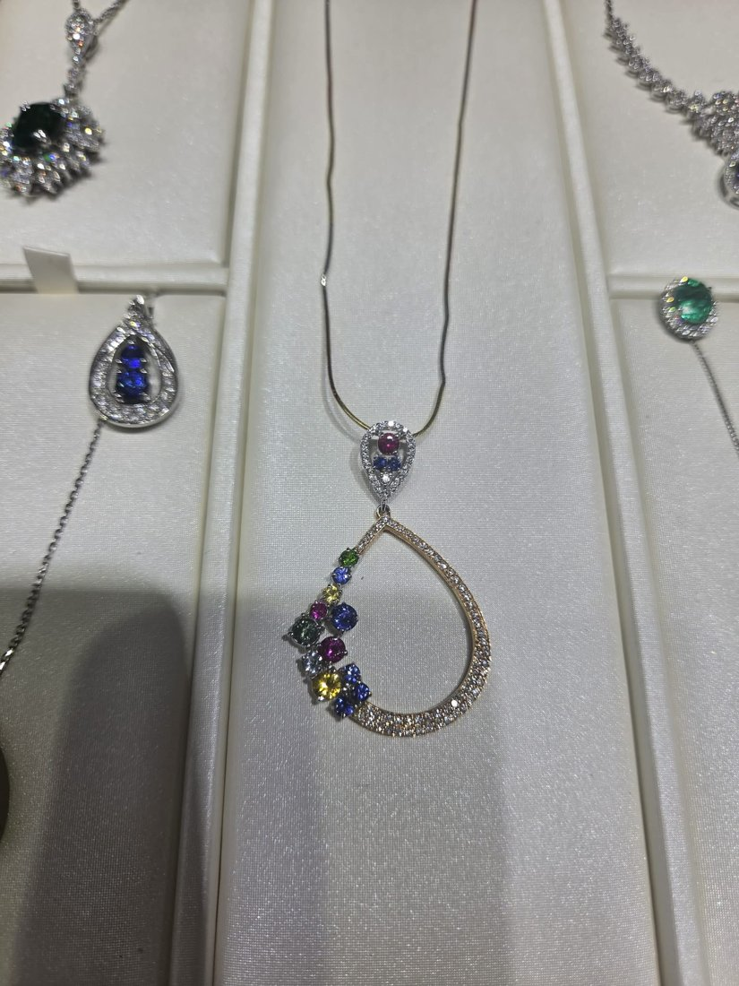
Type / Gem / Metal: Pendant · Multi-color Ceylon fancy sapphire · Rose & white gold + diamonds
What it is: An open teardrop of pavé diamonds with scattered multi-color round sapphires drifting down one side. Modern, artistic, and unlike anything in a typical U.S. case.
Comfortable U.S. retail (est.): $1,200 – $2,800
Note: Confirm sapphire + diamond carat; two-tone gold adds appeal.

9. Vivid Pink Sapphire Marquise-Halo Sunburst Pendant [Best-seller]
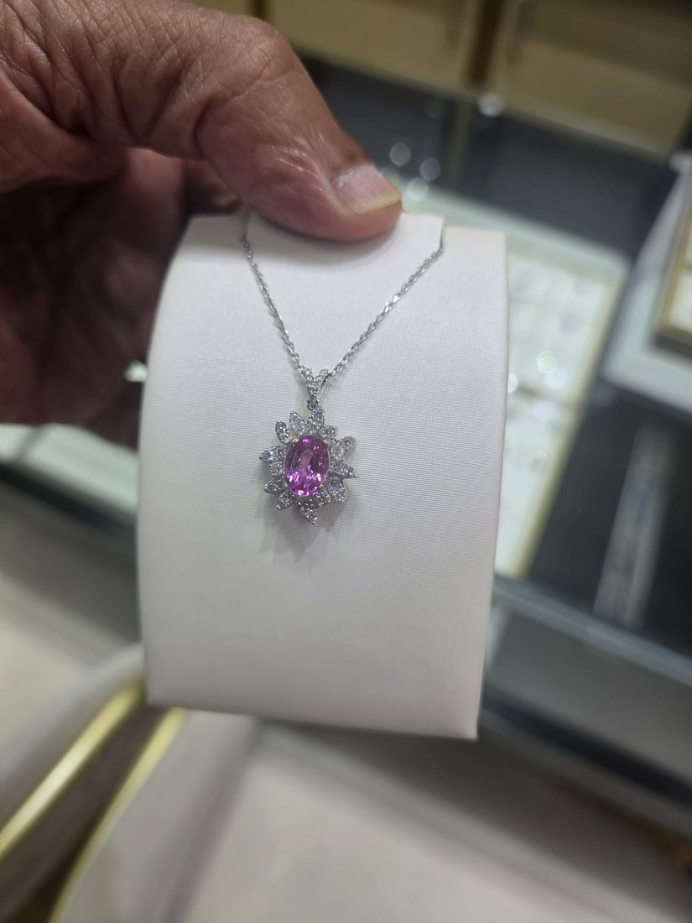
Type / Gem / Metal: Pendant · Pink Ceylon sapphire · White gold + diamonds
What it is: A saturated pink oval sapphire (est. ~2–3 ct) framed by a marquise + round diamond sunburst halo. Pink sapphire is trending hard in the U.S.; this reads far more expensive than its likely cost.
Comfortable U.S. retail (est.): $1,400 – $3,200
Note: Pink hue quality and carat drive value; confirm stone weight.

10. Cat's-Eye Moonstone + Blue Sapphire Halo Bracelet [Unique]
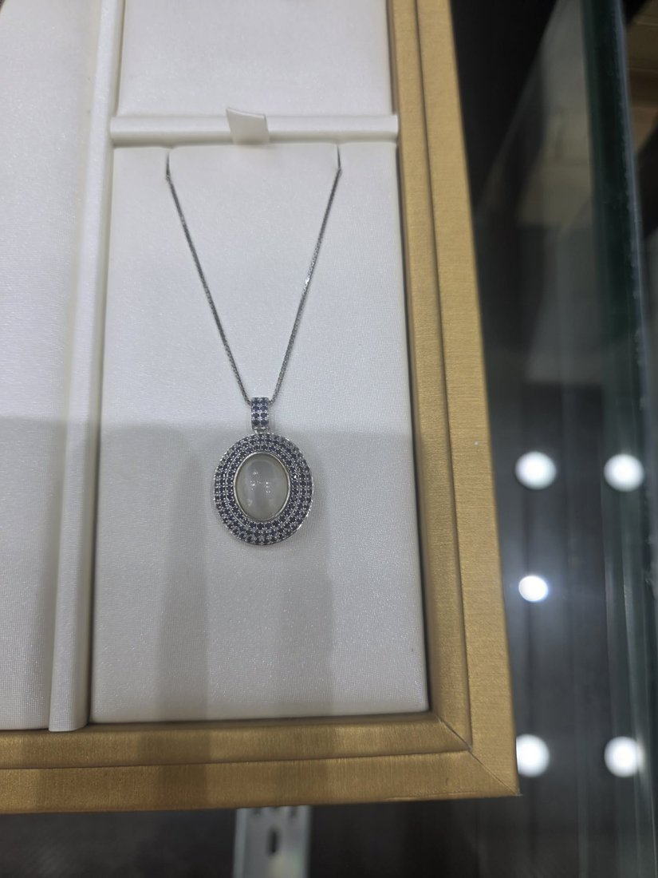
Type / Gem / Metal: Bracelet · Cat's-eye moonstone + blue sapphire · White/yellow gold
What it is: A line bracelet of oval blue-sheen (cat's-eye) moonstone cabochons each framed by blue sapphires, with a sea-turtle center motif. A distinctive Ceylon-specialty combination you won't find in U.S. mall stores.
Comfortable U.S. retail (est.): $900 – $2,000
Note: Moonstone quality (blue sheen strength) + sapphire count drive value; confirm metal (silver vs gold).

11. Lavender Star Sapphire Diamond-Halo Rings [Unique]
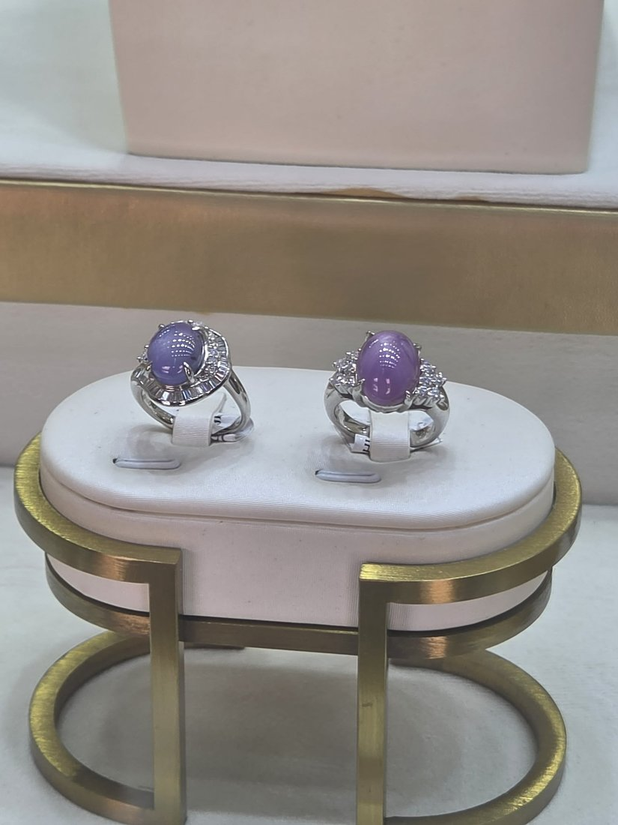
Type / Gem / Metal: Ring · Star sapphire (violet/grey) · Platinum/white gold + diamonds
What it is: A pair of estate-style cocktail rings centering lavender-to-grey star-sapphire cabochons (asterism) in baguette/marquise diamond ballerina halos. Collector appeal and a rare color.
Comfortable U.S. retail (est.): $1,500 – $4,000
Note: Per ring. Star sharpness, body color and carat drive value; a clean centered star + lab note lifts it.

12. Moonstone + Blue Sapphire Pavé Statement Pendant [Unique]
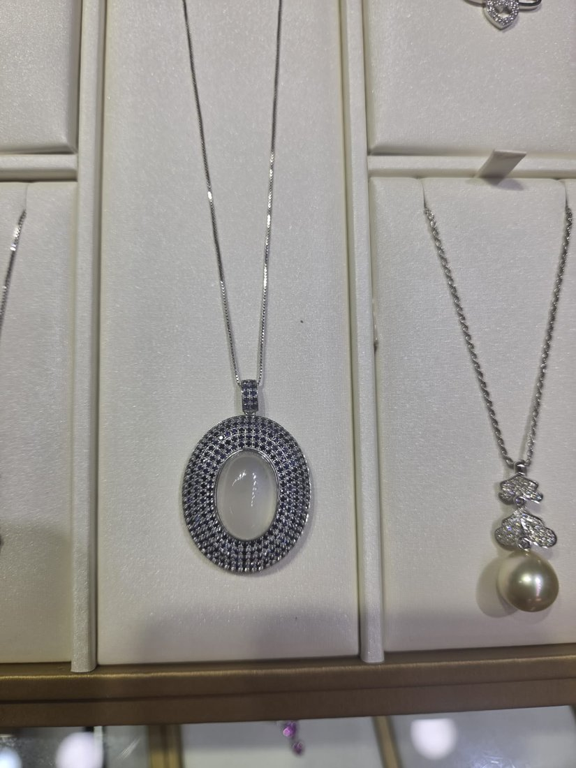
Type / Gem / Metal: Pendant · Moonstone + blue sapphire · White gold
What it is: A large glowing moonstone cabochon framed by a wide oval field of pavé blue sapphires. A bold Ceylon-specialty statement pendant that ties moonstone and sapphire together.
Comfortable U.S. retail (est.): $1,200 – $2,800
Note: Confirm moonstone size/quality and sapphire count/metal.

13. Yellow Sapphire & Diamond Fringe Necklace [Both]
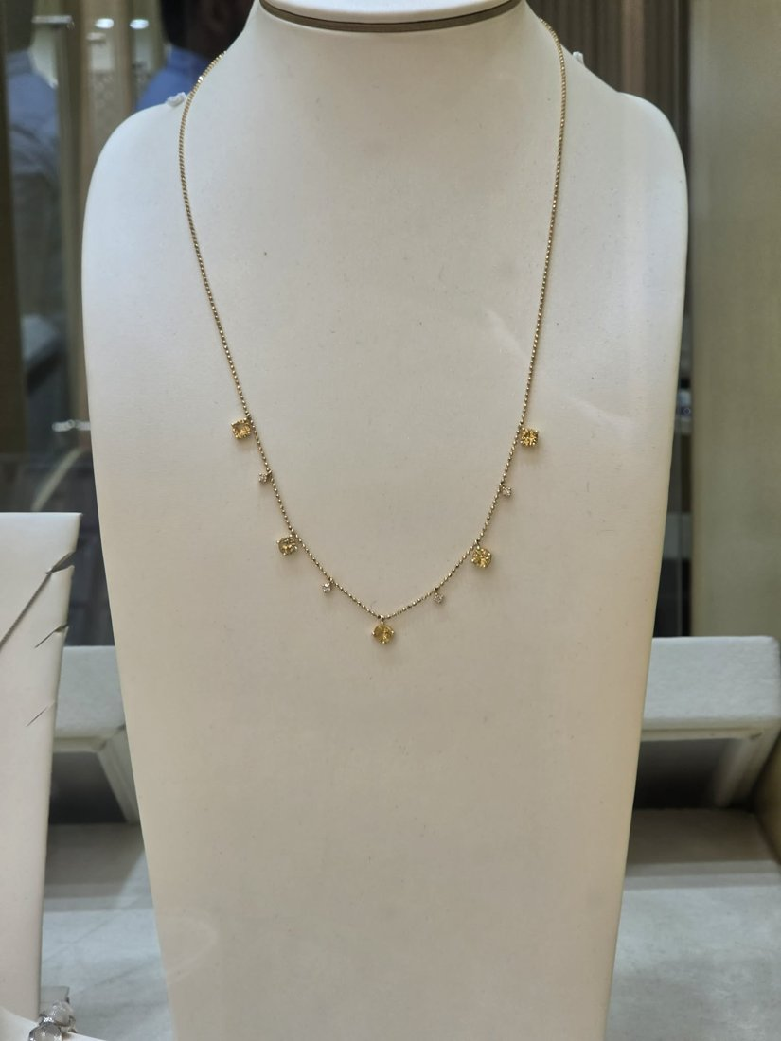
Type / Gem / Metal: Necklace · Yellow Ceylon sapphire · Yellow gold + diamonds
What it is: A delicate 'drippy' fringe/station necklace with yellow sapphires and diamond accents. Yellow sapphire + the fringe style are both on-trend; elegant and wearable daily.
Comfortable U.S. retail (est.): $1,800 – $4,000
Note: Confirm total sapphire + diamond carat and gold weight (fringe styles use more gold).

14. Pear Blue Sapphire & Diamond Laurel Drape Bracelet [Unique]
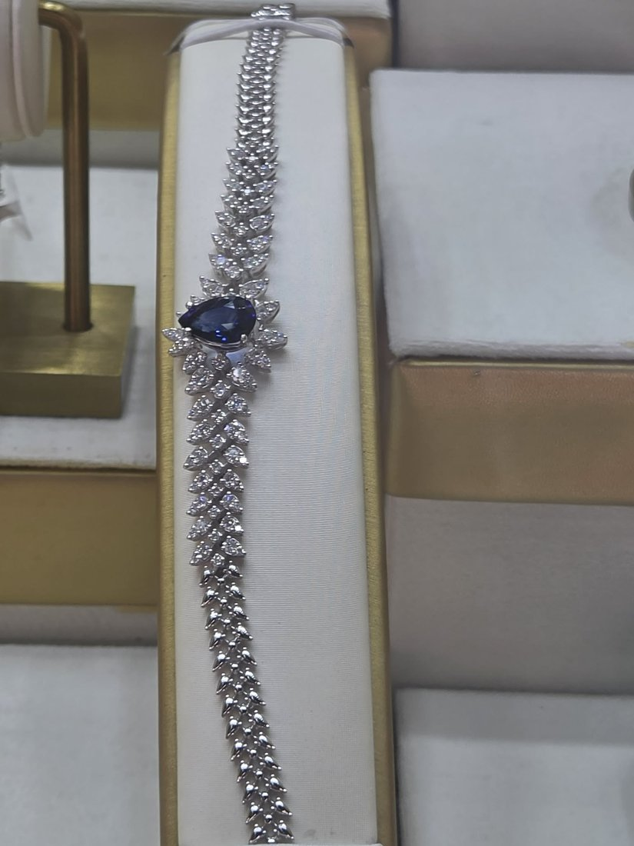
Type / Gem / Metal: Bracelet · Blue Ceylon sapphire · White gold + diamonds
What it is: A pear-shaped blue sapphire with cascading marquise-diamond laurel fronds forming a soft drape along the wrist. Elegant, couture-feeling, and unusual.
Comfortable U.S. retail (est.): $1,500 – $3,500
Note: Diamond content is significant; confirm total diamond carat + sapphire size.

15. Pink Sapphire Art-Deco Filigree Pendant & Stud Set [Unique]
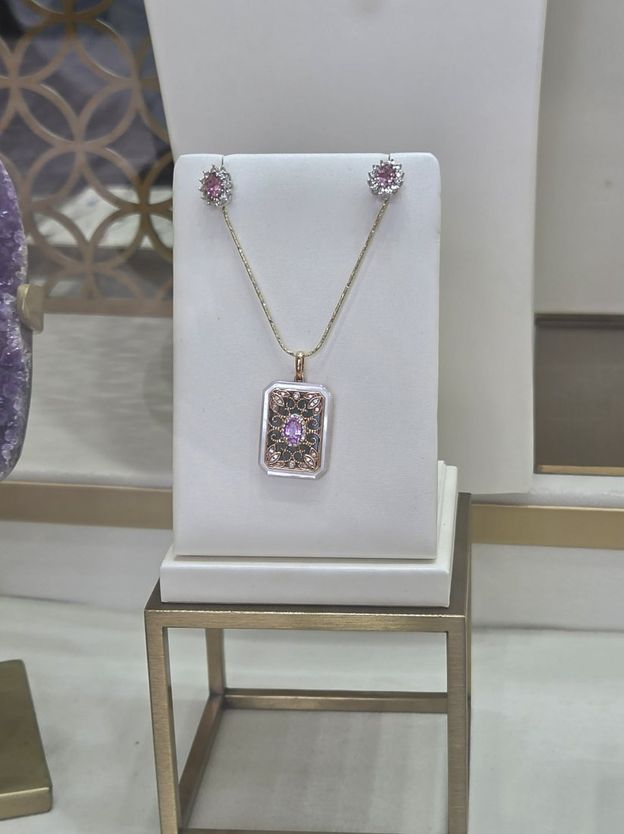
Type / Gem / Metal: Set (pendant + earrings) · Pink Ceylon sapphire · Rose gold + diamonds
What it is: A vintage-revival set: a pear pink sapphire in a black-onyx / mother-of-pearl rose-gold filigree tablet pendant, with matching pink-sapphire diamond-halo studs. Distinctive Art-Deco look.
Comfortable U.S. retail (est.): $1,200 – $2,600
Note: Priced as a set; confirm whether sold together and the sapphire carats.
Estimates only — not an appraisal or guaranteed resale value. All stones described as sapphire are assumed genuine Ceylon sapphire per the supplier (Batcha Gems, Colombo). Verify species, origin, treatment, carat, metal purity/weight and any lab reports on each piece before purchase, and get the supplier’s trade price and export/shipping terms.

