Batcha Gems — Product Information Request
For listing on our U.S. website. Prepared 2026-09-09.
Thank you again! We would love to list the following pieces on our U.S. site. To create accurate listings and work out our delivered cost, could you please fill in the details below for each numbered piece (the photos are your pieces, with our reference number BG-xx). Where a photo shows several pieces, please give the details for each piece separately (its own stock number). Feel free to reply on this document, by email, or on a spreadsheet — whatever is easiest.
A few questions that apply to everything
Can you export directly to the U.S. and handle the NGJA export paperwork on your side? ________________________________________
Insured courier you use + typical cost & transit time to the U.S.: ________________________________________
DELIVERED / LANDED price to our U.S. address (ZIP: __________) — including insured shipping, export fees and any duties — per piece, if you can quote it: ________________________________________
Professional images: can you provide high-resolution photos (several angles, on a white background) and a short video for each piece — with permission for us to use them in our online listings? format & turnaround? ________________________________________
Accepted payment methods for international orders: ________________________________________
Production / lead time if we re-order a piece: ________________________________________
Return / exchange / warranty policy: ________________________________________

For EACH piece below, please provide: stock #, gem & treatment, lab report, carat & size, metal & weight, price, sizing/variants, and whether it belongs to a set. Treatment and lab report are the most important for us — thank you!

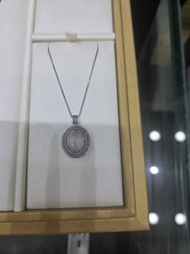 | BG-01 Cat's-eye moonstone + blue sapphire halo line bracelet (turtle motif)  Your stock / SKU #: ________________________________________  Gemstone, variety & colour: e.g. Ceylon blue sapphire ________________________________________  Ceylon / Sri Lanka origin — documented? Natural or synthetic? ________________________________________  Treatment — HEATED or UNHEATED? (and any other treatment): ________________________________  Lab report? (GRS / GIA / SSEF / Lotus / GIT) — number, and included in price? ________________________________________  Carat weight — centre stone / total: ________________________________________  Main stone size (mm) & cut: ________________________________________  Diamonds (if any) — total ct, natural or lab-grown, colour/clarity: ________________________________________  Metal — type, purity (14k/18k/22k/platinum) & colour + gross weight (grams): ________________________________________  Handmade / cast / CAD? One-of-a-kind or can it be re-made? ________________________________________  Other versions available (gem colour / size / carat): ________________________________________  Part of a set? matching pieces available + their prices: ____________________  Your trade price (USD) / normal retail (USD): ________________________________________  Delivered/landed price to our ZIP (incl. insured shipping + export + duty): ________________________________________  High-res photos + video available for this piece? (Y / N) ________________________________________

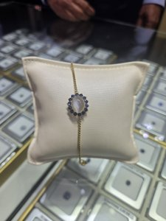 | BG-03 Cat's-eye moonstone cabochon + blue sapphire halo chain bracelet  Your stock / SKU #: ________________________________________  Gemstone, variety & colour: e.g. Ceylon blue sapphire ________________________________________  Ceylon / Sri Lanka origin — documented? Natural or synthetic? ________________________________________  Treatment — HEATED or UNHEATED? (and any other treatment): ________________________________  Lab report? (GRS / GIA / SSEF / Lotus / GIT) — number, and included in price? ________________________________________  Carat weight — centre stone / total: ________________________________________  Main stone size (mm) & cut: ________________________________________  Diamonds (if any) — total ct, natural or lab-grown, colour/clarity: ________________________________________  Metal — type, purity (14k/18k/22k/platinum) & colour + gross weight (grams): ________________________________________  Handmade / cast / CAD? One-of-a-kind or can it be re-made? ________________________________________  Other versions available (gem colour / size / carat): ________________________________________  Part of a set? matching pieces available + their prices: ____________________  Your trade price (USD) / normal retail (USD): ________________________________________  Delivered/landed price to our ZIP (incl. insured shipping + export + duty): ________________________________________  High-res photos + video available for this piece? (Y / N) ________________________________________

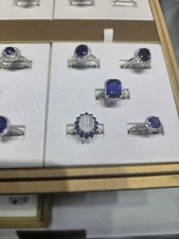 | BG-04 Ring tray — multiple blue-sapphire & cat's-eye halo rings  ⚠ This photo shows several pieces — please list EACH one separately (its own stock #, carat, size and price).  Your stock / SKU #: ________________________________________  Gemstone, variety & colour: e.g. Ceylon blue sapphire ________________________________________  Ceylon / Sri Lanka origin — documented? Natural or synthetic? ________________________________________  Treatment — HEATED or UNHEATED? (and any other treatment): ________________________________  Lab report? (GRS / GIA / SSEF / Lotus / GIT) — number, and included in price? ________________________________________  Carat weight — centre stone / total: ________________________________________  Main stone size (mm) & cut: ________________________________________  Diamonds (if any) — total ct, natural or lab-grown, colour/clarity: ________________________________________  Metal — type, purity (14k/18k/22k/platinum) & colour + gross weight (grams): ________________________________________  Handmade / cast / CAD? One-of-a-kind or can it be re-made? ________________________________________  Ring size now + resizable range (min–max) + cost & time to resize: ____________________________  Other versions available (gem colour / size / carat): ________________________________________  Part of a set? matching pieces available + their prices: ____________________  Your trade price (USD) / normal retail (USD): ________________________________________  Delivered/landed price to our ZIP (incl. insured shipping + export + duty): ________________________________________  High-res photos + video available for this piece? (Y / N) ________________________________________

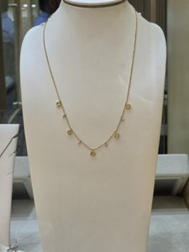 | BG-06 Yellow sapphire & diamond fringe / drip station necklace  Your stock / SKU #: ________________________________________  Gemstone, variety & colour: e.g. Ceylon blue sapphire ________________________________________  Ceylon / Sri Lanka origin — documented? Natural or synthetic? ________________________________________  Treatment — HEATED or UNHEATED? (and any other treatment): ________________________________  Lab report? (GRS / GIA / SSEF / Lotus / GIT) — number, and included in price? ________________________________________  Carat weight — centre stone / total: ________________________________________  Main stone size (mm) & cut: ________________________________________  Diamonds (if any) — total ct, natural or lab-grown, colour/clarity: ________________________________________  Metal — type, purity (14k/18k/22k/platinum) & colour + gross weight (grams): ________________________________________  Handmade / cast / CAD? One-of-a-kind or can it be re-made? ________________________________________  Other versions available (gem colour / size / carat): ________________________________________  Part of a set? matching pieces available + their prices: ____________________  Your trade price (USD) / normal retail (USD): ________________________________________  Delivered/landed price to our ZIP (incl. insured shipping + export + duty): ________________________________________  High-res photos + video available for this piece? (Y / N) ________________________________________

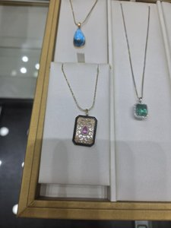 | BG-07 Three pendants — blue topaz pear; pink sapphire filigree; emerald+diamond halo  ⚠ This photo shows several pieces — please list EACH one separately (its own stock #, carat, size and price).  Your stock / SKU #: ________________________________________  Gemstone, variety & colour: e.g. Ceylon blue sapphire ________________________________________  Ceylon / Sri Lanka origin — documented? Natural or synthetic? ________________________________________  Treatment — HEATED or UNHEATED? (and any other treatment): ________________________________  Lab report? (GRS / GIA / SSEF / Lotus / GIT) — number, and included in price? ________________________________________  Carat weight — centre stone / total: ________________________________________  Main stone size (mm) & cut: ________________________________________  Diamonds (if any) — total ct, natural or lab-grown, colour/clarity: ________________________________________  Metal — type, purity (14k/18k/22k/platinum) & colour + gross weight (grams): ________________________________________  Handmade / cast / CAD? One-of-a-kind or can it be re-made? ________________________________________  Other versions available (gem colour / size / carat): ________________________________________  Part of a set? matching pieces available + their prices: ____________________  Your trade price (USD) / normal retail (USD): ________________________________________  Delivered/landed price to our ZIP (incl. insured shipping + export + duty): ________________________________________  High-res photos + video available for this piece? (Y / N) ________________________________________

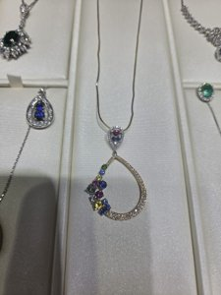 | BG-09 Scatter 'confetti' multi-sapphire + diamond teardrop pendant  Your stock / SKU #: ________________________________________  Gemstone, variety & colour: e.g. Ceylon blue sapphire ________________________________________  Ceylon / Sri Lanka origin — documented? Natural or synthetic? ________________________________________  Treatment — HEATED or UNHEATED? (and any other treatment): ________________________________  Lab report? (GRS / GIA / SSEF / Lotus / GIT) — number, and included in price? ________________________________________  Carat weight — centre stone / total: ________________________________________  Main stone size (mm) & cut: ________________________________________  Diamonds (if any) — total ct, natural or lab-grown, colour/clarity: ________________________________________  Metal — type, purity (14k/18k/22k/platinum) & colour + gross weight (grams): ________________________________________  Handmade / cast / CAD? One-of-a-kind or can it be re-made? ________________________________________  Other versions available (gem colour / size / carat): ________________________________________  Part of a set? matching pieces available + their prices: ____________________  Your trade price (USD) / normal retail (USD): ________________________________________  Delivered/landed price to our ZIP (incl. insured shipping + export + duty): ________________________________________  High-res photos + video available for this piece? (Y / N) ________________________________________

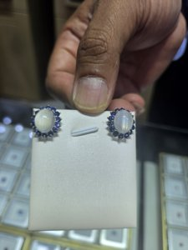 | BG-10 Cat's-eye moonstone cabochon + blue sapphire halo stud earrings  Your stock / SKU #: ________________________________________  Gemstone, variety & colour: e.g. Ceylon blue sapphire ________________________________________  Ceylon / Sri Lanka origin — documented? Natural or synthetic? ________________________________________  Treatment — HEATED or UNHEATED? (and any other treatment): ________________________________  Lab report? (GRS / GIA / SSEF / Lotus / GIT) — number, and included in price? ________________________________________  Carat weight — centre stone / total: ________________________________________  Main stone size (mm) & cut: ________________________________________  Diamonds (if any) — total ct, natural or lab-grown, colour/clarity: ________________________________________  Metal — type, purity (14k/18k/22k/platinum) & colour + gross weight (grams): ________________________________________  Handmade / cast / CAD? One-of-a-kind or can it be re-made? ________________________________________  Other versions available (gem colour / size / carat): ________________________________________  Part of a set? matching pieces available + their prices: (we think: Possible set: BG-03 bracelet / BG-12 ring) ____________________  Your trade price (USD) / normal retail (USD): ________________________________________  Delivered/landed price to our ZIP (incl. insured shipping + export + duty): ________________________________________  High-res photos + video available for this piece? (Y / N) ________________________________________

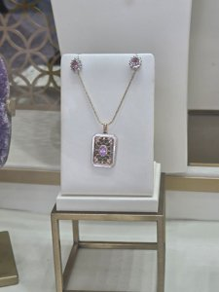 | BG-11 Pink sapphire diamond-halo studs + filigree tablet pendant (Art-Deco set)  Your stock / SKU #: ________________________________________  Gemstone, variety & colour: e.g. Ceylon blue sapphire ________________________________________  Ceylon / Sri Lanka origin — documented? Natural or synthetic? ________________________________________  Treatment — HEATED or UNHEATED? (and any other treatment): ________________________________  Lab report? (GRS / GIA / SSEF / Lotus / GIT) — number, and included in price? ________________________________________  Carat weight — centre stone / total: ________________________________________  Main stone size (mm) & cut: ________________________________________  Diamonds (if any) — total ct, natural or lab-grown, colour/clarity: ________________________________________  Metal — type, purity (14k/18k/22k/platinum) & colour + gross weight (grams): ________________________________________  Handmade / cast / CAD? One-of-a-kind or can it be re-made? ________________________________________  Other versions available (gem colour / size / carat): ________________________________________  Part of a set? matching pieces available + their prices: (we think: Pendant + matching studs) ____________________  Your trade price (USD) / normal retail (USD): ________________________________________  Delivered/landed price to our ZIP (incl. insured shipping + export + duty): ________________________________________  High-res photos + video available for this piece? (Y / N) ________________________________________

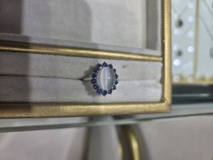 | BG-12 Cat's-eye moonstone cabochon + blue sapphire halo ring  Your stock / SKU #: ________________________________________  Gemstone, variety & colour: e.g. Ceylon blue sapphire ________________________________________  Ceylon / Sri Lanka origin — documented? Natural or synthetic? ________________________________________  Treatment — HEATED or UNHEATED? (and any other treatment): ________________________________  Lab report? (GRS / GIA / SSEF / Lotus / GIT) — number, and included in price? ________________________________________  Carat weight — centre stone / total: ________________________________________  Main stone size (mm) & cut: ________________________________________  Diamonds (if any) — total ct, natural or lab-grown, colour/clarity: ________________________________________  Metal — type, purity (14k/18k/22k/platinum) & colour + gross weight (grams): ________________________________________  Handmade / cast / CAD? One-of-a-kind or can it be re-made? ________________________________________  Ring size now + resizable range (min–max) + cost & time to resize: ____________________________  Other versions available (gem colour / size / carat): ________________________________________  Part of a set? matching pieces available + their prices: (we think: Possible set: BG-03 / BG-10) ____________________  Your trade price (USD) / normal retail (USD): ________________________________________  Delivered/landed price to our ZIP (incl. insured shipping + export + duty): ________________________________________  High-res photos + video available for this piece? (Y / N) ________________________________________

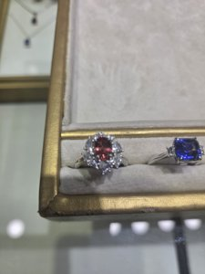 | BG-13 Two rings — pink/red halo ring + vivid blue emerald-cut 3-stone ring  ⚠ This photo shows several pieces — please list EACH one separately (its own stock #, carat, size and price).  Your stock / SKU #: ________________________________________  Gemstone, variety & colour: e.g. Ceylon blue sapphire ________________________________________  Ceylon / Sri Lanka origin — documented? Natural or synthetic? ________________________________________  Treatment — HEATED or UNHEATED? (and any other treatment): ________________________________  Lab report? (GRS / GIA / SSEF / Lotus / GIT) — number, and included in price? ________________________________________  Carat weight — centre stone / total: ________________________________________  Main stone size (mm) & cut: ________________________________________  Diamonds (if any) — total ct, natural or lab-grown, colour/clarity: ________________________________________  Metal — type, purity (14k/18k/22k/platinum) & colour + gross weight (grams): ________________________________________  Handmade / cast / CAD? One-of-a-kind or can it be re-made? ________________________________________  Ring size now + resizable range (min–max) + cost & time to resize: ____________________________  Other versions available (gem colour / size / carat): ________________________________________  Part of a set? matching pieces available + their prices: ____________________  Your trade price (USD) / normal retail (USD): ________________________________________  Delivered/landed price to our ZIP (incl. insured shipping + export + duty): ________________________________________  High-res photos + video available for this piece? (Y / N) ________________________________________

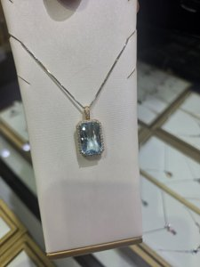 | BG-14 Aquamarine emerald-cut + diamond halo pendant  Your stock / SKU #: ________________________________________  Gemstone, variety & colour: e.g. Ceylon blue sapphire ________________________________________  Ceylon / Sri Lanka origin — documented? Natural or synthetic? ________________________________________  Treatment — HEATED or UNHEATED? (and any other treatment): ________________________________  Lab report? (GRS / GIA / SSEF / Lotus / GIT) — number, and included in price? ________________________________________  Carat weight — centre stone / total: ________________________________________  Main stone size (mm) & cut: ________________________________________  Diamonds (if any) — total ct, natural or lab-grown, colour/clarity: ________________________________________  Metal — type, purity (14k/18k/22k/platinum) & colour + gross weight (grams): ________________________________________  Handmade / cast / CAD? One-of-a-kind or can it be re-made? ________________________________________  Other versions available (gem colour / size / carat): ________________________________________  Part of a set? matching pieces available + their prices: ____________________  Your trade price (USD) / normal retail (USD): ________________________________________  Delivered/landed price to our ZIP (incl. insured shipping + export + duty): ________________________________________  High-res photos + video available for this piece? (Y / N) ________________________________________

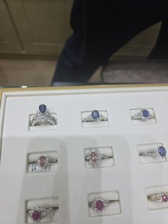 | BG-15 Ring tray — blue sapphire, padparadscha-tone & ruby engagement-style rings  ⚠ This photo shows several pieces — please list EACH one separately (its own stock #, carat, size and price).  Your stock / SKU #: ________________________________________  Gemstone, variety & colour: e.g. Ceylon blue sapphire ________________________________________  Ceylon / Sri Lanka origin — documented? Natural or synthetic? ________________________________________  Treatment — HEATED or UNHEATED? (and any other treatment): ________________________________  Lab report? (GRS / GIA / SSEF / Lotus / GIT) — number, and included in price? ________________________________________  Carat weight — centre stone / total: ________________________________________  Main stone size (mm) & cut: ________________________________________  Diamonds (if any) — total ct, natural or lab-grown, colour/clarity: ________________________________________  Metal — type, purity (14k/18k/22k/platinum) & colour + gross weight (grams): ________________________________________  Handmade / cast / CAD? One-of-a-kind or can it be re-made? ________________________________________  Ring size now + resizable range (min–max) + cost & time to resize: ____________________________  Other versions available (gem colour / size / carat): ________________________________________  Part of a set? matching pieces available + their prices: ____________________  Your trade price (USD) / normal retail (USD): ________________________________________  Delivered/landed price to our ZIP (incl. insured shipping + export + duty): ________________________________________  High-res photos + video available for this piece? (Y / N) ________________________________________

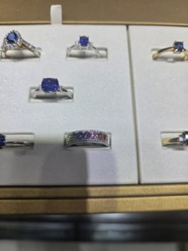 | BG-17 Ring tray — blue-sapphire halos + rainbow fancy-sapphire band  ⚠ This photo shows several pieces — please list EACH one separately (its own stock #, carat, size and price).  Your stock / SKU #: ________________________________________  Gemstone, variety & colour: e.g. Ceylon blue sapphire ________________________________________  Ceylon / Sri Lanka origin — documented? Natural or synthetic? ________________________________________  Treatment — HEATED or UNHEATED? (and any other treatment): ________________________________  Lab report? (GRS / GIA / SSEF / Lotus / GIT) — number, and included in price? ________________________________________  Carat weight — centre stone / total: ________________________________________  Main stone size (mm) & cut: ________________________________________  Diamonds (if any) — total ct, natural or lab-grown, colour/clarity: ________________________________________  Metal — type, purity (14k/18k/22k/platinum) & colour + gross weight (grams): ________________________________________  Handmade / cast / CAD? One-of-a-kind or can it be re-made? ________________________________________  Ring size now + resizable range (min–max) + cost & time to resize: ____________________________  Other versions available (gem colour / size / carat): ________________________________________  Part of a set? matching pieces available + their prices: ____________________  Your trade price (USD) / normal retail (USD): ________________________________________  Delivered/landed price to our ZIP (incl. insured shipping + export + duty): ________________________________________  High-res photos + video available for this piece? (Y / N) ________________________________________

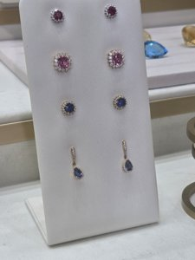 | BG-18 Earring board — pink & blue sapphire halo studs + pear blue drops  ⚠ This photo shows several pieces — please list EACH one separately (its own stock #, carat, size and price).  Your stock / SKU #: ________________________________________  Gemstone, variety & colour: e.g. Ceylon blue sapphire ________________________________________  Ceylon / Sri Lanka origin — documented? Natural or synthetic? ________________________________________  Treatment — HEATED or UNHEATED? (and any other treatment): ________________________________  Lab report? (GRS / GIA / SSEF / Lotus / GIT) — number, and included in price? ________________________________________  Carat weight — centre stone / total: ________________________________________  Main stone size (mm) & cut: ________________________________________  Diamonds (if any) — total ct, natural or lab-grown, colour/clarity: ________________________________________  Metal — type, purity (14k/18k/22k/platinum) & colour + gross weight (grams): ________________________________________  Handmade / cast / CAD? One-of-a-kind or can it be re-made? ________________________________________  Other versions available (gem colour / size / carat): ________________________________________  Part of a set? matching pieces available + their prices: ____________________  Your trade price (USD) / normal retail (USD): ________________________________________  Delivered/landed price to our ZIP (incl. insured shipping + export + duty): ________________________________________  High-res photos + video available for this piece? (Y / N) ________________________________________

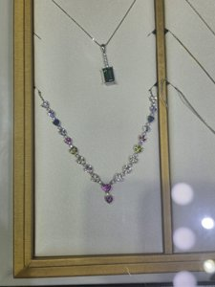 | BG-19 Rainbow fancy-sapphire heart station necklace (emerald pendant also in frame)  Your stock / SKU #: ________________________________________  Gemstone, variety & colour: e.g. Ceylon blue sapphire ________________________________________  Ceylon / Sri Lanka origin — documented? Natural or synthetic? ________________________________________  Treatment — HEATED or UNHEATED? (and any other treatment): ________________________________  Lab report? (GRS / GIA / SSEF / Lotus / GIT) — number, and included in price? ________________________________________  Carat weight — centre stone / total: ________________________________________  Main stone size (mm) & cut: ________________________________________  Diamonds (if any) — total ct, natural or lab-grown, colour/clarity: ________________________________________  Metal — type, purity (14k/18k/22k/platinum) & colour + gross weight (grams): ________________________________________  Handmade / cast / CAD? One-of-a-kind or can it be re-made? ________________________________________  Other versions available (gem colour / size / carat): ________________________________________  Part of a set? matching pieces available + their prices: ____________________  Your trade price (USD) / normal retail (USD): ________________________________________  Delivered/landed price to our ZIP (incl. insured shipping + export + duty): ________________________________________  High-res photos + video available for this piece? (Y / N) ________________________________________

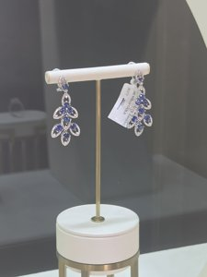 | BG-20 Blue sapphire chandelier / cluster drop earrings  Your stock / SKU #: ________________________________________  Gemstone, variety & colour: e.g. Ceylon blue sapphire ________________________________________  Ceylon / Sri Lanka origin — documented? Natural or synthetic? ________________________________________  Treatment — HEATED or UNHEATED? (and any other treatment): ________________________________  Lab report? (GRS / GIA / SSEF / Lotus / GIT) — number, and included in price? ________________________________________  Carat weight — centre stone / total: ________________________________________  Main stone size (mm) & cut: ________________________________________  Diamonds (if any) — total ct, natural or lab-grown, colour/clarity: ________________________________________  Metal — type, purity (14k/18k/22k/platinum) & colour + gross weight (grams): ________________________________________  Handmade / cast / CAD? One-of-a-kind or can it be re-made? ________________________________________  Other versions available (gem colour / size / carat): ________________________________________  Part of a set? matching pieces available + their prices: ____________________  Your trade price (USD) / normal retail (USD): ________________________________________  Delivered/landed price to our ZIP (incl. insured shipping + export + duty): ________________________________________  High-res photos + video available for this piece? (Y / N) ________________________________________

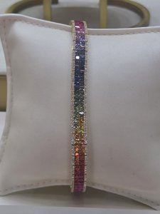 | BG-22 Rainbow invisible-set princess-cut sapphire bracelet  Your stock / SKU #: ________________________________________  Gemstone, variety & colour: e.g. Ceylon blue sapphire ________________________________________  Ceylon / Sri Lanka origin — documented? Natural or synthetic? ________________________________________  Treatment — HEATED or UNHEATED? (and any other treatment): ________________________________  Lab report? (GRS / GIA / SSEF / Lotus / GIT) — number, and included in price? ________________________________________  Carat weight — centre stone / total: ________________________________________  Main stone size (mm) & cut: ________________________________________  Diamonds (if any) — total ct, natural or lab-grown, colour/clarity: ________________________________________  Metal — type, purity (14k/18k/22k/platinum) & colour + gross weight (grams): ________________________________________  Handmade / cast / CAD? One-of-a-kind or can it be re-made? ________________________________________  Other versions available (gem colour / size / carat): ________________________________________  Part of a set? matching pieces available + their prices: ____________________  Your trade price (USD) / normal retail (USD): ________________________________________  Delivered/landed price to our ZIP (incl. insured shipping + export + duty): ________________________________________  High-res photos + video available for this piece? (Y / N) ________________________________________

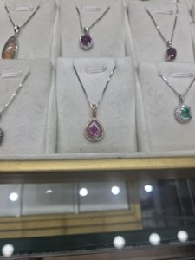 | BG-23 Pink sapphire pear pendant, pale/galaxy halo (rose gold)  Your stock / SKU #: ________________________________________  Gemstone, variety & colour: e.g. Ceylon blue sapphire ________________________________________  Ceylon / Sri Lanka origin — documented? Natural or synthetic? ________________________________________  Treatment — HEATED or UNHEATED? (and any other treatment): ________________________________  Lab report? (GRS / GIA / SSEF / Lotus / GIT) — number, and included in price? ________________________________________  Carat weight — centre stone / total: ________________________________________  Main stone size (mm) & cut: ________________________________________  Diamonds (if any) — total ct, natural or lab-grown, colour/clarity: ________________________________________  Metal — type, purity (14k/18k/22k/platinum) & colour + gross weight (grams): ________________________________________  Handmade / cast / CAD? One-of-a-kind or can it be re-made? ________________________________________  Other versions available (gem colour / size / carat): ________________________________________  Part of a set? matching pieces available + their prices: ____________________  Your trade price (USD) / normal retail (USD): ________________________________________  Delivered/landed price to our ZIP (incl. insured shipping + export + duty): ________________________________________  High-res photos + video available for this piece? (Y / N) ________________________________________

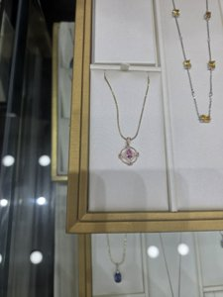 | BG-24 Pink sapphire pear in openwork compass/star rose-gold pendant  Your stock / SKU #: ________________________________________  Gemstone, variety & colour: e.g. Ceylon blue sapphire ________________________________________  Ceylon / Sri Lanka origin — documented? Natural or synthetic? ________________________________________  Treatment — HEATED or UNHEATED? (and any other treatment): ________________________________  Lab report? (GRS / GIA / SSEF / Lotus / GIT) — number, and included in price? ________________________________________  Carat weight — centre stone / total: ________________________________________  Main stone size (mm) & cut: ________________________________________  Diamonds (if any) — total ct, natural or lab-grown, colour/clarity: ________________________________________  Metal — type, purity (14k/18k/22k/platinum) & colour + gross weight (grams): ________________________________________  Handmade / cast / CAD? One-of-a-kind or can it be re-made? ________________________________________  Other versions available (gem colour / size / carat): ________________________________________  Part of a set? matching pieces available + their prices: ____________________  Your trade price (USD) / normal retail (USD): ________________________________________  Delivered/landed price to our ZIP (incl. insured shipping + export + duty): ________________________________________  High-res photos + video available for this piece? (Y / N) ________________________________________

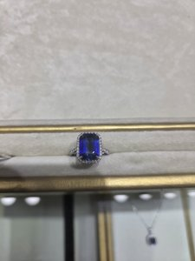 | BG-25 Emerald-cut vivid blue sapphire diamond-halo cocktail ring  Your stock / SKU #: ________________________________________  Gemstone, variety & colour: e.g. Ceylon blue sapphire ________________________________________  Ceylon / Sri Lanka origin — documented? Natural or synthetic? ________________________________________  Treatment — HEATED or UNHEATED? (and any other treatment): ________________________________  Lab report? (GRS / GIA / SSEF / Lotus / GIT) — number, and included in price? ________________________________________  Carat weight — centre stone / total: ________________________________________  Main stone size (mm) & cut: ________________________________________  Diamonds (if any) — total ct, natural or lab-grown, colour/clarity: ________________________________________  Metal — type, purity (14k/18k/22k/platinum) & colour + gross weight (grams): ________________________________________  Handmade / cast / CAD? One-of-a-kind or can it be re-made? ________________________________________  Ring size now + resizable range (min–max) + cost & time to resize: ____________________________  Other versions available (gem colour / size / carat): ________________________________________  Part of a set? matching pieces available + their prices: ____________________  Your trade price (USD) / normal retail (USD): ________________________________________  Delivered/landed price to our ZIP (incl. insured shipping + export + duty): ________________________________________  High-res photos + video available for this piece? (Y / N) ________________________________________

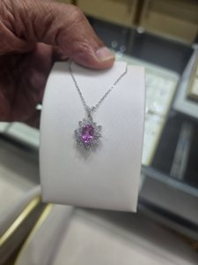 | BG-26 Vivid pink sapphire marquise-halo sunburst pendant  Your stock / SKU #: ________________________________________  Gemstone, variety & colour: e.g. Ceylon blue sapphire ________________________________________  Ceylon / Sri Lanka origin — documented? Natural or synthetic? ________________________________________  Treatment — HEATED or UNHEATED? (and any other treatment): ________________________________  Lab report? (GRS / GIA / SSEF / Lotus / GIT) — number, and included in price? ________________________________________  Carat weight — centre stone / total: ________________________________________  Main stone size (mm) & cut: ________________________________________  Diamonds (if any) — total ct, natural or lab-grown, colour/clarity: ________________________________________  Metal — type, purity (14k/18k/22k/platinum) & colour + gross weight (grams): ________________________________________  Handmade / cast / CAD? One-of-a-kind or can it be re-made? ________________________________________  Other versions available (gem colour / size / carat): ________________________________________  Part of a set? matching pieces available + their prices: ____________________  Your trade price (USD) / normal retail (USD): ________________________________________  Delivered/landed price to our ZIP (incl. insured shipping + export + duty): ________________________________________  High-res photos + video available for this piece? (Y / N) ________________________________________

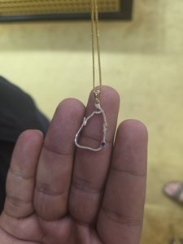 | BG-27 Sri Lanka map pendant (pavé diamond outline + sapphire)  Your stock / SKU #: ________________________________________  Gemstone, variety & colour: e.g. Ceylon blue sapphire ________________________________________  Ceylon / Sri Lanka origin — documented? Natural or synthetic? ________________________________________  Treatment — HEATED or UNHEATED? (and any other treatment): ________________________________  Lab report? (GRS / GIA / SSEF / Lotus / GIT) — number, and included in price? ________________________________________  Carat weight — centre stone / total: ________________________________________  Main stone size (mm) & cut: ________________________________________  Diamonds (if any) — total ct, natural or lab-grown, colour/clarity: ________________________________________  Metal — type, purity (14k/18k/22k/platinum) & colour + gross weight (grams): ________________________________________  Handmade / cast / CAD? One-of-a-kind or can it be re-made? ________________________________________  Other versions available (gem colour / size / carat): ________________________________________  Part of a set? matching pieces available + their prices: ____________________  Your trade price (USD) / normal retail (USD): ________________________________________  Delivered/landed price to our ZIP (incl. insured shipping + export + duty): ________________________________________  High-res photos + video available for this piece? (Y / N) ________________________________________

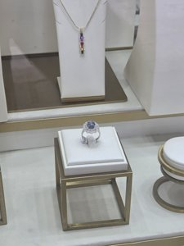 | BG-32 Blue star sapphire cabochon diamond-halo ring  Your stock / SKU #: ________________________________________  Gemstone, variety & colour: e.g. Ceylon blue sapphire ________________________________________  Ceylon / Sri Lanka origin — documented? Natural or synthetic? ________________________________________  Treatment — HEATED or UNHEATED? (and any other treatment): ________________________________  Lab report? (GRS / GIA / SSEF / Lotus / GIT) — number, and included in price? ________________________________________  Carat weight — centre stone / total: ________________________________________  Main stone size (mm) & cut: ________________________________________  Diamonds (if any) — total ct, natural or lab-grown, colour/clarity: ________________________________________  Metal — type, purity (14k/18k/22k/platinum) & colour + gross weight (grams): ________________________________________  Handmade / cast / CAD? One-of-a-kind or can it be re-made? ________________________________________  Ring size now + resizable range (min–max) + cost & time to resize: ____________________________  Other versions available (gem colour / size / carat): ________________________________________  Part of a set? matching pieces available + their prices: ____________________  Your trade price (USD) / normal retail (USD): ________________________________________  Delivered/landed price to our ZIP (incl. insured shipping + export + duty): ________________________________________  High-res photos + video available for this piece? (Y / N) ________________________________________

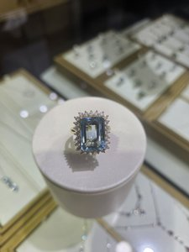 | BG-34 Aquamarine emerald-cut (~8-10ct) diamond-halo cocktail ring  Your stock / SKU #: ________________________________________  Gemstone, variety & colour: e.g. Ceylon blue sapphire ________________________________________  Ceylon / Sri Lanka origin — documented? Natural or synthetic? ________________________________________  Treatment — HEATED or UNHEATED? (and any other treatment): ________________________________  Lab report? (GRS / GIA / SSEF / Lotus / GIT) — number, and included in price? ________________________________________  Carat weight — centre stone / total: ________________________________________  Main stone size (mm) & cut: ________________________________________  Diamonds (if any) — total ct, natural or lab-grown, colour/clarity: ________________________________________  Metal — type, purity (14k/18k/22k/platinum) & colour + gross weight (grams): ________________________________________  Handmade / cast / CAD? One-of-a-kind or can it be re-made? ________________________________________  Ring size now + resizable range (min–max) + cost & time to resize: ____________________________  Other versions available (gem colour / size / carat): ________________________________________  Part of a set? matching pieces available + their prices: ____________________  Your trade price (USD) / normal retail (USD): ________________________________________  Delivered/landed price to our ZIP (incl. insured shipping + export + duty): ________________________________________  High-res photos + video available for this piece? (Y / N) ________________________________________

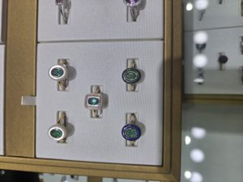 | BG-35 Ring tray — emerald bezel inlay rings (MOP / onyx / lapis)  ⚠ This photo shows several pieces — please list EACH one separately (its own stock #, carat, size and price).  Your stock / SKU #: ________________________________________  Gemstone, variety & colour: e.g. Ceylon blue sapphire ________________________________________  Ceylon / Sri Lanka origin — documented? Natural or synthetic? ________________________________________  Treatment — HEATED or UNHEATED? (and any other treatment): ________________________________  Lab report? (GRS / GIA / SSEF / Lotus / GIT) — number, and included in price? ________________________________________  Carat weight — centre stone / total: ________________________________________  Main stone size (mm) & cut: ________________________________________  Diamonds (if any) — total ct, natural or lab-grown, colour/clarity: ________________________________________  Metal — type, purity (14k/18k/22k/platinum) & colour + gross weight (grams): ________________________________________  Handmade / cast / CAD? One-of-a-kind or can it be re-made? ________________________________________  Ring size now + resizable range (min–max) + cost & time to resize: ____________________________  Other versions available (gem colour / size / carat): ________________________________________  Part of a set? matching pieces available + their prices: ____________________  Your trade price (USD) / normal retail (USD): ________________________________________  Delivered/landed price to our ZIP (incl. insured shipping + export + duty): ________________________________________  High-res photos + video available for this piece? (Y / N) ________________________________________

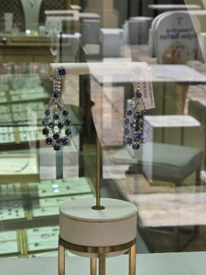 | BG-38 Blue sapphire open-teardrop chandelier drop earrings (18k WG)  Your stock / SKU #: ________________________________________  Gemstone, variety & colour: e.g. Ceylon blue sapphire ________________________________________  Ceylon / Sri Lanka origin — documented? Natural or synthetic? ________________________________________  Treatment — HEATED or UNHEATED? (and any other treatment): ________________________________  Lab report? (GRS / GIA / SSEF / Lotus / GIT) — number, and included in price? ________________________________________  Carat weight — centre stone / total: ________________________________________  Main stone size (mm) & cut: ________________________________________  Diamonds (if any) — total ct, natural or lab-grown, colour/clarity: ________________________________________  Metal — type, purity (14k/18k/22k/platinum) & colour + gross weight (grams): ________________________________________  Handmade / cast / CAD? One-of-a-kind or can it be re-made? ________________________________________  Other versions available (gem colour / size / carat): ________________________________________  Part of a set? matching pieces available + their prices: ____________________  Your trade price (USD) / normal retail (USD): ________________________________________  Delivered/landed price to our ZIP (incl. insured shipping + export + duty): ________________________________________  High-res photos + video available for this piece? (Y / N) ________________________________________

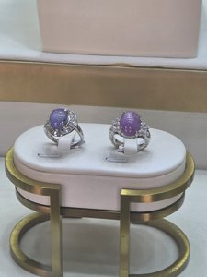 | BG-40 Lavender/violet star sapphire cabochon diamond-halo rings (pair)  ⚠ This photo shows several pieces — please list EACH one separately (its own stock #, carat, size and price).  Your stock / SKU #: ________________________________________  Gemstone, variety & colour: e.g. Ceylon blue sapphire ________________________________________  Ceylon / Sri Lanka origin — documented? Natural or synthetic? ________________________________________  Treatment — HEATED or UNHEATED? (and any other treatment): ________________________________  Lab report? (GRS / GIA / SSEF / Lotus / GIT) — number, and included in price? ________________________________________  Carat weight — centre stone / total: ________________________________________  Main stone size (mm) & cut: ________________________________________  Diamonds (if any) — total ct, natural or lab-grown, colour/clarity: ________________________________________  Metal — type, purity (14k/18k/22k/platinum) & colour + gross weight (grams): ________________________________________  Handmade / cast / CAD? One-of-a-kind or can it be re-made? ________________________________________  Ring size now + resizable range (min–max) + cost & time to resize: ____________________________  Other versions available (gem colour / size / carat): ________________________________________  Part of a set? matching pieces available + their prices: ____________________  Your trade price (USD) / normal retail (USD): ________________________________________  Delivered/landed price to our ZIP (incl. insured shipping + export + duty): ________________________________________  High-res photos + video available for this piece? (Y / N) ________________________________________

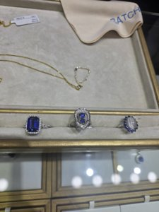 | BG-43 Ring tray — emerald-cut blue halo + double-sapphire pendant-ring + cat's-eye halo  ⚠ This photo shows several pieces — please list EACH one separately (its own stock #, carat, size and price).  Your stock / SKU #: ________________________________________  Gemstone, variety & colour: e.g. Ceylon blue sapphire ________________________________________  Ceylon / Sri Lanka origin — documented? Natural or synthetic? ________________________________________  Treatment — HEATED or UNHEATED? (and any other treatment): ________________________________  Lab report? (GRS / GIA / SSEF / Lotus / GIT) — number, and included in price? ________________________________________  Carat weight — centre stone / total: ________________________________________  Main stone size (mm) & cut: ________________________________________  Diamonds (if any) — total ct, natural or lab-grown, colour/clarity: ________________________________________  Metal — type, purity (14k/18k/22k/platinum) & colour + gross weight (grams): ________________________________________  Handmade / cast / CAD? One-of-a-kind or can it be re-made? ________________________________________  Ring size now + resizable range (min–max) + cost & time to resize: ____________________________  Other versions available (gem colour / size / carat): ________________________________________  Part of a set? matching pieces available + their prices: ____________________  Your trade price (USD) / normal retail (USD): ________________________________________  Delivered/landed price to our ZIP (incl. insured shipping + export + duty): ________________________________________  High-res photos + video available for this piece? (Y / N) ________________________________________

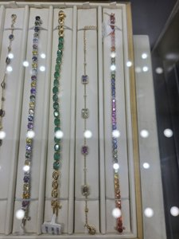 | BG-44 Bracelet tray — multi-sapphire, emerald & rainbow tennis/line bracelets  ⚠ This photo shows several pieces — please list EACH one separately (its own stock #, carat, size and price).  Your stock / SKU #: ________________________________________  Gemstone, variety & colour: e.g. Ceylon blue sapphire ________________________________________  Ceylon / Sri Lanka origin — documented? Natural or synthetic? ________________________________________  Treatment — HEATED or UNHEATED? (and any other treatment): ________________________________  Lab report? (GRS / GIA / SSEF / Lotus / GIT) — number, and included in price? ________________________________________  Carat weight — centre stone / total: ________________________________________  Main stone size (mm) & cut: ________________________________________  Diamonds (if any) — total ct, natural or lab-grown, colour/clarity: ________________________________________  Metal — type, purity (14k/18k/22k/platinum) & colour + gross weight (grams): ________________________________________  Handmade / cast / CAD? One-of-a-kind or can it be re-made? ________________________________________  Other versions available (gem colour / size / carat): ________________________________________  Part of a set? matching pieces available + their prices: ____________________  Your trade price (USD) / normal retail (USD): ________________________________________  Delivered/landed price to our ZIP (incl. insured shipping + export + duty): ________________________________________  High-res photos + video available for this piece? (Y / N) ________________________________________

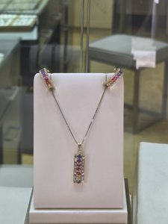 | BG-46 Rainbow fancy-sapphire bar pendant + matching hoop earrings (set)  Your stock / SKU #: ________________________________________  Gemstone, variety & colour: e.g. Ceylon blue sapphire ________________________________________  Ceylon / Sri Lanka origin — documented? Natural or synthetic? ________________________________________  Treatment — HEATED or UNHEATED? (and any other treatment): ________________________________  Lab report? (GRS / GIA / SSEF / Lotus / GIT) — number, and included in price? ________________________________________  Carat weight — centre stone / total: ________________________________________  Main stone size (mm) & cut: ________________________________________  Diamonds (if any) — total ct, natural or lab-grown, colour/clarity: ________________________________________  Metal — type, purity (14k/18k/22k/platinum) & colour + gross weight (grams): ________________________________________  Handmade / cast / CAD? One-of-a-kind or can it be re-made? ________________________________________  Other versions available (gem colour / size / carat): ________________________________________  Part of a set? matching pieces available + their prices: (we think: Pendant + matching hoops) ____________________  Your trade price (USD) / normal retail (USD): ________________________________________  Delivered/landed price to our ZIP (incl. insured shipping + export + duty): ________________________________________  High-res photos + video available for this piece? (Y / N) ________________________________________

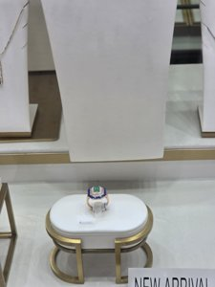 | BG-47 Emerald + lapis + mother-of-pearl inlay Art-Deco ring  Your stock / SKU #: ________________________________________  Gemstone, variety & colour: e.g. Ceylon blue sapphire ________________________________________  Ceylon / Sri Lanka origin — documented? Natural or synthetic? ________________________________________  Treatment — HEATED or UNHEATED? (and any other treatment): ________________________________  Lab report? (GRS / GIA / SSEF / Lotus / GIT) — number, and included in price? ________________________________________  Carat weight — centre stone / total: ________________________________________  Main stone size (mm) & cut: ________________________________________  Diamonds (if any) — total ct, natural or lab-grown, colour/clarity: ________________________________________  Metal — type, purity (14k/18k/22k/platinum) & colour + gross weight (grams): ________________________________________  Handmade / cast / CAD? One-of-a-kind or can it be re-made? ________________________________________  Ring size now + resizable range (min–max) + cost & time to resize: ____________________________  Other versions available (gem colour / size / carat): ________________________________________  Part of a set? matching pieces available + their prices: ____________________  Your trade price (USD) / normal retail (USD): ________________________________________  Delivered/landed price to our ZIP (incl. insured shipping + export + duty): ________________________________________  High-res photos + video available for this piece? (Y / N) ________________________________________

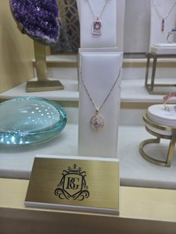 | BG-48 Pink sapphire pear in openwork circle rose-gold pendant  Your stock / SKU #: ________________________________________  Gemstone, variety & colour: e.g. Ceylon blue sapphire ________________________________________  Ceylon / Sri Lanka origin — documented? Natural or synthetic? ________________________________________  Treatment — HEATED or UNHEATED? (and any other treatment): ________________________________  Lab report? (GRS / GIA / SSEF / Lotus / GIT) — number, and included in price? ________________________________________  Carat weight — centre stone / total: ________________________________________  Main stone size (mm) & cut: ________________________________________  Diamonds (if any) — total ct, natural or lab-grown, colour/clarity: ________________________________________  Metal — type, purity (14k/18k/22k/platinum) & colour + gross weight (grams): ________________________________________  Handmade / cast / CAD? One-of-a-kind or can it be re-made? ________________________________________  Other versions available (gem colour / size / carat): ________________________________________  Part of a set? matching pieces available + their prices: ____________________  Your trade price (USD) / normal retail (USD): ________________________________________  Delivered/landed price to our ZIP (incl. insured shipping + export + duty): ________________________________________  High-res photos + video available for this piece? (Y / N) ________________________________________

Thank you very much — this lets us build proper listings and price everything correctly for the U.S. market. We are excited to work together!

