|  |  |
| --- | --- |
|  | International Inc.  ACS |
| **WCS ODS Installation Guide** | |
| Subject: | WCS ODS Installation Guide |
| Version: | 1.0 |
| Last Saved Date: | 10/3/2018 2:53 PM |
| Brief Description: |  |

# 

|  |
| --- |
| Copyright 2018, Mitchell International. All Rights Reserved  This document contains confidential and trade secret information of Mitchell International, Inc. Mitchell International, Inc. has prepared this document for use by its internal personnel in developing new software and hardware products. Any unauthorized use or disclosure of the information herein is prohibited, and the information may not be reproduced, copied, or used in whole or in part without the prior written approval of Mitchell International, Inc. |

**Table of Contents**

Revision History 3

1. WCS ODS versions 4

2. OLTP Reporting DB Objects Deployment 4

2.1 SQL Server Database Objects 4

2.2 SSIS packages 5

2.3 SQL Server Agent Jobs 6

2.4 Smoke Testing 7

3. ODS deployment 9

4.1 SQL Server Database Objects 9

4.2 SSIS packages 9

4.3 SQL Server Agent Jobs 10

4. ODS Format Files 12

5. Megen 12

# Revision History

|  |  |  |  |
| --- | --- | --- | --- |
| Date | Version | Author | Description |
| 09/19/2018 | 0.1 | Theodore Bofia | Initial version. |
| 11/01/2018 | 0.2 | Theodore Bofia | Updated Build labels and Paths |

# WCS ODS versions

As of 10/6/2016, we’ve released the following versions of the ODS:

|  |  |  |  |  |
| --- | --- | --- | --- | --- |
| **Release** | **CM #** | **CM Date** | **Build Label** | **Path to Drop Location** |
| v1.0.0.0 RC | 103365 | 10/25/2018 | SCM_CSG_ODS_SA_v1.0RC_20181025.1 | \\cm1nt\rel\CSG\SCM_CSG_ODS_SA_v1.0RC\20181025.1 |
| v1.0.1.0 RC | 103365 | 10/30/2018 | SCM_CSG_ODS_SA_v1.0RC_20181030.1 | \\cm1nt\rel\CSG\SCM_CSG_ODS_SA_v1.0RC\20181030.1 |
| v1.0.2.0 RC | 103365 | 10/31/2018 | SCM_CSG_ODS_SA_v1.0RC_20181031.1 | \\cm1nt\rel\CSG\SCM_CSG_ODS_SA_v1.0RC\20181031.1 |
| v1.0.3.0 RC | 103365 | 11/01/2018 | SCM_CSG_ODS_SA_v1.0RC_20181101.1 | \\cm1nt\rel\CSG\SCM_CSG_ODS_SA_v1.0RC\20181101.1 |

Current DP OLTP databases are running v1.1.0.0.

# OLTP Reporting DB Objects Deployment

## SQL Server Database Objects

To support the generation of data extracts from each OLTP database, we created objects in the rpt schema that:

1. Determine which tables and columns need to be dumped to file
2. Apply uniform data file formats across all DP versions
3. Keep track of where the last file generation process left off (checkpointing)

The production builds for this are located here:

*\\cm1nt\rel\CSG\SCM_CSG_ODS_SA_<Version>\****<Build>****\Img\OltpReportingDBObjects*

Database deployments are done via the batch file **Install.bat**. The user deploying this code must have sysadmin rights on the SQL server.

For SQL logins:

*Install.bat <ServerName> <UserName> <Password> <DatabaseName>*

For Windows login:

*Install.bat <ServerName> nt nt <DatabaseName>*

Example:

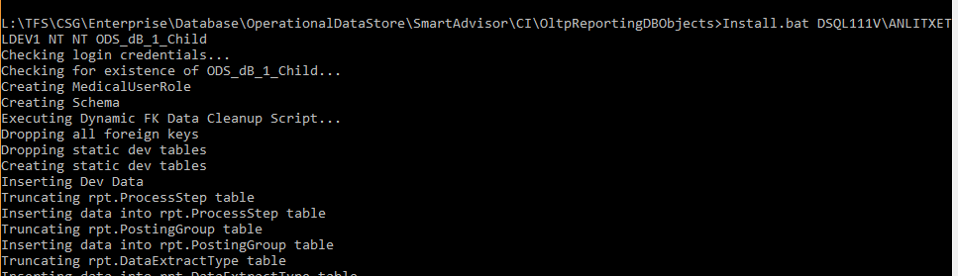

This must be deployed to each production OLTP database that requires reporting capability.

For ACS ODS Robert Henry created an ActiveBatch job to handle the task of running this against all production OLTP instances. In the future, this code can be leveraged to build a completely automated database deployment process.

## SSIS packages OLTP

The SSIS package responsible for generating the data extracts has to be deployed using visual studio from the release branch



* Open SQL Server Management Studio.
* Connect to the SQL Server Database Engine.
* In Object Explorer, expand the server node
* Expand **Integration Services Catalogs** node,
* ***If the SSISDB has not been created, contact DBA.
* Expand SSISDB

***If catalog folder has not yet been created, create a Folder in SSISDB Called **SmartAdvisor_OdsDataDump**

* Right Click SSISDB under intergration services Catalogs
* Create Folder and give the name above.

The SSIS package responsible for importing the data file extracts into the ODS are:

* DataFileExtracts.dtsx

Here’s the location of those packages:

*\\cm1nt\rel\CSG\SCM_CSG_ODS_SA_<Version>\****<Build>****\* *SSIS\Packages\WcsOds*

These are stored in the SSIS Catalog.

Deploy the package to each server by running the batch file in the above path.

For SQL logins:

*Install.bat <ServerName> <UserName> <Password> <DatabaseName> <Folder_name>*

For Windows login:

*Install.bat <ServerName> nt nt <DatabaseName> <Folder_name>*

Note: Folder_name in the command is the folder created in the previous step. In this case: **SmartAdvisor_OdsDataDump**.

## SQL Server Agent Jobs

In order to kick off the SSIS package, we created two SQL Server agent jobs for each OLTP database:

* **DW Data Extracts - <DatabaseName> - Full Load** – This handles creating the initial data extract. It typically runs just once (after initial deployment).
* **DW Data Extracts - <DatabaseName> - Incremental Load** – This handles creating the daily incremental extracts. This job runs every morning on or after 3:00 AM Pacific Time. This doesn’t use a SQL Agent schedule; instead, there’s an ActiveBatch job that executes them daily across all production servers.

Both jobs call the Data File Extracts.dtsx package.

These Jobs are created when the database objects are created. They are only created if they do not already exist.

## Smoke Testing

In order to smoke test in production, we can run both an incremental load, then a full snapshot (in that order) **before the customer is enabled in the ODS**. Both files should then be removed from the NAS (PROD44NAS) in preparation for the generation of the production snapshot (the initial load).

# ODS deployment

## SQL Server Database Objects

The ODS database stores all of the data extracted from the OLTP databases.

The production builds are located here:

*\\cm1nt\rel\CSG\SCM_CSG_ODS_SA_<Version>\****<Build>****\Img\OdsDatabase*

Database deployments are done via the batch file **Install.bat**.

For SQL logins:

*Install.bat <ServerName> <UserName> <Password> <DatabaseName>*

For Windows login:

*Install.bat <ServerName> nt nt <DatabaseName>*

## SSIS packages ODS

The SSIS package responsible for importing the data file extracts into the ODS are:

* OdsLoad_Master.dtsx
* OdsLoad_Archive.dtsx
* OdsLoad_ControlFiles.dtsx
* OdsLoad_Processes.dtsx

Here’s the location of those packages:

*\\cm1nt\rel\CSG\SCM_CSG_ODS_SA_<Version>\****<Build>****\* *SSIS\Packages\SA ODS Loading Project*

These are stored in the SSIS Catalog.

Install packages by running the batch file in the above path.

For SQL logins:

*Install.bat <ServerName> <UserName> <Password> <DatabaseName> <Folder_name>*

For Windows login:

*Install.bat <ServerName> nt nt <DatabaseName> <Folder_name>*

## SQL Server Agent Jobs

In order to kick off the master SSIS package, we’ve created a SQL Server agent job:

* **ETL: Ods DataLoad**

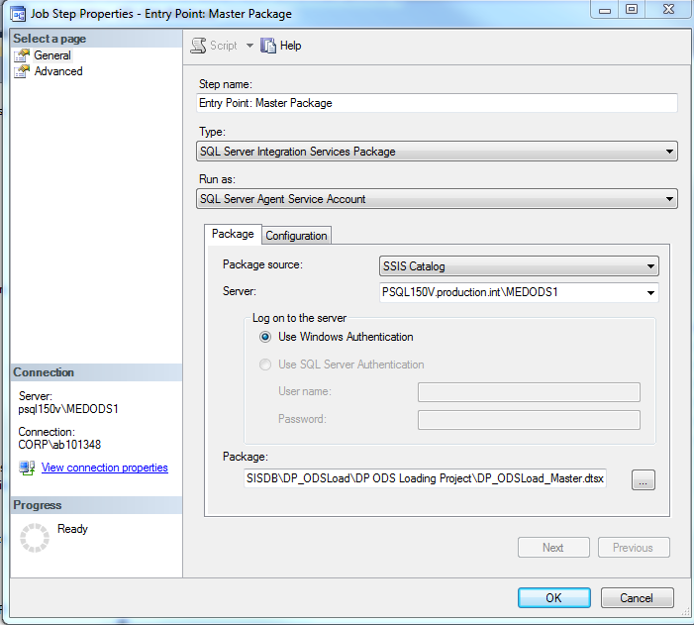

The job currently runs every hour between 3:00:00 AM and 8:59:59 AM.

The package variables are:

* **DataRepositoryPath**: The location where the extract files are stored.
* **TargetDatabase**: The name of the ODS database
* **TargetServer**: The server on which the ODS database sits

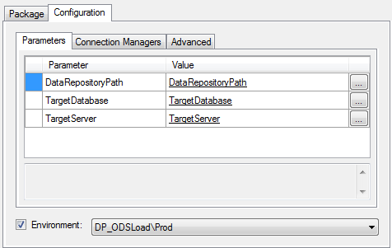

# ODS Format Files

Format files determine the mapping between the data extracts and the table and columns that store this data in the ODS. Each WCS ODS version requires its own set of format files (since the underlying file formats can change).

Here’s the build location:

*\\cm1nt\rel\CSG\SCM_CSG_ODS_SA_<Version>\****<Build>****\Img\ODS_FormatFiles*

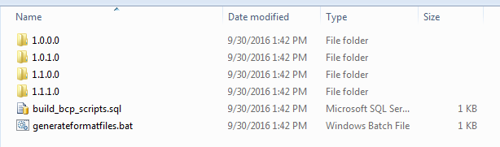

When deploying to production, **all** version folders are copied to ODS_FormatFiles folder of the production NAS.

It’s important to copy and replace previous versions on the production NAS. Changes to the ODS tables will change the format files used to import files generated under previous versions.

# Megen

We use Megen to archive files sitting on the NAS that have already been loaded into the ODS. Those Megen jobs are located here:

*\\cm1nt\rel\CSG\SCM_CSG_ODS_SA_<Version>\****<Build>****\Img\Megen*

