VIETNAM GENERAL CONFEDERATION OF LABOUR
TON DUC THANG UNIVERSITY
FACULTY OF INFORMATION TECHNOLOGY



HUYNH TAN TAI – 523H0090
TRAN NHU MINH TRI – 523H0106

CONDUCT SCORE MANAGEMENT SYSTEM

INFORMATION TECHNOLOGY PROJECT
SOFTWARE ENGINEERING

HO CHI MINH CITY, 2026
VIETNAM GENERAL CONFEDERATION OF LABOUR
TON DUC THANG UNIVERSITY
FACULTY OF INFORMATION TECHNOLOGY

HUYNH TAN TAI – 523H0090
TRAN NHU MINH TRI – 523H0106

CONDUCT SCORE MANAGEMENT SYSTEM

INFORMATION TECHNOLOGY PROJECT
SOFTWARE ENGINEERING
Advisor
M.Sc. Tran Thanh Phuoc

HO CHI MINH CITY, 2026

ACKNOWLEDGEMENTS
First and foremost, we would like to express our sincere gratitude and deep appreciation to M.Sc. Tran Thanh Phuoc. He has continuously provided us with dedicated support and guidance throughout the research process and the completion of the Information Technology Project course with the topic “Conduct Score management”.
Next, we would like to express our gratitude to the Faculty of Information Technology - Ton Duc Thang University for creating favorable conditions for us to study and conduct research throughout our coursework and project implementation. The Faculty of Information Technology has always been ready to support us with knowledge as well as share valuable experience that benefits not only the implementation and completion of this research topic but also our learning and practice at Ton Duc Thang University.
Finally, after a period of studying and implementing the project, we have completed it thanks to the guidance, support, and knowledge gained from our lecturers. Due to limitations in knowledge and skills, shortcomings and limitations are inevitable. We sincerely welcome feedback and guidance from our lecturers to refine our report further. We will strive to achieve better results in future research papers and projects.
We sincerely thank you!

INSTRUCTOR EVALUATION FORM

Instructor's Full Name: M.Sc. Tran Thanh Phuoc.
Feedback:

Total score according to the rubric evaluation form:

Ho Chi Minh City,…................ 2026
Advisor
(Signature and Full Name)

M.Sc. Tran Thanh Phuoc
THIS PROJECT WAS COMPLETED AT TON DUC THANG UNIVERSITY

Our team hereby declares that this research is our own work, conducted under the academic guidance of M.Sc. Vu Dinh Hong. The contents and results presented in this project are truthful and have not been previously published in any form. The data in the tables used for analysis, observation, and evaluation were collected by the authors from various sources, all of which are clearly cited in the references section.
Furthermore, any observations, evaluations, or data from other authors and organizations referenced in this report have been fully cited with their original sources annotated.
If any plagiarism or academic dishonesty is detected, our team takes full responsibility for the content of our Graduation Thesis Report. Ton Duc Thang University is not liable for any copyright or intellectual property infringements caused by us during the execution of this project (if any).
Ho Chi Minh City,…................ 2026
Advisor
(Signature and Full Name)
Huynh Tan Tai | Tran Nhu Minh Tri

TABLE OF CONTENTS
ACKNOWLEDGEMENTS i
INSTRUCTOR EVALUATION FORM ii
TABLE OF CONTENTS v
LIST OF TABLES ix
LIST OF FIGURES x
CHAPTER 1. INTRODUCTION 1
1.1. Background and rationale 1
1.2. Project objectives 1
1.3. Scope of the project 2
1.4. Practical significance of the project 3
1.5. Structure of the project 3
CHAPTER 2. THEORETICAL BASIS 5
2.1. Current state of existing conduct score management systems Error! Bookmark not defined.
2.1.1. Current state of existing conduct score management systems 5
2.1.2. Analysis of studies and tech-enabled attendance solutions 6
2.2. Software Architecture and High-Load Processing Techniques 8
2.2.1. Event-Driven Architecture (EDA) 9
2.2.2. Load Balancing Mechanism with Nginx 10
2.2.3. Message Queue with RabbitMQ 10
2.2.4. In-Memory Caching Mechanism with Redis 10
2.3. Application Development and Data Management Technologies 10
2.3.1. Next.js Framework 10
2.3.2. Node.js Runtime Environment 10
2.3.3. PostgreSQL Relational Database 10
2.4. Specialized Techniques in the System 10
2.4.1. GPS Geofencing 10
2.4.2. Rule-Based Recommendation Engine 10
2.4.3. Automated Data Collection Technique (Web Scraping) 10
CHAPTER 3. REQUIREMENTS ANALYSIS 10
3.1. Current State Survey and Business Processes 11
3.1.1. Existing Process Diagram 11
3.1.2. Proposed Process Diagram 11
3.1.3. Description of Specific Business Flows 11
3.2. Functional Requirements 11
3.2.1. Actor Identification 11
3.2.2. Overall Use Case Diagram 11
3.2.3. Detailed Use Case Diagram 11
3.2.4. Use Case Specifications 11
3.3. Non-Functional Requirements 11
3.3.1. Performance & Concurrency 11
3.3.2. High Availability & Scalability 11
3.3.3. Security & Anti-Fraud 11
3.3.4. Usability & UI/UX 11
CHAPTER 4. SYSTEM DESIGN 11
4.1. System Architecture 12
4.1.1. Client Layer 12
4.1.2. Load Balancing & Proxy Layer 12
4.1.3. Application & Service Layer (Node.js API) 12
4.1.4. Message Broker Layer (RabbitMQ) 12
4.1.5. Caching & In-Memory Storage (Redis) 12
4.1.6. Database Layer (PostgreSQL) 12
4.2. ERD Diagram 12
4.3. Database Design 12
4.4. Sequence Diagrams 12
4.4.1. Organizer-Scanned Attendance Flow 12
4.4.2. Student Self-Check-in Flow via QR Code + GPS Geofencing 12
4.4.3. Smart Event Recommendation Flow 12
4.5. User Interface Design 12
CHAPTER 5. DEVELOPMENT AND TESTING 12
5.1. Development Environment and Tools 12
5.2. Source Code Structure & Module Implementation 12
5.3. Infrastructure Deployment & Load Balancing 12
5.4. System Testing Results 12
5.5. Challenges and Lessons Learned 12
CHAPTER 6. SYSTEM DEPLOYMENT AND EVALUATION 12
6.1. Infrastructure Deployment Strategy 13
6.1.1. Containerization with Docker & Docker Compose 13
6.1.2. Nginx Load Balancer Configuration 13
6.2. Load Testing and Performance Measurement 13
6.2.1. Test Scenarios with k6 13
6.2.2. Actual Performance Metrics 13
6.3. Practical Business Impact Assessment 13
CHAPTER 7. Conclusion 13
7.1. Key Achievements 13
7.2. Pros and Cons 13
7.3. Future Development Directions 13
REFERENCES 13

LIST OF TABLES

LIST OF FIGURES
Figure 2.1 System Architecture Blueprint 9
Figure 2.2 Event-Driven Architecture (EDA) 10
Figure 2.3 General Architecture of Nginx Load Balancer and Failover 12
Figure 2.4 RabbitMQ Architecture & Multi-Worker Load Balancing 14

INTRODUCTION

Background and rationale
Conduct scores are an important indicator of student development, but managing them at universities is often slow and heavily dependent on manual work. Scanning student card barcodes at events has made attendance faster, yet the process after scanning remains complicated. Event data must pass through several people, be filtered in Excel, and then sent to administrators for entry into the system. As a result, students may have to wait several weeks, or even a month, before their scores are updated.
Students also lack a clear way to track their current scores. They may not know how many points they still need or which activities they should join before the semester deadline. When a student is missing from a list or encounters a card-scanning error, resolving the issue can take a long time because there is no transparent channel for submitting evidence.
The Conduct Score Management system was developed to address these problems. Attendance data is sent directly from the card reader to the database in real time, removing unnecessary manual steps. A personalized dashboard allows students to check their current scores, receive alerts when they are short of points, and find suitable events to register for.

Project objectives
Digital transformation in student management is no longer an optional choice, but an imperative step if universities wish to optimize operations. However, the majority of current systems remain limited to static, passive, and extremely slow data storage. This project addresses the challenge from an entirely different angle by building a system based on Event-Driven Architecture with real-time response capabilities.
Instead of forcing students and administrators to wait for manual updates, the system assigns tasks to specialized modules operating in parallel. Attendance check-ins occur instantaneously via barcodes, personal QR codes, or GPS Geofencing at event venues to eliminate proxy attendance. Simultaneously, the Smart Advisor engine automatically calculates remaining required conduct scores and cross-references them with each student's free class schedules to recommend suitable events. Information feeds are continuously refreshed through an automated scraping mechanism from official Fanpages, while all appeals and evidence verifications are received and processed online directly on the platform.
This integration completely frees the volunteer team from cumbersome data entry, while providing students with absolute proactivity and transparency. More importantly, this serves as a flexible foundation for the university to extend into other areas of student administration in the future.

Scope of the project
The project designs, develops, and tests a Conduct Score Management and Recommendation System for supporting student activities at the university level. The system focuses on several conduct-score processes, including event publication, real-time attendance tracking, automatic score calculation, activity recommendations, and online evidence submission. The project does not cover other functions of a University Information System, such as academic grade management, tuition payments, or disciplinary records.
The experimental system uses Next.js for the web application and Node.js for backend APIs. Nginx distributes incoming requests across backend services. PostgreSQL stores the main application data, while Redis is used for caching. RabbitMQ handles queued requests during periods with a large number of simultaneous attendance submissions. The system also includes GPS geofencing for location verification during self-check-in and background web scraping scripts for collecting event information automatically.
Testing is conducted at the Faculty level. The evaluation focuses on system performance and stability under the expected workload. Expansion beyond the Faculty level is not included in the current testing scope.

Practical significance of the project
The system supports several administrative tasks related to conduct score management. After an event, staff can process participant lists and update student records with less manual data entry. This can reduce the time required to enter scores and help limit errors during the process. Conduct score records are also updated across the system more quickly.
Students can check their accumulated conduct scores and review activity records online. When they need to request a review or correction, they can submit an appeal through the system instead of visiting different administrative offices.
Administrative staff can review conduct score data, assign scores based on stored activity records, and generate reports for end-of-term evaluation. Relevant information is stored in one system rather than being managed through separate files or manual records.
The current system focuses on conduct score management. Some of its functions, such as data collection, verification, and online record management, could be adapted for other administrative processes if their requirements are similar..

Structure of the project
The project comprises seven chapters, detailed as follows:
- Chapter 1 - Introduction: Presents foundational background and the study's significance.
- Chapter 2 - Theoretical Basis: Provides the foundational knowledge applied in the system.
- Chapter 3 - Requirements Analysis: Identifies core functional requirements and business logic.
- Chapter 4 - System Design: Presents the architecture, data models, modules, and user interfaces,...
- Chapter 5 - Development and Testing: Covers the implementation process and testing results.
- Chapter 6 - Deployment and Evaluation: Outlines deployment strategies and effectiveness evaluations.
- Chapter 7 - Conclusion: Summarizes advantages, limitations, and future development directions.
This structure ensures logical coherence, helping readers seamlessly follow the entire research and development process of the system.

THEORETICAL BASIS

Related works and current state of solutions
Managing and evaluating student conduct scores is part of the student assessment process at higher education institutions. As the number of students increases, managing conduct score records and applying evaluation regulations can become more difficult when using traditional methods. This creates a need for systems that can support data processing and score management.
Reviewing related studies and examining the current management process can help identify existing limitations and system requirements. These findings provide the basis for defining the functions and technical requirements of the proposed system.

Current state of existing conduct score management systems
Managing and evaluating student conduct scores is a common part of student administration at universities. Conduct score records are used to document student participation in academic, extracurricular, and other university activities. Universities and functional departments can use these records during the student evaluation process. However, the procedures for collecting activity data, assigning scores, and managing student records still involve several practical difficulties.
In the doctoral dissertation “Management of Student Conduct Evaluation in Vietnamese Universities Today,” Ngo Xuan Hieu (2019)[1] examined conduct evaluation and management practices at higher education institutions in Vietnam. The study found differences in evaluation criteria and methods among universities. Each institution may establish regulations based on its own educational and operational requirements. As a result, scoring methods, activity records, and evaluation procedures may differ between institutions. These differences can make direct comparisons difficult.

Student involvement in monitoring conduct scores is another issue. Some students pay more attention to their records near the end of the evaluation period or when they need to provide evidence for previous activities. This can make it difficult for them to identify missing criteria early in the semester. Providing access to current score records and activity information may help students follow their progress throughout the evaluation period. The system can also display activities that match criteria the student has not yet completed.
Collecting and managing activity data can also require considerable administrative work. A single event may involve several organizing units, a large number of students, and different attendance or verification methods. When information is collected from separate sources and processed manually, staff must verify records before assigning conduct scores. This process can lead to duplicate records, data entry errors, or delays in updating student information.
Technology is already used for some administrative tasks, but the related processes are not always managed through the same system. Event information, registration, attendance verification, evidence submission, and score updates may be handled on different platforms. Students may therefore need to search for activity information and submit supporting documents separately. Staff must also process a large number of records and requests, particularly near evaluation deadlines.
These issues define the main requirements for the proposed conduct score management system. The system is intended to support the collection and management of activity records, attendance verification, score processing, and student access to conduct score information. It can also provide activity information based on relevant evaluation criteria. For administrative staff, the system can reduce some manual data processing and provide reports based on stored records. The effectiveness of these functions will be evaluated within the scope of the project.

Analysis of studies and tech-enabled attendance solutions
Traditional attendance verification methods can require considerable time and manual data processing. They may also be vulnerable to proxy attendance. In study on student attendance systems using geo-location and QR code technologies at Universiti Malaysia Pahang, Ahmat (2018)[2] reported that manual roll calls could take 10–15 minutes before a class begins. The proposed system used smartphones to scan QR codes together with location tracking. This allowed attendance records to be created automatically while checking whether the student was within the required location.
RFID-based systems provide another approach to attendance management. Ishaq and Bibi (2023), in “IoT Based Smart Attendance System Using RFID: A Systematic Literature Review”[3], reviewed 21 primary studies on RFID and IoT-based attendance systems. Their review found that RFID can automate attendance recording and reduce the need for manual data entry. However, an RFID system usually verifies the presence of a card or device. It does not necessarily confirm that the person carrying the credential is its authorized owner. This creates a limitation when identity verification is required.
Facial recognition can be used to verify whether a student remains present after checking in. In “AttenFace: A Real Time Attendance System using Face Recognition, Rao (2022)” [4] proposed a system that processes images from classroom cameras at different points during a session. The recognition process runs on a 10-minute cycle instead of continuously processing live video. This reduces the amount of computation required and can identify cases in which a student checks in and leaves before the class ends. However, the approach requires cameras, processing resources, and appropriate measures for handling biometric data.
A more recent study by Siregar, Maulana, Isnaini, Sabrina, and Hutahaean (2026) examined a mobile attendance system that combines dynamic QR codes with GPS geofencing.[5] The system was evaluated in a higher education environment. The reported mean response time was below 1.5 seconds. For location verification, the average GPS error was 4.2 meters outdoors and 12.5 meters indoors, while the configured geofencing radius was 30 meters. These results show that the tested configuration could perform location verification within the defined boundary.

The reviewed studies address different parts of the attendance process. RFID supports automatic attendance recording, while facial recognition can be used to check continued presence. QR codes combined with GPS allow the system to check both a temporary attendance credential and the device location. Based on these characteristics, the proposed system uses time-limited QR codes together with location verification. The Haversine formula is used to calculate the distance between the student's device and the designated check-in location.
Attendance verification is only one part of the system. The platform must also handle periods when many users submit requests at the same time. Rather than relying on benchmark values reported for other systems, this project evaluates the performance of the implemented platform through load testing. Nginx distributes incoming requests across backend services. Redis is used to reduce repeated data retrieval, while RabbitMQ processes queued requests separately from the main request flow. System performance is measured using requests per second, latency, throughput, and error rates.
The reviewed studies provide reference values for the attendance mechanisms used in this project. These include the 10–15 minutes required for manual roll calls reported by Ahmat (2018), the 10-minute processing cycle used in AttenFace, and the response time and GPS error measurements reported by Siregar et al. (2026). The proposed system combines time-limited QR codes with location verification and applies temporal restrictions to the check-in process. Its ability to handle concurrent requests will be evaluated through load testing of the implemented system.

Software Architecture and High-Load Processing Techniques
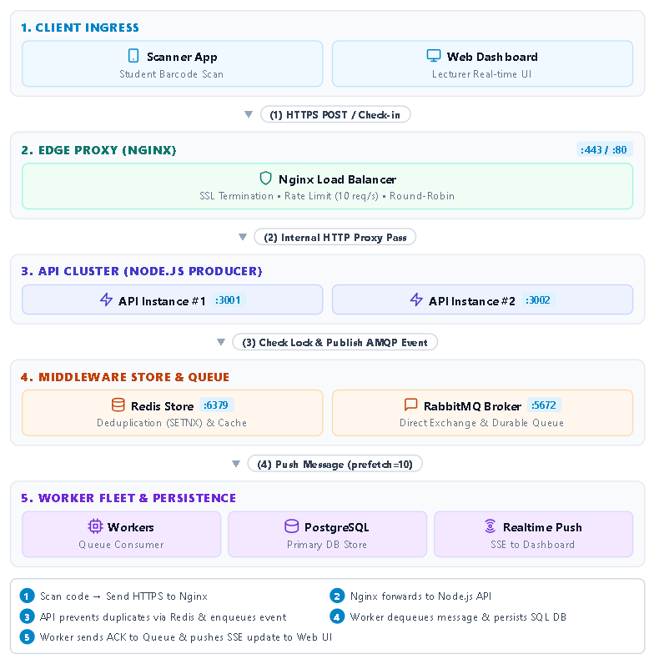
Figure 2.1 System Architecture Blueprint

Event-Driven Architecture (EDA)
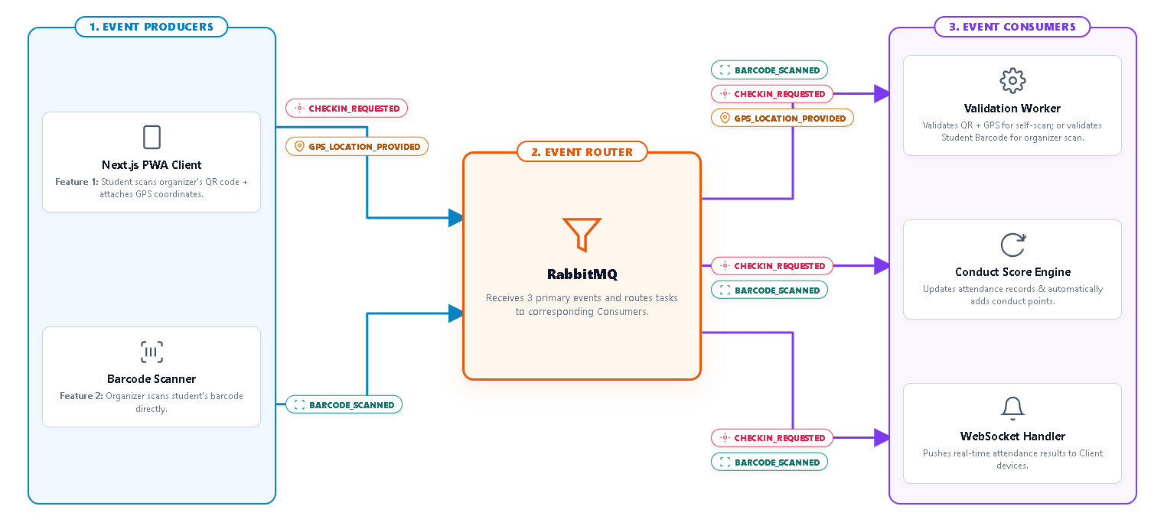Event-Driven Architecture (EDA) is a software architecture pattern in which system components communicate through events. An event represents a change in the state of the system that may require further processing. In an attendance and conduct score management system, examples include a student submitting an attendance request, the system confirming the student's location, and a conduct score update,...
Figure 2.2 Event-Driven Architecture (EDA)
In a traditional request-response model, the client sends a request and waits for the server to complete the corresponding operation. This approach can become a limitation when many users send requests at the same time. EDA separates the handling of incoming events from the services that process them. In this system, the architecture separates three main components:
- Event Producers: Events originate from student-facing applications, including the Next.js PWA Client and Barcode Scanners. The Next.js PWA Client creates an attendance request when a student scans a QR code and sends the device's GPS coordinates with the request. The Barcode Scanner creates an event when a student ID barcode is scanned. Events are CHECKIN_REQUESTED, GPS_LOCATION_PROVIDED, and BARCODE_SCANNED. These events are sent to the Event Router.
- Event Router / Message Broker: RabbitMQ acts as the Event Router and Message Broker in the architecture. It receives events from the Event Producers and routes them to the appropriate Consumers through queues. RabbitMQ handles the three main event types, such CHECKIN_REQUESTED, GPS_LOCATION_PROVIDED, and BARCODE_SCANNED. Each event is delivered to the worker that handles the corresponding task.
- Event Consumers: Event Consumers receive events from RabbitMQ and process them according to their assigned tasks. The system has three main Consumers:
  - Validation Worker: Receives the attendance request, QR code data, and GPS coordinates. It checks the attendance conditions based on time and location. It can also verify the student's identity using the scanned barcode.
  - Conduct Score Engine: Receives the validated check-in result, updates the attendance record, and calculates the corresponding conduct scores.
  - WebSocket Handler: Receives the processing result and sends the attendance status to connected client applications through WebSocket connections.
The Event-Driven Architecture separates the initial attendance request from the processing tasks that follow. This design provides several benefits for the attendance system:
- Handling peak traffic: When many students scan their codes at the same time, incoming requests are placed in queues instead of being processed by the database at once. This reduces the number of concurrent database operations and helps prevent connection pool exhaustion.
- Faster initial response: After a student submits an attendance request, the system can return a request acknowledgement before completing the remaining processing steps. Tasks such as Haversine distance calculation, QR or barcode validation, PostgreSQL updates, and conduct score calculation can be handled by background workers. The target response time for the initial acknowledgement is less than 10 ms.
- Handling service failures: If the Conduct Score Module or Push Notification Service becomes temporarily unavailable, the attendance event can remain in the message queue instead of being lost immediately. Failed messages can be moved to a Dead Letter Queue (DLQ) for later review and processing.

Load Balancing Mechanism with Nginx

Business Context and Problem Statement
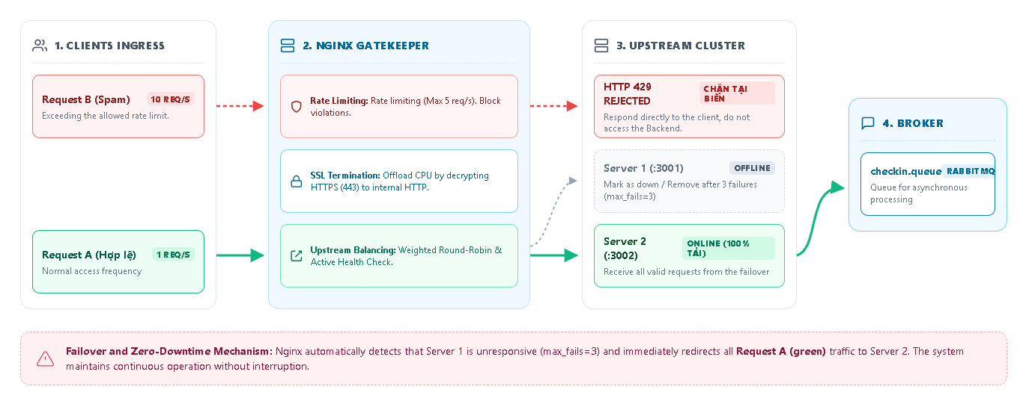In a Student Attendance and Conduct Score Management System, the number of check-in requests can increase significantly during large events or mandatory assemblies. Many students may submit requests within the same period.
Figure 2.3 General Architecture of Nginx Load Balancer and Failover
Using only one backend instance can limit the number of requests the system can process at the same time. As the workload increases, response time may also increase. The system can use Nginx as a reverse proxy and load balancer to distribute incoming requests across multiple backend instances. RabbitMQ can then queue requests that require further processing.
This design provides several functions:
- Distributing incoming requests: Nginx forwards check-in requests to available backend instances instead of sending all requests to a single server. This reduces the workload on each instance.
- Handling unavailable backend instances: If a backend instance becomes unavailable, requests can be routed to other available instances, depending on the configured load-balancing and health-check mechanism.
- Filtering requests at the edge: Nginx can apply rate limits and request filtering before traffic reaches the application services. This can reduce unnecessary or excessive requests handled by the backend.

Load Balancing and Request Routing Algorithms
Weighted Round-Robin Routing: Nginx distributes incoming check-in requests across backend instances, such as those running on ports :3001 and :3002. The weight value assigned to each instance determines how frequently it receives requests. Instances with higher capacity can be assigned a higher weight.
Stateless Routing: The system uses JSON Web Tokens (JWTs) for authentication instead of storing session data in the local memory of a backend instance. Because authentication information is included in the token, a request can be handled by any available backend instance that can validate the JWT.

System Protection Mechanisms at the Nginx Edge Layer
Rate Limiting: Nginx can limit the number of requests received from a client using directives such as limit_req_zone. For example, a limit of 5 req/s can be configured for each IP address. When a client exceeds the configured limit, Nginx can reject or delay requests according to the configuration. Rejected requests may return HTTP 429 Too Many Requests. This reduces the number of excessive requests forwarded to the backend.
SSL/TLS Termination: Nginx can handle TLS connections at the edge of the system. After TLS termination, requests can be forwarded to the Node.js backend through the internal network. This centralizes TLS handling and avoids requiring every backend instance to manage external TLS connections directly.

Failover and Asynchronous Queue Processing
Passive Health Checking: Nginx can detect backend failures while processing requests. With settings such as max_fails=3 and fail_timeout=30s, a backend instance may be temporarily considered unavailable after the configured number of failed connection attempts. Requests can then be sent to other available instances. For example, if the instance on port 3001 cannot accept connections, subsequent requests may be routed to the instance on 3002, depending on the upstream configuration.
RabbitMQ Message Queue: After an attendance request reaches a backend instance, the application can publish the data to a RabbitMQ queue such as checkin.queue. Background workers can then process tasks that do not need to be completed before the initial response, including attendance validation, database updates, or conduct score calculations. The request flow can therefore be represented as: Nginx → Node.js Backend → RabbitMQ → Background Workers
The actual response time and queue processing performance should be measured during system testing rather than stated as a fixed result unless benchmark data is available.

Message Queue with RabbitMQ
This section describes how RabbitMQ is used in the system to route, store, and process attendance-related messages. The design covers AMQP routing, message acknowledgment, queue settings, and the handling of failed messages.
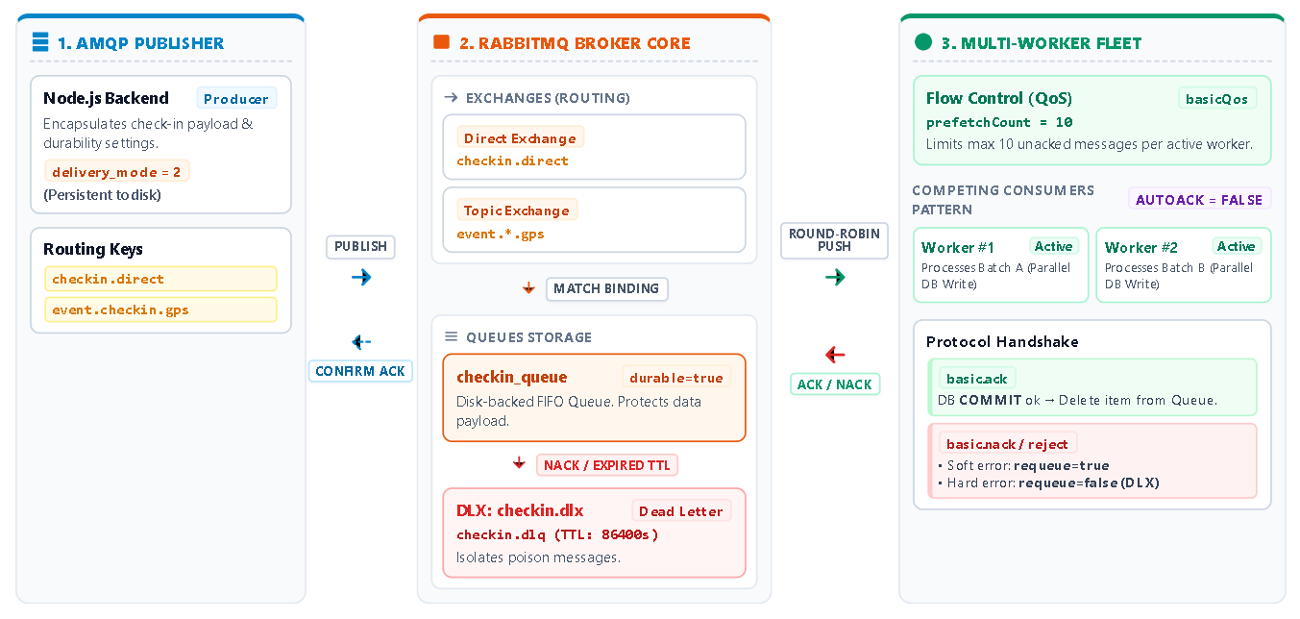
Figure 2.4 RabbitMQ Architecture & Multi-Worker Load Balancing

AMQP Model and Message Routing
RabbitMQ uses the Advanced Message Queuing Protocol (AMQP). In the proposed system, messages are published by the backend to an Exchange, which routes them to one or more queues according to the configured bindings.
The main components are:
- Exchange: Receives messages published by the backend and routes them according to the exchange type, routing key, and configured bindings. An Exchange does not normally store messages itself. The system can use a Direct Exchange for specific check-in events and a Topic Exchange for events that follow a routing pattern, such as GPS or device-related events.
- Binding: Connects an Exchange to a Queue and defines the routing rule used for that connection. Depending on the exchange type, the binding can contain a binding key that is compared with the routing key of an incoming message.
- Queue: Stores messages until they are delivered to a Consumer. Queue behavior and message storage depend on the queue configuration and the durability settings used by the RabbitMQ broker.
The system applies two routing patterns:
- Direct Routing: Used for events that should be sent to a specific queue. For example, a message published with the routing key checkin.direct can be routed to checkin_queue when the Direct Exchange has a matching binding.
- Topic Routing: Used when event names follow a common pattern. For example, the routing key event.checkin.gps matches the binding pattern event.*.gps, where * represents exactly one word separated by dots.

Message Reliability and Processing
The system uses durable queues and persistent messages to improve message recovery after a RabbitMQ restart.
- Queue and Message Persistence
- Queue Durability: The attendance queue can be declared with durable: true. This allows the queue definition to survive a broker restart.
- Message Persistence: Published messages can be marked as persistent using delivery_mode: 2 or the equivalent persistent: true option, depending on the client library.
Queue durability and persistent messages reduce the risk of losing messages during broker failures, but they should not be described as an absolute guarantee against every type of data loss.
- Manual Acknowledgment
The Workers use manual acknowledgment by setting noAck to false. A message remains unacknowledged until the Worker reports that processing has completed.
- Successful Processing (basic.ack): The Worker processes the message and performs the required database operations. If the database transaction is successfully committed, the Worker sends an acknowledgment to RabbitMQ. RabbitMQ can then remove the message from the queue.
- Failed Processing (basic.nack): If processing fails, the Worker can reject the message using basic.nack. For temporary failures, the message may be requeued by setting requeue to true. The transaction should be rolled back before the message is made available for another processing attempt.

Backpressure and Failed Message Handling
- QoS and Prefetch
The system can configure a prefetch count to limit the number of messages delivered to a Worker before previous messages are acknowledged.
For example, with a prefetch count of 10, a Worker channel can have up to 10 unacknowledged messages, depending on the QoS configuration. After messages are acknowledged, RabbitMQ can deliver additional messages.
This prevents a single Worker from receiving an unlimited number of unacknowledged messages while it is still processing previous tasks. The actual distribution of messages between Workers may depend on processing time, Consumer configuration, and queue behavior, so prefetch alone should not be described as guaranteeing perfectly fair distribution.
- Dead Letter Exchange
Messages that cannot be processed successfully should not always be requeued indefinitely. Repeated processing failures can cause the same message to return to the main queue multiple times.
When a Worker rejects a message with requeue = false, RabbitMQ can route it to the configured Dead Letter Exchange. Messages may also be dead-lettered when they expire according to the configured TTL or under other supported dead-letter conditions.
The Dead Letter Queue can then be used to store failed messages for later inspection. Administrators or background processes can review the reason for failure and determine whether the message should be corrected, retried, or discarded.

In-Memory Caching Mechanism with Redis
Redis is used as an in-memory data store to support operations that require fast data access and to reduce repeated queries to PostgreSQL. In the attendance system, Redis is mainly used to handle duplicate check-in requests, cache frequently accessed data, maintain attendance counters, and limit the number of requests from each user.

Preventing Duplicate Check-In Requests
During the check-in process, a student may send the same request more than once by repeatedly scanning a QR code or because the client retries a failed request. To reduce duplicate processing, the API Server creates a temporary Redis key for each check-in request.
The key is formatted as follows: lock:checkin:{eventId}:{studentId}
The key is created using the Redis command: SET key value NX EX ttl
The NX option means that the key can only be created if it does not already exist. The NX option sets an expiration time for the key. In this case, the TTL is set to 10 seconds.
When the first request is received, Redis creates the key. If another request with the same eventId and studentId is sent while the key still exists, Redis does not create a new key. The API Server can then treat the request as a duplicate and stop it before performing additional database operations.

Cache-Aside Strategy for Frequently Accessed Data
Some information is requested many times during an attendance session but does not change often. Examples include event information, the list of eligible students, and the GPS geofence configuration.
This data can be stored in Redis as JSON strings. The application uses the Cache-Aside pattern. The API Server first checks Redis for the requested data. If the data is available, it is returned from the cache. If not, the API Server retrieves it from PostgreSQL and stores it in Redis before returning the result.
Using this approach reduces repeated database queries when many students access the same event information at the same time. The actual effect depends on how often the cached data is requested and how frequently it changes.

Attendance Counter
The system keeps an attendance counter in Redis so that the organizers' dashboard can display the current number of students who have successfully checked in. This avoids querying PostgreSQL with COUNT(*) every time the dashboard needs an updated number.
After a check-in is successfully processed, the system increases the counter for that event using the Redis INCR command
The INCR operation is atomic, so multiple requests can update the same counter without interfering with each other.
A background worker or notification service can read the current value and send updates to connected dashboards through Server-Sent Events (SSE).

Application-Level Rate Limiting
Redis is also used to limit the number of check-in requests sent by each student. This works together with the rate-limiting configuration at the Nginx layer.
The system uses a Redis Sorted Set (ZSET) to implement a sliding window. Each request is stored with its timestamp in a key with the following format: rate:limiter:{studentId}
When a new request arrives, the system removes timestamps that are outside the configured time window and adds the timestamp of the new request. It then counts the remaining requests and compares the result with the configured limit.
For example, if a student is allowed to send up to three requests per second, additional requests beyond this limit receive an HTTP 429 Too Many Requests response.
This helps prevent a single account from sending too many requests within a short period.
Redis is used as a supporting component rather than the main database. PostgreSQL stores the actual attendance records, while Redis handles temporary data such as cached information, request locks, counters, and rate-limiting data.

Application Development and Data Management Technologies

Next.js Framework
Next.js is used to build the frontend of the system based on React. It is combined with Tailwind CSS to develop and maintain the user interface.
The system uses the App Router architecture and separates Server Components from Client Components based on their responsibilities. Components that require user interaction or browser-side state are implemented as Client Components, while other components can be rendered on the server when appropriate.
In the attendance system, Next.js is used to develop the Web Dashboard for instructors. The dashboard displays attendance information and the number of students who have successfully checked in. Server-Sent Events (SSE) are used on the client side to receive updates while an attendance event is active, so the page does not need to be manually reloaded.

Node.js Runtime Environment
Node.js is used as the server-side JavaScript runtime and is built on the V8 Engine. Its event-driven architecture and non-blocking I/O model make it suitable for handling multiple I/O operations at the same time.
In the system architecture, Node.js is used for two main groups of processes:
- API Server (Producer): Receives HTTP requests from mobile applications, performs initial validation, and sends events to the Message Broker.
- Worker (Consumer): Receives messages from the queue and performs background tasks such as processing attendance data and storing records in the database.
Separating the API Server from background workers allows requests from users to be handled without waiting for all database operations to finish.

PostgreSQL Relational Database
PostgreSQL is used as the main relational database of the system. It stores persistent data, including student information, class data, event information, and attendance records.
PostgreSQL supports ACID transactions, which are used for operations that require consistent data processing. Prisma ORM is used to manage the database schema and perform queries between the application and PostgreSQL.
B-Tree indexes can be applied to frequently queried fields. These indexes help reduce query time as the number of records increases.

Docker & Containerization Technology
Docker is used to package and run the components of the system in separate containers. These components include the API Server, Worker processes, Web Dashboard, and supporting services such as Nginx, Redis, RabbitMQ, and PostgreSQL.
Docker Compose is used to define and manage these services in the system architecture. Each service is configured separately and can be started together as part of the same application environment.
Docker provides several practical benefits for the system:
- Environment Consistency: Each container includes the dependencies and configuration required by its service. This helps reduce differences between development, testing, and deployment environments.
- Service Isolation and Scaling: The API Server and Worker services can run as separate containers. Additional instances can be created when needed without installing dependencies manually on the host system.
- Container Networking: Docker allows services to communicate through an internal network using service names. Services such as PostgreSQL, Redis, and RabbitMQ do not need to expose their ports directly to the public network. External HTTP and HTTPS requests are handled through the Nginx reverse proxy.

Specialized Techniques in the System

GPS Geofencing
GPS Geofencing is used to check whether a student is within the allowed area when submitting an attendance request. Each attendance event can be configured with a center location and an allowed radius.
When a mobile device sends an attendance request, the application obtains the student's current coordinates (φ₁, λ₁) and compares them with the configured center coordinates (φ₀, λ₀). The distance d between the two locations is calculated using the Haversine formula:
$$d=2R . arcsin\sqrt{\sin^{2}\left(\frac{Δφ}{2}\right)+\cos\left(φ_{0}\right).\cos\left(φ_{1}\right).\sin^{2}\left(\frac{Δλ}{2}\right)}$$
Where:
- R = 6371 km is the mean radius of the Earth.
- $φ_{0}$ and $φ_{1}$are the latitudes of the configured location and the student's device, expressed in radians.
- $Δφ= φ_{1}-φ_{0}$is the difference in latitude.
- $Δλ$ is the difference in longitude between the two locations.
After calculating the distance d, the system checks whether the student's location is within the allowed radius:
$$f\left(d\right)=\left\{\begin{aligned}1,d≤R_{geofence} \\ 0,d>R_{geofence}\end{aligned}\right.$$
Here, $R_{geofence}$ represents the allowed radius of the attendance area. In the current design, the default value is set to 50 m.
If the calculated distance exceeds the configured radius, the attendance request is rejected.

Rule-Based Recommendation Engine
The system uses a rule-based recommendation mechanism to identify students who still need additional points in specific score categories and suggest relevant events.
The recommendation process first checks the remaining time before the end of the semester. In the current design, the recommendation mechanism becomes active when the semester has 30 days or less remaining. This period was selected to give students enough time to review their current scores and consider upcoming activities.
After the time condition is met, the system reviews the student's accumulated scores and identifies categories that have not reached their required targets. The system then searches for available events associated with those categories.
Only events that are currently ongoing or scheduled to take place before the end of the semester are considered. Events that do not contribute to the student's missing score categories are excluded from the recommendation list.
If suitable events are found, the system sends a notification to the student's application together with information about the relevant events. The student can review the suggested activities and decide whether to participate.

REQUIREMENTS ANALYSIS

Current State Survey and Business Processes

Existing Process Diagram
In the current event attendance process at Ton Duc Thang University (TDTU), student participation is commonly recorded using barcode scanning in combination with Google Sheets. When barcode scanning cannot be performed due to technical issues, attendance may be recorded manually on paper and processed afterward. Although this approach can support basic attendance recording, it still involves several manual steps before the attendance data is reflected in the student conduct score system.
One of the main limitations is the fragmentation of attendance data across different stages of the process. Instead of being recorded directly into a centralized database during the event, attendance information may pass through several intermediate steps, such as barcode scanning → Google Sheets or paper roster → Excel filtering → email or inter-departmental transfer → data import into the Student Portal. Each additional processing step requires data to be transferred, checked, or reformatted, which increases the possibility of inconsistencies between the original attendance record and the final data stored in the system.
Another limitation is the delay between event participation and the update of conduct scores. Since attendance records still need to be collected, filtered, verified, and transferred between responsible units, students may not immediately see the corresponding results on the Student Portal. In practice, updates may take several weeks and, in some cases, may only be completed near the end of the semester. This delay makes it difficult for students to monitor their current conduct scores and identify missing or unrecorded activities in a timely manner.
Exception cases also require considerable manual handling. When a barcode cannot be scanned, a student needs a makeup check-in, or attendance is recorded using a paper roster, event organizers may have to enter or transfer Student IDs manually into spreadsheets. These additional steps increase the administrative workload and create opportunities for data-entry errors, such as incorrect or missing Student IDs. Resolving such errors may require further verification between students, event organizers, and the units responsible for conduct score management.
These limitations indicate that the main issue is not simply the use of barcode scanning itself, but the lack of a continuous data flow from event check-in to attendance verification and conduct score recording. Therefore, a more integrated approach is needed in which attendance data can be captured, validated, and stored directly in a centralized system, while allowing students and administrators to monitor the processing status more promptly. This provides the practical basis for developing an event attendance and conduct score management system with centralized data storage, automated validation, and near-real-time synchronization.

Proposed Process Diagram
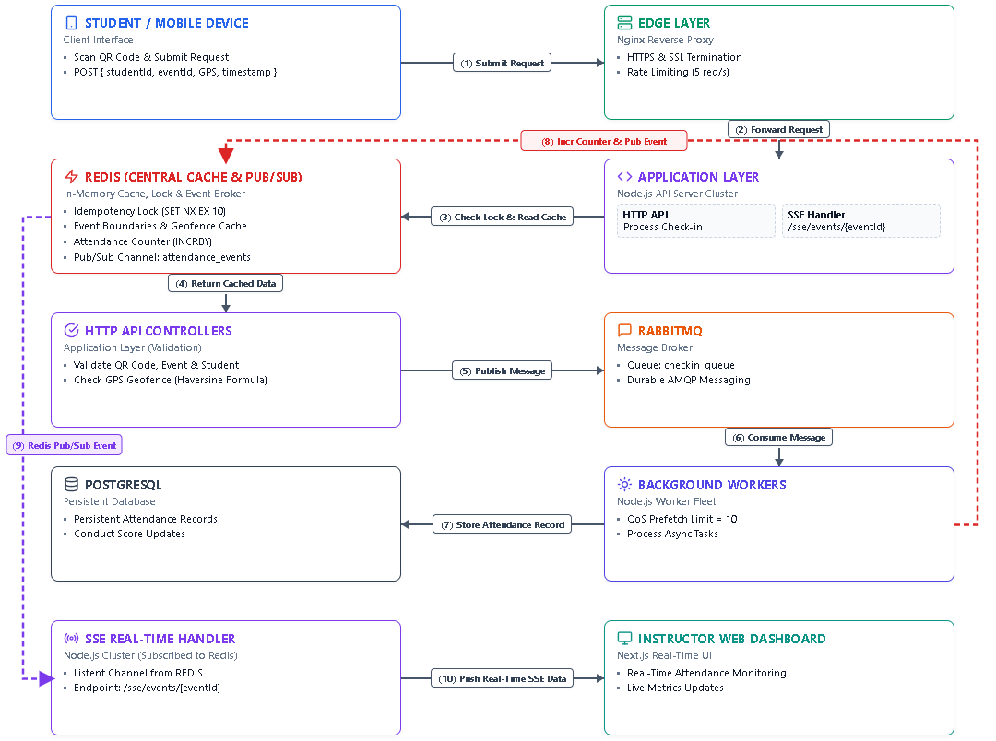
Figure 3.1Proposed Attendance Processing and Real-Time Update Process
Figure 3.1 shows the attendance processing flow from the student's check-in request to the real-time update on the instructor dashboard. The process is divided into request validation, background processing, and dashboard updates.
- Request Validation
When a student scans the event QR code, the mobile client sends the student ID, event ID, GPS coordinates, and timestamp to the system. Nginx receives the request and forwards it to the Node.js API Server.
The API checks Redis for duplicate requests and cached event information. It then validates the QR code, student, event, and GPS location. Valid requests are published to the RabbitMQ checkin_queue for further processing.
- Attendance Processing
Background Workers consume messages from RabbitMQ and process the attendance data. Successful attendance records and related conduct score data are stored in PostgreSQL.
After processing, the Worker updates the attendance counter in Redis and publishes an event to the Redis Pub/Sub channel.
- Real-Time Dashboard Update
The SSE handler subscribes to attendance events from Redis. When a new event is received, the handler sends the updated data through /sse/events/{eventId} to the instructor dashboard.
The Next.js dashboard uses this data to update the attendance count and recent check-in information without reloading the page.

Business Process

Business Process - Attendance
The attendance system supports both single check-in and bi-directional check-in, depending on how an event is configured.
For a single check-in event, students scan once to confirm their attendance. The scan can be performed when entering the event or at the end of the event, depending on the attendance rules set by the organizer.
For a bi-directional event, students are required to scan twice. The first scan records the check-in time, while the second records the check-out time. These two records can be used to determine how long the student stayed at the event.
The system supports two scanning methods:
- Student scans event QR: The organizer displays an event QR code and students scan it using their mobile devices.
- Organizer scans student code: The student presents a personal QR code or barcode, which is scanned by the organizer at the attendance point.
Both methods use the same processing flow. A scan request is sent through Nginx to the Node.js API Server. The API checks duplicate requests through Redis and validates the attendance conditions, including the configured GPS area when required. Valid requests are sent to RabbitMQ and processed by background Workers. Attendance records are stored in PostgreSQL, while Redis Pub/Sub and SSE are used to send attendance updates to the monitoring dashboard.

Business Process - Smart Advisor
The Smart Advisor helps students find events based on their available time and current conduct score progress.
For event recommendations, the system compares upcoming event schedules with the student's timetable. Events that overlap with scheduled classes are excluded, and the remaining events can be suggested to the student.
The system also checks the student's conduct score near the end of the semester. When there are 30 days or less remaining, it identifies score categories that have not reached their required targets. The system then searches for ongoing or upcoming events related to those categories.
If suitable events are available, the student receives a notification containing the relevant event information. The student can review the suggestions and decide whether to register or participate.

Business Process - Verification & Evidence
The verification flow handles attendance appeals and cases where the normal check-in process cannot be completed.
During normal operation, each successful check-in or check-out is stored with information such as the student, event, recorded time, attendance type, and GPS coordinates when location checking is enabled. This information can later be used to review an attendance result.
If the attendance service is temporarily unavailable, the client keeps the attendance request locally instead of immediately treating the attempt as failed. The locally stored data includes the student ID, event ID, scan time, attendance type, and available location information. When the connection is restored, the client can submit the pending request to the server for verification.
Changes made by an administrator are recorded with the administrator, modification time, previous result, new result, and reason for the change. This keeps the original attendance information separate from later administrative adjustments.

Functional Requirements
This section describes the functional requirements of the attendance and event management system. It identifies the system actors and presents the Use Case diagrams for the main system and its sub-systems. The specifications of the main Use Cases are also provided.

Actor Identification
The system involves four main actors:
Table 3.1Actor Description
Code | Name | Description
ACT-01 | Admin | Manages system settings, user accounts, roles, and permissions.
ACT-02 | Faculty Student Affairs  Officer | Manages conduct score activities within the Faculty, manages Event Organizers, monitors student scores, and handles attendance or score disputes
ACT-03 | Event Organizer | Creates and manages events, performs attendance operations, monitors check-in results, and reviews student attendance appeals.
ACT-04 | Student | Participates in events, performs check-in/check-out, tracks conduct scores, receives event recommendations and reminders, and submits attendance appeals.

Use Case Diagram
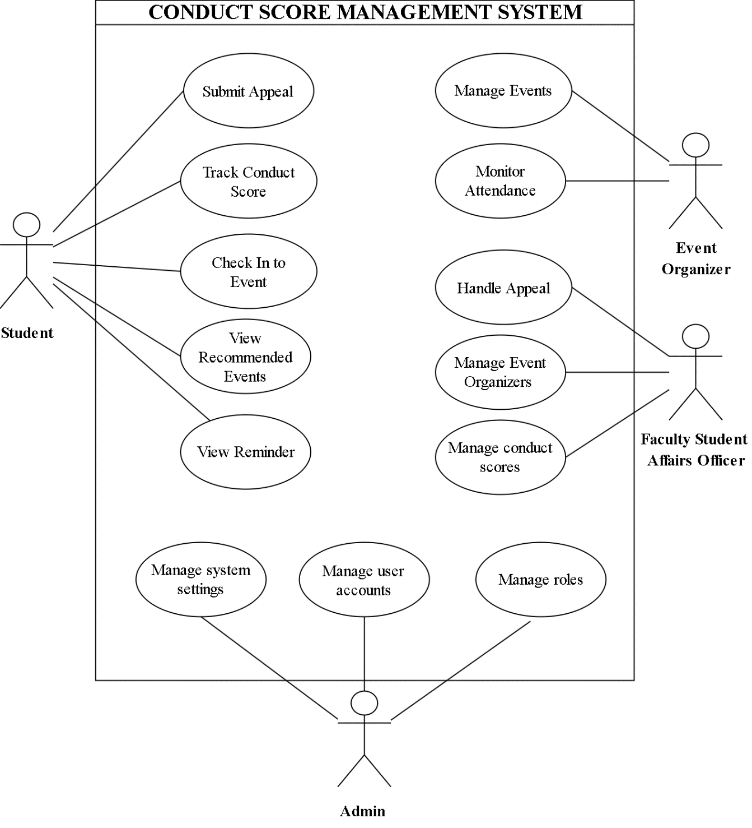
Figure 3.2Overall Use Case Diagram

Table 3.2 Summary of System Use Cases
Code | Use Case | Description
UC1 | Submit Appeal | Allows students to submit appeals related to attendance or conduct scores.
UC2 | Track Conduct Score | Allows students to monitor their conduct scores and score change history.
UC3 | Check In to Event | Allows students to check in when participating in an event.
UC4 | View Recommended Events | Allows students to view events recommended by the system.
UC5 | View Reminder | Allows students to view notifications and reminders related to events or conduct scores.
UC6 | Manage Events | Allows Event Organizers to create, view, update, and delete events.
UC7 | Monitor Attendance | Allows Event Organizers to monitor students’ attendance status and attendance lists for an event.
UC8 | Handle Appeal | Allows Faculty Student Affairs Officers to review and process student appeals.
UC9 | Manage Event Organizers | Allows Faculty Student Affairs Officers to create, view, update, and delete Event Organizer information.

UC10 | Manage conduct scores | Allows Faculty Student Affairs Officers to create, view, update, and delete student conduct score records.
UC11 | Manage system settings | Allows Admins to create, view, update, and delete system configuration settings.
UC12 | Manage user accounts | Allows Admins to create, view, update, and delete user accounts.
UC13 | Manage roles | Allows Admins to create, view, update, and delete roles and their associated permissions.

Use Case Specifications

Use Case - Check In to Event

Use Case - Manage Conduct Scores

Use Case - Submit Appeal & Handle Appeal

Non-Functional Requirements

Performance & Concurrency

High Availability & Scalability

Security & Anti-Fraud

Usability & UI/UX

SYSTEM DESIGN

System Architecture

Client Layer

Load Balancing & Proxy Layer

Application & Service Layer (Node.js API)

Message Broker Layer (RabbitMQ)

Caching & In-Memory Storage (Redis)

Database Layer (PostgreSQL)

ERD Diagram

Database Design

Sequence Diagrams

Organizer-Scanned Attendance Flow

Student Self-Check-in Flow via QR Code + GPS Geofencing

Smart Event Recommendation Flow

User Interface Design

DEVELOPMENT AND TESTING

Development Environment and Tools

Source Code Structure & Module Implementation

Infrastructure Deployment & Load Balancing

System Testing Results

Challenges and Lessons Learned

SYSTEM DEPLOYMENT AND EVALUATION

Infrastructure Deployment Strategy

Containerization with Docker & Docker Compose

Nginx Load Balancer Configuration

Load Testing and Performance Measurement

Test Scenarios with k6

Actual Performance Metrics

Practical Business Impact Assessment

CONCLUSION

Key Achievements

Pros and Cons

Future Development Directions

REFERENCES
- Ngo, X. H. (2019), Management of Student Conduct Evaluation in Vietnamese Universities Today, Doctoral Dissertation in Educational Management, Graduate Academy of Social Sciences, Hanoi. https://fr.slideshare.net/slideshow/luan-van-quan-li-ket-qua-danh-gia-ren-luyen-cua-sinh-vien-hot/142110553
- Ahmat, N. F. S. (2018). Secure Student Attendance System Based on Geo-Location and QR Code Technologies. Final Year Project/Thesis, Universiti Malaysia Pahang. https://umpir.ump.edu.my/id/eprint/27069
- Ishaq, K., & Bibi, S. (2023). IoT Based Smart Attendance System Using RFID: A Systematic Literature Review. https://arxiv.org/abs/2308.02591
- Rao, A. (2022). AttenFace: A Real Time Attendance System Using Face Recognition. https://arxiv.org/abs/2211.07582
- Siregar, R., Maulana, B.., Muhammad Isnaini, Elsa Sabrina, & Hutahaean, H. D. . (2026). Performance Evaluation of a Mobile Attendance System Using Dual-Factor Dynamic Qr Code and Gps Geofencing. Jurnal Multimedia Dan Teknologi Informasi (Jatilima), 7(06),1126–1134. https://doi.org/10.54209/jatilima.v7i06.2281

