Step one

* Have all these files in one folder

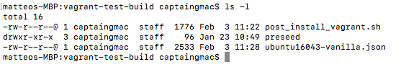

Make sure the preseed file is in the same folder

* Open ubuntu16043-vanilla.json file and in the provisioners section change the path to where our script is located (mine is in the same folder)

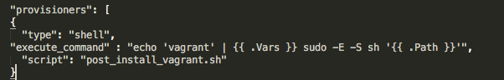

* Open post_install_vagrant.sh file
  + Under the customization section
    - In the script add commands to install apach2 server and for it to automatically start

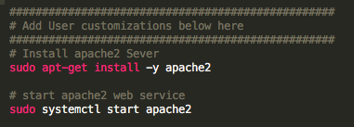

Step two

* Go into the directory where the Ubuntu json file is
  + then in the command line type packer build ubuntu16043-vanilla.json



Wait for the download to finish

* + - now see where the box file got added too ( mine went to my desktop)
      * I then went into the new file and moved on too step 3

Step 3

* add vagrant box to vagrant
  + type vagrant box add ubuntu-vanilla-16043-server-virtualbox-1516773866.box --name ubuntu-test

step 4

* vagrant init ubuntu-test
* vagrant up
* vagrant ssh