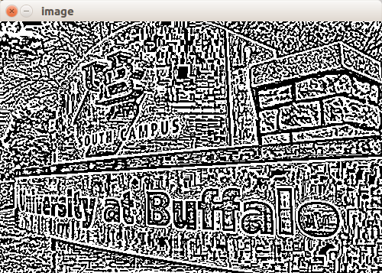Thomas Bong CSE473

HW4 Report

Nov 18 2016

**Problem 1 DoG LoG**

A)

After applying

the DoG mask to the

original image

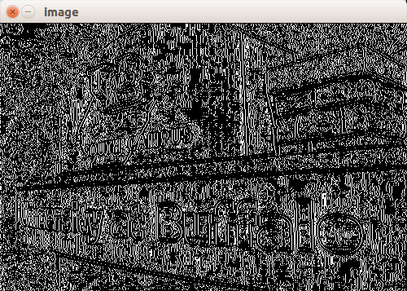

B)

zero crossing of the

image obtained in a)

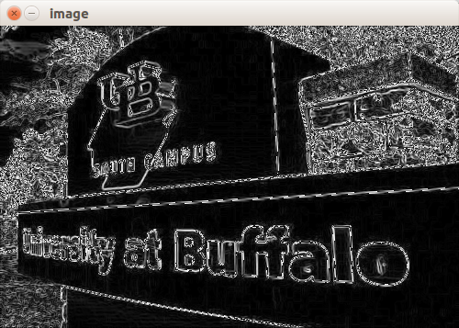

C)

The first derivative

of the original image

by the Sobel operators.

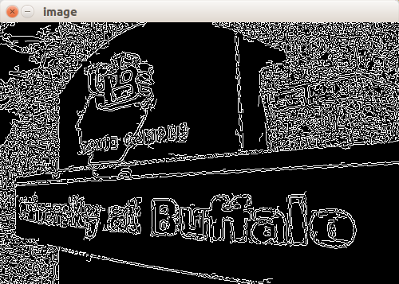C continued..

Zero crossing after getting rid of weak edges

(zero crossing of image obtained in previous

step)

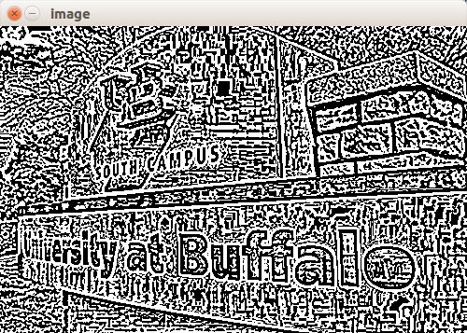

D) LoG

after applying LoG mask to

the original test image

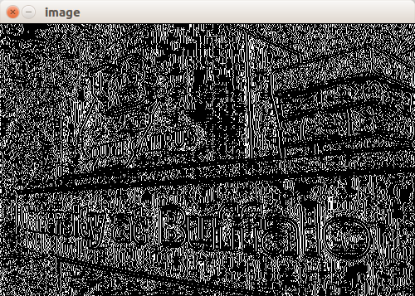D continued.. Zero crossing of LoG

zero crossing of the image obtained

in the previous step(above image)

E) The edges obtained in C(without weak edges) must be different from the image obtained from D(LoG mask) to some extent, because getting rid of weak edges within an image has a substantial amount of impact in edge detecting whereas applying the LoG mask may detect edges but it detects weak edges, too. If the LoG mask consisted of values that neglected weak edges, then the two images may have been similar.

**Problem 2 Region Merging**

Original Image(268 x 400)

Crack Edge Image(536 x 800)

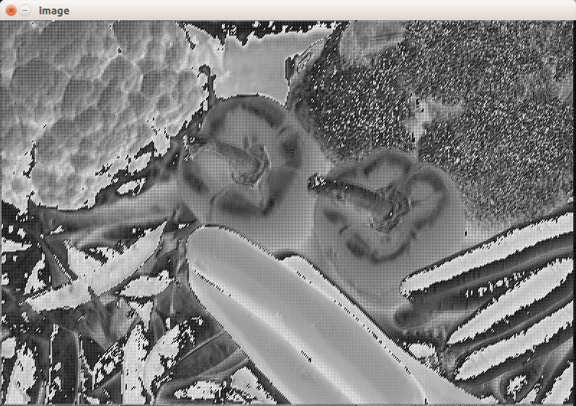

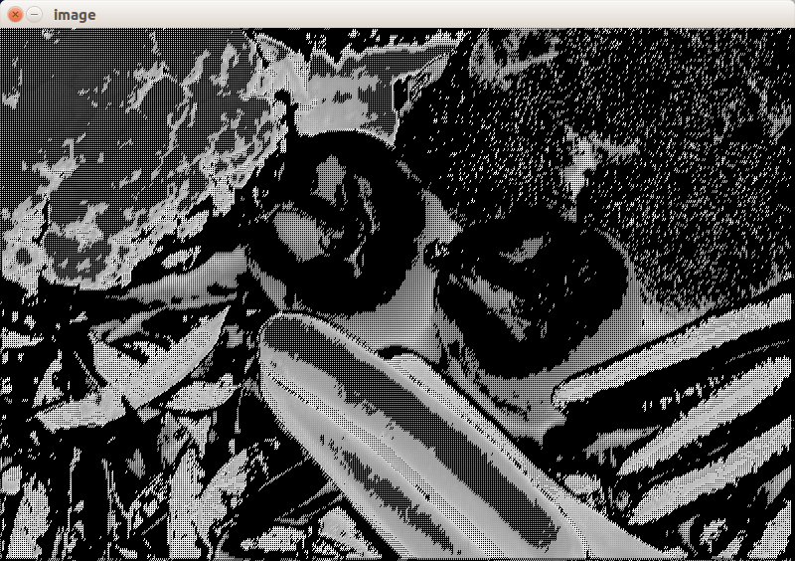Threshold 150

Threshold 180

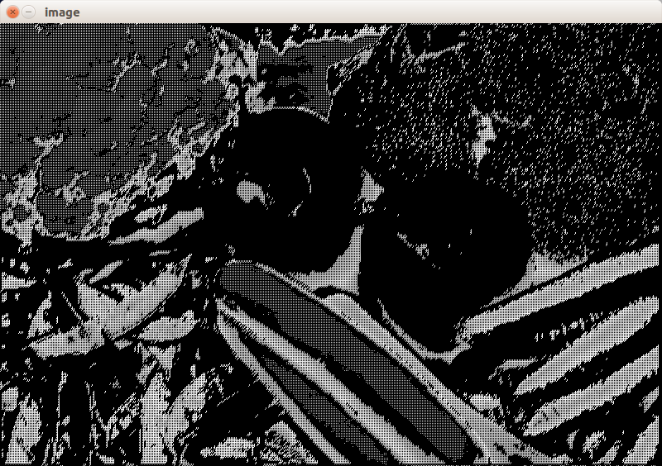

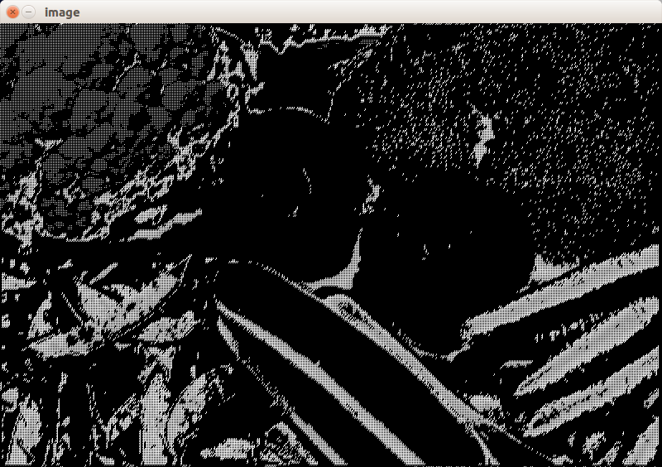Threshold 200

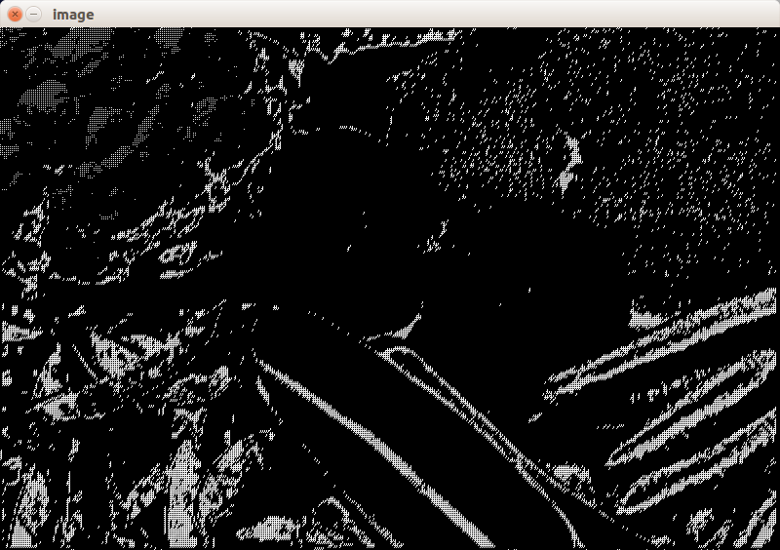Threshold 220

Based on the difference threshold values, the region merging algorithm will output different results. For example, with the image of threshold 220 would treat some of the regions as one region which are not actually the same region but because of the threshold value changes the intensity of the image, region merging algorithm would treat them as one. Based on the output images, threshold 180 returns the most ideal image for region merging algorithm.