Route 53 Custom DNS for the Databricks PrivateLink Endpoint
Design for adding a custom, friendly DNS name (e.g. databricks.internal.example.com) that resolves privately to the Databricks workspace's PrivateLink endpoint, instead of requiring internal users and apps to reference the auto-generated dbc-xxxxxxxx-xxxx.cloud.databricks.com hostname directly.
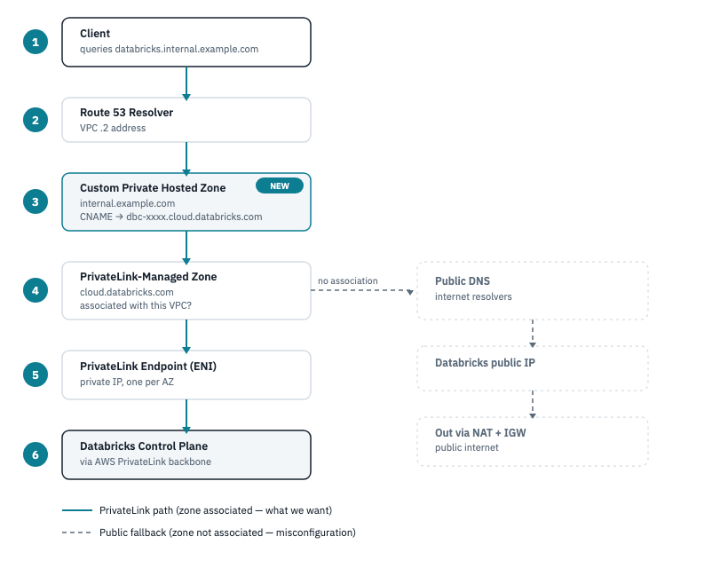
DNS resolution flow for the Databricks PrivateLink endpoint

1. Why this matters
network/main.tf already sets private_dns_enabled = true on the general_access interface endpoint. That makes AWS auto-manage a Route 53 private hosted zone for the exact Databricks hostname (cloud.databricks.com), so clients resolving that hostname inside the VPC get the endpoint's private IP instead of Databricks' public IP — traffic stays on PrivateLink.
That's automatic, but it only resolves the literal workspace hostname. If you want internal tooling to reference something shorter or organization-branded — databricks.internal.example.com — that name doesn't exist anywhere yet. This document adds it as a custom record in a private hosted zone, pointing at the real workspace hostname, so it resolves through the same private path.

2. How resolution works today (no custom entry)
- A client in the VPC queries dbc-xxxxxxxx-xxxx.cloud.databricks.com.
- The query hits the VPC's Route 53 Resolver (the .2 address in the VPC's CIDR).
- The resolver checks hosted zones associated with the VPC. The PrivateLink-managed private hosted zone for cloud.databricks.com is associated here, and the queried name matches it.
- The zone returns the PrivateLink endpoint's ENI private IP (one per AZ).
- Traffic flows to that private IP, over the PrivateLink ENI, onto the AWS PrivateLink backbone to the Databricks control plane — never touching the public internet.
If the zone weren't associated with the VPC (or private_dns_enabled were false), step 3 would fail to match, and the resolver would fall through to public DNS — returning Databricks' public IP, and sending traffic out through the VPC's NAT gateway instead.

3. Adding the custom entry
Add a CNAME record in a private hosted zone, aliasing the custom name to the real workspace hostname:
data "aws_route53_zone" "databricks_private" {
name = "cloud.databricks.com"
private_zone = true
vpc_id = module.network.custom_vpc_id # or aws_vpc.this.id in network/
}
resource "aws_route53_record" "databricks_alias" {
zone_id = data.aws_route53_zone.databricks_private.zone_id
name = "databricks.internal.example.com"
type = "CNAME"
ttl = 300
records = ["dbc-xxxxxxxx-xxxx.cloud.databricks.com"]
}
Two things worth checking before applying this:
- The custom name must live in a zone the VPC can actually query. A CNAME added directly to the PrivateLink-managed zone works only if that zone's apex matches your custom name's parent domain (it generally won't, since the managed zone is cloud.databricks.com, not example.com). More commonly, this record belongs in your own private hosted zone for internal.example.com (or example.com), associated with the same VPC — the CNAME's target still resolves through the PrivateLink-managed zone as a separate, second DNS lookup.
- CNAME, not ALIAS, at a non-apex name. Route 53 alias records only target AWS resources (ELB, CloudFront, other Route 53 records, etc.), not arbitrary external hostnames — a plain CNAME is correct here.

4. Sharing the custom entry across spoke VPCs
If you've followed multi-workspace-provisioning.md to add spoke workspaces, associate your custom zone with each spoke VPC the same way the PrivateLink-managed zone gets shared:
aws route53 associate-vpc-with-hosted-zone \
--hosted-zone-id <your-custom-zone-id> \
--vpc VPCRegion=us-east-1,VPCId=<spoke-vpc-id>
Every VPC needs both zones associated to resolve the custom name end-to-end: your custom zone (for the alias) and the PrivateLink-managed zone (for the real hostname the alias points to).

5. Verify
From an instance or cluster inside the VPC:
dig databricks.internal.example.com
# should return a CNAME to dbc-xxxxxxxx-xxxx.cloud.databricks.com,
# which should itself resolve to a 10.x private IP, not a public one
If it resolves to a public IP, the hosted zone isn't associated with that VPC, or private_dns_enabled is off on the endpoint — traffic will go out through NAT instead of PrivateLink.

