Provisioning Additional Workspaces (Hub-and-Spoke PrivateLink)
How to add workspace 2, 3, etc. in their own VPCs, reusing workspace 1's existing PrivateLink connection to the Databricks control plane instead of building new endpoints for each one.
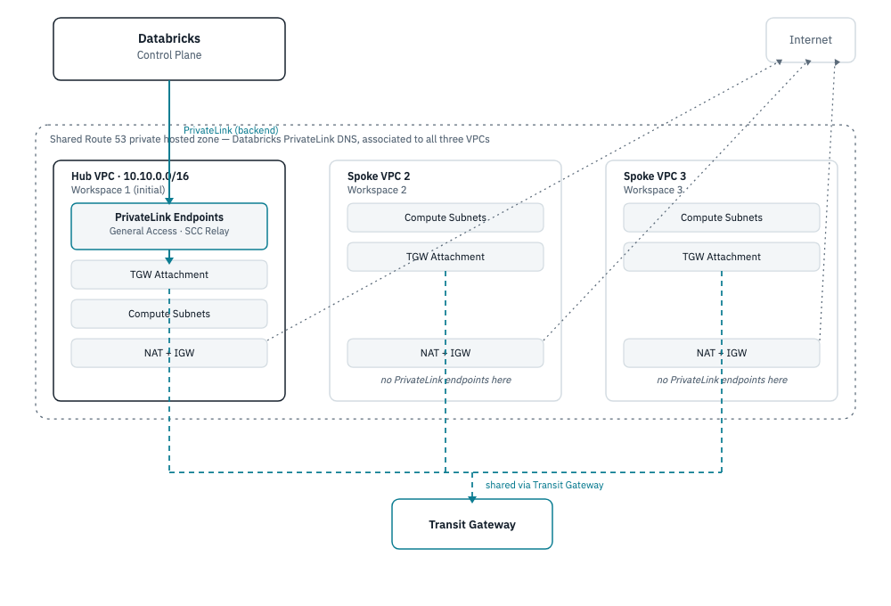
Multi-workspace PrivateLink hub architecture
This assumes workspace 1 (network/ + databricks-sra/) is already applied — see BUILD_PLAN.md. Steps 3 and 4 below (Transit Gateway, Route 53 association) aren't in this repo yet; this document is the runbook for adding them, not a list of commands that already work today.

1. Get the hub's registered PrivateLink endpoint IDs
Spoke workspaces reuse workspace 1's Databricks-side (MWS) VPC endpoint registrations, not the raw AWS endpoint IDs. Pull them from the hub's Terraform state:
cd databricks-sra
terraform state show 'module.databricks_mws_workspace.databricks_mws_vpc_endpoint.general_access[0]' | grep vpc_endpoint_id
terraform state show 'module.databricks_mws_workspace.databricks_mws_vpc_endpoint.scc_tunnel_dataplane_relay_access[0]' | grep vpc_endpoint_id
Note both vpc_endpoint_id values — they go into the spoke's tfvars in step 5.

2. Create the spoke VPC
Copy network/ to network-spoke-2/ and apply it with a different resource_prefix and non-overlapping vpc_cidr (e.g. 10.11.0.0/16).
The spoke doesn't need its own PrivateLink endpoints to the Databricks control plane — it'll reach the hub's instead. Comment out or remove the aws_vpc_endpoint.general_access and aws_vpc_endpoint.scc_relay resources (and the two *_service_name variables) in the copy before applying, since step 4 is what actually connects it to the hub's endpoints.
cd network-spoke-2
terraform init
terraform apply
terraform output # note custom_vpc_id, custom_private_subnet_ids, custom_sg_id

3. Create the Transit Gateway (once, shared by all spokes)
Add this in a new transit-gateway/ directory (or in network/ itself, since the hub VPC attaches to it too):
resource "aws_ec2_transit_gateway" "this" {
description = "dbx-trial PrivateLink sharing"
}
resource "aws_ec2_transit_gateway_vpc_attachment" "hub" {
transit_gateway_id = aws_ec2_transit_gateway.this.id
vpc_id = module.hub.custom_vpc_id # from network/ output
subnet_ids = module.hub.custom_private_subnet_ids
}
Each spoke gets its own aws_ec2_transit_gateway_vpc_attachment. Then, in every VPC's private route table, add a route for the other VPCs' CIDRs pointing at the Transit Gateway:
resource "aws_route" "to_tgw" {
route_table_id = aws_route_table.private.id
destination_cidr_block = "10.0.0.0/8" # covers hub + all spoke CIDRs
transit_gateway_id = aws_ec2_transit_gateway.this.id
}

4. Share the Route 53 private hosted zone
The hub VPC's general_access/scc_relay interface endpoints created a private hosted zone when private_dns_enabled = true. Associate it with each spoke VPC so their clusters resolve the Databricks hostname to the hub's endpoint ENIs:
aws route53 list-hosted-zones-by-vpc --vpc-id <hub-vpc-id> --vpc-region us-east-1
aws route53 associate-vpc-with-hosted-zone --hosted-zone-id <zone-id> \
--vpc VPCRegion=us-east-1,VPCId=<spoke-vpc-id>
(Cross-account associations need an authorization step first via aws route53 create-vpc-association-authorization — not needed here since everything's in the same AWS account.)

5. Deploy the spoke workspace
Copy databricks-sra/ to databricks-sra-2/ (or use a Terraform workspace: terraform workspace new spoke-2). Set its terraform.tfvars:
resource_prefix = "dbx-trial-2"
custom_vpc_id = "<from step 2 output>"
custom_private_subnet_ids = ["<from step 2 output>"]
custom_sg_id = "<from step 2 output>"
custom_general_access_mws_vpce_id = "<from step 1>"
custom_scc_relay_mws_vpce_id = "<from step 1>"
Setting the *_mws_vpce_id variables (already declared in databricks-sra/variables.tf) tells Terraform to skip registering a new AWS endpoint with Databricks and wire the hub's existing registration straight into this workspace's network config.
cd databricks-sra-2
terraform init
terraform plan
terraform apply

6. Verify
- terraform output workspace_host → log in, confirm the workspace loads.
- Start a cluster in the spoke workspace; it should reach the control plane over the hub's PrivateLink connection, not the public internet.
- Confirm the spoke's NAT gateway still gives it independent internet egress for pip install, etc. — that part isn't shared.
Repeat steps 2–6 for each additional workspace, reusing the same Transit Gateway and hosted-zone associations from step 3–4.

