MATLAB Battleship

Team 2

BoraDiTo Co.

CEO Travis Boraten
Chief Engineer Dominic DiTomaso

- Market Analysis – This product provides an entertaining game for people of all ages.
- Goal and Objectives – The goal of this product is create a feasible but profitable application to entertain people by providing a challenging but enjoyable simulation of the classic game of battleship. To achieve this, our product must work properly and run without any errors. The game uses a GUI so it is user friendly. The computer AI is set so that the game is fair.
- Product Description – There are 14 different functions and four figures. First a splash screen pops up for 4.3 seconds, then a figure to place your ships, and then the main figure with an axis to display the 3-D player’s and the computer’s grids, the firing buttons, and text boxes displaying status of ships. A marker is animated in 3-D to look like a missile being fired from both ends at the correct location. When all the ships are sunk another figure pops up and shows who won, statistics, and restarts the game.
- Software Design –
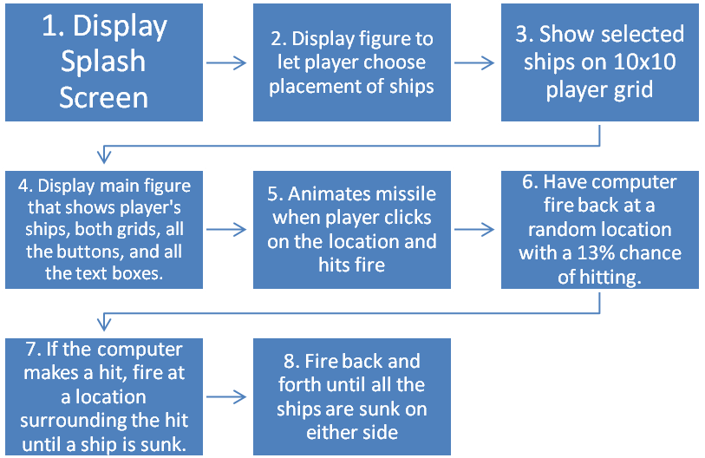
- The splash screen displays a picture with the title for 4.3 seconds.
- Then a figure with a 3-D 10x10 grid appears with a list box, 4 push buttons, 3 drop boxes, and a text box.
- The player can choose which ship to place using a list box. Then uses a drop down box to choose the orientation of the ship, the starting row and column. When the player clicks the pushbutton to submit a ship, it displays the ship on the grid. The user can reset the ships or choose a random formation. When the pushbutton to submit formation is clicked, the figure closes.

1
- After that closes the main figure appears displaying the computer’s grid, the player’s
grid with all of the player’s ships, and a yellow divider in between. 100 grid buttons are shown that are used to select a place to fire. When clicked the location is displayed, the fire button is enabled and turns red.
- After the fire button is clicked, a marker with a tail is animated. The path of the marker is a parabola that goes over the divider and lands at the desired location.
- After .5 seconds the computer chooses a spot to fire back at. If the previous shot was not a hit, the computer has a 83% chance of firing at a random location and a 17% chance of getting a hit.
- Once a hit is made, it checks the surrounding locations for a hit. If another hit is made, it goes in that direction until a ship is sunk or it has nowhere else to fire.
- When either all of the player’s ships are sunk or all of the computer’s ships are sunk, the game is over and statistics are displayed and the game is restarted.
- Software Test – After running the program many times, the figures pop up in the correct order. All of the graphics displayed on the axis and all the buttons and text boxes displayed correctly. The animated missile correctly fires at the desired location. The ships turn to red when hit.
- Summary and Conclusion – The project was evenly split between the two of us. We each had an objective to do and we would meet every couple of days to talk about what we got done and what we can add. We have learned a lot while making this project. We learned how to program the GUI using the callback functions and handles. We learned how to output a variable from one GUI to another. We have learned how to manage our time wisely. Finally we learned how to take on a big project by splitting it up into pieces.

2
Table of Contents
Market Analysis……………………………………………………………………………………………………………..……pg. 1
Goal and Objectives………………………………………………………………….……………………………………...…pg. 1
Product Description………………………………………………….……………………………………………………..….pg. 1
Software Design…………………………………………………………………….………………………………………...pg. 1-2
Software Test………………………………………………………………………………………………………………………pg. 2
Summary and Conclusion…………………………………………………………………………………………………….pg. 2

