Requirements Extractor Architecture document

Table of Contents
1)History of this document 2
2)Introduction 3
3)System description 4
Overview 4
Use cases 4
5)Human Machine Interface 6
MVC Pattern 6
Graphical User Interface 8
6)Software structure 9
UML Class diagram 9
7)Specific information regarding the Word file 10
Requirements naming rule 10
Error detection 10

History of this document
Date | Author | Comment
5th May 2012 | Thomas Bores | Initial version of the document.  Creation of the chapters:  - System description  - HMI  - SW Structure  - Specific information regarding the Word file

Introduction
This document describes the architecture of the program named “Requirements Extractor”

System description
This chapter describes the program: its role, its interaction with the user...

Overview
Goal of the program is to extract the requirements from a Microsoft Word specification document. The program is able to recognize requirements-id thanks to a regular expression given by the user. Once the requirements are extracted in memory, they are then written in an excel file.

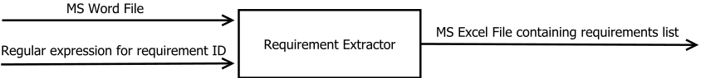

Use cases
The user is able to:
- Enter the path to the Word file, he wants to be parsed by the program.
- Enter a regular expression, so the program can recognize the requirements ID
- Enter a path where he wants to save the output excel file
- Starts the extractions of the requirements
- Read the program run-time status
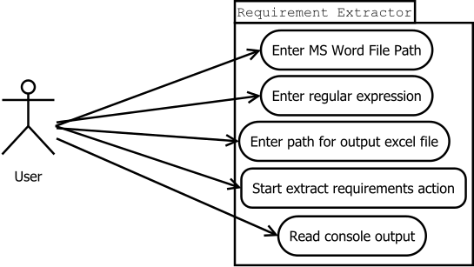

Human Machine Interface
This chapter describes the HMI, it means how the user interacts with the program and how are the information treated.

MVC Pattern
The program use a Model, View, Controller pattern. This pattern is well known in HMI design. It exists different implementation of the MVC pattern. We describe here the implementation for Requirements Extractor.
The View represents the user interface, its actually what the user see on the screen. In our case the user interface is designed with Qt Designer and generated using pyside-uic.
The Model is the collection of data so the View can display program information.
The Controller contains the HMI logic, its role is to detect user inputs like button clicks and to be the interface between the View and the Model. In our case, it can also receives information from the program core.
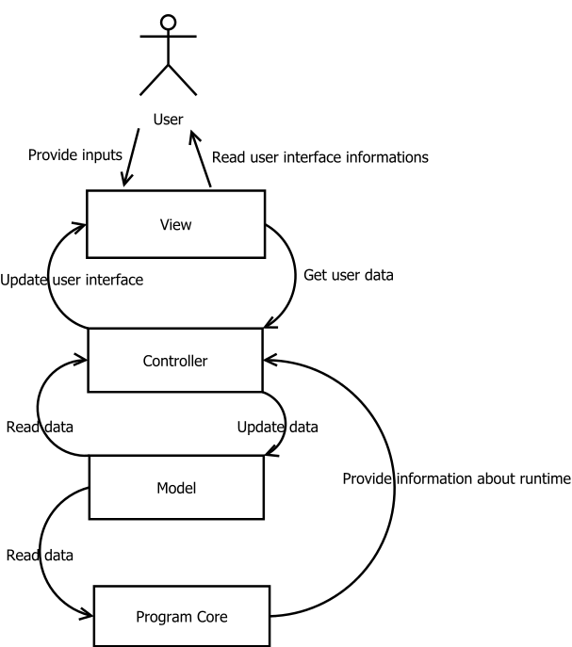

Graphical User Interface
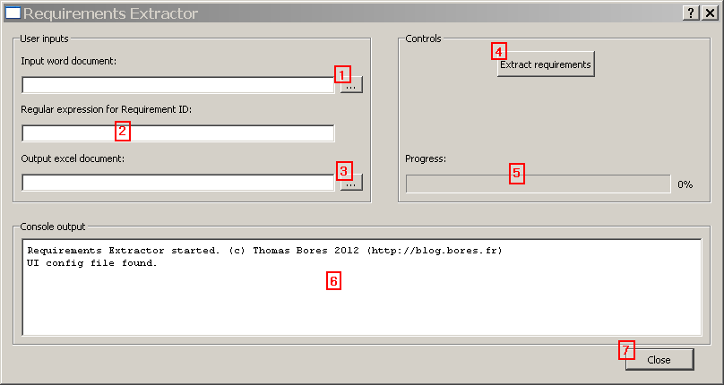
The user interface is composed of six dialogs:
- A main dialog that you can see in the screenshot above.
- A first error dialog that appears when the button 4 is pressed and field 1 is empty.
- A second error dialog that appears when the button 4 is pressed and field 2 is empty.
- A third error dialog that appears when the button 4 is pressed and field 3 is empty.
- A file chooser dialog that appears when the button 1 is pressed.
- A file chooser dialog that appears when the button 3 is pressed.

The main dialog, you can see above, is divided in three parts:
- Users inputs, where the user enter the path of the word and excel documents, and the regular expression.
- Controls, where the user can start the requirements extraction and follow the extraction progress
- Console outputs, where the user can follow the program runtime.

Software structure

UML Class diagram

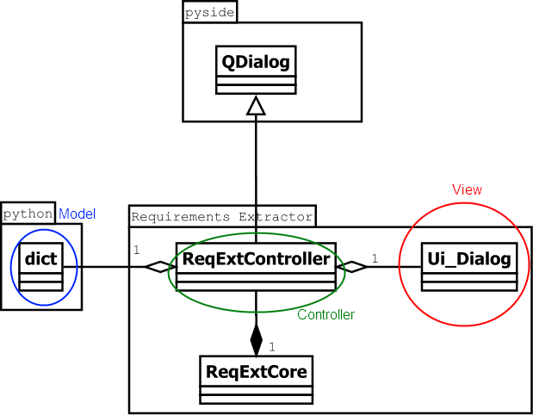

Specific information regarding the Word file

Requirements naming rule
The program assumes that the Word files respects the following rules in its requirements writing.
- Each requirement is contained in a row of a table
- Each requirement is composed of a minimum of two columns.
- The first column contains the requirement-id
- The second column contains the requirement description
- The requirement-id can be followed by a space character and then a version number in parenthesis.

A typical requirement in the word file can be:
PROJECT_REQ-ID_001 (1) | This is a requirement example | This last column is ignored

Error detection
If a requirement ID is detected in two different table in the word document, it will be reported to the user:
- A message will be shown in the console output to the requirement id is duplicated
- A sheet named Error in the output excel file will contains a line with the requirement id and the error.

