ETHICS EXAM

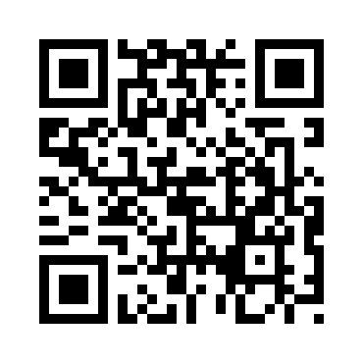

ETHICS EXAM