**Tyler Bradley – ECES T580 Lab 5**

**Lab 5.1.1**

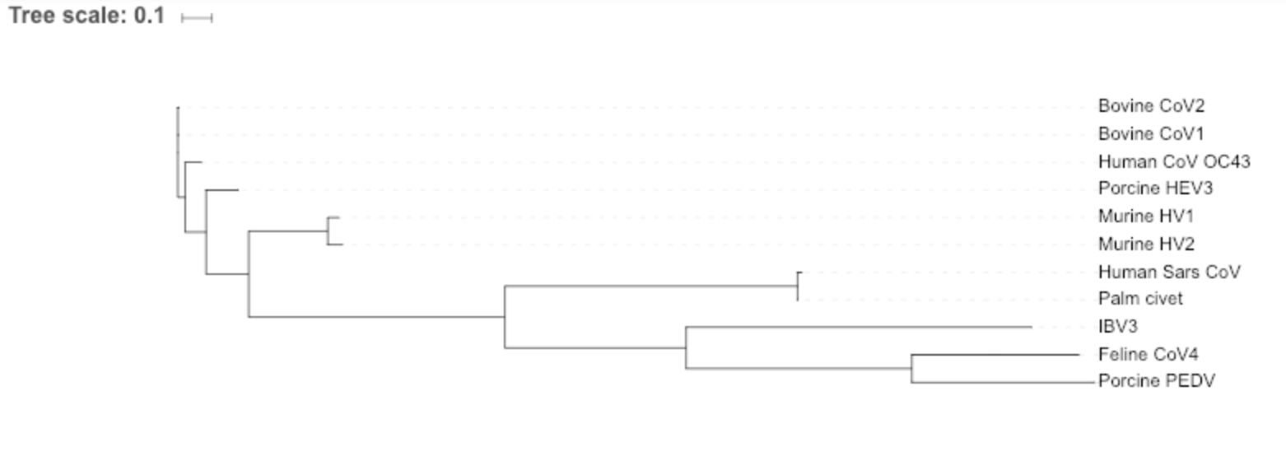  
The corovirus that is most closely related to Human SARS CoV is Palm Civet.

**Lab 5.2.1 – Online Portion**

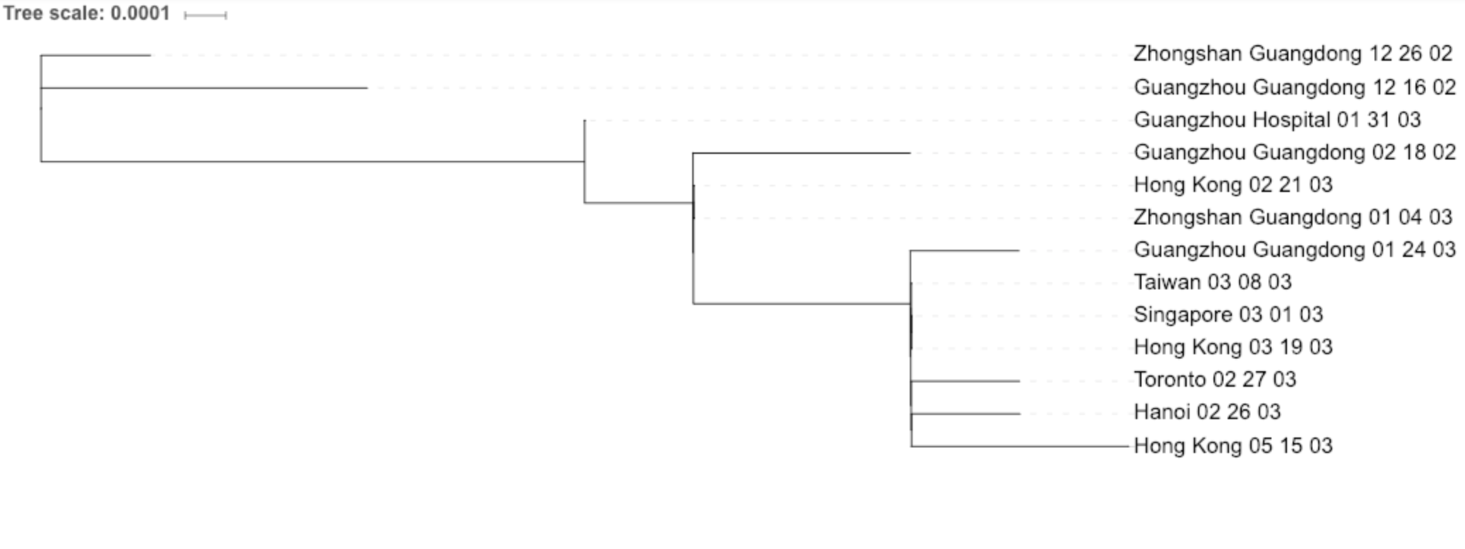

The origin of the SARS epidemic appears to have begun at Gaungzhou Guangdong on Dec 16, 2002 but is also closely related to another strain of the norovirus from 12/26/02 in Zhongshan Guangdong. However, the 12/16/02 strain seems to be more closely related to strains sequenced in the early months of 2003.