TakeContact

UserGuide



# Introduction

TakeContact is a revolution for your relationship with your visitors. Thanks to a top of the edge technology each single visitor will become a high rewarding customer. TakeContact is able to handle up to ten millions of new customers per second, thus giving you an extraordinary advantage towards your competitors.

Thanks to the incredible power and flexibility of TakeContact you will boost your Return On Investment in meetings and will let an exceptional image of your company to your visitors.

Best designers of the world have been working on this smart engine to provide the best user experience as possible. Thanks to TakeContact you will get new fresh input to your emailing marketing. TakeContact is great, TakeContact is smart, so take it!

# Presentation of the functionality

The goal of the TakeContact is to allow visitor to give you their name, and Mail.

You should run this program and put in in full screen

There are three screens :

+ Form screen composed of input fields and a submit button ( this is the startup screen)

+ Confirmation screen composed of a simple message and a continue button

+ Display list screen : display the full list

# Standard Behavior

This section describes how TakeContact works by default. Folowing section will explain you how you can change things.

|  |  |
| --- | --- |
|  | Double click on TakeContact.exe |
|  | The main window is displayed.  Notice that the number of customers is displayed on the lower left corner, here there is already 1 customer in the database.  The 3 text inputs are for (French) customers  The button below is dashed because you need some text in the 3 fields.  The button on the lower right corner display a list of all customers |
|  | Once the 3 data are entered the button below is clickable. |
|  | You got a confirmation screen, and the click on the button returns to the previous empty page . |
|  | Now there are 2 customers in the database.  To inspect the content of the database, clic on the button of the right. |
|  | You get the content of the database.  Click on the button on the left to come back to the input screen.  Click on the button of the right to export in excel. |
|  |  |
|  |  |

|  |  |
| --- | --- |
|  |  |

# Full screen

One of the features of TakeContact is to take the full screen so you can put it in a room with visitor and the visitors are invited to enter their information.

To put in full screen, just double clic on the title bar.

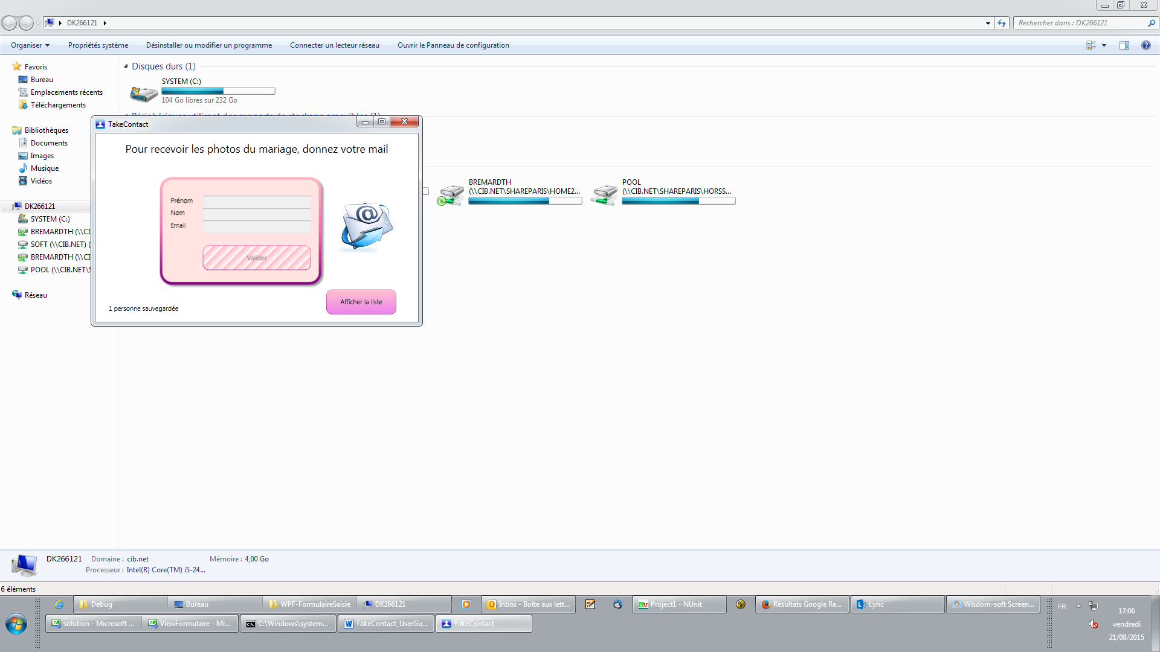

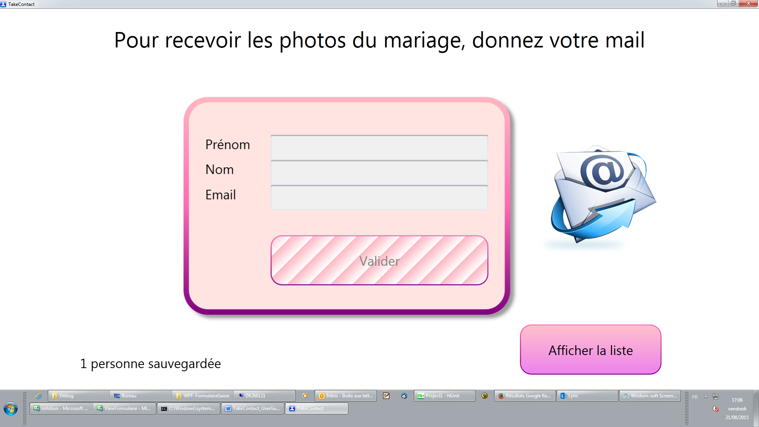

# Configuration of the text displayed

|  |  |
| --- | --- |
| MainTitle | Text displayed at the top of the Form Screen |
| ConfirmationContent | Text displayed once you submitted the Form Screen |

Default value of the file:

|  |
| --- |
| <?xml version="1.0" encoding="utf-8" ?>  <configuration>  <appSettings>  <add key="MainTitle" value="Pour recevoir les photos du mariage, donnez votre mail"/>  <add key="ConfirmationContent" value="Merci !&#10; N'oubliez pas de nous envoyer aussi vos photos: t.bremard@gmail.com"/>  </appSettings>  </configuration> |

The changes are taken in account at the next program startup.

|  |
| --- |
| <?xml version="1.0" encoding="utf-8" ?>  <configuration>  <appSettings>  <add key="MainTitle" value="AAAAAAAAAA"/>  <add key="ConfirmationContent" value="BBBBBBBBBBB"/>  </appSettings>  </configuration> |

|  |  |
| --- | --- |
|  | key="MainTitle" value="AAAAAAAAAA" |
|  | key="ConfirmationContent" value="BBBBBBBBBBB" |

The other fields or content of buttons are not customizable in this version.

Full customizable application and source code is available on request at [t.bremard@gmail.com](mailto:t.bremard@gmail.com).

# Command Line

## Clear database

The program uses a local database (Database.sdf ) so you do not need any server running, and do not need internet connection

To reset the database, start the program with -clear in comandline:

>TakeContact.exe -clear

At the next startup, the program will display "0 person in database"

|  |
| --- |
| Main window after launching with:  >TakeContact.exe –clear  Notice 0 at the lower corner |

## Hide Listing button

The program propose to display the content of the database by default. To hide the button to display the database use the option -nolist

Typically you can find interesting to let the customers enter their contact, and prevent them from looking at the other contacts.

|  |
| --- |
| Main window after launching with:  >TakeContact.exe -nolist  Notice that the button to display the list is hidden |