**Documentation**

**Travis Bresnahan:**

* Created github repository
* Added collaborators and practiced git commands with Susan
* “Website Side” section of Powerpoint Demo for 3/27/2019

**Web Development (Susan, Isaiah, Travis):**

* Discussed web design layouts options (Whole Group)  
  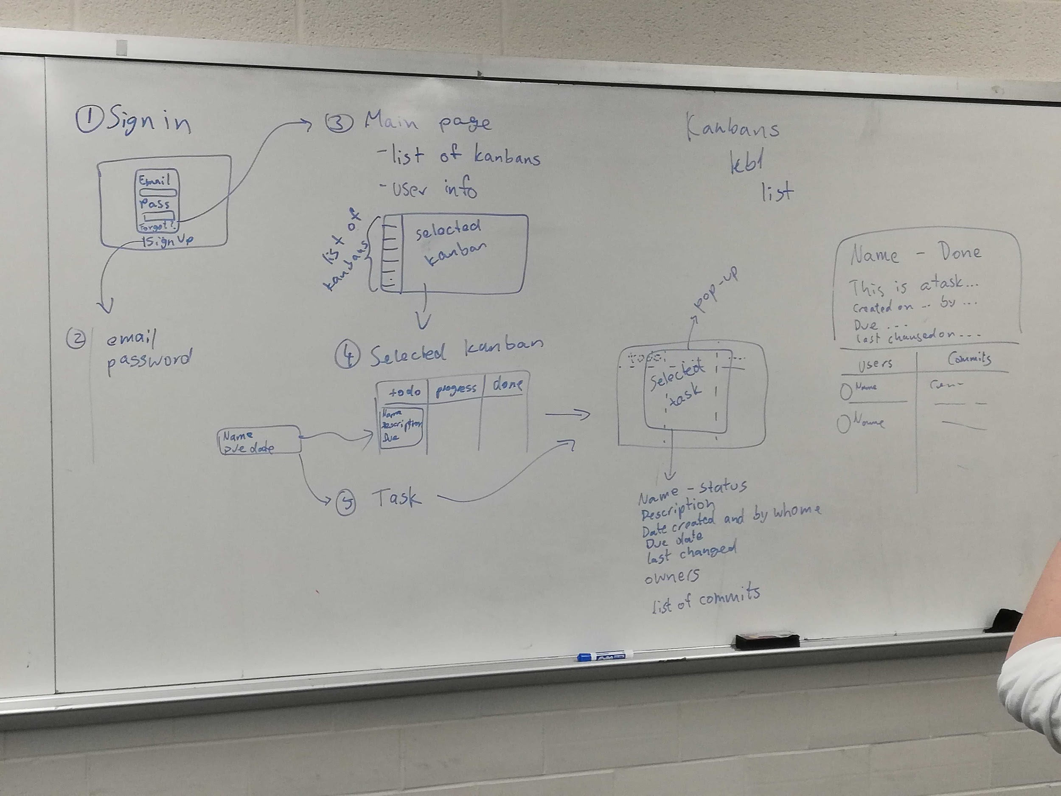
* Integrated firebase DB and web hosting for public facing webpage (Travis)
* Started to develop initial login page <Attempting to use OAuth with Github> (Travis)
* Decided against OAuth for now. Linked DB to index.html through javascript (Travis)
  + Created buttons with event listeners to call javascript + firebase functions
  + Functioning login check (Logged in or not)
  + New sign up with information stored
  + Console warning messages

**Tasks** - Documented by Isaiah

**Web**

|  |  |  |
| --- | --- | --- |
| To do | In progress | Done |
|  |  | * Get an estimate for when steps will be done by next week (assigned on 3/26) (Isaiah, Travis, Susan) * Build kanban page overall template (assigned on 3/28) (Isaiah) * Print out task info from database (assigned on 3/28) (Susan) * Redo authentication to just username and have the login button linked to Isaiah’s Kanban page (assigned on 3/28) (Travis) * Handle partially pre-defined keys, redefine JS functions for clarity, add CSS to login.html (Assigned 4/2)(Travis) * Try and pull something from DB and display it on the kanban page, look into PHP sessions (Assigned 4/2) (Isaiah) * Commit info of task and dates (Created/due) of tasks (Assigned 4/2)(Susan) * Set default board value for new users, Make sure username does not contain invalid characters, check if field is empty before logging in (Assigned on 4/9) (Travis) * Create Javascript for adding users on kanban page (assigned 4/9) (susan) * Create Javascript for creating new kanbans (assigned 4/9) (Radu) * Display kanban/task information on kanban page from DB as well as the kanban ID and look into making every object modifiable within the kanban page (assigned 4/9) (Isaiah) |

**Console**

|  |  |  |
| --- | --- | --- |
| To do | In progress | Done |
|  |  | * Get an estimate for when steps will be completed by next week (assigned on 3/26) (Andrew) * Connect w/ Firebase and pull info from the database (assigned on 3/28) (Andrew) * Make python class structure to represent boards, users, etc. (Assigned 4/2) * Work on manipulating task in console (assigned 4/9) (Andrew) |

**Cloud**

|  |  |  |
| --- | --- | --- |
| To do | In progress | Done |
|  |  | * Start looking into the API’s and see how the functions are going to look like by next week(assigned on 3/26) (Radu, Esteban) * Keep trying to figure out how to ssh with nodejs. Talk with Dr. Dymacek (assigned on 3/28) (Radu, Esteban) * Continue figuring out Git API (Assigned 4/2) (Radu, Esteban) * Finish git connection (4/9) (Esteban) |

**Unit Testing**

|  |  |  |
| --- | --- | --- |
| To do | In progress | Done |
|  | * Start template for unit test (assigned on 3/28) (Steven) * Look into unit testing platforms to use. Potentially thinking of using Selenium for web page and python’s built in unit test for console (Assigned 4/2) Update - Continuing research into selenium and python unit tester (4/9) | * Unit Test Research (assigned on 3/26) (Steven) |

**Meeting Log**

3/26/19 - Documented by Isaiah

* Travis, Susan, Steven, Isaiah met from 4pm - 4:30pm as a mini meeting before everyone else would arrive
  + Discussed on having more thorough documentation in the Google Docs (Meeting Log and Tasks status)
  + Discussed on the overall roles per person. Group decided to have one person committed to unit testing and agreed the role be given to Steven
  + Discussed on everyone’s current task status and struggles
* Esteban and Radu joined from 4:30 - 5:30pm and the overall meeting began
  + The team discussed on the 5 minute presentation demo for Wednesday and worked on the powerpoint together
  + Discussed that the team should meet twice a week on Tuesdays and Thursdays at 4pm
  + Shared topics from the previous “mini meeting” and everyone agreed on what was said about documentation and Steven being the unit tester
  + Discussed overall individual task status and plans moving forward

3/28/19 - Documented by Isaiah

* The entire team held a meeting from 4 - 4:35pm in the Stevens lounge
  + Discussed on everyone's new set of tasks to do by the next meeting
  + Discussed issues anyone may be having and where everyone is at in their current tasks
  + Discussed on how authentication will be handled across web-interface, database, and Github

4/2/19 - Documented by Isaiah

* Meeting was held from 4-5pm in the Lab
  + Again discussed on where everyone is at in their individual task and what new goals everyone has for themself by next week
  + Decided as a team to not meet on thursday (4/4) because no major updates on anyone would be given by then
  + Discussed how the team felt with how progress was being made and how confident we would be in finishing everything by the end of semester. We agreed things were going well and to keep at this pace

4/9/19 - Documented by Isaiah

* Meeting held from 4-5:10pm in the lab
  + Worked together on finding errors within Drop Table461’s project/code and made a google doc where we wrote down all errors found
  + Discussed how to handle implementing a new user that is not in the database and how they should be brought to a blank kanban page. Discussed how we could implement a button for other users to add someone new to their kanban. Discussed how we could implement a button for a new user to create a new kanban themselves.
  + Shared an overview status of where everyone is on their project and discussed on what new goals are for the next week

4/11/19 - Decided to have a “slack meeting” and discussed where everyone was in terms of there current goals

4/16/19 - Once again another “slack meeting” was held and the team did not meet together in person

4/18/19 - And again another “slack meeting was held” this day instead of meeting in person

4/23/19 - Documented By Isaiah

* Steven, Esteban, Andrew, Isaiah, Susan met together in the lab at 4pm and meeting was held until 4:40pm (Travis and Radu were available through slack during this time instead of being there in person for personal reasons)
  + Discussed the final goals that everyone had to get done by Thursday and if there were any final challenges that anyone was still struggling and how we could approach to fix the problem

4/25/19 - Documented By Isaiah

* Everyone met at 4pm in the lab and meeting was held until 5pm.
  + Discussed the absolute final things to get done by next week and how everything was going to be wrapped up and done with

4/28/19 - Documented By Isaiah

* Everyone meet at 1:40pm and was held until 2:30pm
  + Shared our final projects with each other and tested everything in preparations for the live demo on Monday
  + Discussed how presenting our project would work and in what order we would present things

**3/29/19 - Documented by Travis**

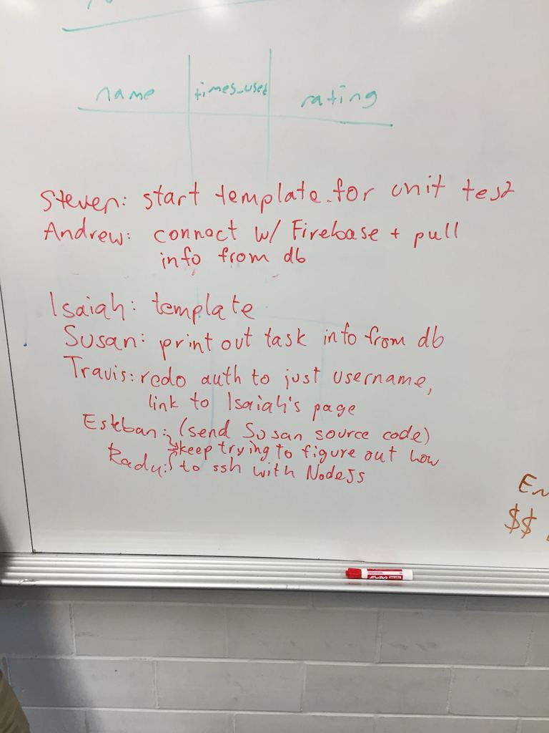

**4/2/19 Documented By Travis:**

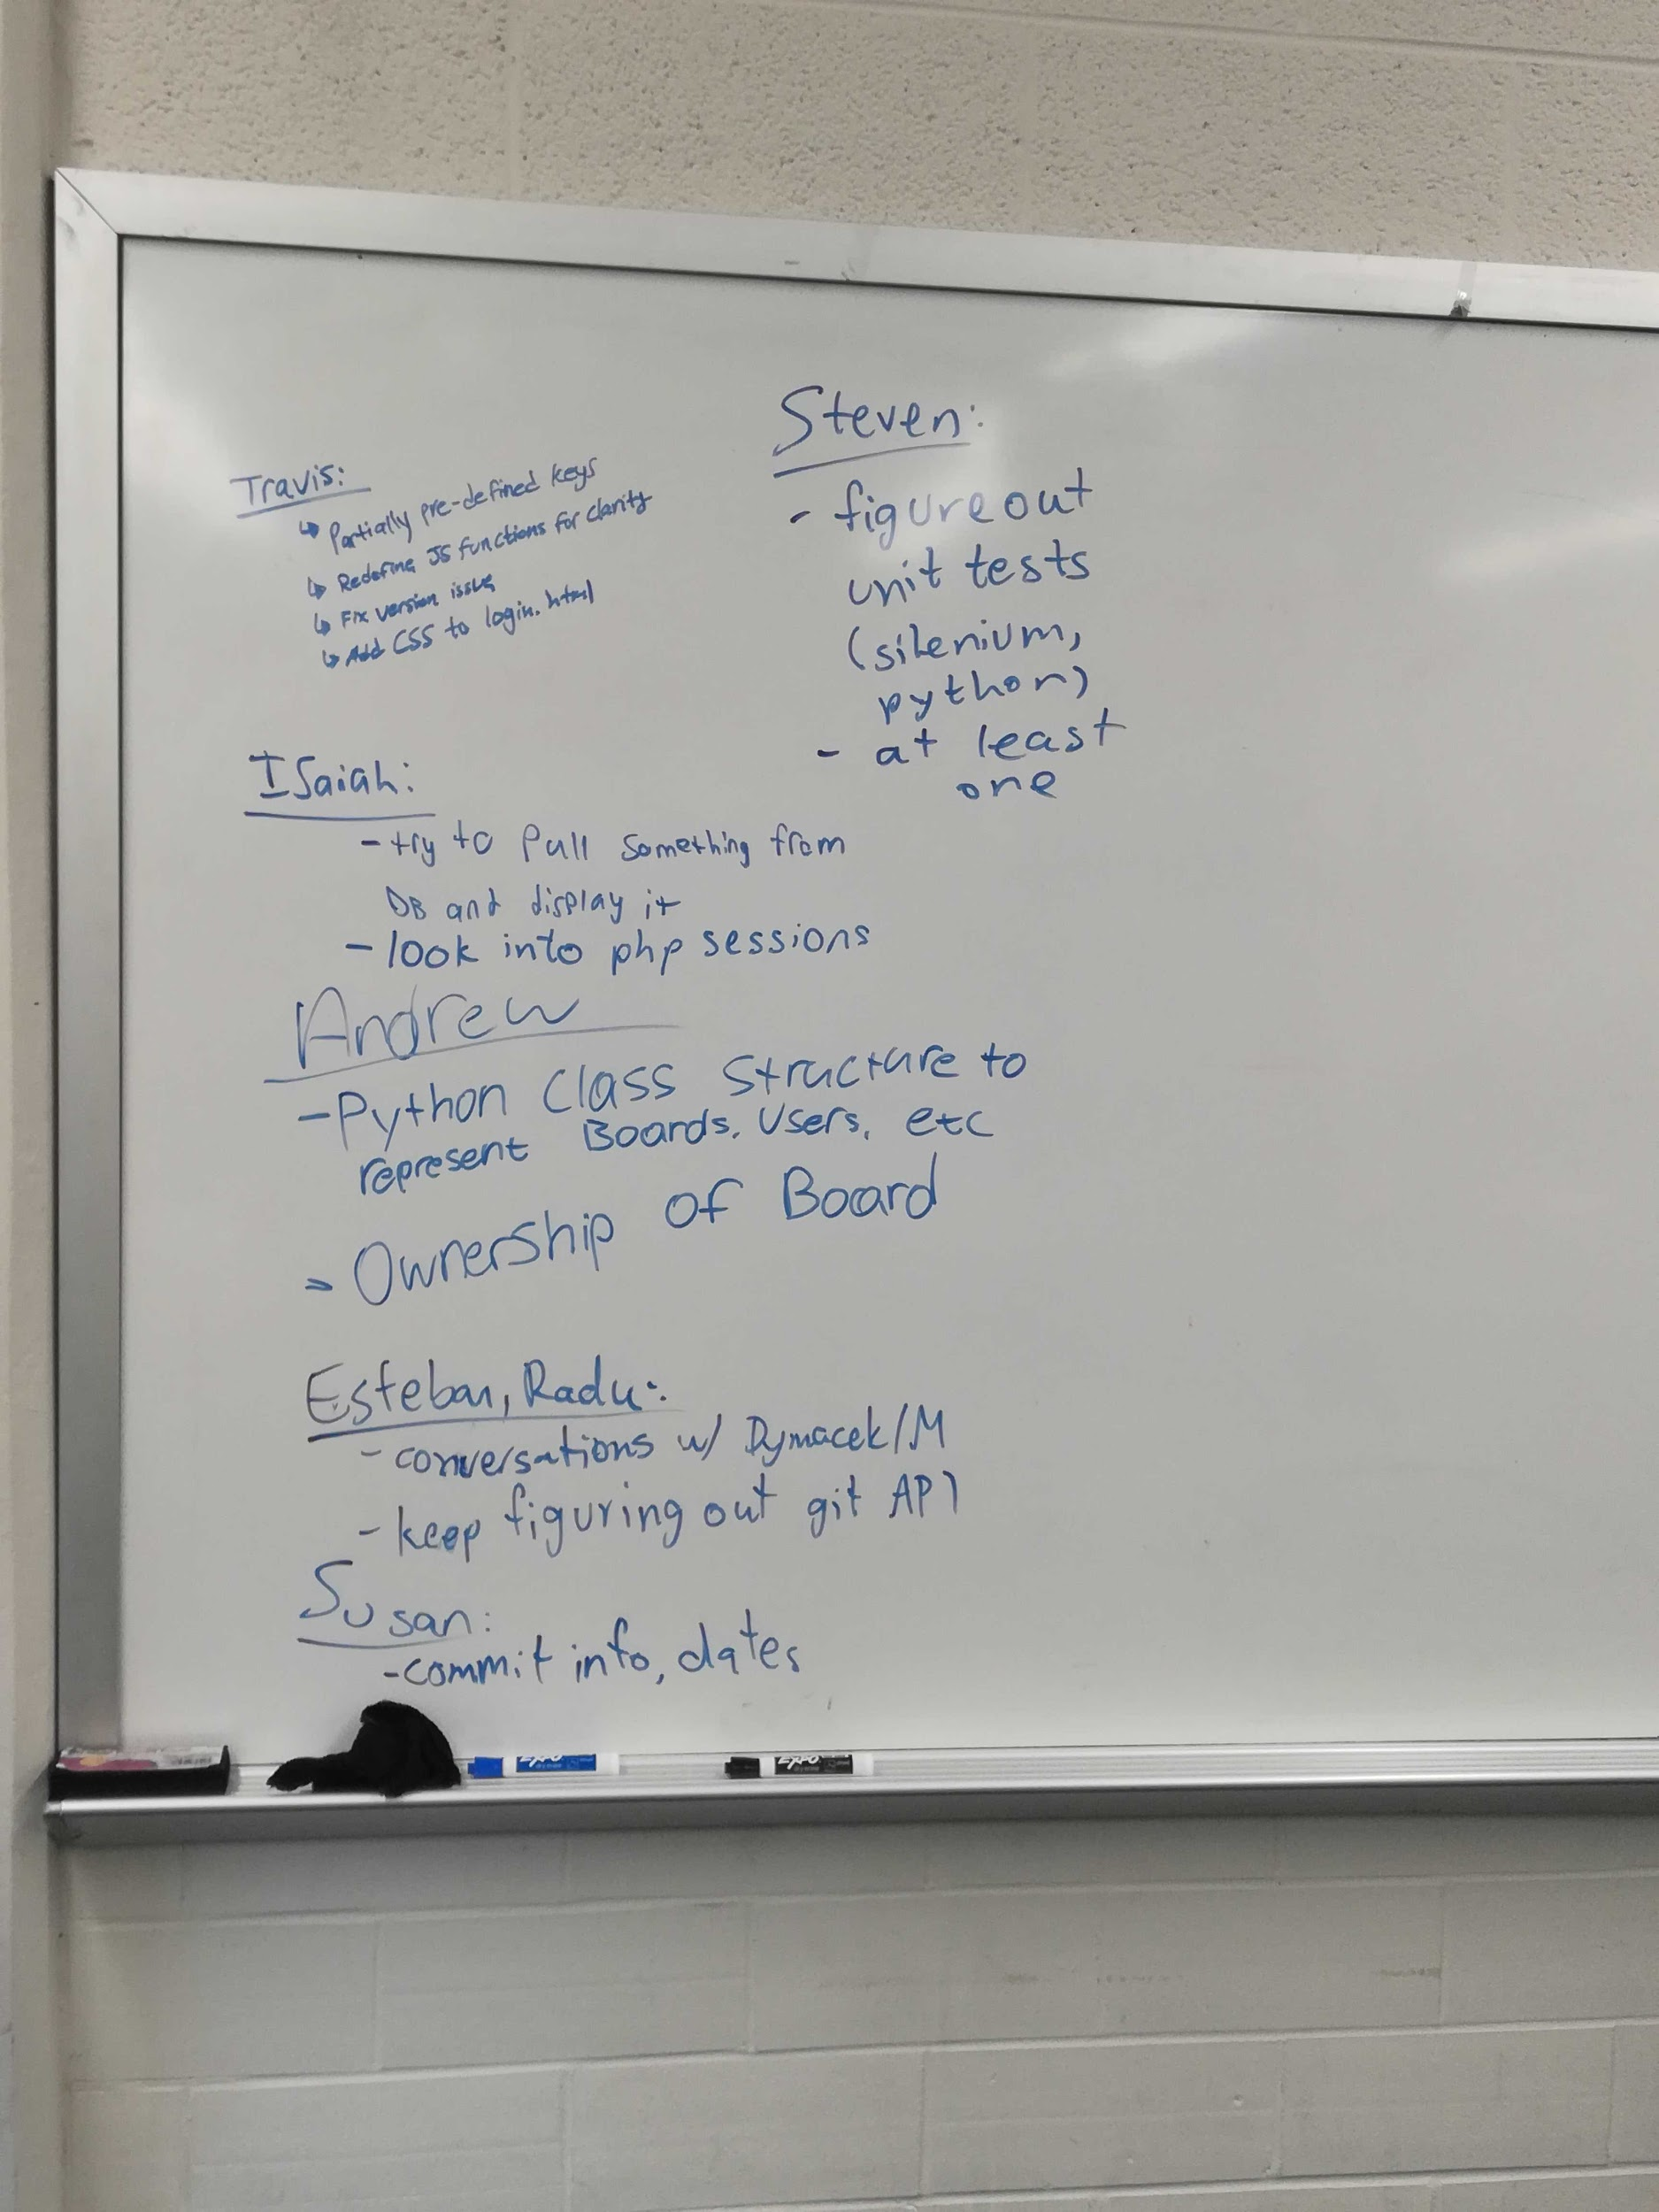

**4/9/19 - Documented by Isaiah**

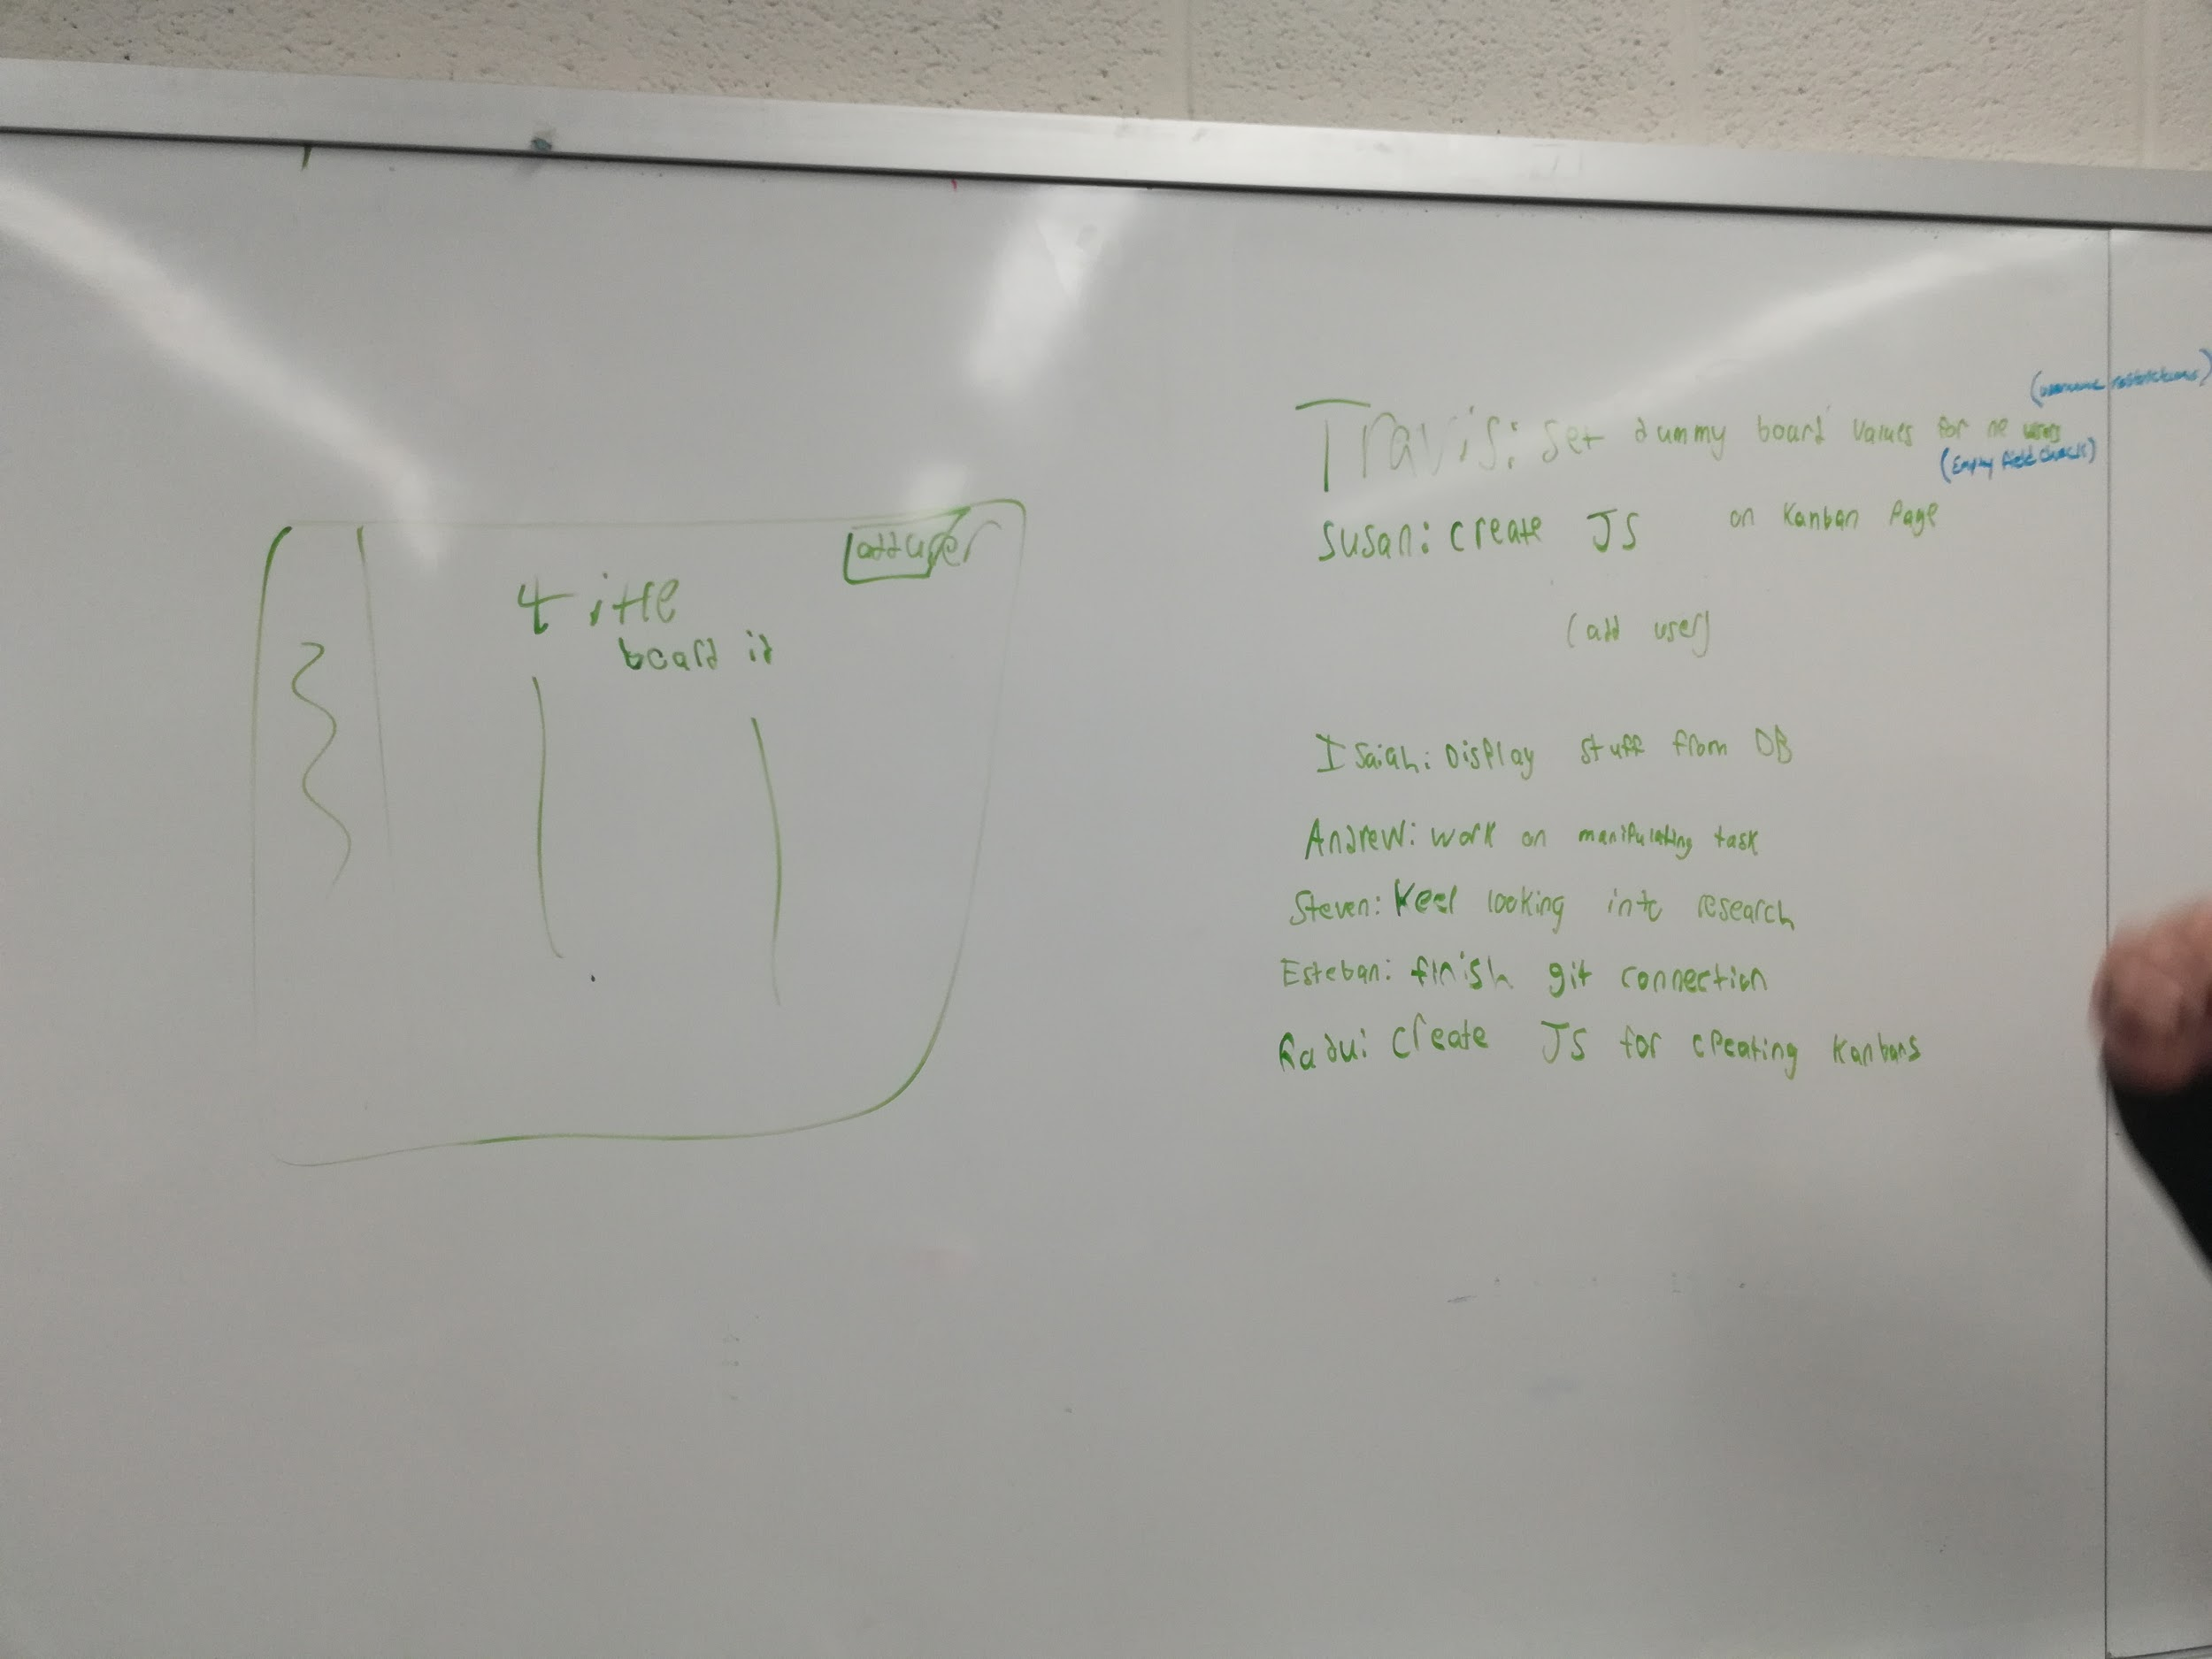

**4/16/19 - Documented by Travis**

**Slack Meeting:**

* **Web Dev continue to work on fixing some bugs and changing input of login screen. Drag and drop implementation coming soon**
* **Console updating integrations with firebase DB as web team changes layout**
* **Testing is being worked on with selenium and pytest**

**4/23/19 - Documented by Travis**

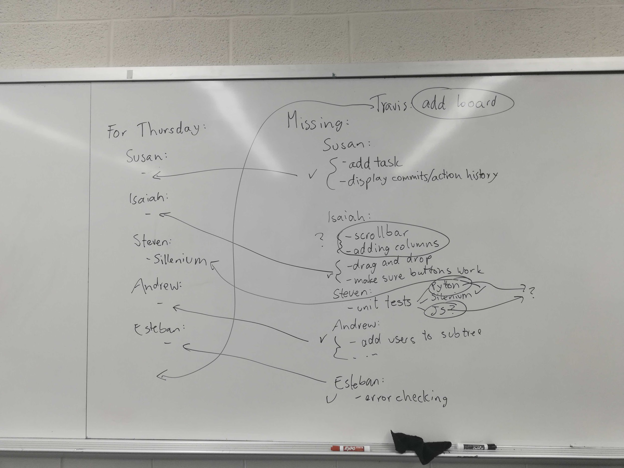

**4/25/19 - Documented By Isaiah**

