Railroad Controller Board

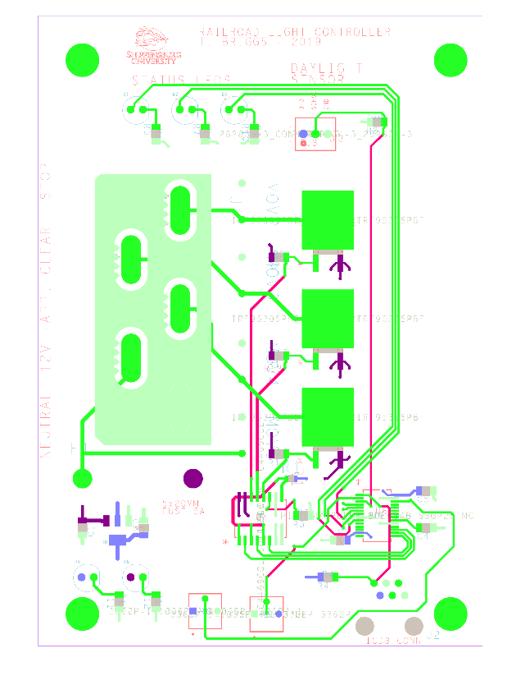

12V Fuse – 20mm x 5mm – 5A  
Slow Blow (60 watt)

Daylight Sensor

Red (3V3+)

Yellow (Sensor)

Black (3V3-, Ground)

Adjust Light Speed

CCW – Faster

CW – Slower

Max CCW – Stop

Min CCW – 10 seconds

Adjust Daylight Cutoff

CCW – Darker

CW – Lighter

Full CCW – Always Off

Full CW – Always On

Status LEDs – Follow external lights

Stop Clear Approach

f

3mm Mounting Holes

Wires to the lights:

STOP

CLEAR

APPROACH

12VDC +

Ground / 12VDC -

# Theory of Operation

* Supports operation of three output channels corresponding to:
  + STOP,
  + CLEAR,
  + APPROACH.
* Only one output channel will be energized at a time.
* Output channel is connected to the positive rail of the external 12 VDC power supply
* Each output channel is expected to share a common ground with the negative rail of the 12 VDC supply.
* The speed of the pattern is controlled with a trimmer pot – allows speed from a fraction of second through approximately 30 seconds per channel, or 90 seconds for a complete cycle
* A daylight sensor is used to detect when there is sufficient sunlight for proper operation
* A trimmer pot can be used to adjust the level of sunlight that is sufficient
* Turning the daylight trimmer to one extreme will disable the output operation of the controller
* Turning the daylight trimmer to the other extreme will always enable the output operation of the controller (i.e. ignore the daylight sensor)
* The yellow power LED (bottom left corner of diagram) shows a sufficient 3.3V rail
* The red power LED (also bottom left corner) shows a sufficient 12V rail
* If the input fuse is blown then neither of the power LEDs will be lit
* The three status LEDs light-up with the corresponding output channel:
  + GREEN – Approach
  + YELLOW – Clear
  + RED - Stop

# Installation Notes

* The large 5-posn screw-down block holds the “high” voltage (12VDC connection)
  + Connect approximately 12 – 17 VDC to the indicated terminals
  + Connect the high-side of the signal LEDs to the output channels
* The small 3-posn screw-down block holds the “low” voltage daylight sensor
* The mounting holes are 3in and 4.5in (see template on page 1) and accommodate #4 - #8 machine screws.
* Negative rail should be connected to chassis ground or (preferably) earth ground to protect battery and other components from lightening, ground bounce, and attenuation due to length of buried wire

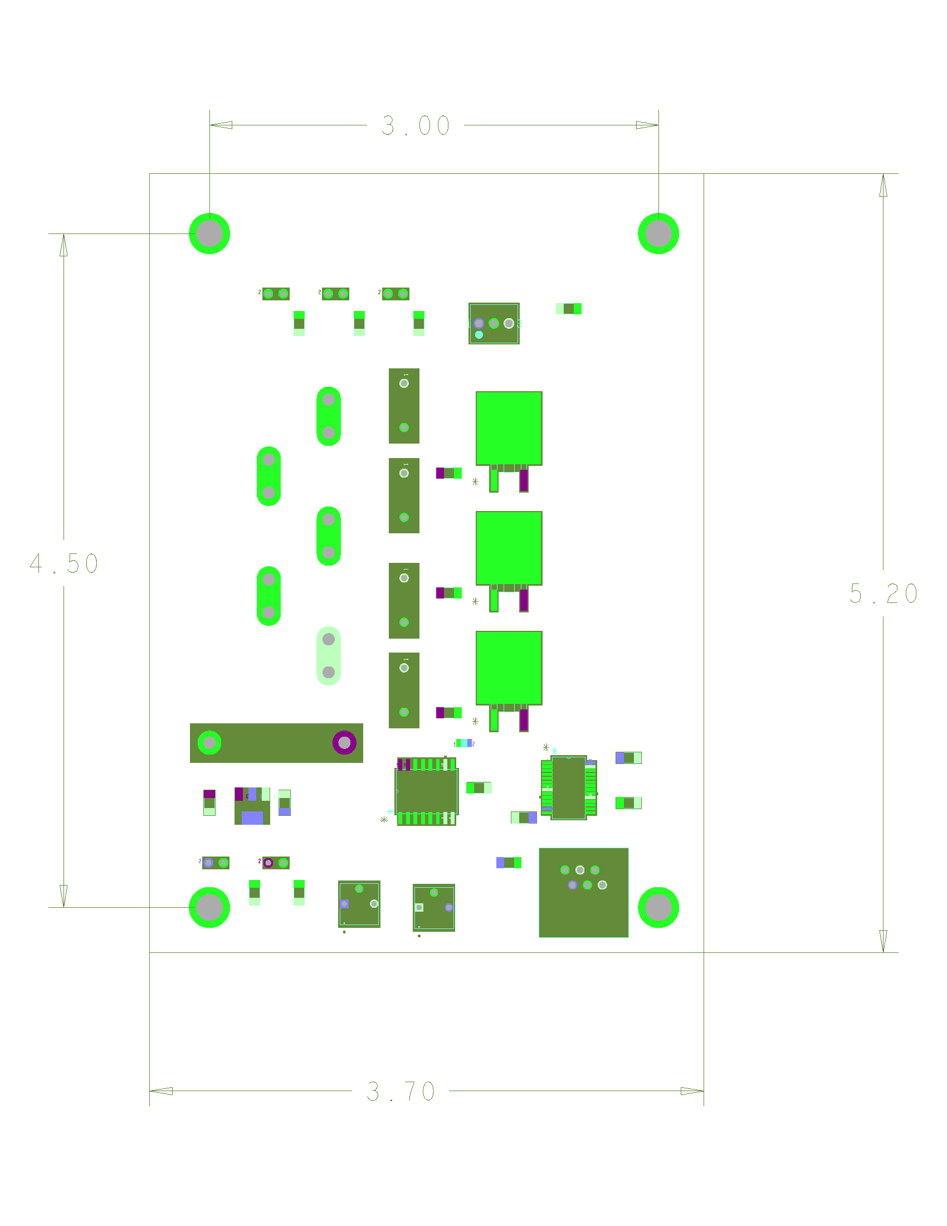

Figure 1 - Installation Template (not to scale)

