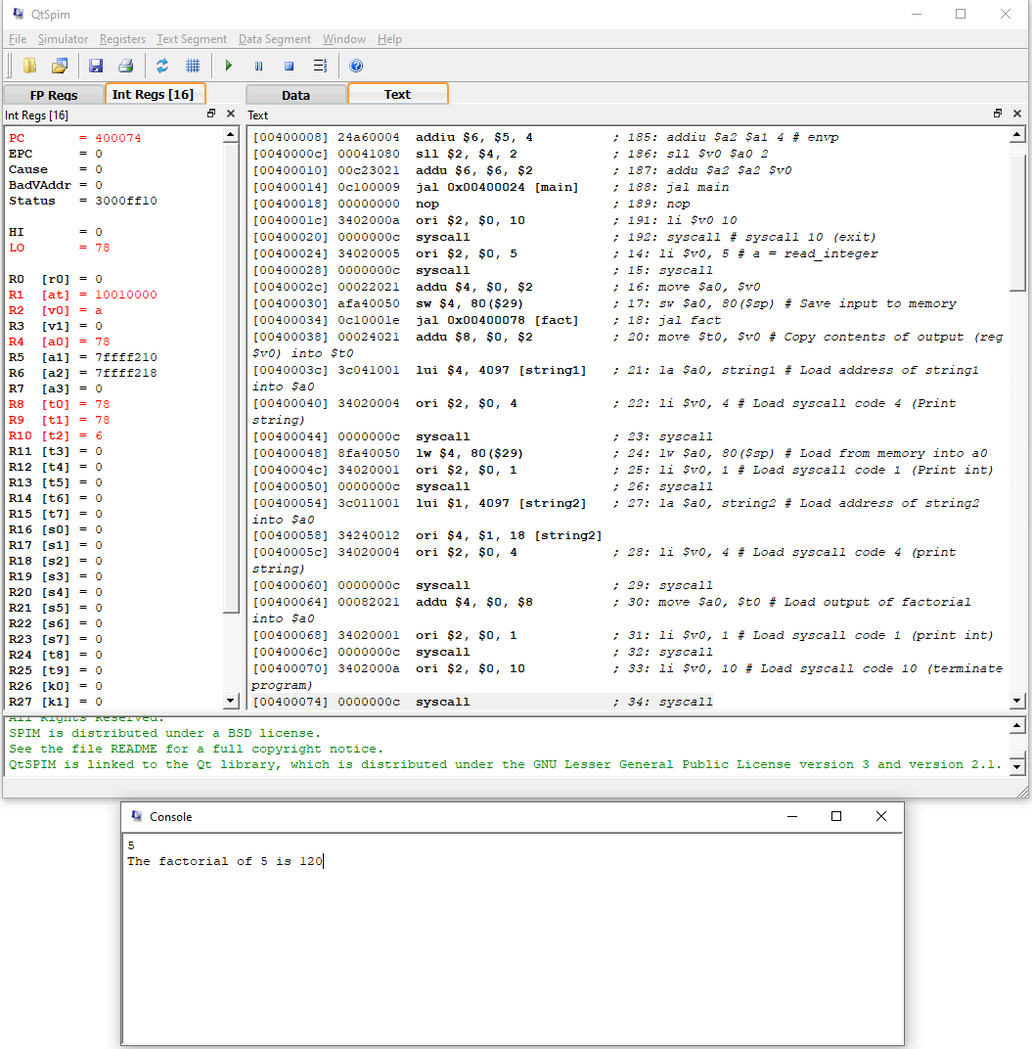Thomas Brosh

ENEE350

HW1 Screenshot of code running in QtSPIM