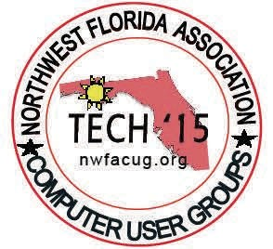

# Computer Tech 2016

## Northwest Florida State College

**Student Services Center January 30, 2016 - Saturday**

**8:00 AM - 4:00 PM**

**Public Invited-Free**

Computer Tech 2016 is a one day event. Computer enthusiasts, from Beginners to Ad- vanced, come together to learn about the latest technology and how to use the different software's and hardware devices.

## 40 Workshops

Workshops available for Apple, Microsoft, Lenox, Android, Games, plus a variety of apps and software programs. The workshops are conducted by **18** of our outstanding local IT experts and trainers with many years of experience.

## Guest Speaker

TBA

## Preregister - Schedule

Go to Northwest Florida Association of Computer User Groups web site: http:// [www.nwfacug.org/](http://www.nwfacug.org/) to preregister, view schedule and campus map.

For questions contact Carl Lofstrom, [850-586-0603/sandcloud@embarqmail.com](mailto:850-586-0603/sandcloud@embarqmail.com) **Please support our sponsors listed on the reverse side of this flyer.**

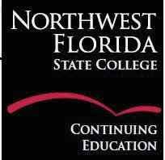 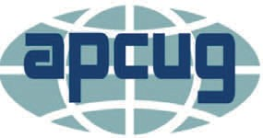 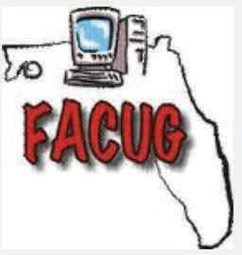

Sponsors: