**How to make a persistent USB**

The first thing you want to do is to install MKUSB this program can create normal live CD or a persistent one. This only works with Buntu/Deb based OS’s.

Open the terminal and type in:

sudo add-apt-repository ppa:mkusb/ppa

sudo apt-get update

sudo apt-get install mkusb

Once the program has installed you will find 2 New Icons in your All Menu one is called guidus and the other is mkusb. I really does not matter which one you use but for simplicity sake we will use mkusb. Open the program

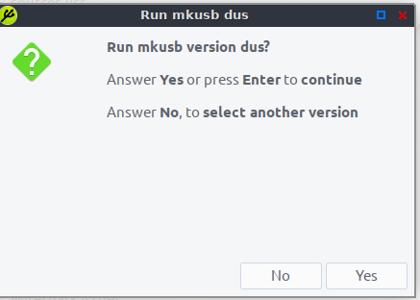

Click Yes

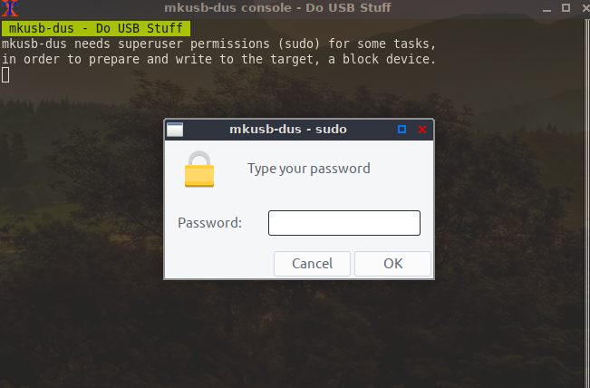

Type in your password

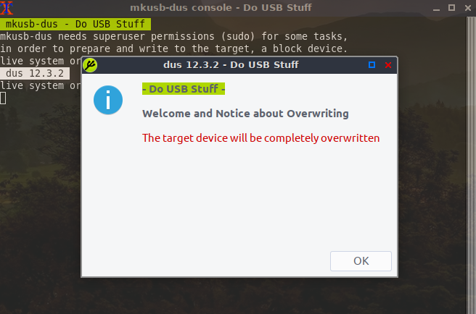

Click OK

Here we are going to select Install (Make a boot device) and click OK

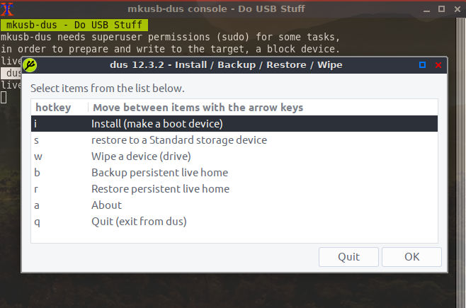

Next we select Persistent Live – only Debian and Ubuntu

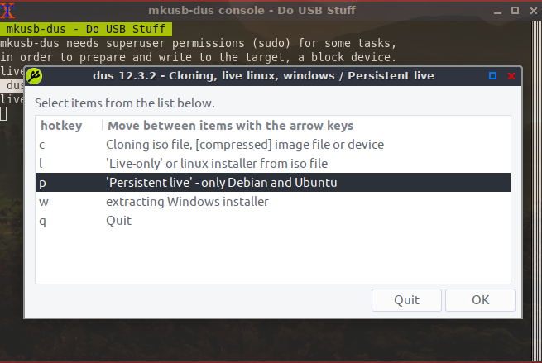

Next you will select the ISO file you downloaded – in this example I used Peppermint 9

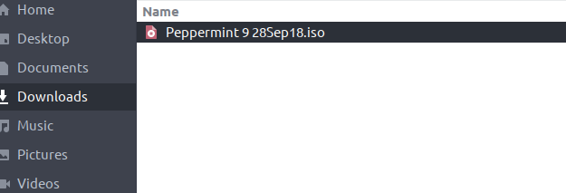

Next it will ask you to where to save the files

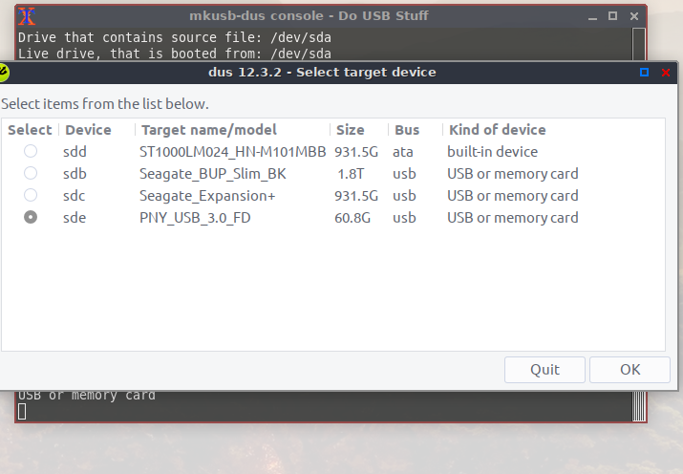

Select your USB Drive I would recommend a 32GBs or larger. Here I used a 64GB PNY_USB_3.0

Now it will ask you what kind of boot loader type you want

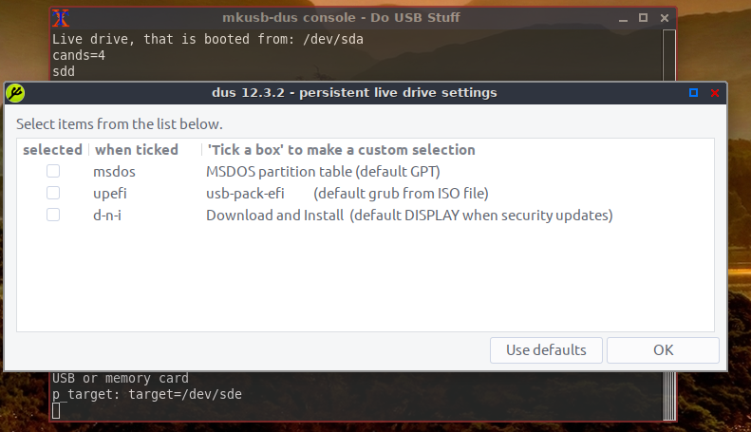

Generally I select “Use defaults”

Now the next screen how much of the thumb drive you want to use for the operating system – default is 50% - a 64GB thumb drive like in this example that should be fine. The remaining 50% if have will be partitioned to NTFS and will be empty this way you can use this drive on a Windows machine and copy the files from Windows to the NTFS portion of the drive. If you want to use the entire thumb drive simply move the slider over to 100 or to whatever size you desire and select OK

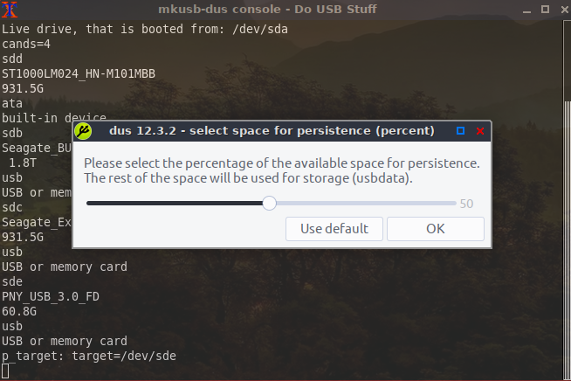

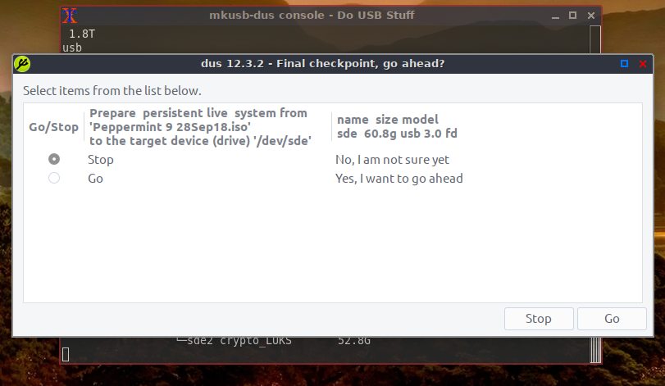

By default Stop is selected under Go/Stop click Go then click on Go at bottom right

Next type in your password and click go

Now the magic starts this will take some time to setup your USB and write to it.

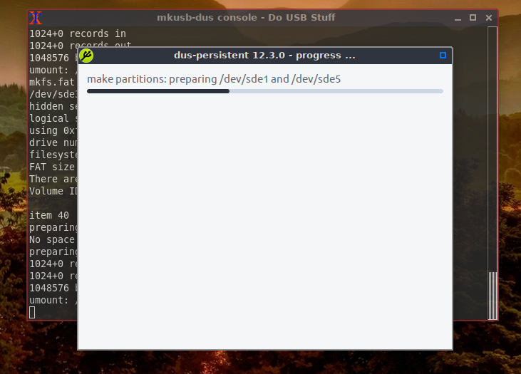

When it is finished you will see this

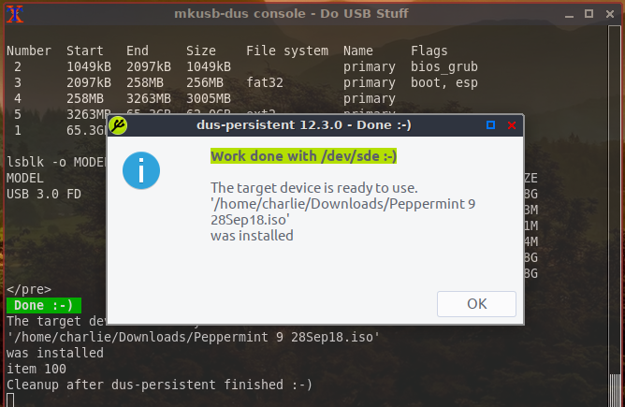

– click OK then click Quit twice and Enter to exit. - all done