NWFLUG
Northwest Florida Linux User Group

Free Your Computer Today.

Next Meeting:
Monday, August 3rd, 2015, 5:00-7:00 PM, Room 400, Crosspoint Church, Niceville.
Visit <nwflug.org> for more information.

Next Linux Installation Session:
Monday, August 10th, 2015, same time and place as above, by appointment only, see web site for details.

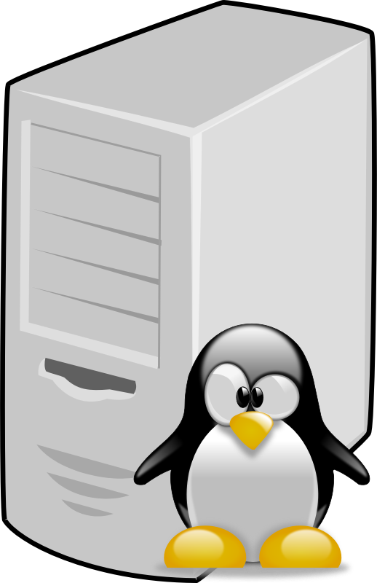
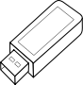
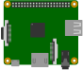


Learn about computers /
micro-controllers and run them
with GNU/Linux.
Discuss electronics,
computers,
and free software
Learn to use free software.
Discover GNU/Linux.
Free your computer from
“unfree” software.

