NWFLUG
Northwest Florida Linux User Group

Free Your Computer Today.
Next Meeting:
Monday, May 4, 2015, 5:00-7:00 PM, Room 400, Crosspoint Church, Niceville
Visit <nwflug.org> for more information

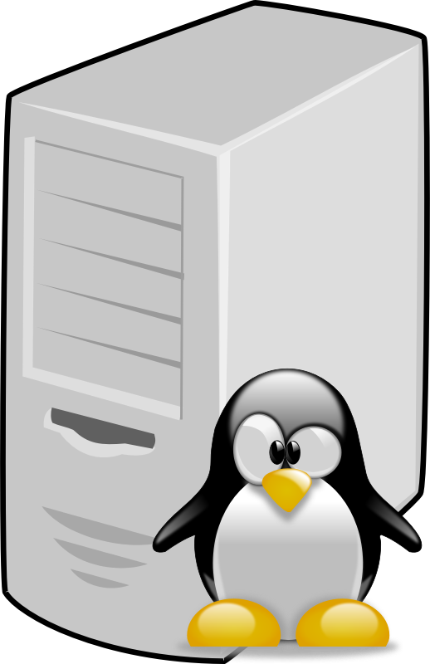
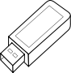
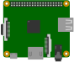


Learn about computers /
micro-controllers and run them
with GNU/Linux.
Discuss electronics,
computers,
and free software
Learn to use free software.
Discover GNU/Linux.
Free your computer from
“unfree” software.

