What is the natural capability and why was it chosen?

With technology becoming more efficient, we are searching for ways to make smaller and smaller devices. In order to make devices more efficient, we can minimize the computers used on a small device. We strive towards a goal of minimizing processing power and minimize energy use. Small insects, such as ants, have the same limitations, and have developed more efficient brains and algoritms to succeed.

One of the White House's Grand Challenges is related to this, as it seeks for computers to operate at the operating efficiency of the human brain. [12] While the human brain is certainly impressive, it contains an astonishing 86 billion neurons. [13][14] In comparison, an ant's brain is only about 250,000 neurons. [14] That's a ratio of 344,000:1. With that ratio, if an ant can perform the same task as human, then it should be a lot more impressive.

What are the key benefits that this capability provides?

There are many tasks performed by ants, but some of the most impressive are ones that modern robotic engineers are already trying to implement in robotic ants.

In navigation, ants have been shown to follow paths previously traveled by other ants, developing a path memory to travel between food sources and thier nest. [1][2][5]

When an ant strays from a memorized path, correct visual cues have been shown to improve an ant's effectiveness at returning to their memorized path. After several experiments, the behavior of the ants in response to visual cues indicates that ants also navigate based on landmarks they store in their brains. Ant brains can store up to 400 images in their brains to serve as landmarks. [1][2]

While the individual processing power of a single ant is only ratio of 1 neuron per 344,000 in a human, the sheer number of ants means that there are more ant neurons in the world. There are about 10 quadrillion ants in the world [15] and 7.4 billion humans [16], resulting in a ratio of about 1.35 million : 1 of ants to humans. This leads to a ratio of about 3.9:1 for ant neurons to human neurons. With these huge number of neurons, if ants could combine their intelligence, then they could outsmart all of humanity. Fortunately for ants, they have developed a method in which they can combine their intelligence to create what is known as a super-organism. In a super-organism, they can perform high level processing tasks. [10][11]

In order to prove that minimizing the processing power and energy use of brains, we have to look at at a creature that sacrifices the ability to see in order to preserve the energy and processing power used by vision. By examining crayfish, we can see evolution work in reverse, as the crayfish in dark caves are gradually losingtheir sight. This indicates that their is a disctinct evolutionary advantage towards minimizing the brain power and energy used in visual processing. [7][9]

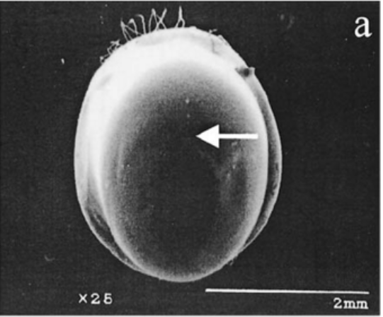
How does nature provide the benefit?

With microtechnology, one of the goals is to create smaller computers with low power use. This also means that processing power and data storage will be lower, so we could use efficient algorithms based on nature.

Ant's use a positive feedback loop to lead to a heuristic algorithm. Ants place a pheremone trail for others ants to follow. Ants will attempt to follow any pheremone trails laid down by previous ants. Successive ants following the same trail will increase to strength of the pheremone trail. When approaching two branches both marked by ants, the ant will make a choice following this equation [10]:

p1 = (x1 + α) ^β /(x1 + α)^β + (x2 + α)^β
p2 = 1 − p1

p1 = Probability of taking branch 1
p2 = Probability of taking branch 2
x1 = Amount of pheremone on branch 1
x2 = Amount of pheremone on branch 2
α = Attraction level of unmarked branch
β = nonlinearity of the choice function (2 in this case) [10]

While social insects require additional brain power in order to communicate with eachother, as the insects increase in their social capability, the can divide the labor and processing across their society. This advanced division of labor allows social insects to divide tasks among their community. This has led to the reduced need for large brain sizes. This leads to evolutionary need for smaller brain sizes for the social creatures. [3]

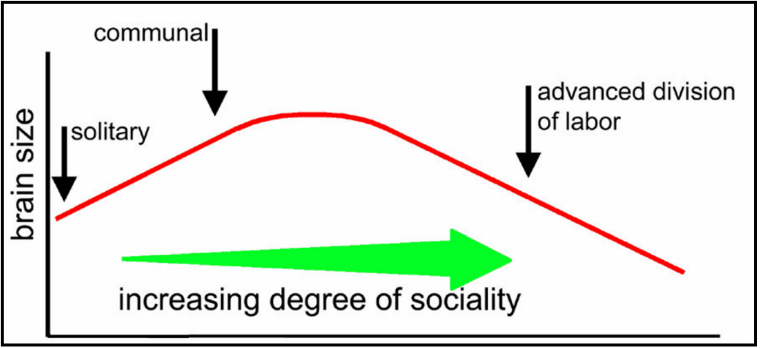

Despite the well known preferred method of tracking pheremones, we have to ask the question, "Why do ants have eyes?" Some scientists decided to examine the use of vision to compliment path integration. When experimenting with ants, they were able to find that when disrupting a learned path, the ants performed better at following various visual cues that without these visual cues. [3]

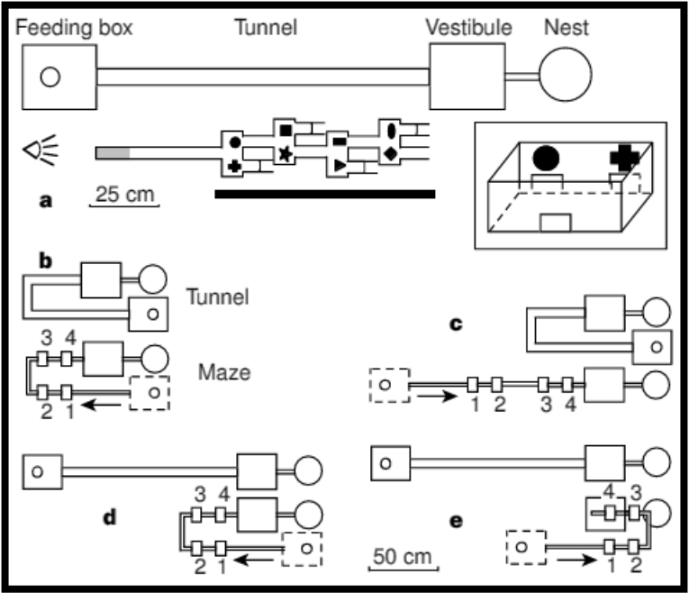
Ants and other small insects have compound eyes that work with a series of light receptors called ommatidium. The size of each individual ommatidium determines it's light gathering power. The number of light receptors determines the resolution, as each ommatidium effectively creates a pixel in an image. These eyes perform better with motion detection, than examining static images. [3][6][9]

How have biomimicry principles already been implemented?

Robotics have been able to use some ant behavior to develop a low processing power robot that lays down a light trail to guide any robots following the first robot towards the goal. This method leads to a heuristic algoritm that approaches an ideal path. As this is designed to follow path integration, it followed the equations and were able to develop an optimal path. [4][5]

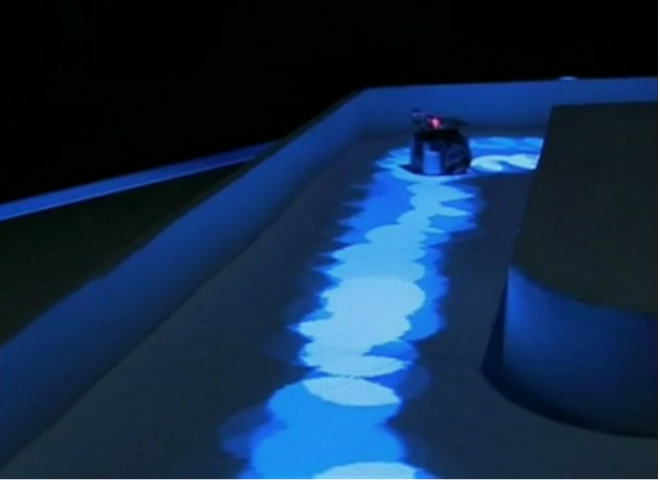

In order to take advantage of the low energy use and processing power of compound eyes, robotic compound eyes have been created to mimic the low energy use, low processing power behavior of compound eyes. These eyes are designed to work with small nanomachines, ideally to be used in flight. Similar to insect eyes, robotics compound eyes have performed well with motion detection and performing in the dark. [8]

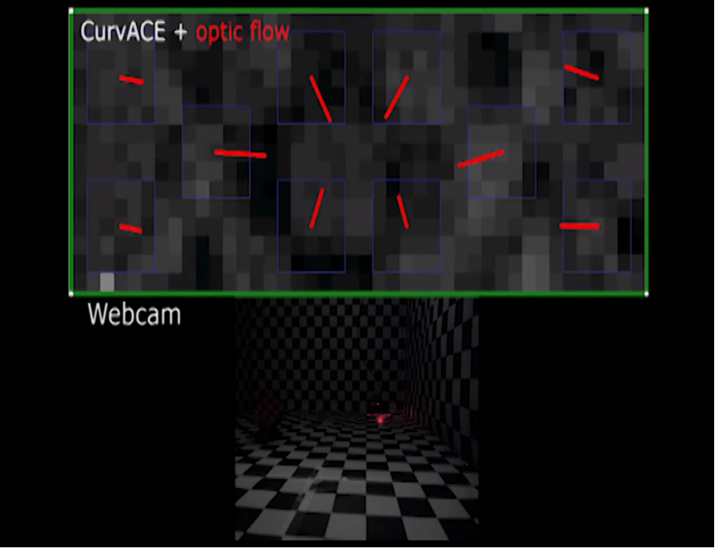

What is the total system that this capability is a part of?

The goal is to minimuze energy and processing power. More efficient processing can lead to the need for less neurons and use of less energy. [3][6][9] This applies to all four total systems

Harness Resource Efficiency – The process will harness energy and processing power efficiently.

Eliminate Waste - The process will reduce wasted energy and processing power.

Develop Systems that Reward doing More with Less for Longer - The process will reduce wasted energy and processing power.

Develop systems that Restore and do not Deplete Natural Capital - The process will not reduce as much natural capital (energy and processing power), but will enable insects to restore energy and processing power by gathering more food.

Conclusion:

Without high level processing power, we can perform several difficult tasks, but a new challenge erupts when we try to do the same tasks with lower level processing power. The solution comes from analyzing the brains of ants and studying how they think. Since evolution has already led to small brains with low energy use in these ants, they have also learned new methods of using their limited intelligence to perform complicated tasks. We can develop new technologies that adapt these principles in order to make smaller and smaller nanotechnology robots. I'm not the first person to come to this conclusion either, as various robotic engineers have started creating robots based on ants. Who knows what new technologies can be developed from studying ants?

References:

[1] Hogenboom, Melissa. "Ants Can Navigate despite Tiny Brains." BBC Earth. BBC, 26 May 2015. Web. 21 Mar. 2016. <http://www.bbc.com/earth/story/20150526-ants-navigate-despite-tiny-brains>.

[2] Schatz, B., S. Chameron, G. Beugnon, and T. S. Collett. "The Use of Path Integration Toguide Route Learning in Ants." Nature.com. Nature Publishing Group, 24 June 1999. Web. 21 Mar. 2016. <http://www.nature.com/articles/21625.epdf>.

[3] Gronenberg, Wulfila. "Social Insects' Brains." Social Insect Lab. The University of Arizona. Web. 21 Mar. 2016. <http://eebweb.arizona.edu/faculty/dornhaus/courses/read_ECOL597S/Wulfi Soc Insect brain lecture Nov10 bw.pdf>.

[4] Gill, Victoria. "Robot Ants: Mini-machines Mimic Insect Colony." BBC News. BBC, 29 Mar. 2013. Web. 21 Mar. 2016. <http://www.bbc.com/news/21956795>.

[5] Simon. "Pheromone Trail Networks in Ants." Collective Animal Behavior RSS. Couzin Lab, 22 Sept. 2009. Web. 21 Mar. 2016. <http://icouzin.princeton.edu/pheromone-trail-networks-in-ants/>.

[6] "The Drosophila Eye - a Model to Study the Genetic and Cellular Basis of RP12 and LCA." Fruitfly Model. EU CRUMBS. Web. 21 Mar. 2016. <http://crfb.univ-mrs.fr/Crumbs/section/en/Fruitfly_model/107>.

[7] Mejia-Ortiz, Luis M., and Richard G. Hartnoll. "Modifications of Eye Structure and Integumental Pigment in Two Cave Crayfish." Research Gate. Journal of Crustacean Biology. Web. 21 Mar. 2016. <https://www.researchgate.net/publication/232694344_Modifications_of_Eye_Structure_and_Integumental_Pigment_in_Two_Cave_Crayfish>.

[8] Hauert, Sabine. "Plug-and-play Artificial Compound Eye for Robotic Applications." Robohub. 20 May 2013. Web. 21 Mar. 2016. <http://robohub.org/plug-and-play-artificial-compound-eye-for-robotic-applications/>.

[9] Stephens, Phil. "Zoo Trip and Questions for Guest Lecturer." Message to the author. 18 Mar. 2016. E-mail.

[10] Detrain, Claire, and Jean-Louis Deneubourg. "Self-organized Structures in a Superorganism: Do Ants “behave” like Molecules?" Physics of Life Reviews. Université Libre De Bruxelles, 27 Sept. 2006. Web. 21 Mar. 2016. <http://www.ulb.ac.be/sciences/use/publications/JLD/221.pdf>.

[11] Shurkin, Joel N. "When Ants Get Together to Make a Decision." Inside Science. Inside Science News Service, 05 Nov. 2012. Web. 21 Mar. 2016. <https://www.insidescience.org/content/when-ants-get-together-make-decision/834>.

[12] Whitman, Lloyd, Randy Bryant, and Tom Kalil. "A Nanotechnology-Inspired Grand Challenge for Future Computing." The White House. The White House, 20 Oct. 2015. Web. 22 Mar. 2016. <https://www.whitehouse.gov/blog/2015/10/15/nanotechnology-inspired-grand-challenge-future-computing>.

[13] Randerson, James. "How Many Neurons Make a Human Brain? Billions Fewer than We Thought | James Randerson." The Guardian. Guardian News and Media, 28 Feb. 2012. Web. 22 Mar. 2016. <https://www.theguardian.com/science/blog/2012/feb/28/how-many-neurons-human-brain>.

[14] "How Small Is an Ant's Brain Compared to an Elephant's Brain?" How Small Is an Ant's Brain Compared to an Elephant's Brain? Wonderopolis. Web. 22 Mar. 2016. <http://wonderopolis.org/wonder/how-small-is-an-ants-brain-compared-to-an-elephants-brain/>.

[15] Moore, Hannah. "Are All the Ants as Heavy as All the Humans? - BBC News." BBC News. 22 Sept. 2014. Web. 22 Mar. 2016. <http://www.bbc.com/news/magazine-29281253>.
[16] "Current World Population." World Population Clock: 7.4 Billion People (2016). 22 Mar. 2016. Web. 22 Mar. 2016. <http://www.worldometers.info/world-population/>.

