Arp Sweeper

ARP sweeper is a utility for sweeping IP based networks. This utility will allow you to passively detect hosts on a network, actively scan hosts, and monitor host latency.

Main Window
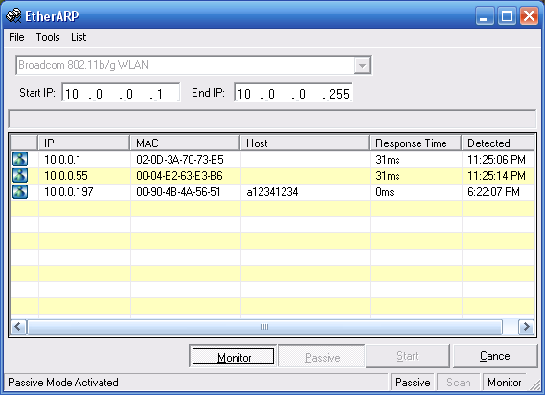

Monitor

Passive
Start
Cancel

File
Tools – The tools menu contains the options to control scan mode and options.
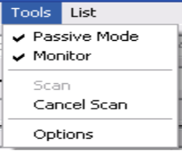

Passive: enables passive mode detection.
Monitor: enables monitor mode

List – The list menu allows you to save and open an existing result set.
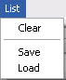

Options
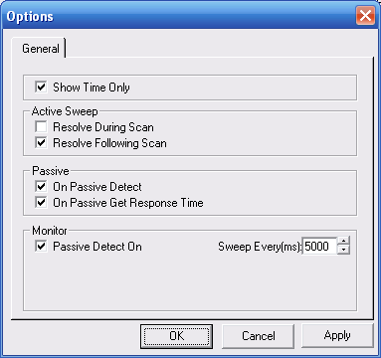

- Main
  - Show Time Only – This property determines if the full date and time are displayed in the results grid.

- Active Sweep
  - Resolve During Scan – Using this option will attempt to resolve the host name from the ip address when the host is detected during a scan. This option is not recommended because the results can be unpredictable when there is a high latency in resolving host names.
  - Resolve Following Scan – Using this option will attempt to resolve host names following a scan. This is the recommended resolution path.
- Passive
  - On Passive Detect – Using this option will resolve the host name of a detected device. If you do not wish to make your presence known to an Intrusion Detection System (IDS) it is highly recommended that you avoid this option.
  - On Passive Get Response Time – This will send an ARP ping to the host when it is detected. The results will be displayed in the record.
- Monitor: Monitor mode allows you to actively monitor the response time and online status of hosts that have been detected.
  - Passive Detect On – Using this option will enable passive mode detection when monitoring.
  - Sweep Every(ms) – When using monitor mode EtherARP will actively ping each host that is listed updating the host status and response time.

