Installing R, Rstudio, and Incorporating them into your Path
All these instructions only ever need to be performed once!

I am using Windows 7, so you may need to tweek it a bit for new versions of the Windows OS. If you need help please just e-mail me and I can help you guys out :)

Install R

1. Googling “R” is the easiest way to find the R website but if it doesn’t pop up, here is the URL:
https://www.r-project.org

2. Press download R link.
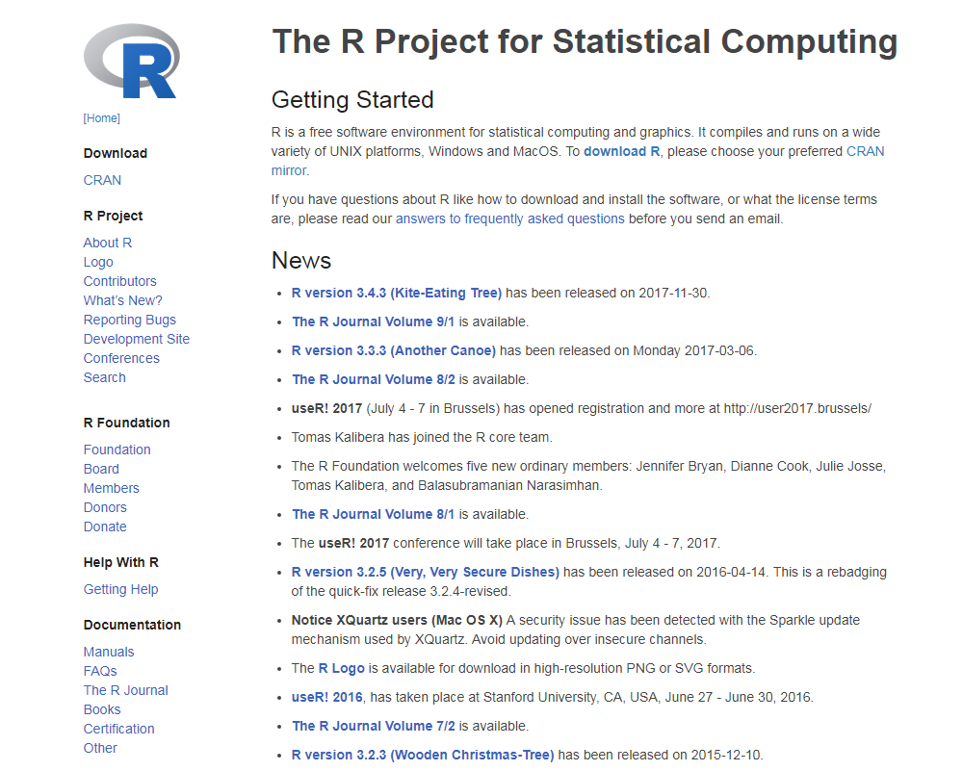

3. Select a CRAN mirror. I usually pick a https located in the USA. I am going to use Berkeley’s mirror:

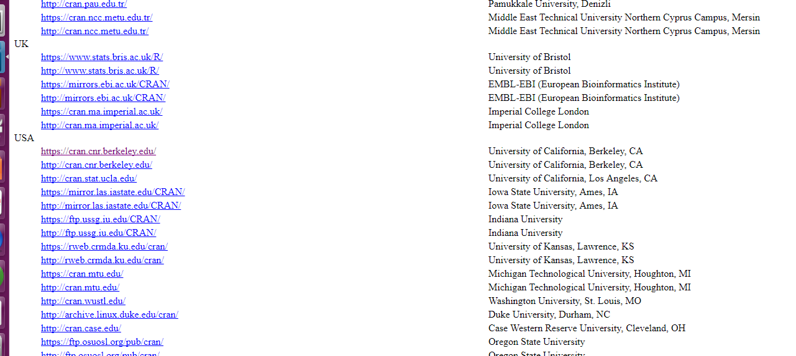

4. Select your OS. In this case, I am going to select Windows:
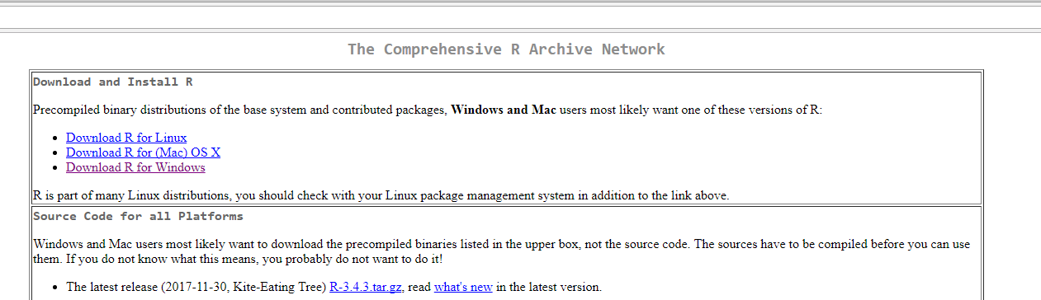

5. Next, install the R base directory:

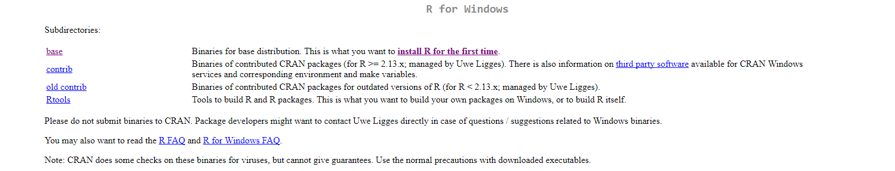

6. Click on “Download R 3.4.2 for Windows”. It shouldn’t matter if you have a 32 or 64-bit system since R is the same for both systems.
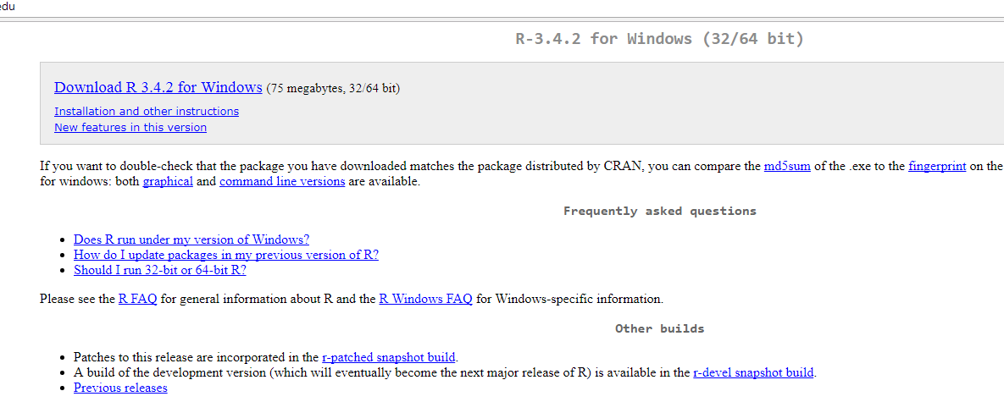

7. Once it finishes downloading press the .exe download. For windows 7 on Chrome, the download shows up at the bottom left corner of the web browser. On some browsers it may be be located in the top right corner of the page.

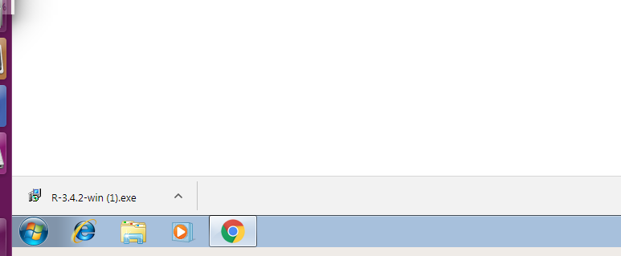

8. This should launch 2 window/security warnings. Press “Run” and “Yes”.

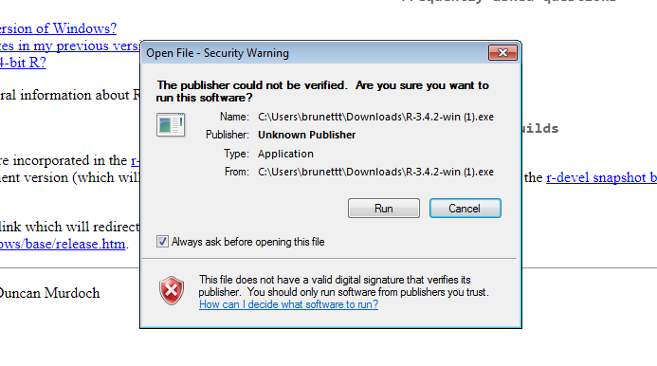
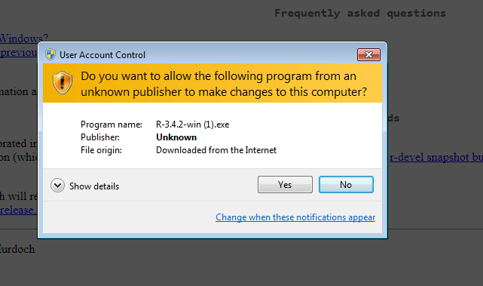

9. This will launch the R installation GUI. Do not change anything from what is selected or written in from the Default. Keep pressing “Next” until you press “Finish” on the last page of the installation GUI.
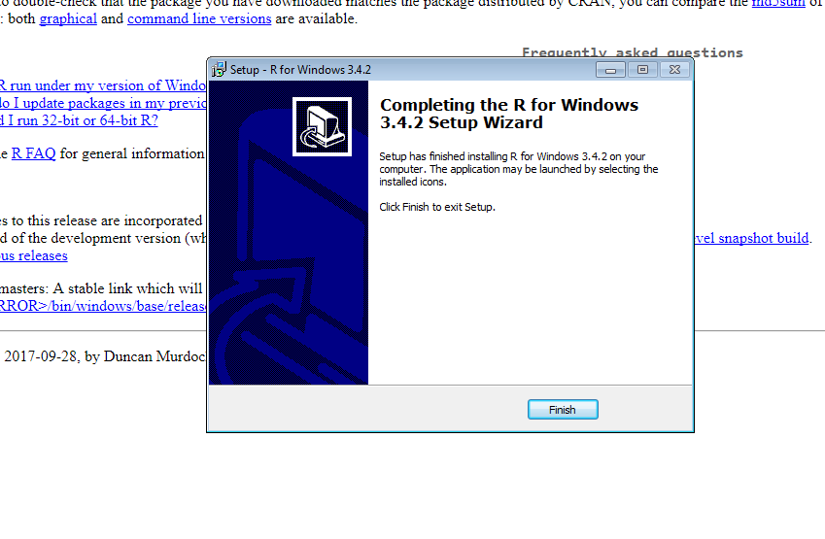

Install Rstudio (You must successfully install R first!)

1. Googling “Rstudio” is the easiest way to find the Rstudio website but if it doesn’t pop up, here is the URL:
https://www.rstudio.com
Then press the Download icon under the Rstudio image:
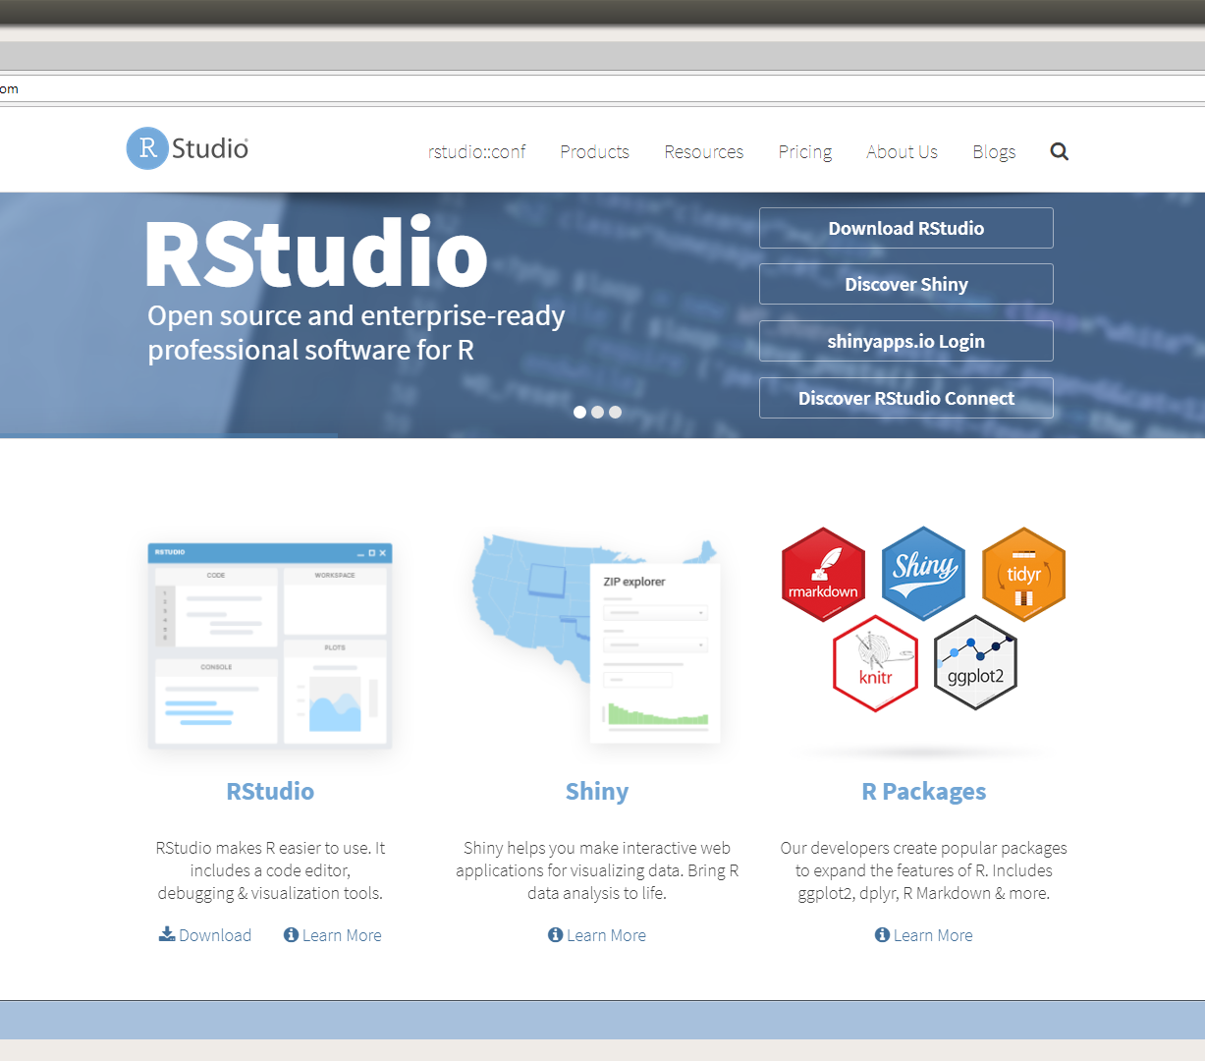

2. Download the free Rstudio Desktop Open Source License. Scroll down to the very bottom of the webpage and select the Windows Vista/7/8/10 under Installers for Supported Platforms. Do not download the Zip/Tarballs version or you will have to build and compile Rstudio manually!
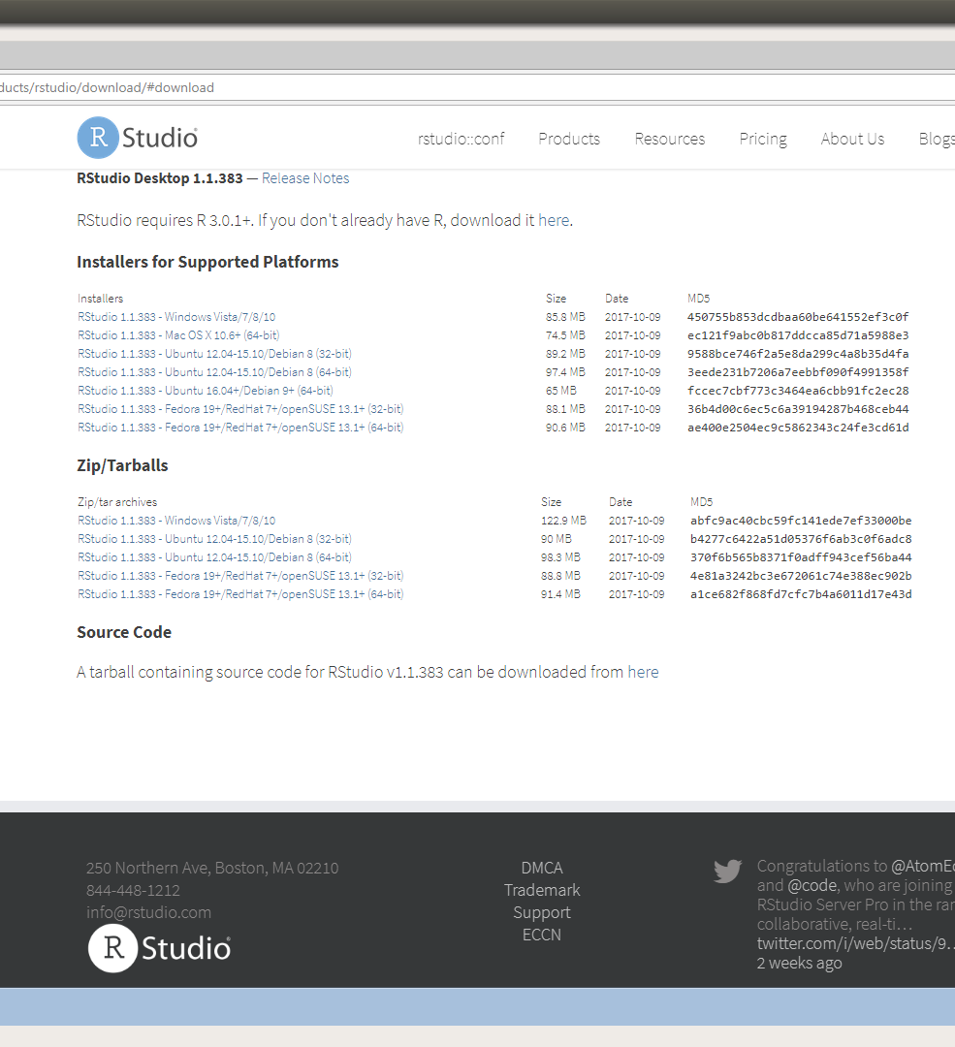

3. Now follow the same installation instructions from steps 7-9 from the R installation instructions listed above.

4. R and Rstudio should now both be installed.

Put R and Rstudio Executables in your path

1. Go back to your Windows Desktop and in the start menu type in “cmd” in your search.
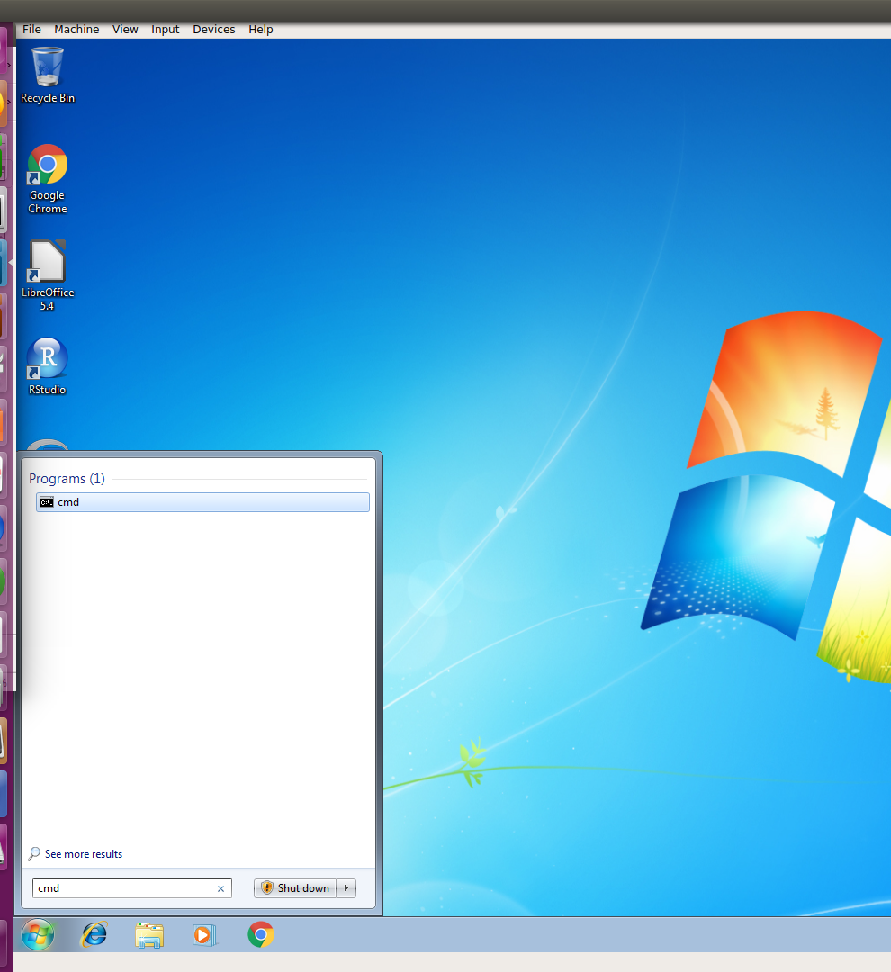

2. Press the black cmd program from the start menu to open a terminal with a command prompt.

3. Next type in: where R and press enter in the command prompt:
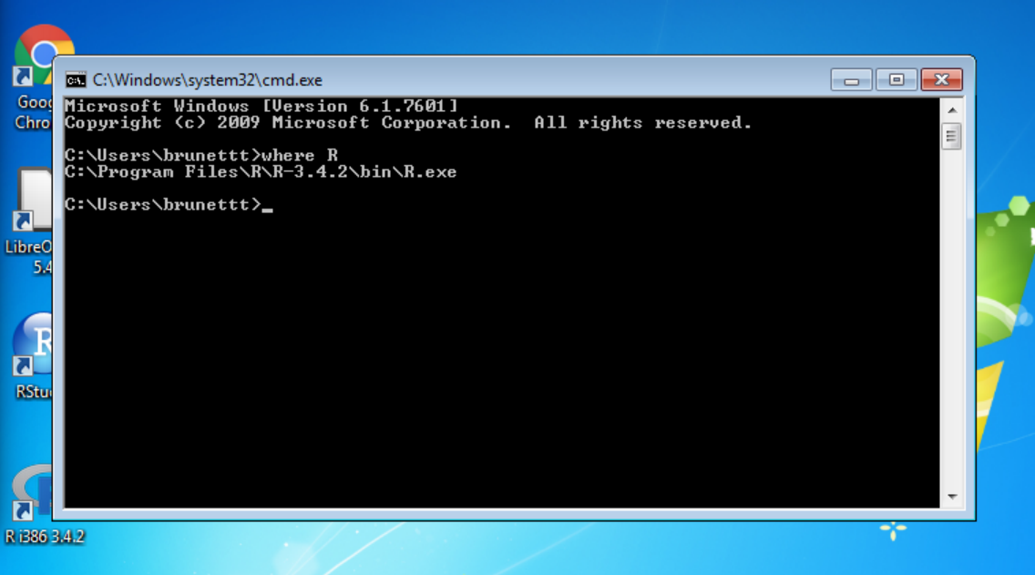

4. You will see the full path to where Windows automatically installed R. For me it is:
C:\Program Files\R\R-3.4.2\bin\R.exe

5. Copy this path exactly up through the last backslash but do not include the R.exe part! So everything highlighted in yellow:
C:\Program Files\R\R-3.4.2\bin\R.exe

6. Now you are going to paste this path into your Windows environmental variables path. To get to the environmental variables path, go to the start menu and search “environment variable”. You should see something similar to the following and select “Edit the system environment variables”:
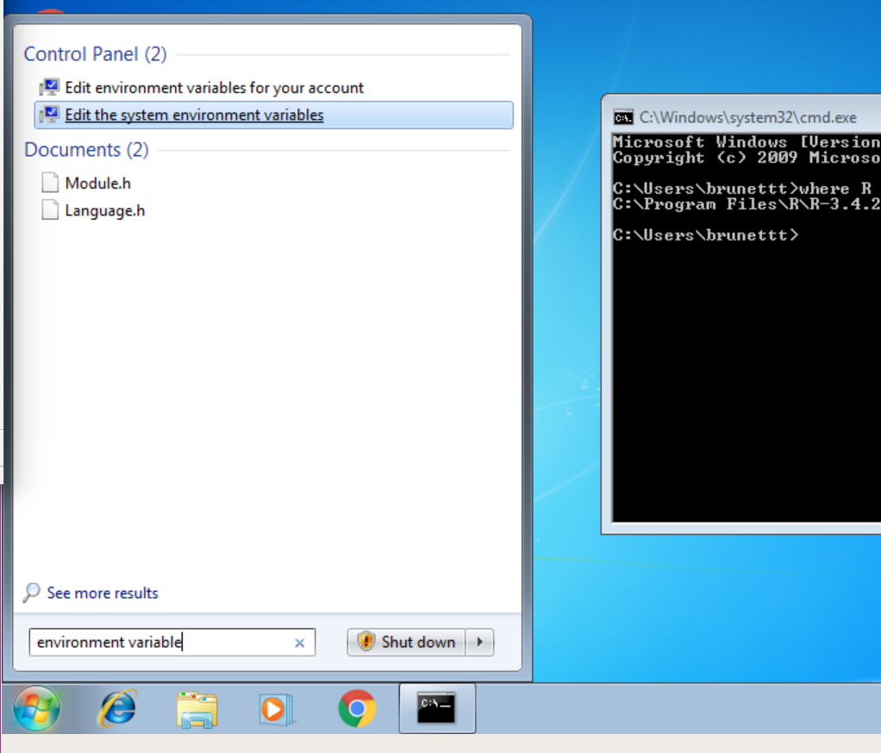

7. This should open a page that looks similar to the following image below. Press “Environmental Variables...”
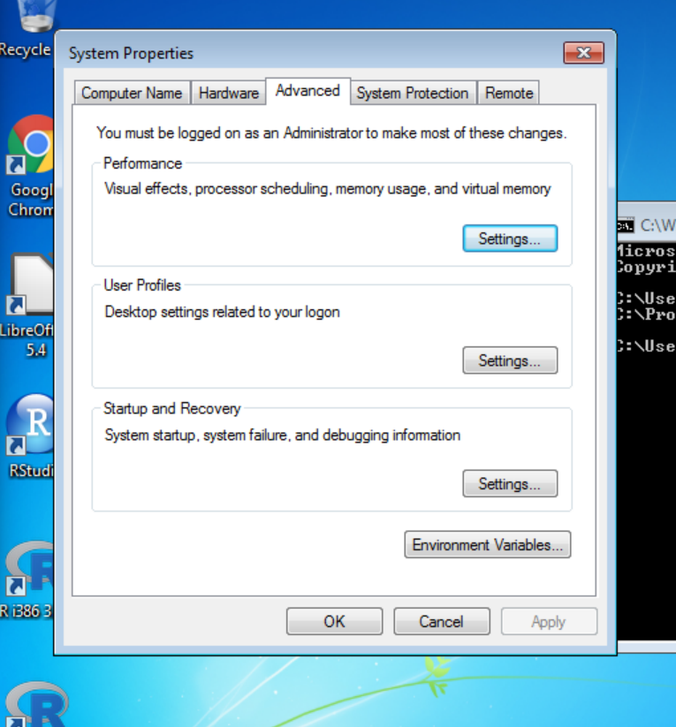

8. This will open a new window that looks similar to the following image below. Under System Variables highlight “Path” and select “Edit...”
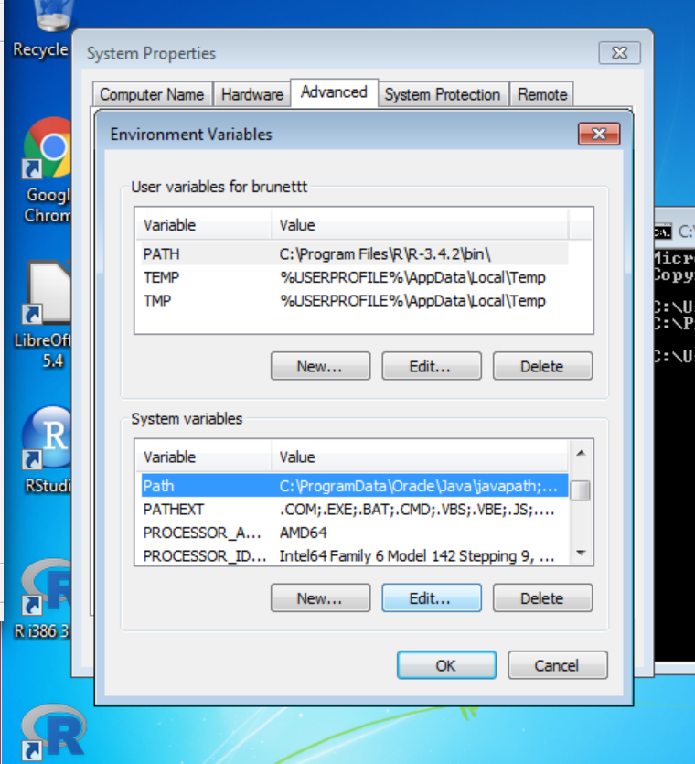

9. It will open a window, “Edit System Variable”. Scroll to the very end of the Variable value. Be careful, do not modify to erase anything that is already existing in the Variable value field. You just want to append to the end of it! If you modify something, just cancel out and go back in to the Edit button again.

After you reach the end of the variable value field, place a semicolon (;) at the end with NO SPACE!Then immediately following the semicolon (no space following it!) paste the file path you copied from step 5. It should look similar to the image below. Then press “OK”.
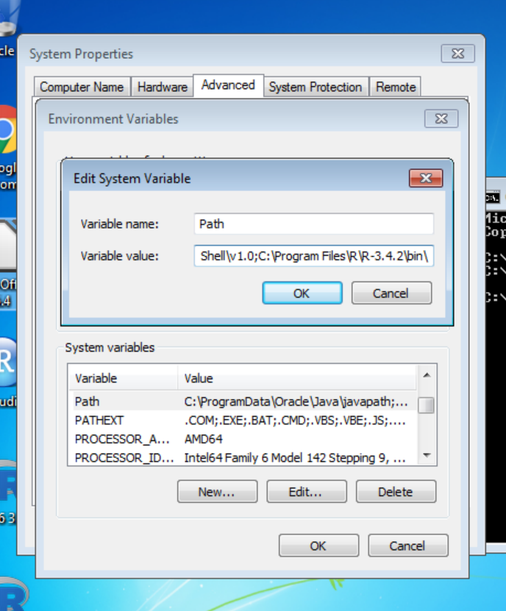

10. After pressing “OK” press “OK” on again on the previous window to save changes. Continue to press “OK” until all the Windows disappear and you have exited the Environmental Variables windows.

11. Exit out of the black terminal/command prompt screen. Now open a new terminal by repeating step 1 and 2. Type in “R” (no quotes) at the command prompt. You should see the following listed in the terminal output:

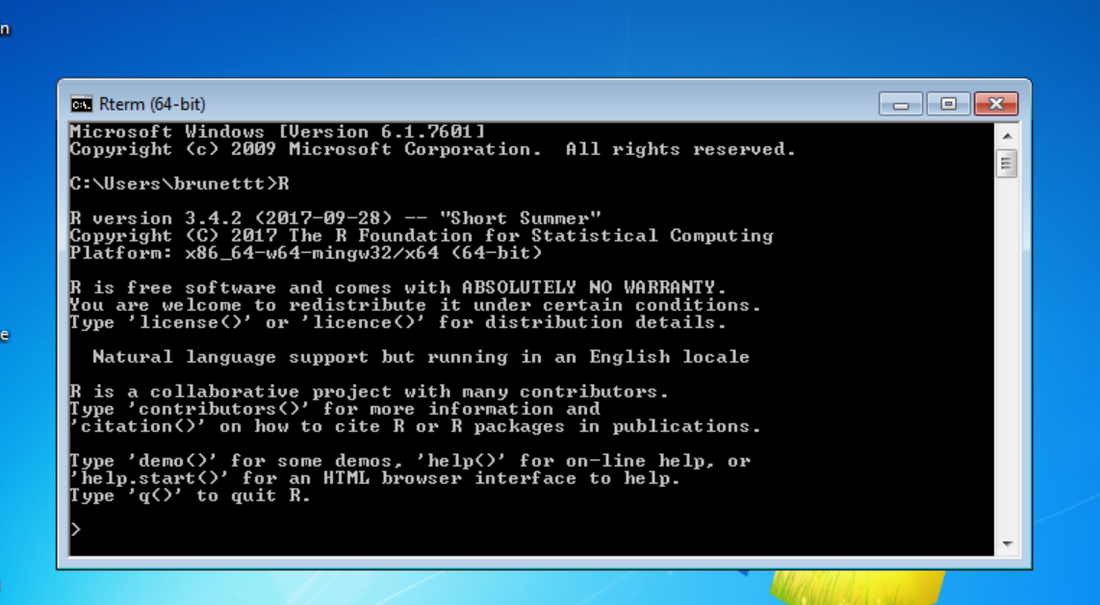

If you see this page, you have successfully installed R system-wide! You should never have to do this again unless you get a new computer or wipe this one clean. To exit, you can press the “x” in the upper right corner or type q() followed by enter and it will exit R for you.

Installing R libraries for scripts

1. Open/Start Rstudio either from the Desktop Icon or from the Start menu. It should open a GUI like the image below:
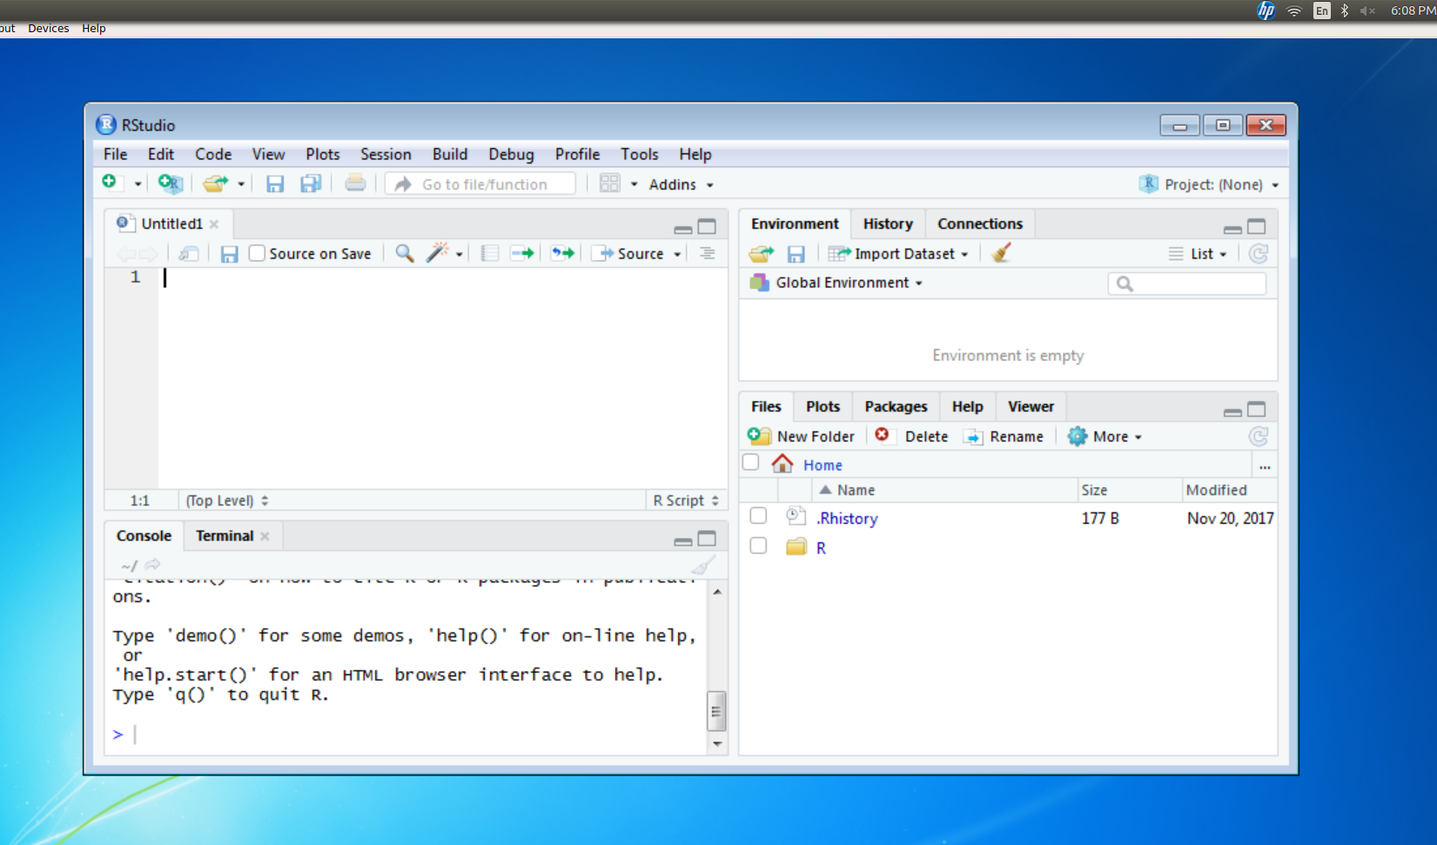

2. In the box on the bottom labeled “Console” you are going to type in the following and then press enter: (do not copy and paste the line into the R console because the characters do not always translate properly in R)
install.packages(“XLConnect”, dependencies=T)

You should see a lot of red writing indicating it is installing it. Once this is done. Continue to repeat step 2 for the next 3 install.packages() lines:

install.packages(“readxl”, dependencies=T)

install.packages(“gtools”, dependencies=T)

install.packages(“stringr”, dependencies=T)

3. You should now have all the packages installed that are required for the scripts! You can close the Rstudio GUI.

Congratulations! You are finished!top

