Transfer Market Efficiency in European Football
Project Scoping Document
Field | Detail
Author | Tyler Brunsting
Status | Scoped, pre-build
Stack | Python · PostgreSQL · R · Power BI
Cost | $0 — all sources and tools are free

1. What this project is trying to find out
Every summer, European football clubs spend enormous sums moving players between each other. Some of that money buys players who transform a team. Some of it buys players who never play. Meanwhile a handful of clubs quietly fund themselves by buying undervalued players and selling them at a large profit.
Almost all public coverage of this focuses on how much clubs spend. Very little of it asks whether the spending actually worked.
The central question:
Which clubs in Europe's top five leagues extract the most on-field value per euro spent in the transfer market, which burn the most money for the least return, and — over nine seasons — which clubs actually got smarter?
Three sub-questions follow from it:
- Who buys well? Which clubs find players cheaply who then produce?
- Who sells well? Which clubs consistently sell above what a player was worth when they bought him?
- Who is the opposite? Which clubs spend heavily on players who don't play, don't produce, and don't hold their value?
The output is a two-page Power BI dashboard: a league-wide view that answers the question, and a club-level view that lets anyone inspect a single team in detail.

2. Why this project
Two honest reasons, and they reinforce each other.
It demonstrates a full analytics pipeline end to end. Data ingestion, entity resolution across mismatched sources, dimensional modeling, statistical scoring, and BI delivery — every stage of the work an analyst actually does, on a dataset nobody handed over clean.
It's a subject worth caring about. Football finance is genuinely interesting, and a question about money and competition is one people will actually click on. The sport is the hook; the engineering is the substance.

3. Scope
Dimension | Decision
Leagues | Premier League, La Liga, Serie A, Bundesliga, Ligue 1
Seasons | 2017/18 – 2025/26 (nine complete seasons)
Clubs | ~98, accounting for promotion and relegation
Financial inputs | Transfer fees only (wages excluded for now)
Performance inputs | Goals, assists, minutes, xG/xA, progressive passing, defensive actions
Excluded | The 2026/27 window — spend is known, output is not yet

4. Key decisions and why
Every one of these was a real fork in the road. Documenting the reasoning is part of the work, not commentary on it.

4.1 Why the window starts at 2017/18 and ends at 2023/24
FBref's advanced statistics were supplied by Opta (Stats Perform) and begin with the 2017/18 big-five season. Before that, the available data is goals, assists, minutes and cards — nothing more.
That constraint is decisive because of section 4.4 below. Position-adjusted scoring is the mechanism that stops a center back from looking useless for not scoring goals, and it depends entirely on the advanced metrics. Extending back to 2015/16 would mean two seasons scored on a fundamentally different and much cruder basis.
Understat offers xG back to 2014/15 and was considered. It was rejected because it is shot-based only: it would have improved coverage for forwards while leaving defenders just as poorly measured. That buys three extra years at the direct cost of the project's central methodological idea.
Why the window ends at 2023/24. On 20 January 2026, Opta (Stats Perform) terminated FBref's access to its data, citing an unspecified breach of their agreement, and demanded the data's immediate deletion. Sports Reference complied, removing every Opta-sourced advanced statistic from FBref: xG and xAG, progressive passes and carries, advanced defensive actions, and shot- and goal-creating actions. The removal covers past seasons as well as new ones. Basic statistics such as minutes, goals, assists and cards remain [1][2]. Sports Reference has said some advanced data may return in future, but "at a dramatically smaller scale" [1]. The gap is therefore current rather than necessarily permanent, and any data that does return would need to match the snapshot described below before this project used it.
This project confirmed the removal directly. FBref's 2023/24 Big 5 player pages, fetched in September 2026, still list every player, but each advanced column is either blank for every player or gone from the table (docs/phase-1-scraper-diagnostics.md in the repository).
The last complete public copy of the Opta-era data is the worldfootballR data repository, archived on 18 September 2025, four months before the removal. Its defensive, possession, aerial-duel and goalkeeping tables are complete through 2023/24 but hold only nine matchweeks of 2024/25. Scoring 2024/25 from part of a season would break the consistency this section is built on, so the scored window ends at 2023/24. Transfer activity after that is still shown on the club page, unscored (see 4.8).
Sources: [1] Sean Forman (President, Sports Reference), "FBref & Stathead Data Update", Sports-Reference.com blog, 20 January 2026, https://www.sports-reference.com/blog/2026/01/fbref-stathead-data-update/. [2] Catalina Bush, "FBref's loss of advanced stats is a blow to women's soccer data accessibility", The IX, 4 February 2026, https://www.theixsports.com/the-ix-soccer/fbrefs-loss-advanced-stats-womens-soccer-data-accessibility/.
Decision: start at 2017/18, end at 2023/24. Seven seasons, one consistent data standard, no asterisk.

4.2 Why nine seasons rather than five
An earlier draft scoped five seasons and excluded the COVID-affected period entirely. That was reconsidered.
The transfer market's COVID distortion was concentrated in the summer 2020 and summer 2021 windows, when spending fell roughly 40% and had not fully recovered. In a five-season window that period is 20% of the data and a genuine problem. In a nine-season window it is a controllable effect, and can be handled with a season-level control rather than by deletion.
Nine seasons also spans a much richer set of natural experiments: two distinct Chelsea ownership eras, the rise of Brighton and Brentford, the tightening of Financial Fair Play, and the Saudi Pro League's entry into the market.

4.3 The genuine risk of a long window — and the mitigation
The risk of a nine-year window is not that more data lets you prove anything. That concern properly belongs to testing many hypotheses until one sticks, which is a separate discipline problem.
The real risk is regime change. Newcastle in 2017 and Newcastle in 2025 are different organizations with different owners, budgets and strategies. Chelsea before and after the Boehly takeover are barely comparable entities. Collapsing nine years into a single average can blend two genuinely different clubs into a meaningless middle number.
Mitigation: efficiency is computed per club per season, and reported as a trend, not only as a nine-year aggregate. Season filters let a reader compare 2017–2021 against 2022–2026 directly.
This mitigation turns a weakness into the most interesting finding available: which clubs got smarter? is a better question than who is best?, and only a long window can answer it.

4.4 How performance is measured — position-adjusted output
Judging a signing on goals and assists would systematically misjudge most of the pitch. A center back who never scores may be excellent; a defensive midfielder who never assists may be the reason the team functions.
Approach: players are grouped by position — goalkeeper, center back, fullback, central midfield, attacking midfield/winger, forward — and scored against their own group using metrics appropriate to it. Defenders are measured on tackles, interceptions, clearances, aerial duels and progressive passing. Creators are measured on shot-creating actions, which credits the pass before the assist. Nobody is measured against a standard designed for a different job.

4.5 How injuries are handled — split, not corrected
If a signing misses two seasons through injury, a naive metric records near-zero output and marks the purchase a failure.
Removing injury effects entirely would be wrong in the other direction: signing a player with a long injury history is a scouting failure, not merely bad luck.
Approach: performance is split into two independent axes.
- Quality — output per 90 minutes played. Judges a player on the minutes he actually played, so injury doesn't distort the assessment of his ability.
- Availability — minutes played as a share of minutes available. Keeps fragility visible rather than excusing it.
Together these distinguish three outcomes a single metric would flatten into one:
Quality | Availability | Interpretation
High | Low | Good player, couldn't stay fit
Low | High | Fit and trusted, not good enough
Low | Low | The genuine flop

4.6 How transfer fee inflation is handled
Fees have inflated substantially across the window. A €40m signing in 2018 and a €70m signing in 2025 are not comparable in nominal terms.
An external price index was considered and rejected as a poor fit — general inflation has little to do with football's internal market dynamics.
Approach: deflate using the market itself. Every fee is expressed relative to that season's own market — as a share of total top-five league spend, or as a multiple of that season's median fee. The method is self-contained, requires no external data, and measures what actually matters: how expensive a signing was relative to what clubs were paying at the time.

4.7 Why transfer fees only, for now
Wages are a real part of the cost of a player and their exclusion is a genuine limitation of this analysis.
They are excluded initially because wage data requires an additional and less reliable scraping source, and because fee data alone is complete and consistent across all nine seasons. Adding a fragile dependency before the core pipeline works would risk the whole build.
Revisit criterion: if the fees-only rankings produce results that look systematically wrong in a way wages would explain — a club with modest fees but an enormous wage bill scoring implausibly well — wages get added.

4.8 Why the 2026/27 window is shown but not scored
The summer 2026 window has closed, so spending is fully known. But those signings have played only a handful of matches.
Scoring them would penalize every club that spent this summer, purely because the season is young — a distortion any informed reader would immediately spot.
Approach: the 2026/27 window appears on the club page as a recency layer showing what each club just did, clearly flagged as too new to score.

4.9 Manager tenure — annotation, not attribution
Because efficiency is tracked over nine seasons, a natural question follows: does the trend move when the manager changes? The club page answers this with a single full-width panel combining three layers — an efficiency trend strip, per-season transfer cash flow, and manager tenure bands.
The attribution problem is real and is handled by design. Managers frequently do not control transfers. Sporting directors do at most German clubs, and at Brighton and Brentford recruitment is explicitly a department rather than a coach's remit. A chart claiming to show "what a manager spent" would therefore overclaim.
Managers are also sacked mid-season. Aggregating spend by coach would require deciding who owns a season that had two of them, and any rule chosen would be wrong somewhere.
Approach: bars remain one pair per season and are never aggregated by coach. Manager tenure is shown as a colored band beneath the axis, snapped to season boundaries, so an era is visible as a run of seasons without forcing an attribution the data cannot support. The panel is labeled "during tenure," not "manager spend" — an accurate description of what is being measured.
Why gross and net are both shown. Each season carries a pair of bars — fees received and fees paid — rather than a single net figure. A club that spent €200m and sold €200m nets to zero, which would look identical to a club that did nothing. Since the project's question is about how well clubs trade, both sides of the ledger have to remain visible. The net figure is printed above each pair.
Why color encodes cash, not manager. Bar color carries direction of money — green for fees received, red for fees paid — consistently with the transfers table elsewhere on the page. Manager identity therefore cannot also be carried by bar color, and is confined to the bands beneath. One visual variable, one meaning.
Why the efficiency line sits in its own strip. Overlaying the index directly on the bars would place two different zero points at two different heights on the same chart, which misleads the eye. The line occupies a separate band above the bars, sharing the horizontal season axis but keeping its own scale.
Data source: worldfootballR's tm_team_staff_history() supplies manager tenures with dates, and tm_team_transfer_balances() supplies per-season fees paid and received. Both originate from Transfermarkt and join cleanly to data already being ingested.

5. The efficiency score
Four pillars, each z-scored across all clubs:
Pillar | What it captures
Recruitment ROI | Output delivered by signings per deflated euro of fee
Trading profit | Sale price against market value at time of purchase
Squad value growth | Whether signings appreciated, net of spend
Sporting return | League points — so "efficient" can't just mean cheap and bad

The weights are derived, not chosen. Rather than assigning weights by judgment, each pillar is regressed against actual sporting success across the nine seasons, and the coefficients set the weights. The model is answerable to the data rather than to the analyst's priors.
Two guardrails:
- Spend floor and log transform. A club spending near zero produces a mathematically enormous ROI. Untreated, this would put the league's most passive clubs at the top.
- Revenue-scale normalization. Without it, the index collapses into a proxy for club size, and the finding becomes "small clubs spend less," which is not a finding.
Validation: the top and bottom ten are checked against informed football judgment before the result is trusted. If the model ranks clubs in a way that is obviously wrong to anyone who follows the sport, the model is wrong. That check is not a formality.

6. Architecture
Python for ingestion and modeling — the natural tool for scraping, reshaping and loading. R for the statistical layer, where the regression-derived weights are computed, and for worldfootballR's pre-built FBref-to-Transfermarkt player mapping. PostgreSQL as the warehouse, holding a proper star schema. Power BI for delivery.
The split is deliberate rather than decorative: each tool is used where it is genuinely strongest.
Stage | Tool | Purpose
Ingest | Python | Scrape and reshape Transfermarkt and FBref data
Entity mapping | R (worldfootballR) | Pre-built FBref ↔ Transfermarkt player dictionary
Manager tenures | R (worldfootballR) | Coach appointment and departure dates per club
Warehouse | PostgreSQL | Star schema — facts and dimensions
Scoring | R | Position adjustment and regression-derived weights
Delivery | Power BI | Two-page interactive dashboard

7. Known risks
Risk | Assessment | Mitigation
Club name matching across sources | Highest risk in the project. "Man Utd" / "Manchester United" / "Manchester Utd" all refer to one club. Projects like this commonly stall here | worldfootballR's player dictionary handles players; a manual club mapping table handles clubs. Time budgeted explicitly
Scraper fragility | FBref rate-limits; a nine-season pull is a multi-hour unattended job | Test on one season before the full run. Cache aggressively
Undisclosed fees | Some transfers have no public fee | Excluded and documented, not guessed
Loan and add-on data quality | Inconsistently recorded on Transfermarkt | Verify availability before building dependent visuals
Wage exclusion | A real limitation, stated plainly | Documented; revisited if rankings look systematically off

8. Deliverables and success criteria
- Two-page Power BI dashboard (.pbix)
- Public GitHub repository containing the ingest scripts, schema DDL, and scoring code
- README documenting question, method, findings, limitations, and reproduction steps
- LinkedIn write-up, led by the finding
The project succeeds if:
- The question is answered with a defensible, reproducible number
- Someone with a football background looks at the rankings and finds them credible
- Someone with an analytics background can read the repo and follow the reasoning
- The methodology limitations are stated openly rather than hidden
An interesting wrong answer that is honestly documented is worth more than a clean answer that quietly hides its assumptions.

Appendix — Dashboard design mockups
Both pages were mocked up before any code was written, so the build has a fixed visual target. All figures and club names shown are placeholders.

Page 1 — League overview
Answers the central question. The scatter plot is the centerpiece: transfer spend on the horizontal axis, sporting return on the vertical, split into quadrants at the median club on both axes. The quadrants make the finding readable in seconds — top-left is smart spending, bottom-right is money burned. Supporting elements: a definitions strip so the axes need no explanation, a KPI row, a spend-by-league donut that drills down into individual clubs, and best/worst efficiency rankings.
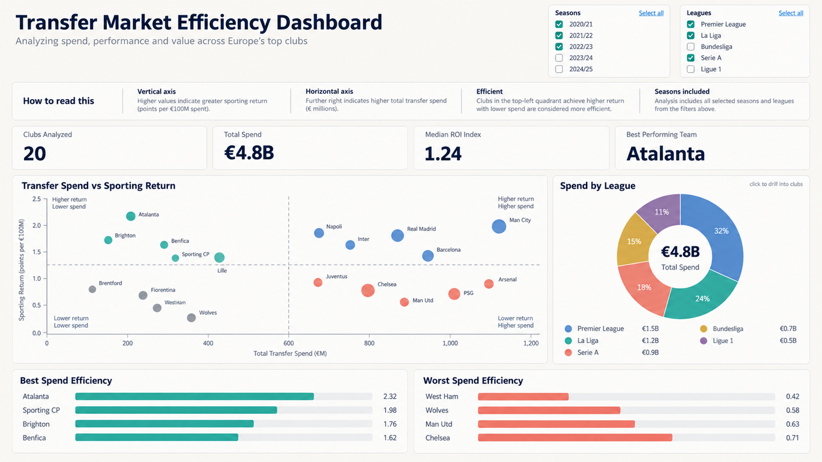
Figure 1 — League overview page. Placeholder data.

Page 2 — Club detail
Lets a reader inspect any single club. Squad with market values and nationality, the club's efficiency score broken into its four component pillars, a spending breakdown split by permanent, loan and free transfers, largest transfers with a bought / sold / loan filter, honors, and — across the full width beneath — the combined cash flow and manager tenure panel described in section 4.9.
Two deliberate design choices: the pillar sub-scores sit directly beneath the headline number so the score is never a black box, and transfer fees are colored by direction of cash — money paid out in red, money received in green — in muted tones distinct from the brighter accent colors used for the efficiency verdict.
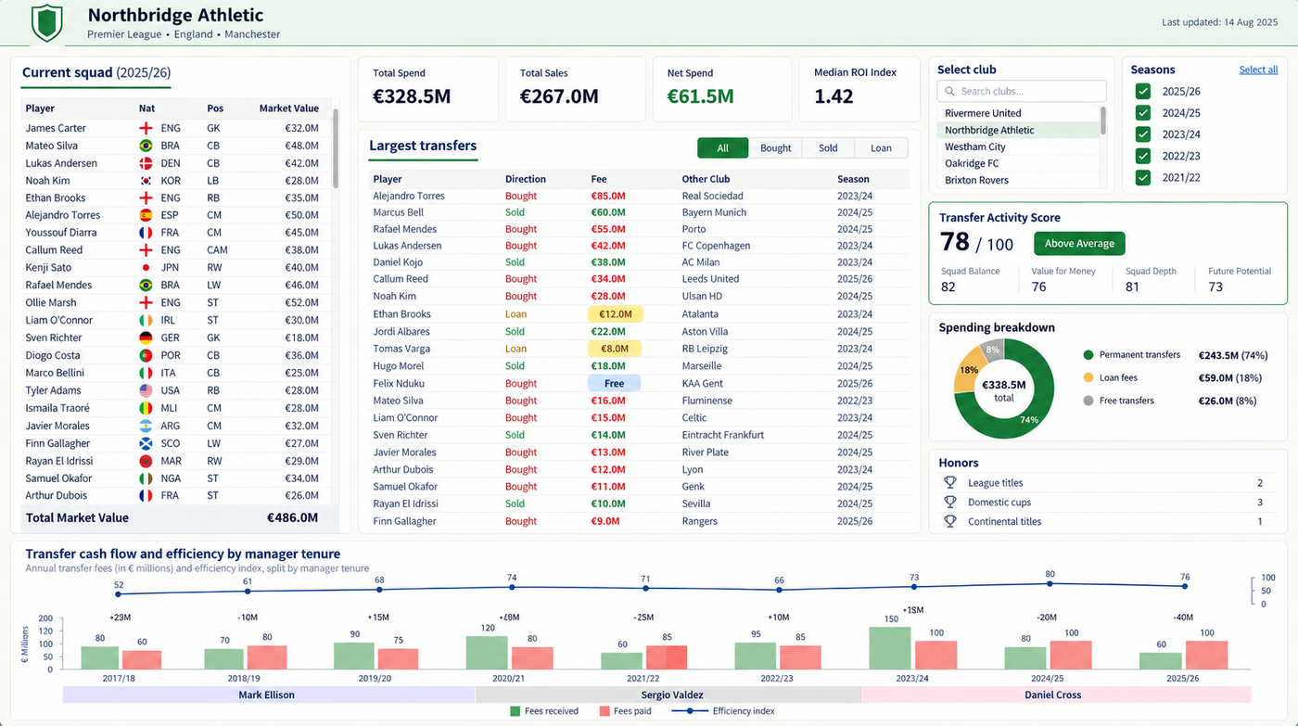
Figure 2 — Single club detail page. Placeholder data.
Two known defects in this mockup, noted so it is not mistaken for a specification: the net figures printed above each bar pair do not reconcile with the bars themselves, and the manager bands do not align to season boundaries. Both are artifacts of the mockup tool. In the build, net is computed from the underlying figures and bands snap to whole seasons.

