For QC

1. Open Eclipse and checkout below projects:

1. jobbuzz-admin-branch

2. jobbuzz-admin-packaging-branch

3. jobbuzz-core-branch

2. Right click on the projects and click on synchronize with Repository

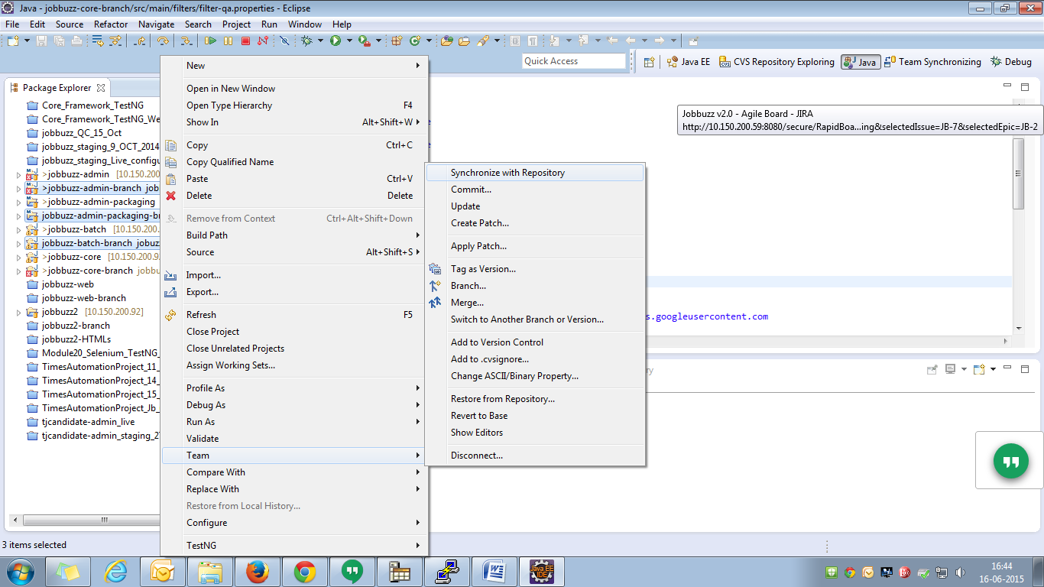

3. Right Click and Click on Update

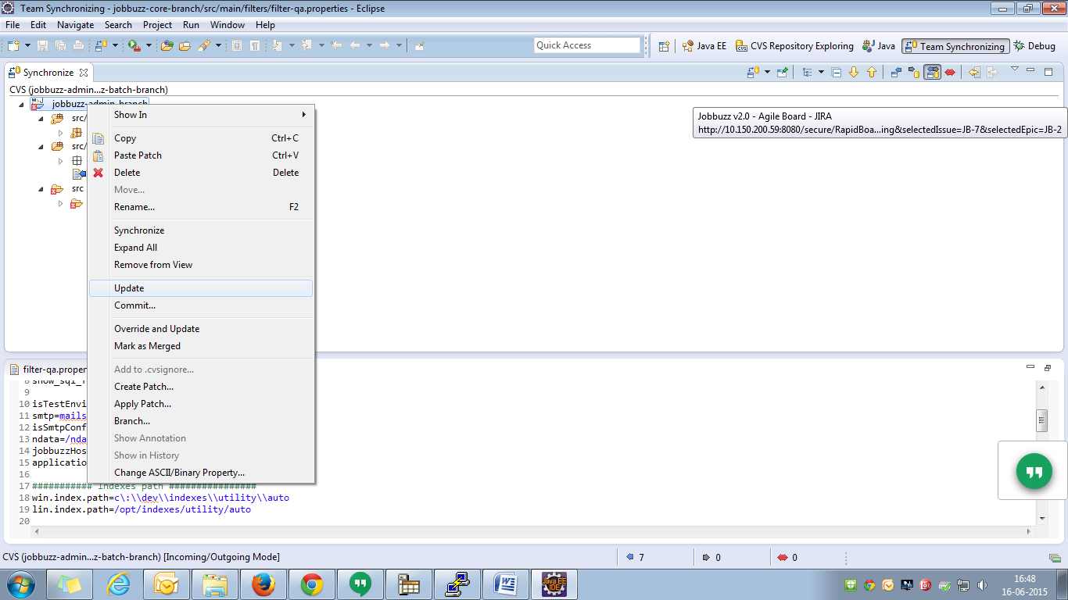

4. Go to below path where project exist using below commands on cmd

cd d:

cd workspace/jobbuzz-admin-packaging-branch

mvn clean install –Denv=qa

5. Login to 10.150.200.53 using Putty

Username-root

Password-mise2@

6. Go to below Path

cd /opt/tomcat/webapps/jobbuzz-admin-branch/

7. Delete all files in jobbuzz-admin-branch folder using below command

rm -rf \*

8. Login to 10.150.200.53 using winscp

Username-root

Password-J0Bbuzz79

9. Copy war from D:\Workspace\jobbuzz-admin-branch\target\jobbuzz to /opt/tomcat/webapps/jobbuzz-admin-branch

10. Then Extract war on 53 putty using below command

jar-xvf jobbuzz-admin.war

11. Remove war file using on 53 putty using below command

rm jobbuzz-admin.war

13. shutdown the server using below command

/opt/tomcat/bin/shutdown.sh

14. Check for if any java process is running using below command

ps -ef | grep tomcat

15. kill if any java process is running

kill -9 "javaprocessid"

16. Shutdown the server using below command

/opt/tomcat/bin/startup.sh

For staging

1. Open Eclipse and checkout below projects:

1. jobbuzz-admin

2. jobbuzz-admin-packaging

3. jobbuzz-core

2. Right click on the projects and click on synchronize with Repository

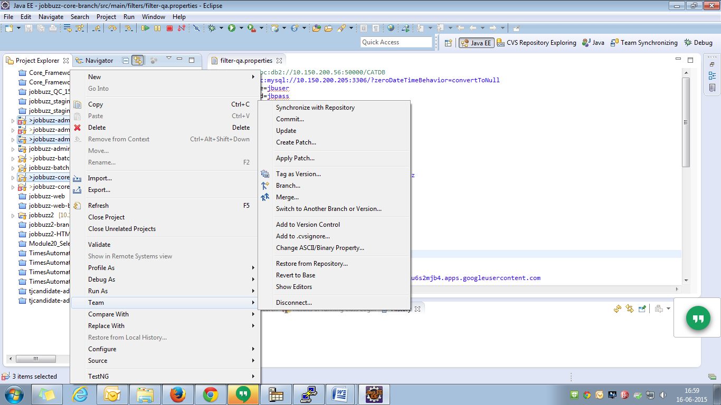

3. Right Click and Click on Update



4. Go to below path where project exist using below commands on cmd

cd d:

cd workspace/jobbuzz-admin-packaging

mvn clean install –Denv=staging

5. Login to 115.112.207.79 using Putty

Username-root

Password- J0Bbuzz79

6. Go to below Path

cd /opt/tomcat/webapps/jobbuzz-admin/

7. Delete all files in jobbuzz-admin folder using below command

rm -rf \*

8. Login to 115.112.207.79 using winscp

Username-root

Password-J0Bbuzz79

9. Copy war from D:\Workspace\jobbuzz-admin \target\jobbuzz to /opt/tomcat/webapps/jobbuzz-admin

10. Then Extract war on 79 putty using below command

jar-xvf jobbuzz-admin.war

11. Remove war file using on 79 putty using below command

rm jobbuzz-admin.war

13. shutdown the server using below command

/opt/tomcat/bin/shutdown.sh

14. Check for if any java process is running using below command

ps -ef | grep tomcat

15. kill if any java process is running

kill -9 "javaprocessid"

16. Shutdown the server using below command

/opt/tomcat/bin/startup.sh