Medical RAG QA System
Tyler Buzenski, Christopher Protheroe

University of New Haven
West Haven, Connecticut

Abstract
This paper presents a retrieval-augmented generation (RAG) system for infectious disease question answering over PubMed abstracts. We assemble a domain corpus through the NCBI Entrez/PubMed API, preprocess and chunk abstracts, embed the chunks with Sentence-BERT style sentence embeddings, and index them in ChromaDB. At inference time, the system retrieves the top-k relevant chunks and conditions three locally served open-source language models; Llama-3-8B, Mistral-7B, and Phi-3-mini, on the same evidence and prompt. The project goal is: to build a practical, fully local medical RAG pipeline and to compare model behavior under identical retrieval conditions. Evaluation combines automated RAGAS-style metrics from our experimental spreadsheet (faithfulness and answer relevancy) with two human rankings on ten domain-specific questions based on COVID-19, influenza, tuberculosis, and HIV. Our results suggest that Llama-3-8B offers the strongest overall balance of grounding and human preference, Mistral-7B is concise and often highly relevant but can be too brief, and Phi-3-mini is competitive on faithfulness yet more verbose and less consistently relevant. The system is designed as a prototype rather than a clinical tool, but it demonstrates how local models can be compared in a medically grounded RAG workflow.

Keywords
retrieval-augmented generation; medical question answering; PubMed; open-source LLMs; ChromaDB; sentence transformers; local inference; hallucination analysis

Introduction
Large language models have become interfaces for question answering, but their parametric memory alone is unreliable for factual and critical domains. Retrieval-augmented generation (RAG) addresses this limitation by pairing a generator with an explicit external knowledgebase, allowing the system to ground answers in retrieved evidence rather than in unsupported memorization [1]. This property is especially important in medicine, where plausible but unsupported statements can become safety risks. Recent work on medical LLMs shows strong promise for question answering, but also emphasizes persistent concerns around hallucination, calibration, and trustworthy deployment [7, 8].
The goal of this project is to build a compact medical RAG system that can run on consumer hardware and support a fair comparison among three open-source models: Llama-3-8B, Mistral-7B, and Phi-3-mini [3–5]. Instead of optimizing a state-of-the-art model, we focus on a reproducible local pipeline built from openly available tools. Our domain is infectious disease literature, with PubMed abstracts covering COVID-19, influenza, tuberculosis, and HIV. The system collects documents with the Entrez API, chunks and embeds the text, indexes the chunks in ChromaDB, retrieves top-k evidence for each question, and then queries all three models through the same prompt and local serving stack.
This paper makes three contributions. First, it documents an end-to-end implementation of a PubMed-based RAG system. Second, it evaluates the same retrieval context across three local LLMs using both automated and human-centered criteria. Third, it analyzes the tradeoffs between fluency, grounding, concision, and uncertainty handling in a medical QA setting. Although the resulting system is not intended for clinical use, it serves as a useful prototype for understanding how smaller open-source models behave when grounded in biomedical abstracts.

Related Work
Our design follows the standard RAG formulation introduced by Lewis et al., who combine parametric generation with non-parametric retrieval to improve factuality and provenance on knowledge-intensive tasks [1]. Because our retriever operates over short PubMed passages, sentence-level dense retrieval is a natural fit. We therefore use sentence-transformer embeddings derived from the SBERT line of work, which was developed specifically to make semantic similarity search practical and efficient [2].
For generation, we compare three recent open-source models. Mistral-7B emphasizes architectural efficiency through grouped-query attention and sliding-window attention [3]. Llama-3-8B is a strong instruction-tuned general model that has become a popular local baseline for dialogue and QA [4]. Phi-3-mini is a smaller 3.8B-parameter model whose technical report highlights strong reasoning performance relative to its size, making it particularly attractive for low-resource deployment [5].
To analyze the outputs, we use metrics inspired by the RAGAS framework, which was proposed as an automated evaluation toolkit for RAG pipelines [6]. Automated scores are useful for screening many responses, but they do not fully replace human inspection. In medicine, recent surveys stress that evaluation should consider factuality, reasoning quality, and the consequences of unsupported answers, not only surface fluency [7, 8].

System and Implementation

Corpus
The corpus consists of PubMed abstracts retrieved through the NCBI Entrez API. The data collection script defines four topic-specific searches: COVID-19, influenza, tuberculosis, and HIV. Each topic query combines disease names with clinical meaningful terms such as treatment, symptoms, diagnosis, prevention, severity, latent versus active disease, and therapy. In the default configuration, the system requests twenty-five abstracts per topic, giving a target corpus of one hundred abstracts.
Each record stores the PubMed identifier, title, abstract, journal, year, topic label, author list, and MeSH terms when available. Empty titles or abstracts are filtered out during preprocessing. Because PubMed abstracts are relatively short, the system preserves document source text and enriches each chunk with metadata rather than aggressively compressing the text.

Preprocessing, Chunking, and Retrieval
The preprocessing stage normalizes whitespace, splits abstracts into sentences, and creates overlapping chunks. In the supplied code, the default chunk size is four sentences with an overlap of one sentence. Each chunk is prefixed with structured metadata including title, topic, year, and journal. The resulting representation makes retrieval more interpretable because both the abstract text and bibliographic context are available to the generator.
For embeddings, the system uses the sentence-transformers model for all-MiniLM-L6-v2, a lightweight dense encoder suitable for local semantic search. Chunk vectors are written to a persistent ChromaDB collection. At query time, the retriever returns the top three chunks by default, and an optional topic filter. This means that HIV, influenza, tuberculosis, and COVID-19 questions search a smaller topic-specific subset whenever a keyword match is detected.

Prompting and Local Model Serving
All three models are queried with the same prompt template. The system instruction explicitly restricts the answer to the retrieved context, asks the model to state when evidence is insufficient, and warns against inventing facts, statistics, or treatment recommendations. This prompt is intentionally conservative because the project is aimed at comparing grounding behavior rather than maximizing stylistic creativity.
Generation is performed locally through Ollama. The default models in the code are llama3.1:8b-instruct-q4_K_M, mistral:7b-instruct-q4_1, and phi3:mini. The experiment script loops over the question set, retrieves one evidence set per question, builds a shared prompt, and then records each model's answer, latency, error status, and serialized retrieval context. A Streamlit application provides an interactive interface for querying the system, inspecting retrieved chunks, and comparing model outputs side by side.
Evaluation Setup
We evaluate the system on ten domain-specific questions designed to stress symptoms, diagnosis, treatment, prevention, and uncertainty handling across the four infectious disease topics.
1. What evidence in the corpus describes common symptoms of COVID-19?
2. What does the corpus say about influenza vaccine effectiveness?
3. How is latent tuberculosis different from active tuberculosis?
4. What treatments are discussed for HIV infection?
5. What complications are associated with severe COVID-19 cases?
6. What diagnostic approaches are mentioned for tuberculosis?
7. What risk factors are associated with influenza severity?
8. What does the corpus say about antiviral therapy for HIV?
9. How do the retrieved studies describe prevention strategies for tuberculosis spread?
10. What limitations or uncertainties are reported in the corpus for infectious disease treatment?
Each question is answered by all three models using the same retrieved evidence, resulting in thirty model responses. The uploaded experimental spreadsheet reports two automated metrics—faithfulness and answer relevancy—as well as two human rankings labeled Tyler Ranking and Chris Ranking. Lower human rank is better. We interpret these manual rankings as a preference judgment that jointly reflects answer quality, factual grounding, and usefulness. The evaluation scripts also generate a manual review sheet with fields for consistency, relevance, context use, hallucination risk, and medical terminology, making it possible to extend the analysis beyond the spreadsheet.
For quantitative analysis, the uploaded spreadsheet records faithfulness and answer relevancy along with two human rankings. Lower human rank indicates a better answer. We report average values by model and then supplement the numbers with close reading of representative outputs. Because the same retrieved chunks are reused across models for each question, differences in quality largely reflect the generator rather than the retriever.
Results
Average results show a clear but nuanced ordering among the three models. Llama-3-8B achieved the best human preference, with a combined mean rank of 1.65 across the two raters. Phi-3-mini ranked second overall at 2.00, while Mistral-7B ranked third at 2.35. On automated metrics, Phi-3-mini and Llama-3-8B were nearly tied on faithfulness (0.879 versus 0.878), whereas Mistral-7B obtained the highest answer relevancy score (0.865).
The aggregate pattern suggests that answer relevancy alone did not determine human preference. Mistral-7B often produced concise answers that stayed close to the question, which likely helped its relevancy score, but human raters frequently preferred the fuller and better-grounded outputs from Llama-3-8B. Phi-3-mini showed surprisingly strong grounding for a smaller model, yet its lower relevancy indicates that it sometimes added detail that was not as directly responsive to the prompt.
Using the average human rank as the primary selection criterion, Llama-3-8B won six of the ten questions, while Phi-3-mini won the remaining four. Mistral-7B did not win a question outright under this rule, despite having the strongest answer-relevancy score overall. This reinforces the idea that relevance metrics and reader preference are related but not identical.
The model-by-model averages are as follows: Llama-3-8B: faithfulness 0.878, answer relevancy 0.804, average human rank 1.65. Mistral-7B: faithfulness 0.822, answer relevancy 0.865, average human rank 2.35. Phi-3-mini: faithfulness 0.879, answer relevancy 0.667, average human rank 2.00.
The most challenging items were those in which the retrieved context only partially addressed the question. On such questions, the best behavior was to explicitly acknowledge insufficient evidence. The score sheet notes one especially strong abstention behavior: on the severe-COVID-19 complications item, a top answer refused to hallucinate rather than invent unsupported complications.
Qualitative Analysis
Qualitative notes from the spreadsheet align with the numerical results. The raters observed that Llama tends to organize answers as lists, which worked well for symptom, diagnostic, and uncertainty questions. In several cases, Llama was also the strongest at explicitly stating when the evidence was incomplete, which is desirable in a medical setting. For example, on the question about complications associated with severe COVID-19, a top answer acknowledged that the retrieved context did not contain direct evidence and avoided inventing unsupported complications.
Mistral-7B generally favored short and direct answers. This style likely boosted its answer relevancy score because the responses usually addressed the user question immediately. However, the same brevity sometimes reduced context integration. On questions that required synthesis across multiple chunks—such as HIV treatment or tuberculosis prevention—Mistral more often omitted nuances that human readers considered useful.
Phi-3-mini produced long and thoughtful answers relative to its size. This helped it on some synthesis-heavy questions, and the model won several tuberculosis and HIV items in the human ranking. At the same time, its lower average relevancy suggests that it occasionally drifted beyond the most salient evidence or restated supporting detail that did not sharpen the answer. In a practical assistant, this behavior could be beneficial for explanation, but it also raises the risk of over-answering.
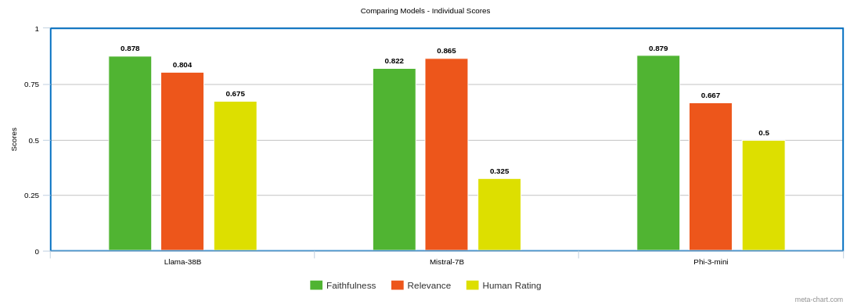
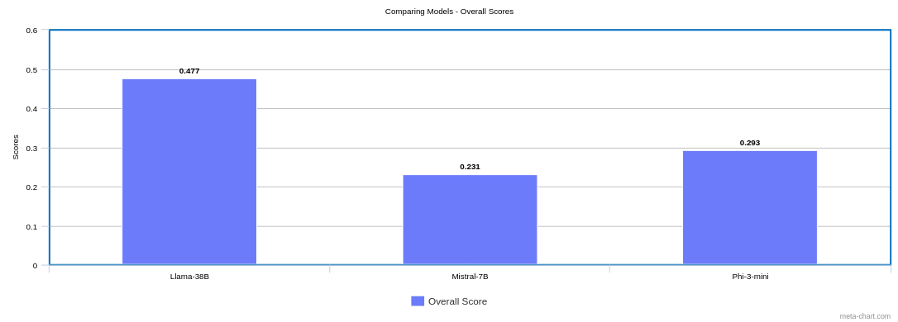
Across the three systems, grounding quality was highest when the retrieved chunks contained direct lexical overlap with the question and when the answer could be formatted as a short evidence-backed summary. Performance dropped when the evidence was more indirect, spread across multiple chunks, or focused on background discussion instead of explicit recommendations. This failure mode is consistent with the broader RAG literature, where retrieval coverage and context exploitation jointly determine final answer quality [1, 6].
Strengths, Weaknesses, and Limitations
The strongest aspect of the system is its transparency. Because every answer is generated from retrieved PubMed chunks, users can inspect the evidence and verify whether the response is grounded. The modular codebase is also easy to reproduce: one script fetches abstracts, another preprocesses them, another builds the Chroma index, and separate scripts handle generation, evaluation, and interactive demonstration.
The main weakness is that the corpus is small and abstract-only. Abstracts provide useful summaries, but they may omit details needed for difficult clinical questions. Retrieval quality is also constrained by the simple dense retriever and a relatively small top-k. In addition, our evaluation set contains only ten handcrafted questions, so the conclusions should be interpreted as indicative rather than definitive.
A second limitation is that the automated evaluation is partial. The spreadsheet includes faithfulness and answer relevancy plus two human rankings, but not a full clinical adjudication. Moreover, the system has not been validated against physician-written gold answers or external benchmarks such as MedQA. Therefore, while the prototype is useful for studying relative model behavior, it should not be treated as a clinical support tool.
There are also implementation-level limitations. The retriever uses a general-purpose embedding model rather than a biomedical encoder, and the current system retrieves a fixed number of chunks rather than adapting retrieval depth to question difficulty. Future revisions could test hybrid search, re-ranking, or topic-conditioned retrieval to improve evidence coverage without making the interface more complex.
Conclusion
This paper presented a local infectious-disease RAG system built from PubMed abstracts, sentence-transformer retrieval, ChromaDB indexing, and three open-source LLMs served through Ollama. The implementation demonstrates that a small, reproducible stack can support evidence-grounded medical QA and facilitate controlled comparison across models.
Among the three models, Llama-3-8B gave the best overall balance between faithfulness, completeness, and human preference. Mistral-7B was the most directly relevant on average but could be too terse, while Phi-3-mini remained competitive on grounding despite its smaller parameter count. Future work should enlarge the corpus, include full-text or guideline-level evidence, expand the question set, and use richer evaluation with explicit references and clinician review.

References
[1] Patrick Lewis, Ethan Perez, Aleksandra Piktus, Fabio Petroni, Vladimir Karpukhin, Naman Goyal, Heinrich Kuettler, Mike Lewis, Wen-tau Yih, Tim Rocktaeschel, Sebastian Riedel, and Douwe Kiela. 2020. Retrieval-Augmented Generation for Knowledge-Intensive NLP Tasks. In Advances in Neural Information Processing Systems 33.
[2] Nils Reimers and Iryna Gurevych. 2019. Sentence-BERT: Sentence Embeddings using Siamese BERT-Networks. In Proceedings of EMNLP-IJCNLP 2019, pages 3982-3992.
[3] Albert Q. Jiang, Alexandre Sablayrolles, Arthur Mensch, Chris Bamford, Devendra Singh Chaplot, Diego de las Casas, Florian Bressand, Gianna Lengyel, Guillaume Lample, Lucile Saulnier, and others. 2023. Mistral 7B. arXiv:2310.06825.
[4] Meta AI. 2024. Meta-Llama-3-8B-Instruct Model Card.
[5] Marah Abdin, Sam Ade Jacobs, Ammar Awan, Jong Lee, and others. 2024. Phi-3 Technical Report: A Highly Capable Language Model Locally on Your Phone. arXiv:2404.14219.
[6] Shahul Es, Jithin James, Luis Espinosa-Anke, and Steven Schockaert. 2024. RAGAS: Automated Evaluation of Retrieval Augmented Generation. In Proceedings of EACL 2024 System Demonstrations, pages 150-158.
[7] Karan Singhal, Tao Tu, Shekoofeh Azizi, Trevor Campbell, and others. 2023. Towards Expert-Level Medical Question Answering with Large Language Models. arXiv:2305.09617.
[8] Hongjian Zhou, Fenglin Liu, Boyang Gu, Xinyu Zou, Jinfa Huang, Jinge Wu, and others. 2023. A Survey of Large Language Models in Medicine: Progress, Application, and Challenge. arXiv:2311.05112.

