Tristan Bouchard

260747124

February 3, 2019

ECSE 443, Introduction to Numerical Methods in Electrical Engineering

Assignment 1

***Please note that the following assignment contains snippets of MATLAB code to aid the reader in understanding the procedure and logic in the problem. The full MATLAB script for all snapshots of code below can be found at the end of this assignment.***

**Question 1)** (**10 Marks**)

a)

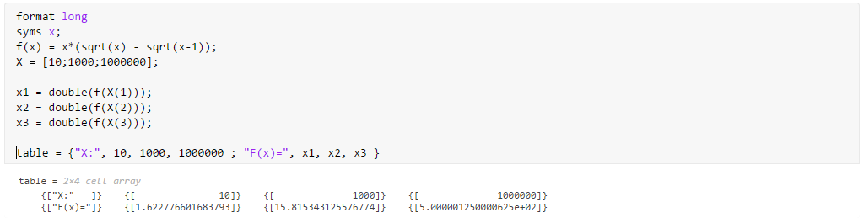

Figure 1: MATLAB Script for question 1 a)

|  |  |  |  |
| --- | --- | --- | --- |
| X= | 10 | 1000 | 1000000 |
| F(x)= | 1.622776601683793 | 15.815343125576774 | 5.000001250000625e+02 |

b)

X = 10

X = 1000

X = 1000000

|  |  |  |  |
| --- | --- | --- | --- |
| X= | 10 | 1000 | 1000000 |
| F(x)= | 1.6228 | 15.8 | 0 |

c)

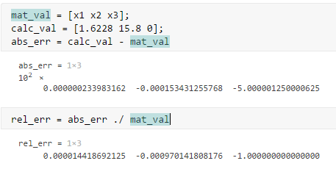

Figure 2: Script for question 1 c)

Based on the above equations, here are the results for the absolute error and relative error between part a) and b):

|  |  |  |  |
| --- | --- | --- | --- |
| X= | 10 | 1000 | 1000000 |
| Absolute Error | 2.339831620679078e-05 | 0.015343125576774 | -5.000001250000625e+02 |
| Relative Error | 1.441869212466626e-05 | -9.701418081761649e-04 | -1 |

The error above is mainly due to rounding errors, as there are many operations in the formula involving square root computations. This yields irrational numbers with decimal places that need to be rounded, according to the six-significant-figure rule. The rounding error also caused the value for x = 1000000 to be completely erroneous, which is why the absolute error is so large and the relative error is -1.

d) Simplifying the equation yields:

Calculations for:

X = 10

X = 1000

X = 1000000

|  |  |  |  |
| --- | --- | --- | --- |
| X= | 10 | 1000 | 1000000 |
| F(x)= | 1.62278 | 15.8153 | 500.00 |

e)

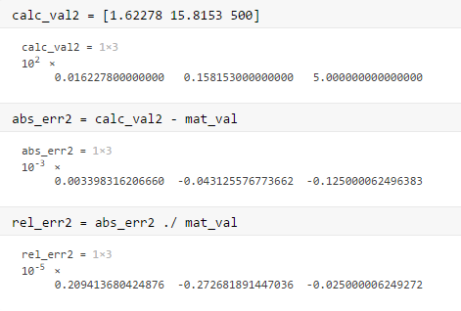

Figure 3: MATLAB Script used in 1 e)

|  |  |  |  |
| --- | --- | --- | --- |
| X= | 10 | 1000 | 1000000 |
| Absolute Error | 3.398316206659757e-06 | -4.312557677366158e-05 | -1.250000624963832e-04 |
| Relative Error | 2.094136804248757e-06 | -2.726818914470363e-06 | -2.500000624927195e-07 |

The error introduced in this section is generally much smaller than in part c). This is due to the calculations that did not involve such small numbers, as well as that the information to calculate the values was properly encoded in the entire range of the significant figures, not just the small latter portion. The principal source of error is rounding errors, but they are much more minimal than the error introduced in part c).

**Question 2)** (**10 Marks**)

a)

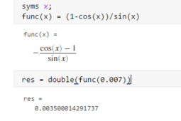

Figure 4: MATLAB Script used for question 2 a)

|  |  |
| --- | --- |
| X= | 0.007 |
| F(x) = | 0.003500014291737 |

b)

|  |  |
| --- | --- |
| X= | 0.007 |
| F(x) = | 0 |

c)

As in question 1 c):

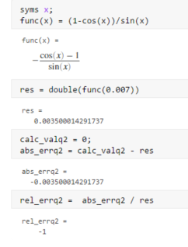

Figure 5: MATLAB Script used for question 2 c)

|  |  |
| --- | --- |
| X= | 0.007 |
| Absolute Error | -0.003500014291737 |
| Relative Error | -1 |

Due to the six significant digit limitation, the result computed by the calculator rounded up from 0.999999992 to 1.00000. Such, this is a rounding error.

d)

Using the trigonometric identity :

Calculating the value of

|  |  |
| --- | --- |
| X= | 0.007 |
| F(x) = | 0.000611087 |

e)

As in part c), using the value found in part a) as true:

|  |  |
| --- | --- |
| X= | 0.007 |
| Absolute Error | -0.002888927291737 |
| Relative Error | -0.825404427221130 |

The sources of error here are yet again due to rounding, as was found in part c) of this question. The magnitude of the error is due to working with very small numbers which are greatly modified by rounding them up or down, which affects the final result.

**Question 3)** (**14 Marks**)

a)

By the product rule, the derivative

Using MATLAB to compute the above function at x = 0.5:

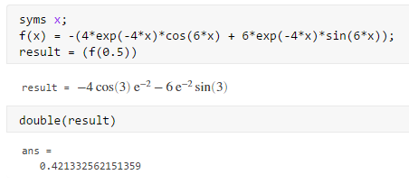

b)

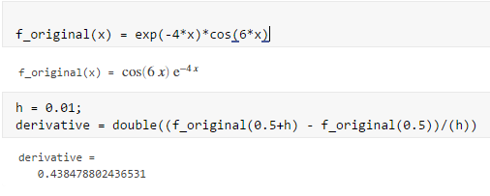

c)

Given that the Taylor series expansions for the following functions are:

Then the expression for the function:

Keeping only the first three lower order polynomials:

Then, using this function to compute the approximation with a step size of h = 0.01:

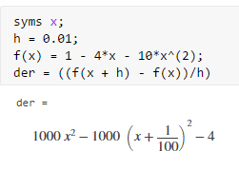

Figure 6: MATLAB script used in question 3 c)

So, the first order approximation of the derivative of the function above is:

d)

Using the result obtained in part a) for the derivative computed using calculus, the “true” reference value is equal to 0.421332562151359.

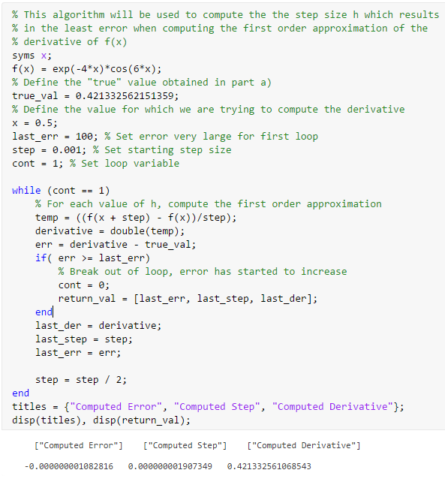

Figure 7: MATLAB Script used to compute optimal step size

|  |  |  |
| --- | --- | --- |
| Minimum Error | Optimal Step | Computed Derivative |
| -1.082816059039260e-09 | 1.907348632812500e-09 | 0.421332561068543 |

**Question 4)** (**12 Marks**)

a)

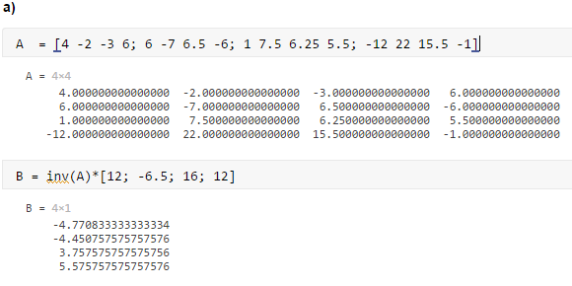

Figure 8: MATLAB Script used in question 4 a)

b)

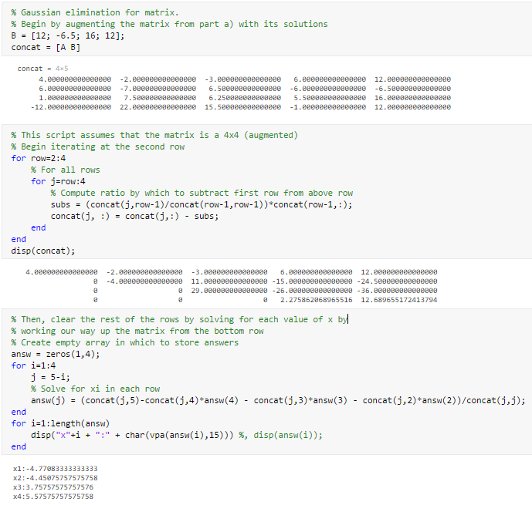

Figure 9: MATLAB Script used for question 4b)

c)

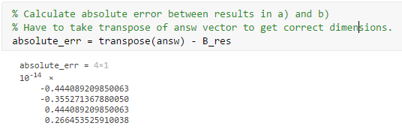

Figure 10: MATLAB Script used for question 4c)

**Question 5) (5 Marks)**

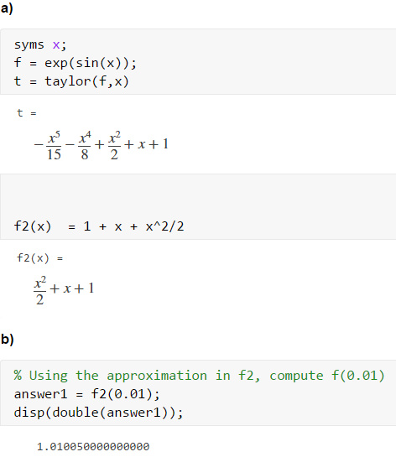

Figure 11: MATLAB script used for question 5 a) and b)

c)

d)

Comparing the results in part b) and c), many things are apparent. Obviously, approximating the function with only three terms of the infinite Taylor series is not going to be the most precise operation, which is why the result obtained in b) is quite different from the result obtained in c). Even with the rounding error introduced in part c), the result is probably more realistic with the exact value, as much more of the series of both functions are used in the calculator to compute the value.