**Non-Transitive Dice: An Investigation into Constraint Programming**

**1 Introduction**

Non-transitive dice are any set of dice where Dice n rolls a higher number than Dice n+1 more than half the time but Dice n=0 does not roll higher than Dice nmax. The non-transitive dice problem fits well to constraint programming (and constraint satisfaction problems) due to a well defined set of rules governing winning and losing. A basic example set of non-transitive dice are given below in figure 1.

The aim of this report was to use the non-transitive dice puzzle as a building block, asking a number of questions into dice combinations and rules as a tool to gain an understanding of constraint programming and the techniques involved. The purpose of the experiments conducted within this report was simply to attempt to gain an answer to questions in as interesting a way as possible. A number of techniques reviewed and attempted in this report include eliminating symmetry in solutions, preprocessing, variable and value ordering, and simply reformulating initial constraints.

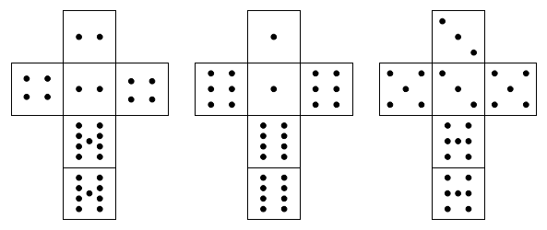

Figure 1. Basic Dice

**2 Modeling the Basic Problem**

As an introduction to constraint programming it was important to start with the most basic model of non-transitive dice. The set shown in figure 1 was used as a base and a set of constraints were extracted to create this set of dice.

Variables:

* Parameter declarations from parameter file
  + Integer N, determines how many sides on each dice
  + Integer MAX, determines the maximum value in the domain of values to put on the dice
* Constant declarations
  + Values over a domain ranging from 1 to MAX
* Decision variables
  + 1D matrix for each dice being modelled: D1, D2, D3
    - Indexed by an integer from 1 to N
    - with an integer domain of values from 1 to MAX

Constraints:

* each 2 faces of each die must be equal e.g.
  + D1[1]=D1[2],
  + D1[3]=D1[4],
  + D1[5]=D1[6]