Docker

**Overview**

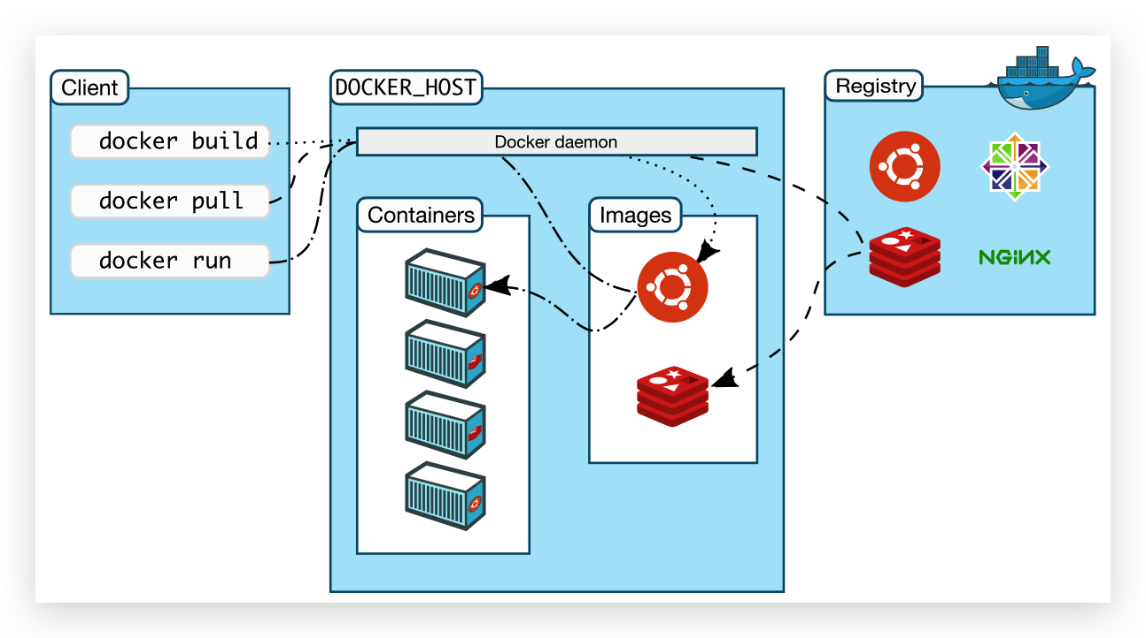

1. C/S架构：client是客户端，daemon是负责管理的守护进程，Registry是镜像仓库。
2. An image is a read-only template with instructions for creating a Docker container.
3. A container is a running process of an image.

Dockerfile

Networking

Storage