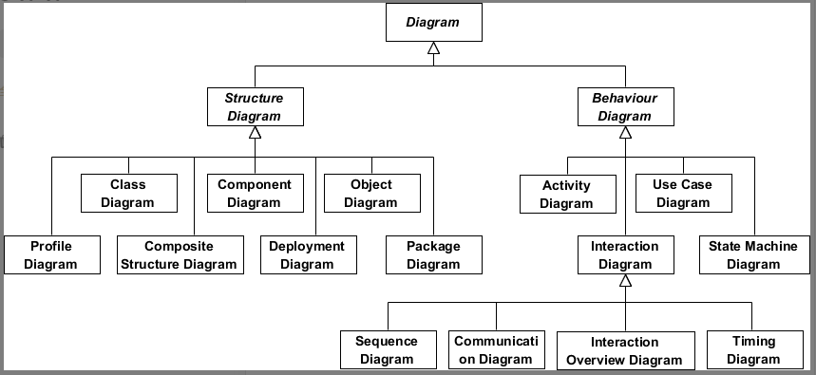

Structure Diagram: show **static structure** of the system and its parts on different abstraction and implementation levels and how those parts are related to each other.

* **类图 (Class Diagram)**

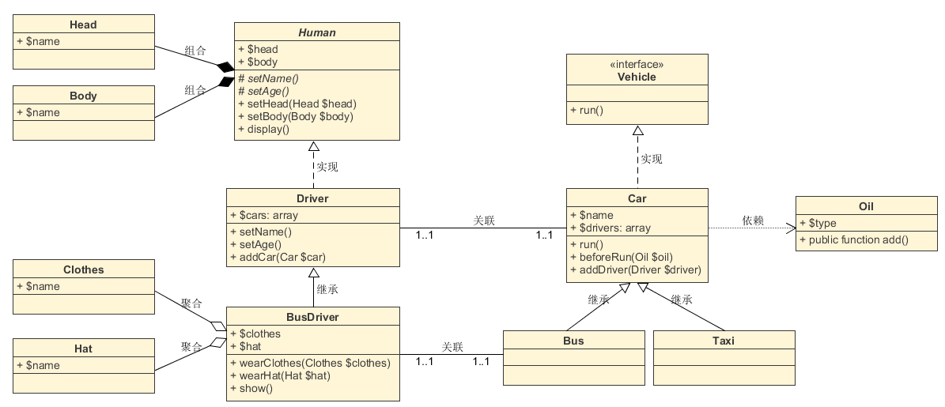

1. **Generalization 类继承：directed relationship** between a more general **classifier** (superclass) and a more specific classifier (subclass).
2. **Realization 接口实现：**realizes the behavior specifies.
3. **Composite 组合：**a whole/part relationship.
4. **Aggregation 聚合：**a **property** and one or more composite objects which group together a set of instances.
5. **Association 关联：**could be either **linked** to each other or **combined** logically or physically into some aggregation.
6. **Dependency 依赖：**needs or depends on other model elements for **specification** or **implementation**.

* **组件图 (Component Diagram)**
* **部署图 (Deployment Diagram)**
* **对象图 (Object Diagram)**
* **包图 (Package Diagram)**
* **复合结构图 (Composite Structure Diagram)**
* **轮廓图 (Profile Diagram)**

Behavior Diagram: show the **dynamic behavior** of the objects in a system, which can be described as a series of changes to the system over **time**.

* **用例图 (Use Case Diagram)**
* **活动图 (Activity Diagram)**
* **状态机图 (State Machine Diagram)**
* **序列图 (Sequence Diagram)**

focuses on the **message** interchange between a number of **lifelines**.

* **通讯图 (Communication Diagram)**
* **交互概述图 (Interaction Overview Diagram)**
* **时序图 (Timing Diagram)**